KITUTU CENTRAL JOINT EXAMINATION
Kenya Certificate of Secondary Education (K.C.S.E.)

232/3 - PHYSICS - Paper 3
(PRACTICAL)
2 ¹/₂HOURS

FORM 4, TERM 2, DECEMBER 2021

Name …………………………………….………………… Index Number ……………………

Candidate’s Signature……………………………………….Date ….………..………………….

INSTRUCTIONS TO CANDIDATES
- Write your name and index number in the spaces provided
- Answer ALL the questions in the spaces provided in the question paper.
- You are supposed to spend the first 15 minutes of the 2¹/₄ hours allowed for this paper reading the whole paper carefully before commencing your work.
- Marks are given for clear record of observations made, their suitability, accuracy and the use made of them.
- Candidates are advised to record their observations as soon as they are made.
- Non-programmable silent electronic calculators and KNEC mathematical table may be used.
- This paper consists of 6 printed pages. Candidates should check to ensure that all pages are printed as indicated and no questions are missing

FOR EXAMINER’S USE ONLY

QUESTION |  | MAXIMUM SCORE | CANDIDATES SCORE
1 | Part A | 15
1 | Part B | 05
2 |  | 20
TOTAL |  | 40

QUESTION 1

PART A

You are provided with the following:
You are provided with the following apparatus;
- A rectangular glass block
- A rectangular Soft board
- Four optical pins
- Two thumb pins
- A half metre rule
- Complete mathematical set (protractor must be there)

Proceed as follows
  - Fix the plain paper on the soft board using the two thumb pins
  - Place the glass block on the plane paper (fixed on the soft board). Let the glass block rest on the paper from the broader face
  - Trace the glass block using a pencil and then remove the glass block
  - Mark point X on the one of the longer side of the traced glass block a shown below. Point X should be between 1.5 and 2.0cm cm from edge A Construct a normal at X to emerge through line DC. Let this normal meet line DC at point M as shown in figure 1.

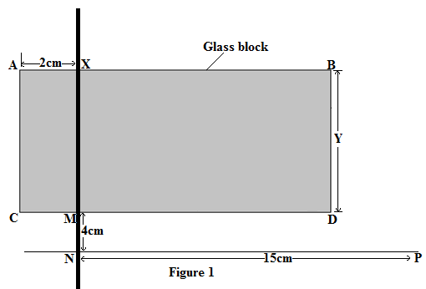

  - Mark point N along the emergent normal, 4cm from M.
  - Construct line NP to meet the normal at N at 90º. Line NP can be about 15cm
  - Using a protractor, construct an incident ray RX at an angle of incidence i=10º. Fix two pins P₁ and P₂ along RX.
  - Replace the glass block to the traced figure. View the path of the incident ray RX through the glass block using the other two pins P₃ and P₄. This can be done by ensuring that the images of pin P₁ and P₂ are in line with P₃ and P₄ (i.e., no parallax method) as shown in figure 2.
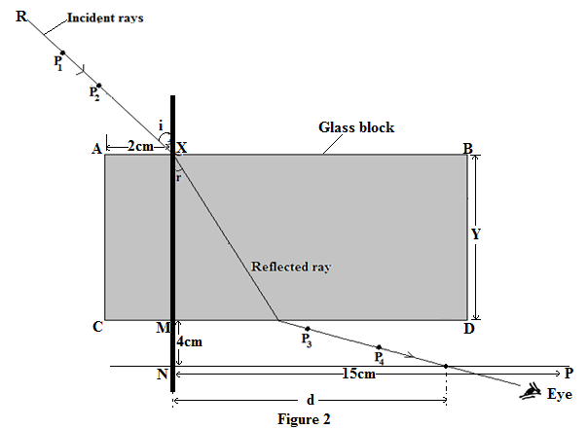
  - Remove the glass block and draw the emergent ray through P₃ and P₄.
  - Measure the distance d of the emergent ray from point N along line Record the corresponding values of d in the table below

Angle of incidence iº | 10 | 20 | 30 | 40 | 50 | 60
Distance d(cm)
Sin i
Sin ²i

(7 marks
  - Repeat the procedure for other values of i = 20⁰,30⁰,40⁰,50⁰ and 60⁰

  - Plot a graph of sin² i against d (5marks)



o) Determine the slope, S, of the graph. (3 marks)

PART B
You are provided with the following:
- A retort stand, clamp and boss.
- A spiral spring.
- A stop watch.
- Three 100g masses.

Proceed as follows:
- Suspend a 100g mass at the end of the spring as shown in figure 3.
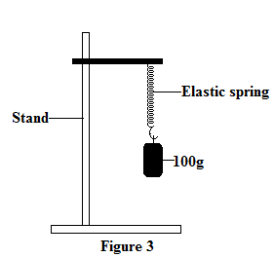
- Give the mass a small vertical displacement and release it so that it performs vertical
oscillations. Time ten oscillations and determine the period T. Enter your results in table 2.
- Repeat the experiment for the other values of mass and complete the table.
Mass m (g) | 100 | 200 | 300
Time for 10 oscillations (s)
Periodic time T(s)
Table 1 (3marks)

- Given that 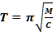 where C is the spring constant, find the average value C for the spring. (2marks)

QUESTION 2
You are provided with the following:
- 2 dry cells
- A cell holder
- A nichrome wire mounted on a metre rule
- An ammeter, A
- A voltmeter, V
- A jockey J
- A switch S
- 8 connecting wires.

Proceed as follows:

- Set up the apparatus as shown in figure 4

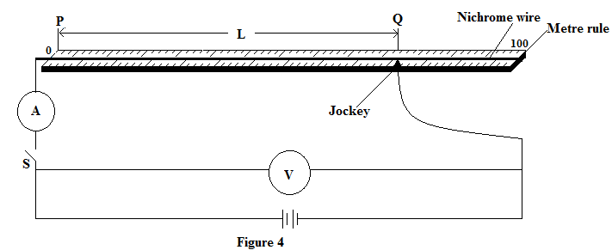

- With the switch open, record the reading E. of the voltmeter.
E = _________________________________________________________(1 mark)

- Place the jockey on the nichrome wire at 100cm mark. Close the switch, read and record the values of I (ammeter reading) and the corresponding values of V (voltmeter reading) in table 1.
- Repeat (c) above for various values of L and complete table 1 below. (7 marks)

Length L (cm) | 100 | 70 | 60 | 50 | 40 | 20
I (Amps)
V(Volts)
E-V (Volts)
Table 3

- Plot a graph of ((E - V) (y axis) against I(x-axis) (5 marks)



- Determine the slope of the graph. (3 marks)

- Given that E = V + Ir, from the graph determine
- The internal resistance, r, of the battery. (2 marks)

- V when I is 0.3A. (2 marks)

