FORM FOUR
PAPER 3 MARKING SCHEME

1. a)

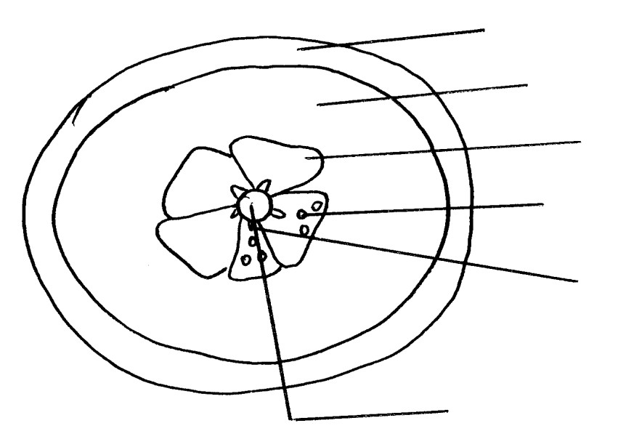Epicarp /Exocarp; Mesocarp;
Endocarp; Juice -sacs

Seed

placenta

Drawing – 1mk Accuracy – 1mk Labelling – 6/2 = 3mks Magnification = 1mk Total = 6mks

b) A berry / Hesperidium;
c) i) Animal Dispersal
ii) – Succulent endocarp / juicy endocarp;
- Seeds resistant to digestions ;
- Scented ;
- Bright coloured exocarp;
d) i) Animal
ii) -Fleshy/ juicy pericarp to attract the animal
- Brightly coloured epicarp to attract the animal
- Indigestible seed coats to avoid digestion by enzymes

e)

Food substance Procedure Observation Conclusion

Vit . C (Ascorbic
Acid)
- Put 2cm3 given vol. of DCPIP in test –tube.
- Add juice / test substance
DCPIP
decolourised
- Vit C present

Reducing sugar - Put test substance in t.tube
- Add Benedict soln;
- Boil;
- Colour changes to yellow / orange
/ red.
-
- Reducing sugar present

Proteins To the juice add sodium Hydroxide Solution then copper (II) sulphate Solution
-Blue colour is retained
Proteins absent

2. I (a) (i) epigeal
(ii) - cotyledons are above the ground
(b) (i) - positive hydrotropism in roots
- positive phototropism in shoot.
(ii) Positive phototropism
Light causes lateral migration of auxins away from the light side, towards the darker side;
high auxin concentration stimulates growth in the shoot; thus the cells on darker side grew and elongated faster than the cells on the illuminated side; causing the curvature towards light;
(iii) Provides yield energy required by the cell for various functions;
Positive hydrotropism.
Water causes auxins to migrate towards the side with water / moisture, auxin, are positively hydrotropic; low auxin concentration stimulates growth in roots, auxin high concentration inhibit growth in roots; the cells on the side away from the water grow and elongated faster; leading to curvature towards water.
(ii) Phototropism enables plants (shoot) to obtain optimum light for photosynthesis.
Hydrotropism by roots enables plants to absorb water and mineral salts for metabolic processes.
II (a) plate 6 - stamen plate 7 - pistil
(b) (i) dioecium
(ii) facilitates pollination leading to variation within the species and increase in hybrid vigour.
(c)(i) wind pollination
(ii) Small incospicuous bracts; that are dull coloured
(d) (i) cross pollination.
(ii) - male and female parts occur in different plants.
- the plant pollen grains are sterile to the stigma of the same plant.
3. (a) (i)

Specimen | Food | Reason
A | Aquatic matter and small invertebrates | Wide shovel shaped beak
B | Nectar | Long, thin beak
C | Nuts | Short, thick strong beak
F | Flesh | Strong sharp curved talons /claws

(ii)
Part Habitat Reason
D Aquatic Webbed feet for swimming / wadding
E Tree branches Long feet / toes for grasping / perching

(b) (i) Divergent evolution; (4mks)
Reason: Similar basic structure and embryonic origin but modified into different forms / appearance;
(ii) Enable the organisms / animals to utilize different ecological niches; to avoid competition for food; (2mks)

