ASUMBI GIRLS HIGH SCHOOL
PRE-MOCK
MAY-JUNE
2022
121/1
MATHEMATICS
PAPER 1
MARKING SCHEME

 | SECTION I
1 | = 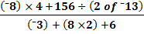  = 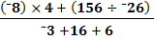  = 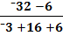  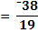  = ⁻2 | M₁  M₁  A₁ | Numerator completely simplified  Denominator completely simplified
 |  | 3
2 | School fees =  Remainder = 1 - =  Electricity and water bills = =  Remainder = 1 - 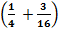 = 1 - =  Transport = =  Remainder = 1 - 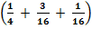 = =  Let the net salary be S  Then S = 3 400  S = Ksh. 6 800 | B₁  M₁  A₁ | Remaining fraction  Equating to 3 400
 |  | 3
3 | Total area = (6 x 10 000)m²  = 60 000 m²  Plots area = 60 000 – 1 500  = 58 500 m²  Area of 1 plot = 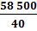  = 1 462.5 m² | B₁  M₁  A₁ | Conversion of hectares to m²  Division by 40
 |  | 3
4 | L₁ : 3y + 4x – 6 =0  3y = ⁻4x + 6  y = -x + 6  Gradient m₁ = -  Gradient m₂ =  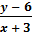 =  4(y – 6) = 3 (x + 3)  4y – 24 = 3x + 9  4y = 3x + 33  y = x + | B₁  M₁  A₁ | Gradient of L₂  Or equivalent equations
 |  | 3
5 | Let the total number of eggs bought be x.  Then C.P. per egg =  S.P. per egg = 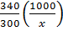 = 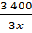  Number of good eggs = x – 4  Total S.P. = 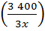(x – 4) = 1100  3 400x – 13 600 = 1 100x  100x = 13 600  x = 136 eggs | M₁  M₁  A₁ | Expression for the S.P. per egg  Equating total S.P. to 1 100
 |  | 3
6 | 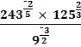  = 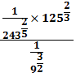  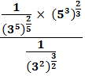  = 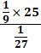  = 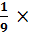25 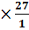  = 75 | M₁  M₁  A₁ | Removal of all the negative indices  Removal of all the roots
 |  | 3
7 | (x + 3)² + 2x – 4)² = (2x)²  x² + 6x + 9 + 4x² – 16x +16 = 4x²  x² – 10x + 25 = 0  (x – 5) (x – 5) = 0  x – 5 = 0  x = 5  2x – 4 = 10 – 4 = 6 cm  x + 3 = 5 + 3 = 8 cm  2x = 2(5) = 10 cm | M₁  M₁  A₁  B₁ | Applying Pythagoras theorem  Complete factorisation  Solving the quadratic equation  For all the three sides
 |  | 4
8 | 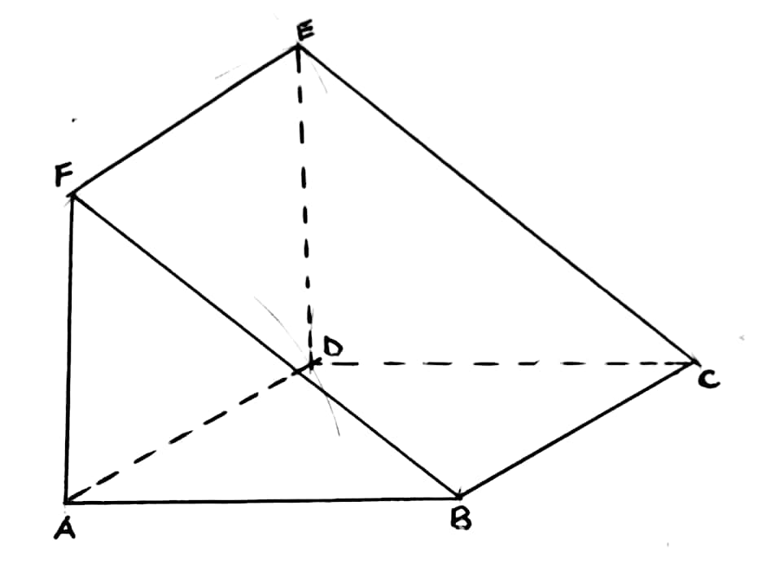 | B₁  B₁  B₁ | Lines AF and ED drawn equal and parallel to BC, 0.1cm  For any 2 pairs of lines drawn equal and parallel: AB and FC, AE and DF, BE and CD.  Completion of the solid with the broken lines shown.  Note: The lines must not be extended
 |  | 3
9 | 2 < < 11  2 <  6 < 2x²  3 < x²  < x²  1.732 < x  < 11  2x² < 33  x² < 16.5  x <  x < 4.062  1.732 < x < 4.062  x = 2, 3, 4 | B₁  B₁  B₁ | Solving for x  Solving for x  All the 3 values correct
 |  | 3
10 | M = 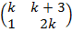  Determinant of M = 0  Thus 2k² – 1(k + 3) = 0  2k² – k – 3 = 0  2k² + 2k – 3k – 3 = 0  2k (k + 1) – 3 (k + 1) = 0  (2k – 3) (k + 1) = 0  Either 2k – 3 = 0  2k = 3  k =  or  k = ⁻1 | M₁  M₁  A₁ | Equating the determinant to zero  Complete factorization.  For both values of k
 |  | 3
11 | 20,000×147.86  =Ksh 2,957,200  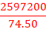  US$5975.8389 | _{M1}  M₁  _{A1}
 |  | 3
12 |  |  | For 37⁰  For the pair of 143⁰ and 123⁰  For the pair of 323⁰ and 303⁰
 |  | 3
13 | L.F.S. =  A.S.F. = (L.S.F.)²  A.S.F. = 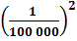= 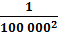  Actual area = (200 x 100 000 x 100 000) cm²  Actual area = 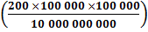 km²  = 200 km² | B₁  M₁  A₁ | For A.S.F.  For conversion of cm² to km²
 |  | 3
14 | OP = , OQ = 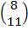, OR = 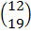  PQ = OQ – OP = - = 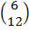 PQ = 6  PQ =  PR = OR – OP = - = 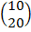 PR = 10  PR =  Therefore PQ = PR  10 PQ = 6 PR  Hence PQ is parallel to PR.  Point P is common. | B₁  B₁  B₁ | For 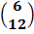  For 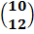  For both conditions  NB: Follow through the candidate’s work.
 |  | 3
15 | Distance covered by the bus in 30 minutes = 70 x = 35 km  Relative speed of the car over the bus = 90 – 70 = 20 kmh⁻¹  Time taken for the car to catch up with the bus =  t = 1.75 hours  Distance travelled by the car =  90 x 1.75  D = 157.5 km. | B₁  M₁  A₁ | For 20 kmh⁻¹ seen  For multiplication  C.A.O.
 |  | 3
16 | 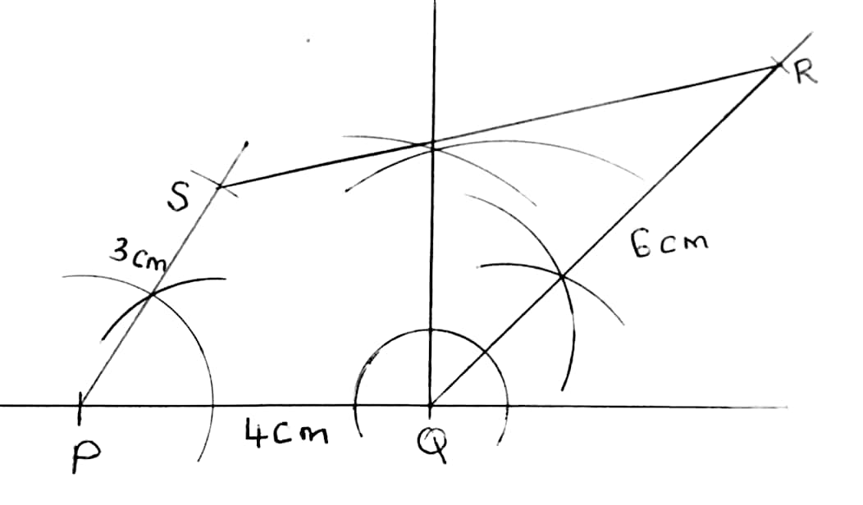  RS = 7.0 0.1 cm | B₁  B₁  B₁  B₁ | Correct location of point R, i.e., construction of PQ = 4.0 0.1 cm, 135 1⁰ and QR = 6.0 0.1 cm.  Correct location of point S, i.e., construction of i.e., 60 1⁰ at P and PS = 3.0 0.1 cm.  Correct quadrilateral PQRS completed.
 |  | 4

17. | (a)  (b)(i) October’s sales:  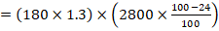  Percentage decrease in amount received:  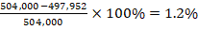  (ii) New price ==  = sh. 1,862  (c) November’s bags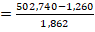  =270  t% | B1  M1  A1  B1  M1  A1  M1  A1  M1  A1
 |  | 10
18 | (a)  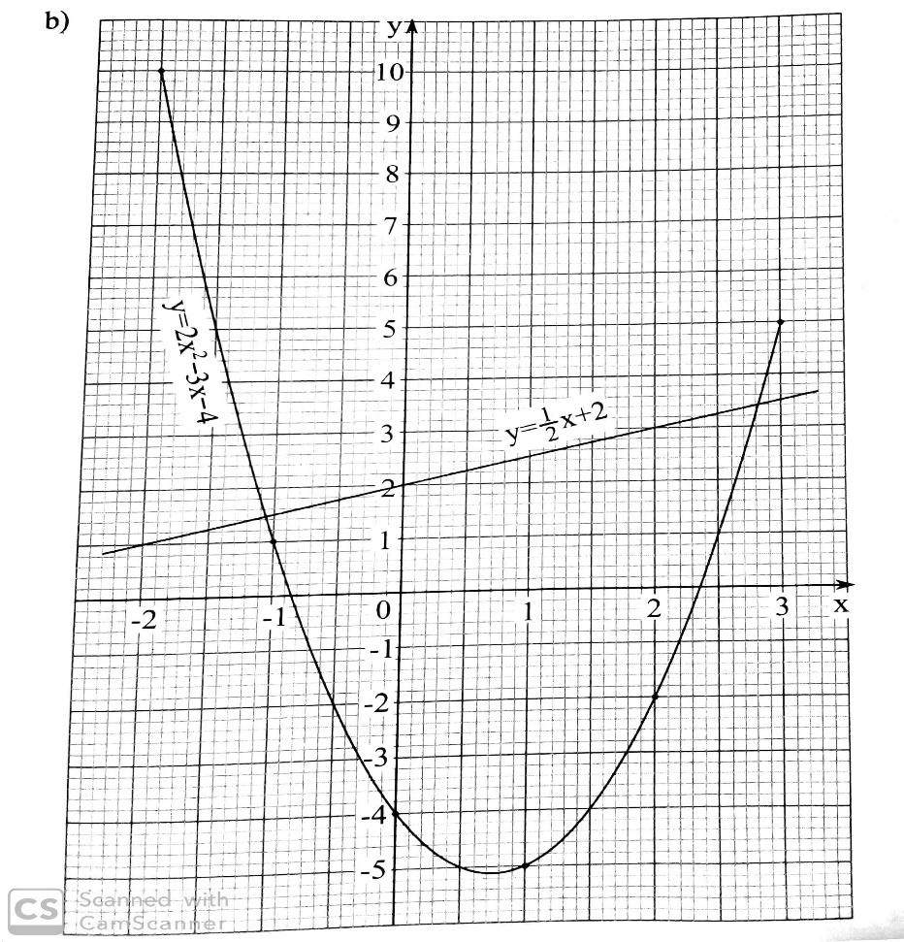  (b)  (c)  (d) | B1B1  B1  B0  S1  P1  C1  B1  B1B1  B1  B1 | all correct values  6-8 correct values  Less than 6 values  Scale  plotting  curve  for Line  Each value one mark  For Both values
   | -2 | -1 | 0 | 1 | 2 | 3
   | 8 | 2 | 0 | 2 | 8 | 18
   | 2 | -1 | -4 | -7 | -10 | -13
   | 10 | 1 | -4 | -5 | -2 | 5
 |  | 10
19 | (a)  Mean=  (b) median class = 60 – 64  Median 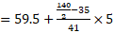  = 59.5 + 4.268  = 63.77  (c) 63.77 – 62.57 = 1.2  (d) 60 - 64 | B1  B1  M1  A1  B1  M1  M1  A1  B1  B1 | For Fx  For cf
  marks | x | f | fx | cf
  45-49 | 47 | 10 | 470 | 10
  50-54 | 52 | 11 | 572 | 21
  55-59 | 57 | 14 | 798 | 35
  60-64 | 62 | 41 | 2542 | 76
  65-69 | 67 | 27 | 1809 | 103
  70-74 | 72 | 18 | 1296 | 121
  75-79 | 67 | 19 | 1273 | 140
   |  |  | 8760
 |  | 10
20 | - The diagonal of the base =25  The perpendicular height of the original pyramid  =30  Perpendicular height of the frustumx30  =21cm  - The altitude of the cut-off pyramid is  30-21= 9cm  Volume of frustum  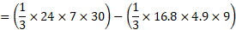  = 1680-246.96  = 1433.04cm³  - Perpendicular height of face VHG ==30.2  Perpendicular height of face VHG =32.3  SA of original pyramid  =  =1118.9cm² | M1  M1  M1  A1  M1  M1  A1  M1M1  A1
 |  | 10
21 | 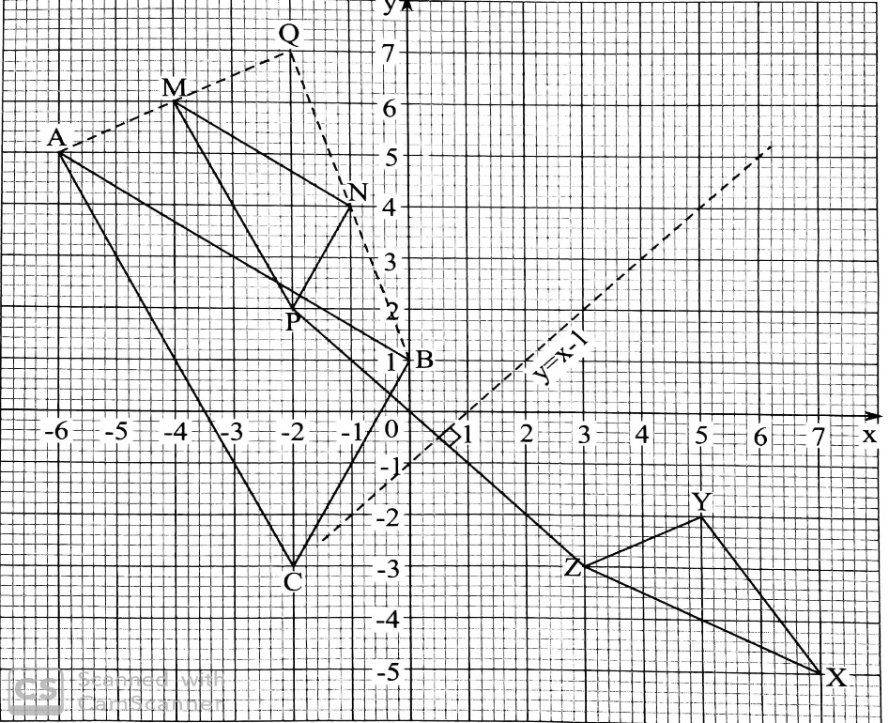  - Q(-2,7) - (centre of enlargement)  Scale factor =  - ASF=(LSF)²  2² = 4  Area of triangle ABC = 4Qcm² | S1  B1  B1 B1  B1  B1  B1  B1 –  M1  A1 | Scale  Each for each triangle  For centre of enlargement  Scale factor of enlargement  mirror line Drawn  eqn of the mirror line
 |  | 10
22 | - DC  =  = 5.8cm  - Tan α=  α = Tan⁻¹ (1.677)  α = 59.0⁰  cos =  cos =-0.4  = 113.6⁰  - Area  = 7.5+18.3  = 25.8cm² | M1  A1  M1  A1  M1  M1  A1  M1M1  A1
 |  | 10
23 | 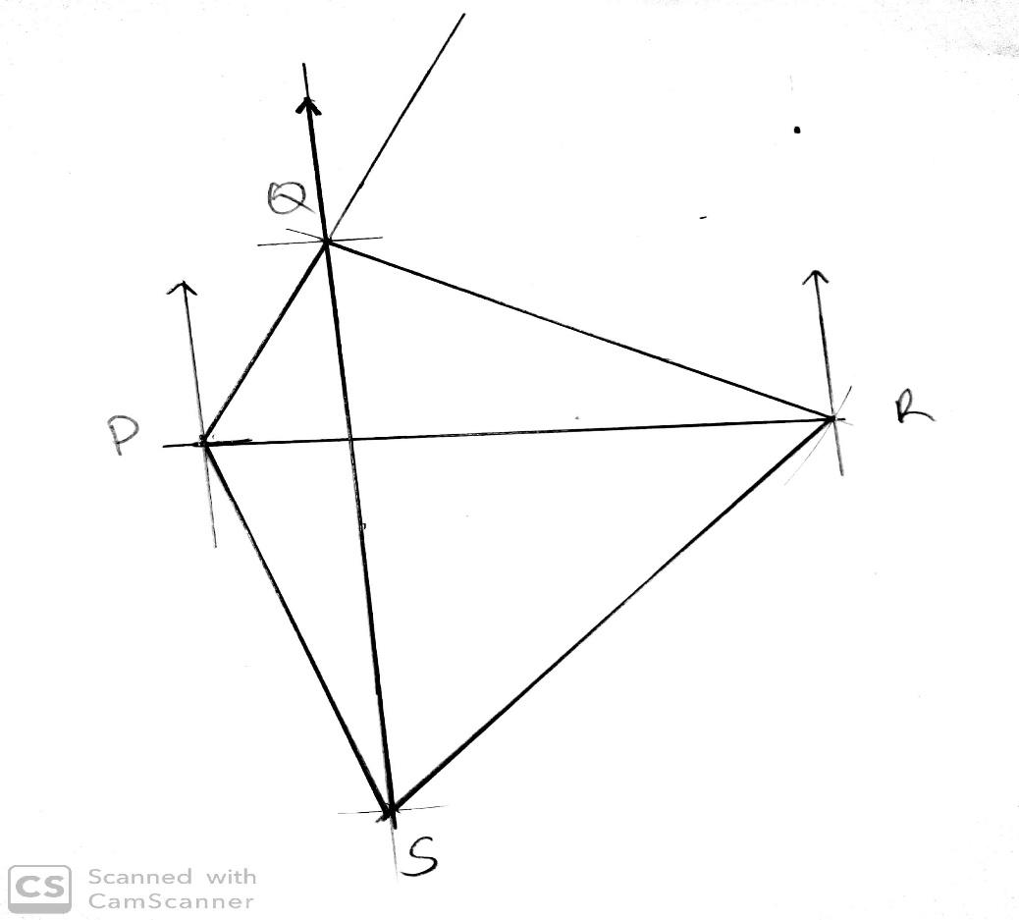  (a)  (b) (i) 343⁰ ±1  (ii) 226⁰ ±1  - (i)6.8x100=680km  (ii)9x100km=900km  - (i) 300⁰  (ii)272⁰ | B1  B1  B1  B1  B1  B1  B1  B1  B1  B1 | for each point located
 |  | 10
24 | - S = (4)³ – 5(4)² + 4(4) + 3  = 3m  =3(4 – 10(4) + 4  =12m/s  - 3t²-10t+4=0  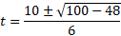  = | M1  A1  M1  M1  A1  M1  M1  A1  M1  A1 | (both values)
 |  | 10

