NAME…………………….................................................ADMNO................CLASS.........
121/1
MATHEMATICS
Paper 1
2½ Hours
ASUMBI GIRLS HIGH SCHOOL
PRE-MOCK
MAY-JUNE
2022

MATHEMATICS

INSTRUCTIONS TO CANDIDATES
- Write your name, index number and class in the spaces provided above.
- The paper contains two sections: Section I and Section II.
- This paper contains 14 PRINTED pages make sure all PAGES ARE PRINTED and NON IS MISSING
- Answer ALL the questions in Section I and ANY FIVE questions from Section II.
- All working and answers must be written on the question paper in the spaces provided below each question.
- Marks may be awarded for correct working even if the answer is wrong.
- Negligent and slovenly work will be penalized.
- Non-programmable silent electronic calculators and mathematical tables are allowed for use.
For examiners use only
Section I
1 | 2 | 3 | 4 | 5 | 6 | 7 | 8 | 9 | 10 | 11 | 12 | 13 | 14 | 15 | 16 | Total

Section II
Grand
Total
17 | 18 | 19 | 20 | 21 | 22 | 23 | 24 | Total

SECTION I (50 marks)
Answer all the questions in this section in the spaces provided.
- Without using Mathematical tables or a calculator, evaluate
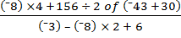
(3 marks)

2. Antony spent one quarter of his net January salary on school fees. He spent a quarter of the remainder on electricity and water bills. He then spent one ninth of what was left on transport. If he finally had sh. 3 400, calculate his net January salary. (3 marks)

3. A residential estate is to be developed on a 6 hectares piece of land. 1 500 m² is taken up by the roads while the rest is divided into 40 equal plots. Calculate the area of each plot. (3 marks)

4. The equation of a straight line L₁ is 3y + 4x – 6 = 0. Another straight line L₂ is perpendicular to L₁ and passes through point P (⁻3, 6). Determine the equation of L₂ in the form y = mx + c, where m and c are constants. (3 marks)

5. A shopkeeper bought a number of eggs for which he paid a total of Ksh. 1000. Four eggs were broken. He sold the rest at 13% profit, thereby making a cash profit of Ksh. 100. Calculate the number of eggs that he had bought at the first place. (3 marks)

6. Without using Mathematical tables a calculator evaluate 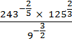 (3 marks)

7. The longest side of a right-angled triangle is (2x) cm. The other sides are (x + 3) cm and (2x – 4) cm. Find the value of x and hence the lengths of the sides of the triangle. (4 marks)

8. Below is part of sketch of a wedge ABCDEF. Complete the sketch of the solid, showing the hidden edges with broken lines. (3 marks)

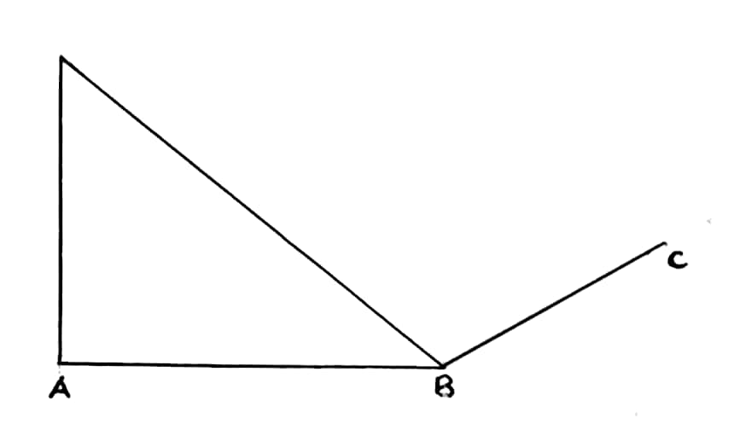
9. If x is a positive integer, solve the inequality 2 < < 11 and hence list the integral values that satisfy the inequality. (3 marks)

10. The matrix M = 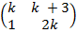 has no inverse. Determine the possible values of k. (3 marks)

11. A Kenyan Bank buys and sells foreign currencies at the exchange rates shown below
Buying selling

Kshs Kshs
1 Euro 147.86 148.00
1 US Dollar 74.22 74.50
An American arrived in Kenya with 20000 Euros. He converted all the Euros to Kenya shillings at the Bank. He spent kshs.2,512, 000 while in Kenya and converted the remaining Kenya shillings into US Dollars at the bank. Find the amount in Dollars that he received. (3 marks)

12. Given that tan (θ + 20)⁰ = ⁻0.7660, find θ, to the nearest degree, in the range 0⁰ θ 360⁰.
(3 marks)

13. The area of an island on a map of scale 1:100 000 is 200 cm². Calculate the actual area on the ground in square kilometers. (3 marks)

14. P(2, ⁻1), Q(8, 11) and R(12, 19) are three points on a Cartesian plane. Show that P, Q and R are collinear. (3 marks)

15. A bus leaves Nairobi travelling towards Mombasa at a speed of 70 kmh⁻¹. Half an hour later, a car leaves Nairobi travelling in the same direction at a speed of 90 kmh⁻¹. Calculate the distance travelled by the car when it overtook the bus. (3 marks)

16. Use a ruler and a pair of compasses in this question.
- Construct a quadrilateral PQRS in which PQ = 4 cm, QR = 6 cm, PS = 3cm, angle PQR = 135⁰ and angle SPQ = 60⁰. (3 marks)

- Measure the length of RS. (1 mark)

SECTION II
Answer five questions only in this section.
- (a) Aisha sold 180 bags of rice in September 2017. The cost of each bag was sh. 2800.
Calculate the amount of money that he received from the sale of rice that month.
(1 mark)

(b) (i) In October that year, the price of a bag of rice decreased by 24% and the number of bags that she sold increased by 30%. Determine the percentage decrease in the amount of money she received from the sale of rice.
(3 marks)

(ii) In November that year, the price of a bag of rice changed in the ratio of 7:8. Find the
price of each bag in November.
(2 marks)

(c) The amount that he received from the sale of rice in September was sh. 1260 more than what was received in November. If the number of bags that were sold in November were t% more that those sold in September, find t.
(4 marks)
- (a) Complete the table below for the function for
(2 marks)
 | -2 | -1 | 0 | 1 | 2 | 3
 |  | 2 | 0 | 2 | 8
 | 2 |  | -4 |  |  | -13
 |  |  | -4 |  |  | 5
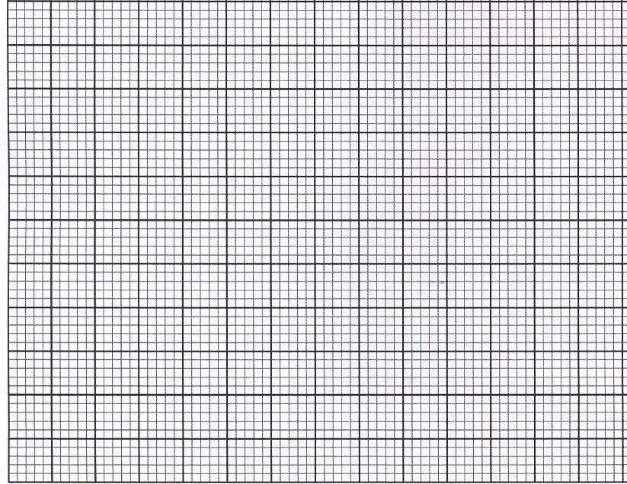
(b) On the grid below, draw the graph of for
(3 marks)
(c) Use your graph to estimate the roots of (2 marks)

(d) Use your graph to solve (3 marks)
- The marks scored by a certain number of students in a mathematics contest are as shown in the table below.

Marks | 45-49 | 50-54 | 55-59 | 60-64 | 65-69 | 70-74 | 75-79
No. of students | 10 | 11 | 14 | 41 | 27 | 18 | 19

- Calculate to 2d.p. the mean of the marks scored. (4 marks)

- State the median class and hence calculate the median. (4 marks)

- Calculate the difference between the mean and the median. (1 mark)

- State the modal class. (1 mark)
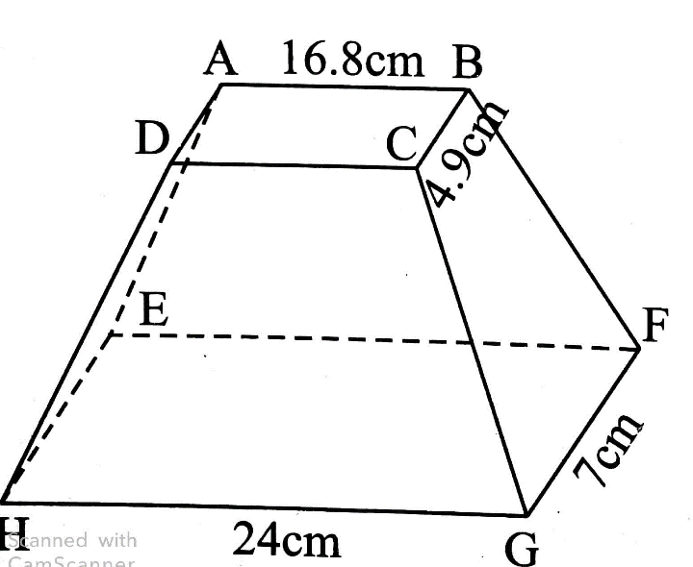
- The figure below shows a solid frustum of right pyramid with a rectangular base EFGH measuring 24cm by 7cm. The frustum was obtained by cutting off a small pyramid along plane ABCD that is parallel to base EFGH. Plane ABCD measures 16.8cm by 4.9cm, and is exactly seven tenths way up the vertical height of the original pyramid.
Given that the original pyramid had a slant edge of 32.5cm, find:
- The altitude (perpendicular height) of the frustum. (4 marks)

- The volume of the frustum (3 marks)

- The surface area of the original pyramid. (3 marks)
- Triangle ABC has vertices A(-6,5), B(0,1) and C(-2,-3). Triangle MNP is the image of triangle ABC under an enlargement. The vertices of triangle MNP are M(-4,6), N(-1,4) and P(-2,2). A reflection then maps triangle MNP onto triangle XYZ whose vertices are X(7,-5), Y(5,-2) and Z(3,-3).
- Plot the three triangles on the grid below. (3 marks)
- Determine the centre and the scale factor of enlargement that maps ABC onto MNP.
(3 marks)

- Find the equation of the mirror line of the reflection. (2 marks)

- Given that triangle XYZ has an area of Qcm2, state the area of triangle ABC in terms of Q. (2 marks)
- In the figure below, AB = 11cm, BC = 8cm, AD = 3cm, AC = 5cm and ‹DAC is a right angle.

C
8CM

5CM
D B
3CM 11CM
A
Calculate, correct to one decimal place:
- The length DC (2 marks)

- The size of ‹ADC (2 marks)

- The size of ‹ACB (3 marks)

- The area of the quadrilateral ABCD (3 marks)

- Three warships P, Q and R are at sea such that ship Q is 400km on a bearing of 030⁰ from ship P. Ship R is 750km from ship Q and on a bearing of 120⁰ from ship Q. An enemy warship S is sighted 1000km due south of ship Q.
- Taking a scale of 1cm to represent 100km locate the relative positions of ships P, Q, R and S. (4 Marks)

- Find the compass bearing of
- P from S (1 mark)

- S from R (1 mark)

- Use the scale drawing to determine the distance of;
- S from P (1 mark)

- R from S (1 mark)

- Find the bearing of;
- Q from R (1 mark)

- P from R (1 mark)

- A particle moving along a straight line passes through a fixed point P. Its displacement S metres from P after a period at t seconds is given S=t³-5t²+3.
Find;
- The particle’s displacement from P at t=4 (2 marks)

- The particle’s velocity at t = 4. (3 marks)

- The possible Value(s) of t when the particle is momentarily at rest. (3 marks)

- The acceleration of the particle at t = 3. (2 marks)

