ASUMBI GIRLS HIGH SCHOOL
PRE-MOCK
MAY-JUNE
2022

231/2 – BIOLOGY PAPER TWO MARKING SCHEME.

- (i) A – Transverse processes;
B – Vertebrarterial canal; Rej vertebraterial canal
C – Centrum;
D – Neural Spine;
(ii) Cervical vertebra; RJ Vertebrae
- Presence of vertebrarterial canals;
- Passage of nerves and blood vessels;
- Neck region; (of the verterbral column)

- (a) To show that water and carbon (IV) oxide are produced during aerobic respiration;
(b) Bubbles will be observed;
- The solution turns into a white precipitate;
(c) Water droplets will be seen;
(d) Water is produced during aerobic respiration;
- Carbon (IV) oxide is produced during aerobic respiration

- (a) Divergent evolution (1 mark)
(b) Ancestry origin of the lib suggests there were habitants of aquatic environment. (1 mark)
(c) i) Vestigial structures
Highly reduced structure due to disuse (1 mark)
ii) Appendix, coccyx, nictating membrane eye, muscles that moves the ear. (1 mark)
(d)(i) Natural selection
Situation whereby the nature favours organisms suited for survival and eliminate those that are less adapted. (2 marks)
ii) An example of nature selection in action. (2 marks)
- Resistance to antibiotics and pesticides
- Industrial mechanism
- More precipitation is observed when serum of closely related organism are mixed and vice versa. (1 mark)

- (a) Herbivorous;
(b) Structural: J – Narrow/sharp/chisel like
L – Broad/ridge

Functional: J – Cutting and bitting
L – Grinding and crushing.

(c) (i) Diastema
(ii) To allow manipulation of food by tongue/separating chewed and new cut vegetation.

- Calcium phosphate;

- Homodont – Organism having same/similar kind/type of teeth, hence same function.
Heterodont – Organisms having different type/kind of teeth hence different function.

-2-
- (a) Bb , Bb
(b) Parental phenotype male female
Parental genotypes Bb x Bb
Gametes

 | B | b
B | BB | Bb
b | Bb | bb

(c) Ratio is 3.1 (i.e. in every 4, 1 died)
¼ = 390 therefore those that survived are ¾
¾ = ¾ x 390 x ⁴/_{1;} = 1170;

SECTION B (40 MARKS).
- (a) (i) Scale: x-axis: 1cm rep 0.02g/100cm , y-axis: 1cm rep 10% R.b.c. haemolysed
(ii) 0.403 + 0.002 (iii) 10 = 1%

(b) (i) 0.33 percent salt concentration – Less concentration/dilute/hypotonic than blood cells
cytoplasm; water is drawn in by osmosis; the cells swell and eventually burst (a process
called haemolysis)
(ii) 0.48 percent salt concentration – Concentration of red blood cells cytoplasm is same as
concentration of salt solution (isotonic) therefore no net movement of water by osmosis;
hence cells remained normal and none were haemolysed.

(c) 0.5% salt concentration is highly concentrated solution/hypertonic than blood cells cytoplasm;
Red blood cells would lose water by osmosis; shrink and become crenate.

- The cell sap is more concentrated than surrounding; water enters into the cell by osmosis; the
cell swells/becomes turgid; but does no burst due to the rigid cellulose cell wall.
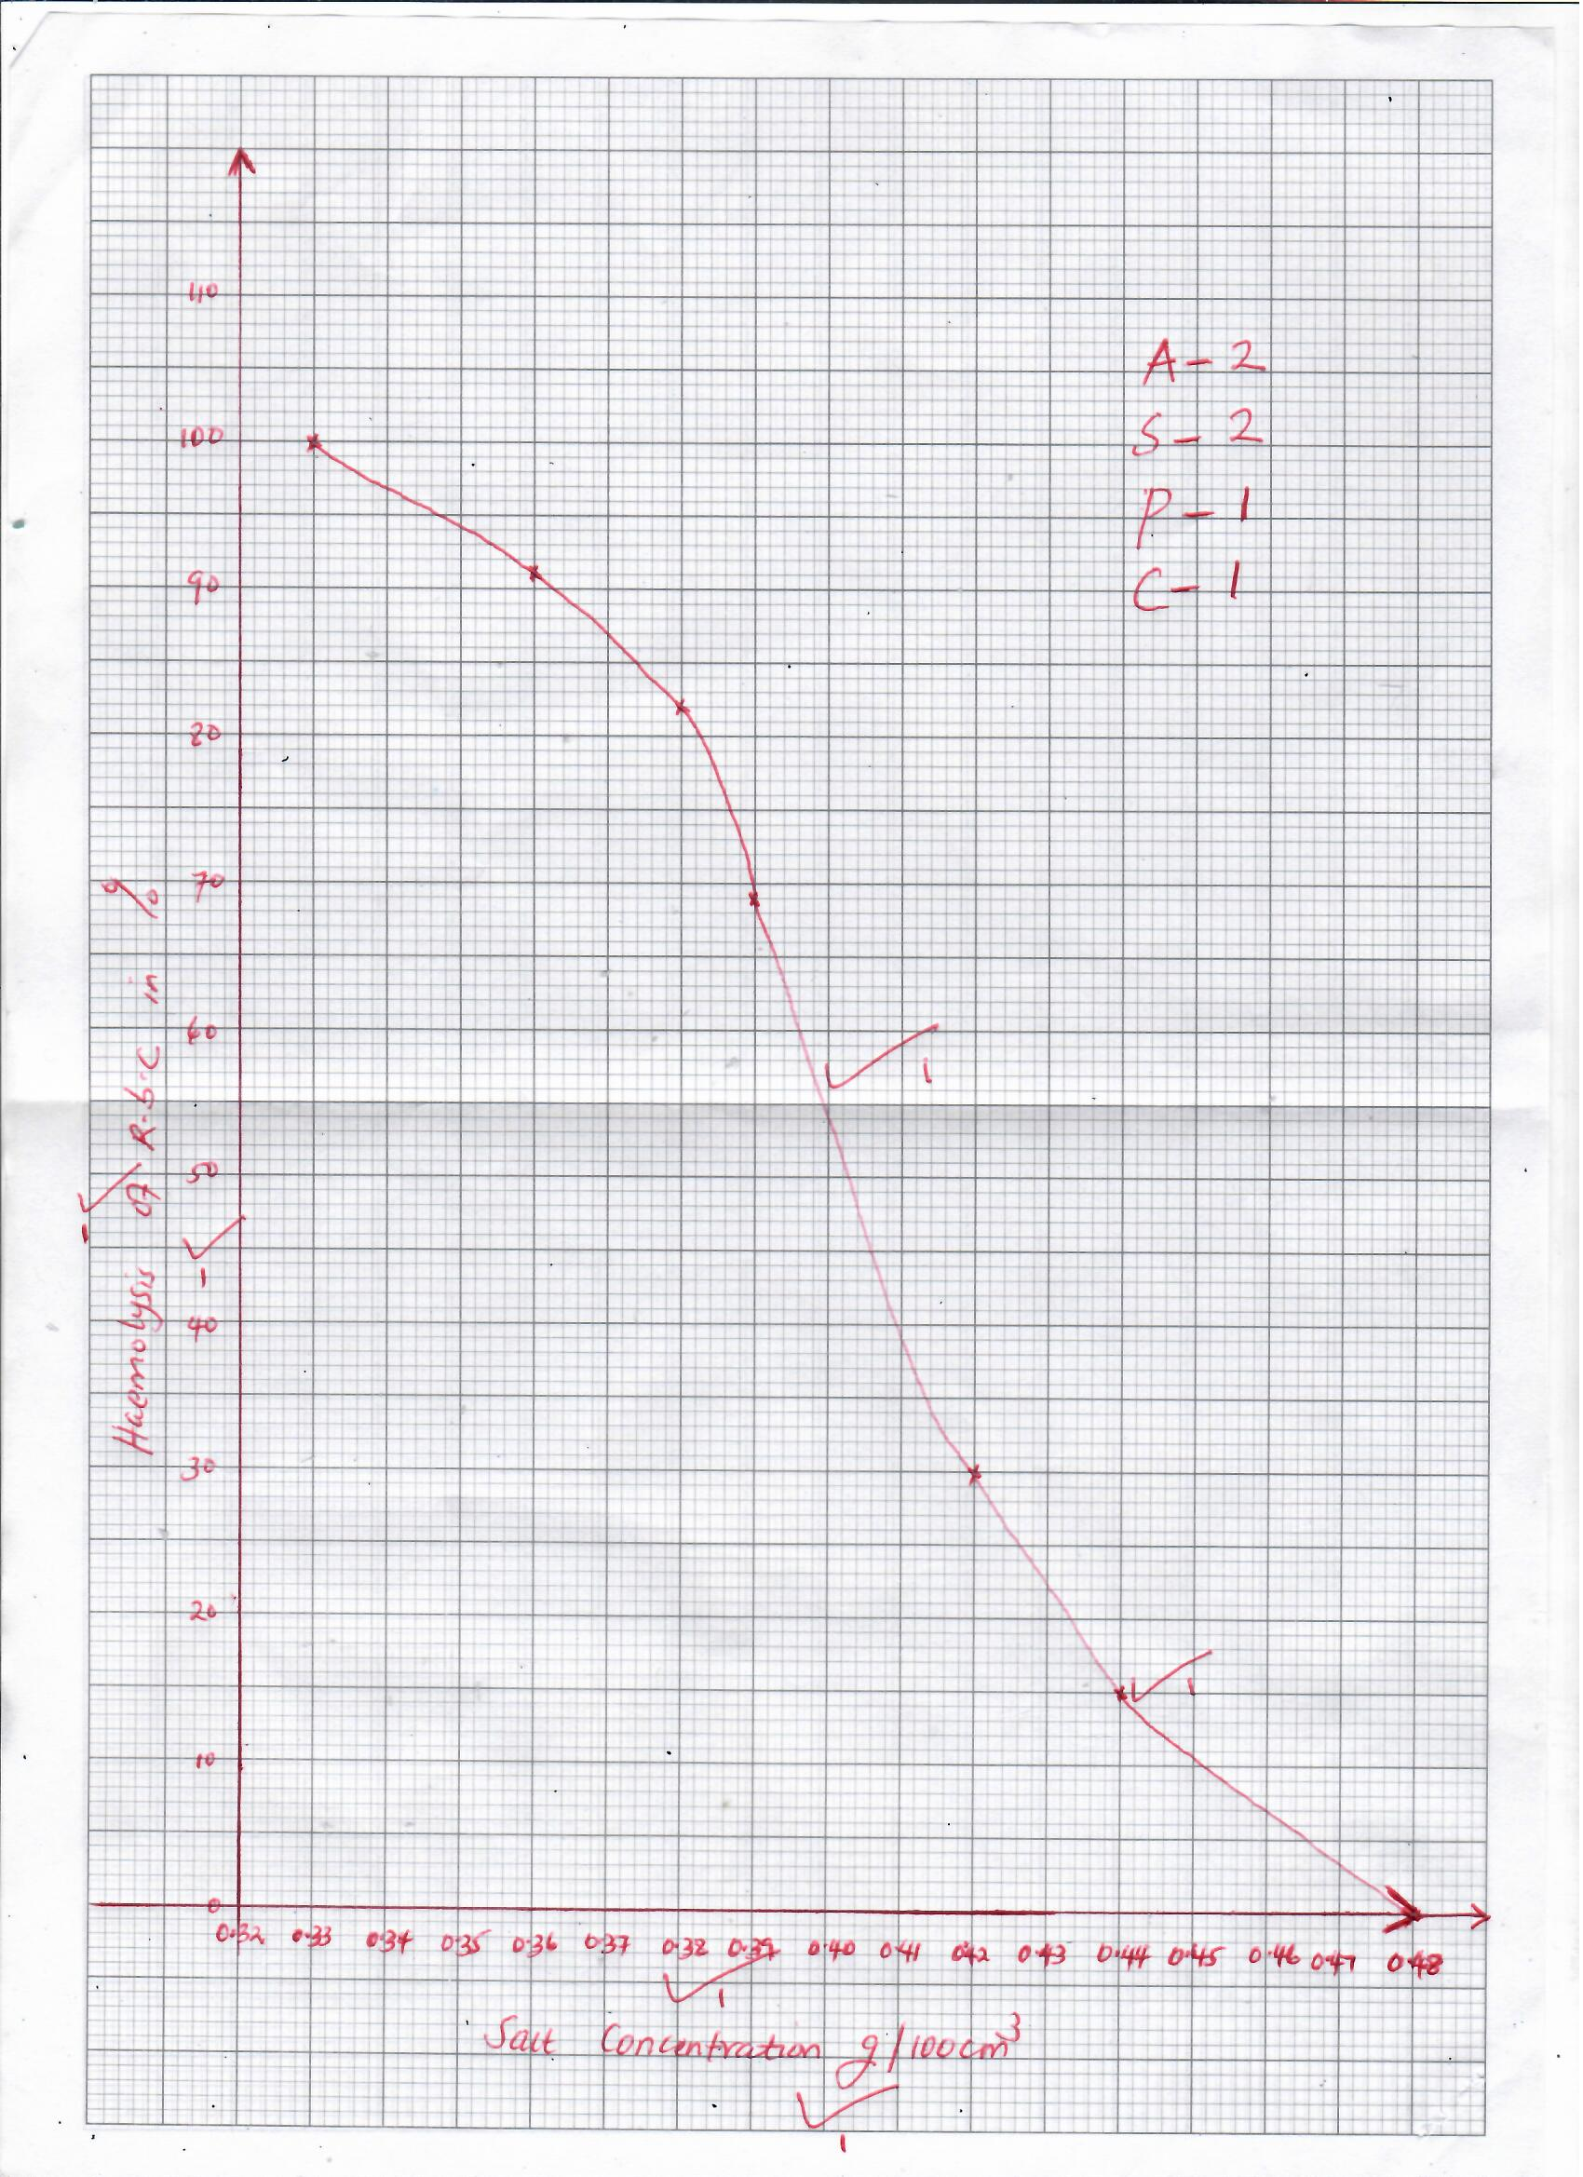

7. Kidneys receive blood from renal artery, a branch of dorsal aorta, hence blood is under high
pressure. The afferent arteriole which is the branch of renal artery supplies blood to glomerulus;
The afferent arteriole has a wider diameter than the efferent arteriole; this causes back resistance
hence high pressure in the glomerulus leading to ultra-filtration. The walls/capsular barrier are one
cell thick hence glucose, amino acids, vitamins, hormones, salts, (creatinine) urea and water filter
into Bowman’s Capsule to form glomerular filtrate; White blood cells/red blood cells and plasma
proteins such as (Globulin, fibrinogen, platelets) are too large to pass through the capillaries: the
filtrate flows into the proximal convoluted tubule, where all amino acids, vitamins and all glucose
are selectively reabsorbed back into the blood stream by active transport. There are many
mitochondria to provide energy for re-absorption of these substances against concentration gradient
by active transport. The Glomerular filtrate flow into loop of Henle. Water in descending loop
moves by osmosis into the blood capillaries; sodium chloride is actively pumped from the
ascending limb of loop of Henle into the blood capillaries with the help of aldosterone hormone
produced by adrenal gland. The glomerular filtrate flow into the distal convoluted tubule, water is
re-absorbed from distal convoluted tubule into blood capillaries; the glomerular filtrate flows into
collection tube/duct from where more water is reabsorbed into blood stream. Antidiuretic
hormone influences the amount of water reabsorbed depending on osmotic pressure of blood; the
glomerular filtrate from collecting duct no referred to as urine; is emptied into pelvis. The urine
passes though pelvis and ureter into urinary bladder out of the body through urethra when sphincter
muscles relax.

8. Begins with the division of vascular cambium; It produce new cambium cells between vascular
bundles; to form a continous cambium ring; cambium cells divide to form new cells; that are
added to older ones; cambium cells now become meristematic; New cells produced outside cambium differentiate to become secondary phloem; while those inside differentiate to become secondary xylem; more secondary xylem formed that secondary phloem, inter vascular cambium; cuts off parenchymatous; cells to form secondary medullary rays; increase in volume of secondary tissues exert pressure on outer cells of stem; resulting in stretching; and rupturing; of epidermal cells New band of cambium cork cambium/phellogen; formed to replace the protective outer of stem; cork cambium divides; and produce new cells on either sides; cells on inner side of cork cambium differentiate into secondary cortex; cells on outer side become cork cells. Cork cells are dead with thickened walls; their walls become coated with water proof substance called suberin; cork cell increase in number and became bark of the stem;
(23 marks)

Maximum 20 marks

