PHYSICS FORM THREE PAPER THREE
END OF TERM 1 2022
NAME ______________________________________ADM NO _______________CLASS ________
TIME 2½ HOURS
- Question 1
You are provided with the following apparatus:-
      - A rectangular glass slab.
      - A soft board.
      - White sheets of paper.
      - 4 optical pins.
      - Four tamp pin
NB: You should have mathematical tables / calculator, geometrical set and a transparent ruler.
Proceed as follows:
        - Fix a white sheet of paper on the soft board using tamp pins.
        - Place the glass slab on the white piece of paper. Trace the outline of the glass slap on the paper.
        - Stick two pins P₁ and P₂ so that the line joining them falls on the edge of the glass obliquely, forming an angle of 15⁰ with normal NA.
        - Stick two other pins P₃ and P₄ so that they appear to be in line with the images of object pins P₁ and P₂ in the slab as shown on the diagram below.
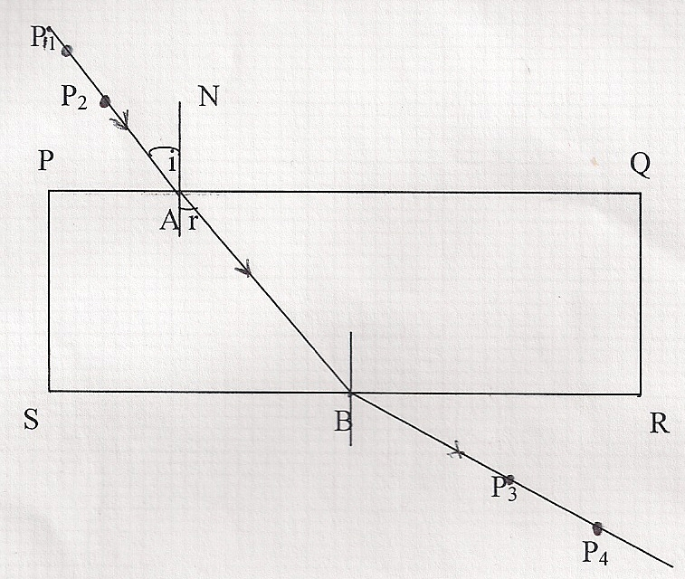
        - Now remove the slab. Draw the lines joining P₁ and P₂ and P₃ and P₄. Extend the two lines to meet the outline of the block at the points A and B respectively. The lines P₁ and P₂, AB and P₃ and P₄ show the path the ray follows as it passes from one medium to another: air to glass and back to air again. Mark the direction with arrows.

        - Measure the angle of refraction (r) between AB and the normal. Record it in the table below. Repeat the procedure for angles of incidence of 30⁰, 45⁰, 60⁰ and 75⁰ and record the values in the table below. (8mks)

Angle of incidence (i⁰) | 15⁰ | 30⁰ | 45⁰ | 60⁰ | 75⁰
Angle of refraction (r⁰)
Sin i⁰
Sin r⁰

        - Draw a graph of sin i⁰ (Y-axis) against sin r⁰ (X-axis) in the grid provided below. (5mks)

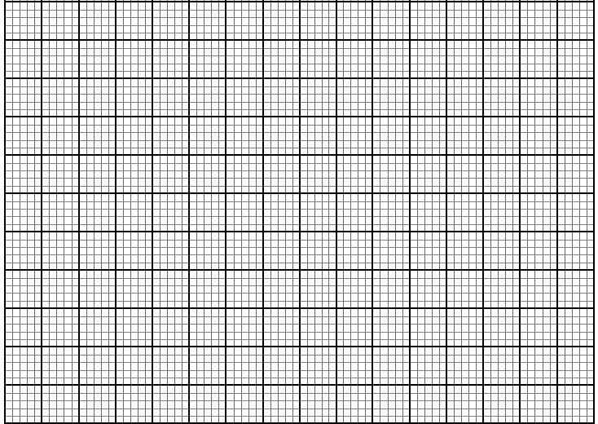

        - Determine the gradient of the graph. (3mks)

        - Compare the value of refractive index, n, if n = sin i / sin r using a point on the graph. (2mks)

NB: Remember to hand in the pieces of white sheet of paper you used. (1mk)

- Question 2
You are provided with following apparatus
- A pendulum bob
- A cotton thread 1m long
- A retort stand and clamp
- A metre rule
- A stopwatch
- Some cellotape

Proceed as follows
- Clamp the pendulum as shown starting with L=80cm
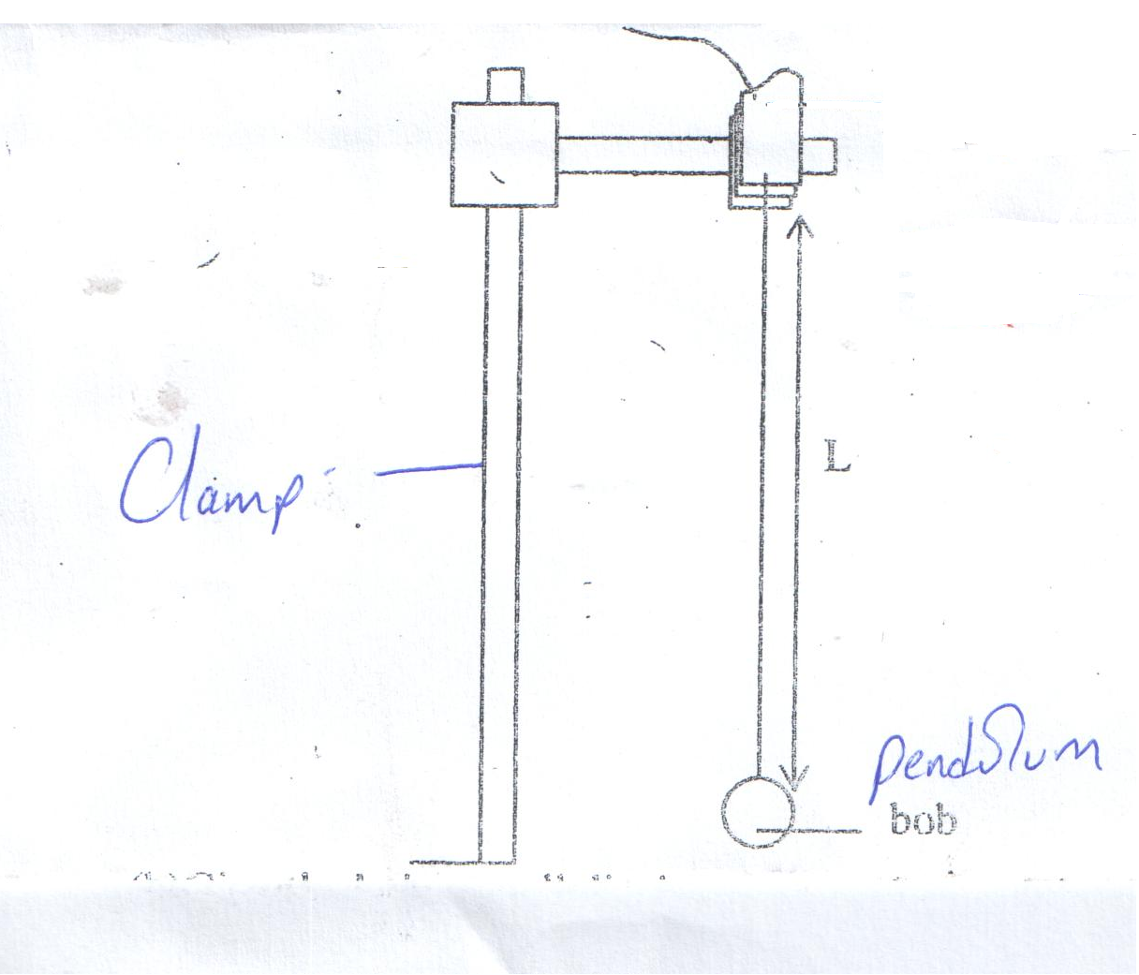

- Give the bob a small displacement and record the time t for 20 complete oscillations. Record also periodic time T for one complete oscillation.

- Repeat the procedure above for values of L as shown in the table. Record and complete the table.(8marks)

Length L (cm) | L (m) | Time for 20 oscillations | Period T | (T²)  (s²)
80
70
60
50
40
30
20

- Plot the graph of T against L(m)(5marks)

- Determine the slope of the graph(3marks)

- The equation for the graph is given by T² = where g is a constant. From the graph find the value of g.(3marks)

- What is the significance of g.(1mark)

