Term 2 - 2022
AGRICULTURE
(QUESTION PAPER I)
FORM FOUR
TIME: 2 HOURS
INSTRUCTIONS TO CANDIDATES:
- Write your name and index number in the space provided. • Sign and write the date of examination in the space provided • This paper consists of three section A, B and C. • Answer all questions in section A and B.
- Answer any two questions in section C
- All the questions should be answered in the spaces provided.
FOR EXAMINERS USE ONLY
SECTION | QUESTINS | MAX SCORE | CANDIDATES SCORE
A | 1-16 | 30
B | 17-20 | 20
C | 21 | 20
C | 22 | 20
C | 23 | 20
TOTAL |  | 90
SECTION A (30MARKS)
Answer all the questions in this section in the space provided.
- Give four advantages of intensive farming. (2 mks )
……………………………………………………………………………………………………
……………………………………………………………………………………………………
……………………………………………………………………………………………………
…………………………………………………………………………………………………..
- State four benefits of agroforestry to a maize crop. (2 mks )
……………………………………………………………………………………………………
……………………………………………………………………………………………………
……………………………………………………………………………………………………
………………………………………………………………………………
- Name the plant part used for vegetative propagation of each of the following plants.
(i) Sisal (½ mk)
……………………………………………………………………………………… (ii) Pyrethrum (½ mk)
………………………………………………………………………………………
  - Sweet potatoes (½ mk)
………………………………………………………………………………………
  - Sugar cane (½ mk)
………………………………………………………………………………………
- State four cultural ways of controlling couch grass (2mks)
……………………………………………………………………………………………………
……………………………………………………………………………………………………
……………………………………………………………………………………………………
……………………………………………………………………………....
- Name three sources of underground water (1 ½mks )
……………………………………………………………………………………………………
……………………………………………………………………………………………………
……………………………………………………………………………………
- State three causes of blossom end of rot in tomatoes (1 ½mks )
…………………………………………………………………………………………………… ……………………………………………………………………………………………………
……………………………………………………………………………………
- Give three qualities of a good green manuring plant (1 ½mks )
……………………………………………………………………………………………………
……………………………………………………………………………………………………
…………………………………………………………………………………....
- State four reasons for practicing minimum tillage. (2 mks )
……………………………………………………………………………………………………
……………………………………………………………………………………………………
……………………………………………………………………………………………………
………………………………………………………………………………
- Name four farm records that should be kept by a poultry farmer. (2 mks )
……………………………………………………………………………………………………
……………………………………………………………………………………………………
……………………………………………………………………………………………………
………………………………………………………………………………
- Give three ways in which pastures are classified (1 ½mks )
…………………………………………………………………………………………………… ……………………………………………………………………………………………………
……………………………………………………………………………………
- State four ways in which land reforms can be implemented in Kenya. (2 mks )
……………………………………………………………………………………………………
…………………………………………………………………………………………………… ……………………………………………………………………………………………………
………………………………………………………………………………
- State four factors that determine the stage at which a crop is harvested. (2 mks )
……………………………………………………………………………………………………
…………………………………………………………………………………………………… ……………………………………………………………………………………………………
………………………………………………………………………………………….…………
- Give four beneficial effects of weeds to a farmer. (2 mks )
……………………………………………………………………………………………………
……………………………………………………………………………………………………
……………………………………………………………………………………………………
…………………………………………………………………………….………………………
- Give four advantages of practicing crop rotation. (2 mks )
……………………………………………………………………………………………………
……………………………………………………………………………………………………
……………………………………………………………………………………………………
……………………………………………………………………………………………………
……………………………………………………………………………………………………
- Name four methods of controlling pests. (2 mks )
……………………………………………………………………………………………………
……………………………………………………………………………………………………
……………………………………………………………………………………………………
……………………………………………………………………………………………………
- Distinguish between intensive hedgerow and border planting forms of agroforestry (2mk)
……………………………………………………………………………………………………
……………………………………………………………………………………………………
……………………………………………………………………………………………………
……………………………………………………………………………………………………
…………………………………………………………………………………………………… …………………………………………………………………………………………………… ……………………………………………………………………………………………………
…………………………………………………………

SECTION B (20 MARKS)
Answer all the questions in this section in the spaces provided.
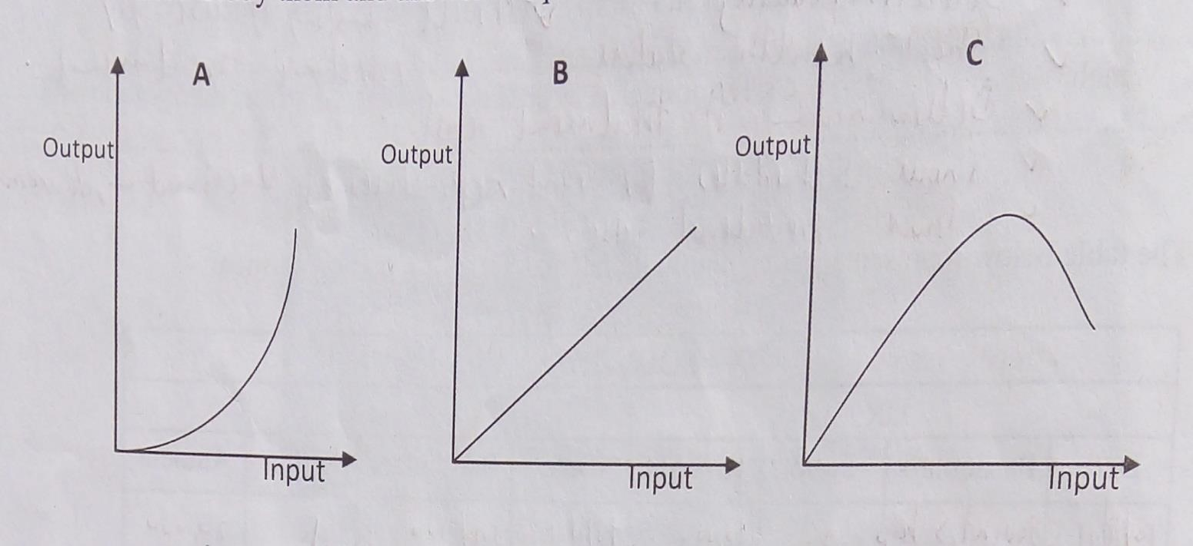
- The following illustrations show different production function curves in agricultural economics. Study them and answer the questions which follows;
  - Identify the production function curves labeled A, B and C
    - …………………...………………………………………………………….. (1mk)
    - ……………………….……………………………………………………… (1mk)
    - ………………………………………………………………………………. (1mk)
  - What does the law derived from the production function labeled C state? (1mk)
………………………………………………………………………………………………
(c)
  - Which one of the three production functions curves is rare in Agriculture (1mk)
…………………………………………………………………………………………………..
  - Give a reason for your answer in (i) above (1mk)
…………………………………………………………………………………………………..
- The table below shows the population and gross domestic products of countries A and B
Country | Gross Domestic product  (million Ksh) | Population  (million)
A | 1800 | 36
B | 1200 | 15
  - Calculate the per capita income for each country show your working (2mks)
………………………………………………………………………………………………
………………………………………………………………………………………………
………………………………………………………………………………………………
…………………………………………………………………………………...………….
  - Which of the two countries is more developed economically (1mk)
…………………………………..…………………………………………………………..
  - Give a reason for your answer in (b) above (1mk)
………………………………………………………………………………………………
………………………………………………………………………………………………
  - How can agriculture increase the gross domestic product of a country (1mk)
………………………………………………………………………………………………
…………………………..………………………………………………………………….
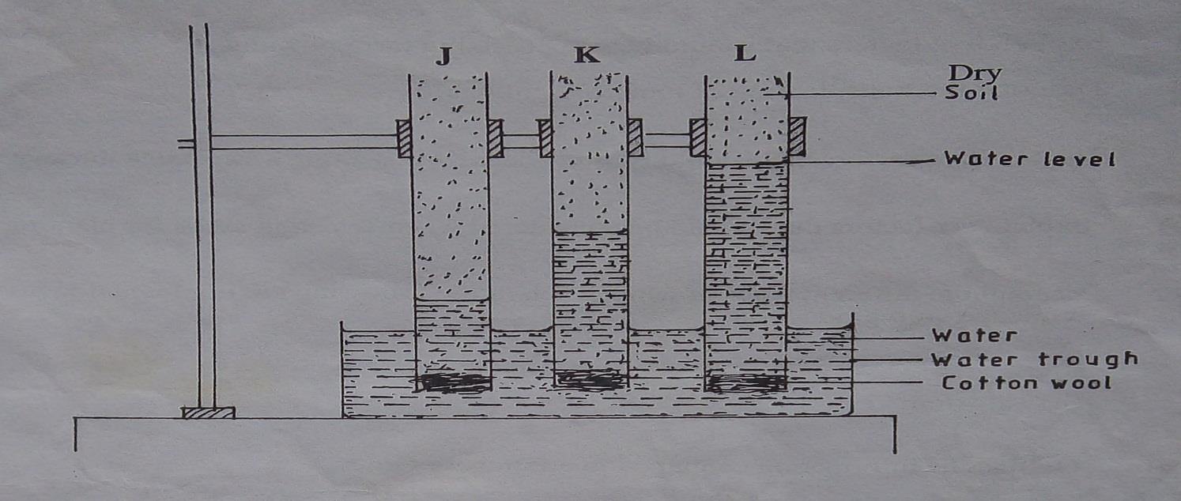
- The diagram below illustrate investigation on a property of soil using soil samples labeled J, K and L.
  - Name the property of soil being investigated (1mk)
………………………………………………………………………………………………
…………………………………………………………………………………….
  - What is the relationship between the soil property above and the size of soil particles?
(1mk)
………………………………………………………………………………………………
……………………………………………………………………………………………..
  - Which soil sample would be suitable for growing paddy rice? (1mk)
…………………………………..………………………………………………………
  - Give a reason for your answer in (c) above (1mk)
…………………………………………………………………………………………..
- The following is a list of nutrients: copper, calcium, nitrogen, molybdenum, zinc, phosphorus, carbon, sulphSSSSSur, iron and magnesium. Which of the above nutrients are;
  - Macro – nutrients (1mk)
………………………………………………………………………………………….. (b) Micro – nutrient (1mk)
…………………………………………………………………………………………..
(c) Fertilizer elements (1mk)
………………………………………………………………………………………….. (d) Liming elements (1mk)
…………………………………………………………………………………………. (e) Primary macro nutrients (1mk)
…………………………………………………………………………………………
SECTION C
Answer any two questions in this section in the spaces provided after question.
21.
(a) Explain five functions of a live fence in a farm. | (5mks)
(b) Describe various risks and uncertainties in crop farming | (10mks)
(c) State five functions of young farmers clubs in Kenya | (5mks)
22.
  - Explain five factors that should be considered in farm planning (10mks)
  - Explain the different ways in which each of the following environmental factors influence crop production.
(i) Wind | (5mks)
(ii) Temperature 23. | (5mks)
(a) Outline the information contained in a purchase order. | (5mks)
(b) Describe the harvesting of tea | (7mks)
(c) Explain the cultural methods of controlling soil erosion | (8mks)

