Term 2 - 2022
AGRICULTURE
(QUESTION PAPER II) FORM FOUR
TIME: 2½ HOURS
Name: …………………………………………………………. Adm No: ………………. School: ……………………………………………………….. Class: …………………..
Signature: …………………………………………………….. Date:

SECTION A: (30 MARKS)
Answer all questions in this section in the spaces provided.
- Name three meat breeds of sheep. (1½ marks)
…………………………………………………………………………………………..…………
………………………………………………………………………………..……………………
………………………………………………………
- List two methods of identifying pigs. (1 mark)
…………………………………………………………………………………………..…………
………………………………………………………………………
- Differentiate between oestrus cycle and heat period. (1 mark )
…………………………………………………………………………………………..…………
………………………………………………………………………………..……………………
……………………………………………………………………..……………………………… ………………………………………
- State three qualities of marketable eggs. (1½mks)
…………………………………………………………………………………………..…………
………………………………………………………………………………..……………………
……………………………………………………………………..………………………………
………………………………………
- Name any four notifiable diseases in livestock. (2mks)
……………………………………………………………………………………….……………
…………………………………………………………………………..………………………… ………………………………………………………………..…………………………………… ……………………………………………
- State four factors that affect maintenance ration required by an animal (2mks)
………………………………………………………………………………………….…………
………………………………………………………………………………..……………………
……………………………………………………………………………………………………… …………………………………………
- Give a reason why ruminant animals are able to digest grass. (1 mark)
…………………………………………………………………………………….………………
…………………………………………………………………….
- Give the difference in meaning of the following terms as used in livestock health.
    - Quarantine and Isolation (1 mark)
…………………………………………………………………………………….………………
…………………………………………………………………….………………………………
…………………………………………………….……………………………………………… ………………………………….
    - Zoonotic and notifiable diseases (1 mark)
…………………………………………………………………………………….………………
…………………………………………………………………….………………………………
…………………………………………………….
- Give four reasons for feeding calves with colostrum. (2mks)
……………………………………………………………………………………………………… ……………………………………………………………………………………………………… ……………………………………………………………………………………………………… ……………………………………………………………………………………………………… ……………………………………………………………………………………………………..
………
- Differentiate between cropping and harvesting in fish production.(1 mark )
……………………………………………………………………………………………………… ………………………………………………………………………………………………………
……………………………………………………………………………………………………… ………………………………………
- State four major routes of administering vaccines in day old chicks. (2 mks )
……………………………………………………………………………………..……………… ……………………………………………………………………..……………………………… …………………………………………………..………………………………………………… …………………………………...…………………………………………………………………
………………..
- Give two reasons for feeding bees (1mk)
……………………………………………………………………………………………………… ……………………………………………………………………………………………………… …………………
- Name the vectors for each of the following livestock diseases. (2 marks )
  - East coast fever……………………………………………………………
  - Rift valley fever…………………………………………………………...
  - Trypanosomiasis……………………………………………………….
  - Nairobi sheep disease…………………………………………………...
- (a) Name the tools used in ( 2 marks)
- Cutting curves on thin wood………………………………………
- Measuring the inner diameter of a circular object/surface…………………..
- Cutting thin sheets of metal…………………………………………………… (iv)Tightening wires during fencing…………………………………………….
b) State Four care and maintenance practices of masonry tools and equipment. (1 mark)
……………………………………………………………………………………………………… ……………………………………………………………………………………………………… ………………………………………………………………………………………………………
…………………………………………………………
- State two ways in which proper feeding contributes to disease control in livestock. (1 mark)
……………………………………………………………………………………………………… ………………………………………………………………………
- Outline four factors which would be considered when culling layers. (2 marks)
……………………………………………………………………………………..………………
……………………………………………………………………..……………………………… ……………………………………………………..
……………………………………………………………………………………..
- a. What is parasitism? (½ mark)
………………………………………………………………………………………………………
………………………………………………………………………
  - Name one parasite of bees. (½ mark)
……………………………………………………………………………………
  - Give any four harmful effects of lice on livestock. (2mks)
…………………………………………………………………………………………………
…………………………………………………………………………………………………
…………………………………………………………………………………………………
……………………………………………
- Name two methods used in ration computation. (1mk)
……………………………………………………………………………………………………… ………………………………………………………………………
SECTION B: (20 MARKS)
Answer all questions in this section in the spaces provided.
- Below is a diagram of a bee hive.
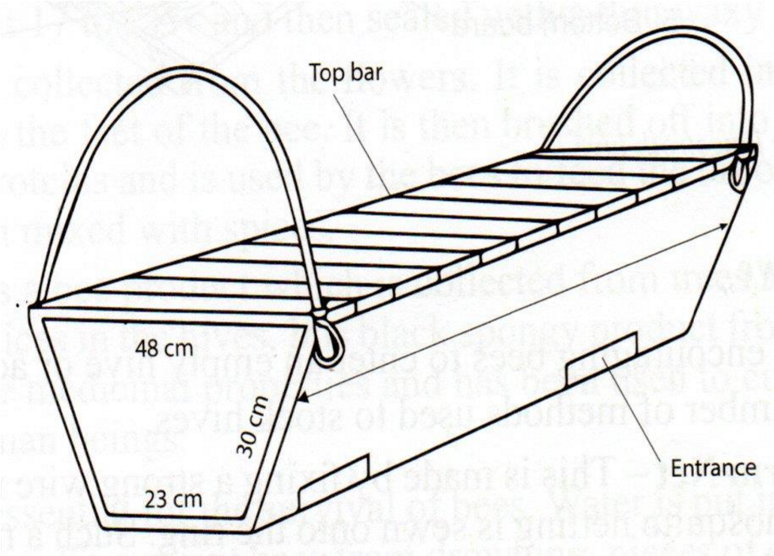
  - Identify the type of hive above. (1mk)
………………………………………………………………………………..
  - Give t wo advantages of using this type of hive on the farm. (2mks)
…………………………………………………………………………………………………
………………………………………………………………………………………………… …………………………………………………………………………………………………
…………………………………………
  - State two reasons why bees swarm. (2mks)
…………………………………………………………………………………………………
………………………………………………………………………………………………… …………………………………………………………………………………………………
……………………………………………
The following diagram illustrate symptoms of a disease in poultry. Study it carefully and answer the question that follows.
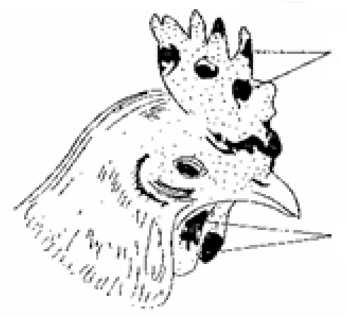
Lesions or
wound

Lesions or
wound

    - Identify: (i) The disease. (½ mark)
…………………………………………………………………
(ii) The causal organism. (½ mark)
…………………………………………………………………
    - State two other symptoms of the disease apart from lesion.(2 marks)
……………………………………………………………………………………...
……………………………………………………………………………………...
……………………………………………………………………………………...
    - State two control measures for the disease. (2 marks)
……………………………………………………………………………………...
……………………………………………………………………………………...
…………………………………………………………………………………...
The illustrations below shows behavior of chicks in a brooder in response to certain conditions. Study it carefully and answer the questions that follow.
A KEY
C

B

D

REPRESENT CHICKS.
Heat source
(a)Explain the reasons for the behavior of chicks in the above diagrams (4 marks)
A…………………………………………………………………………………………………… ………………………………………………………………………………………………………
…..
B…………………………………………………………………………………………………… ………………………………………………………………………………………………………
…..
C…………………………………………………………………………………………………… ………………………………………………………………………………………………………
…..
D…………………………………………………………………………………………………… ………………………………………………………………………………………………………
…..
(b) Give two other signs the chick will show other than the ones you have given in( a) above.(1 mark)
………………………………………………………………………………………………………
……………………………………………………………………………………………………… ………………….
The diagrams below show some farm tools. Study them and answer the question that
follow.
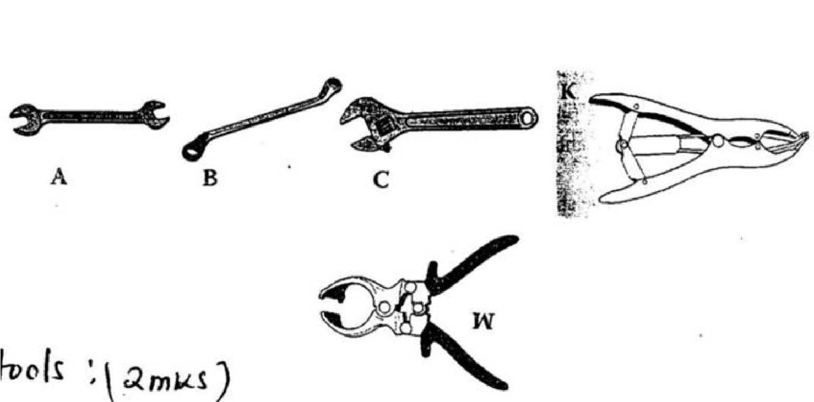
K

a)
Name the tools.
(2
marks
)

A………………………………………………………………………
B………………………………………………………………………
C……………………………………………………………………… W……………………………………………………………………..
- State the functional differences between tools K and W. (1mark)
………………………………………………………………………………………
……………….………………………………
- What advantage does C have over A and B? (1 mark)
………………………………………………………………………………………………………
……………………………………………………………………………………………………… ……………………………………………………………………………………………………..
- State one common maintenance practice carried out tool C and W. (1 mark)
............................................................................................................................................................
..............................................................................................................
SECTION C: (40 MARKS)
Answer any two questions from this section.
23. a) Describe trypanosomiasis disease under the following sub-headings.
- Causal organism (1 Mk)
............................................................................................................................................................ ..............................................................................................................
- Animal attacked (1 Mk)
............................................................................................................................................................ ..............................................................................................................
- Symptoms of attacked animals (5 Mks)
............................................................................................................................................................ ............................................................................................................................................................ ............................................................................................................................................................ ............................................................................................................................................................ ............................................................................................................................................................ ............................................................................................................................................................ ............................................................................................................................................................ ............................................................................................................................................................
............................................................................................................................................................ ............................................................................................................................................................ ............................................................................................................................................................ .............
- Control measures (3 Mks)
............................................................................................................................................................ ............................................................................................................................................................ ............................................................................................................................................................ ............................................................................................................................................................ ............................................................................................................................................................ ............................................................................................................................................................
................................................................................................................................
b) Describe five control measures for cannibalism in poultry (5 Mks)
............................................................................................................................................................ ............................................................................................................................................................ ............................................................................................................................................................ ............................................................................................................................................................
............................................................................................................................................................ ............................................................................................................................................................ ............................................................................................................................................................ ............................................................................................................................................................ ............................................................................................................................................................
............................................................................................................................................................ ............................................................................................................................................................ ............................................................................................................................................................ ............................................................................................................................................................ ............................................................................................................................................................ .............................................................................
(c) Explain the procedure in establishment of foundation in farm buildings (5mks)
............................................................................................................................................................
............................................................................................................................................................
............................................................................................................................................................ ............................................................................................................................................................ ............................................................................................................................................................ ............................................................................................................................................................ ............................................................................................................................................................ ............................................................................................................................................................ ...................................................................
24. a) State the functions of any six parts of a plunge dip (5mks)
.................................................................................................................................................................... .................................................................................................................................................................... ....................................................................................................................................................................
....................................................................................................................................................................
....................................................................................................................................................................
.................................................................................................................................................................... .................................................................................................................................................................... .................................................................................................................................................................... ..........
- State five signs of parturition in cattle (5mks)
.................................................................................................................................................................................
................................................................................................................................................................................. ................................................................................................................................................................................. ................................................................................................................................................................................. ................................................................................................................................................................................. .............................................................................................................
- State five maintenance practices of a fish pond (5mks)
.................................................................................................................................................................................
.................................................................................................................................................................................
................................................................................................................................................................................. ................................................................................................................................................................................. ................................................................................................................................................................................. ................................................................................................................................................................................. ..............
- Explain five factors considered when selecting livestock for breeding (5 mks )
................................................................................................................................................................................. ................................................................................................................................................................................. .................................................................................................................................................................................
................................................................................................................................................................................. ................................................................................................................................................................................. ................................................................................................................................................................................. ................................................................................................................................................................................. .....................................................................................................
12
25.
a) Describe the management of a sow during parturition. (10 marks)
.................................................................................................................................................................... .................................................................................................................................................................... ....................................................................................................................................................................
....................................................................................................................................................................
....................................................................................................................................................................
.................................................................................................................................................................... .................................................................................................................................................................... .................................................................................................................................................................... .................................................................................................................................................................... .................................................................................................................................................................... .................................................................................................................................................................... ....................................................................................................................................................................
.................................................................................................................................................................... .................................................................................................................................................................... .....................................................................................................................................................
- Describe the lifecycle of a three host tick. (7 marks)
..................................................................................................................................................................... ..................................................................................................................................................................... .....................................................................................................................................................................
..................................................................................................................................................................... ..................................................................................................................................................................... ..................................................................................................................................................................... ..................................................................................................................................................................... ..................................................................................................................................................................... ....................
- Outline three effects of endo-parasites to the host animals (3 mks )
.....................................................................................................................................................................
..................................................................................................................................................................... ..................................................................................................................................................................... ..................................................................................................................................................................... ..................................................................................................................................................................... .....................
13

