Name: ……………………………………………………….Index number…………………….
School…………………………………Candidate’s Signature…………Adm No……………...
Date…………………
443/1
AGRICULTURE
PAPER 1
TIME: 2 HOURS

KIJISET EXAMINATION
2022
JOINT EVALUATION TEST
KENYA CERTIFICATE SECONDARY EDUCATION
FORM FOUR
PAPER 1
Instructions to students
- This paper contains three sections A, B and C
- Answer ALL the questions in section A and B
- Answer any Two questions from section C
- All answer should be written in the spaces provided

FOR EXAMINERS USE ONLY
SECTION | QUESTION | MAXIMUM SCORE | CANDIDATE  SCORE
A | 1-15 | 30
B | 16-19 | 20
C | 20-22 | 40

This paper consists of 8 printed pages
Candidates should check the question paper to ensure that all the
pages are printed as indicated and no questions are missing.
Candidates should answer the questions in English.
SSECTION A: 30 MARKS
Answerallthe questions in this section in the spaces provided

- State two ways in which agriculture contributes directly to the development of industries. (1 mark)
……………………………………………………………………………………………………………………………………………………………………………………………………………………………………………………………………………………………………………………………………………………………...
- State four advantages of shifting cultivation (2 marks)
………………………………………………………………………………………………………………………………………………………………………………………………………………………………………………………………………………………………………………………………………………………………………………………………………………………………………………………………………………………………………………………………………………
- The diagram below shows an experiment set up using soil types G, H and J and observations made after 24 hours. Study the diagram and answer the questions that follow.
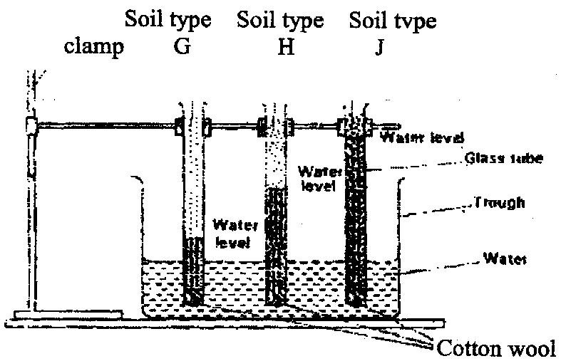
Soil type
J
Soil type H
Soil type
G
Clamp

Water level
Water level
Glass tube
Trough
Water
level
Water

Cotton wool

- What is the experiment represented above designed to study? (1/2mark)
……………………………………………………………………………………………………………………………………………………………………………………………………………………………………………………………………………..
- Name the three soil types G, H and J. (1 1/2marks)
………………………………………………………………………………………………………………………………………………………………………………………………………………………………………………………………………………………………………………………………………………………………………………………………………………………………………………………………………………………………………………………………………
- What is the characteristic texture of soil types G and J? (1 marks)
………………………………………………………………………………………………………………………………………………………………………………………………………………………………………………………………………………
- State two maintenance practices that should be carried out on a wheelbarrow.
(1 mark)

………………………………………………………………………………………………………………………………………………………………………………………………………………………………………………………………………

- Give four farming practices that may help in achieving minimum tillage. (2 marks)
……………………………………………………………………………………………………………………………………………………………………………………………………………………………………………………………………………………………………………………………………………………………………………………………………………………………………………………….
- The table below shows pH values of different soil samples. Study it and answer
the questions that follow.
Soil Sample pH value
S₁ 3
S₂ 4
S₃ 5
S₄ 6
S₅ 7
S₆ 8
S₇ 9
S₈ 10
(a) Which soil sample has the highest acidity? (¹/₂mark)
……………………………………………………………………………………….
(b) State two ways in which the pH value of sample S 10 can be lowered. (1 mark)
………………………………………………………………………………………………………………………………………………………………………………………………………………………………………………………………………

(c) Which of the above soil samples is suitable for growing tea? (1¹/₂ mark)
………………………………………………………………………………………………………………………………………………………………………………………………………………………………………………………………………………………………………………………………………………………………
7.Calculate the plant population per hectare of a maize crop planted at a spacing of100cm x 50cm. Show your working. (2 marks)
………………………………………………………………………………………………………………………………………………………………………………………………………………………………………………………………………………………………………………………………………………………………………………………………………………………………
8. (a) State four advantages of crop rotation. (2 mark) ………………………………………………………………………………………………………………………………………………………………………………………………………………………………………………………………………………………………………………………………………………………………………………………………………………………………………………………………………………………………………………………………………
(b) State four factors considered when designing a crop rotation programme (2 marks)
………………………………………………………………………………………………………………………………………………………………………………………………………………………………………………………………………………………………………………………………………………………………………………………………………………………………………………………………………………………………………………………………………
9. (a) State four practices which encourage soil erosion (2 marks) ………………………………………………………………………………………………………………………………………………………………………………………………………………………………………………………………………………………………………………………………………………………………………………………………………………………………………………………………………………………………………………………………………
(b) Name two forms of gulley erosion (1 mark) ………………………………………………………………………………………………………………………………………………………………………………………………………………………………………………………………………………………………………………………
10. Give a weed for each case, which has the following effect on cattle:
(a) Poisoning (¹/₂mark)
………………………………………………………………………………………………………………………………………………………………………………………………………….
(b) Tainting milk when eaten before milking (¹/₂mark)
……………………………………………………………………………………………………………………………………………………………………………………………………………...
11. State four advantages of land consolidation (2 marks)
………………………………………………………………………………………………………………………………………………………………………………………………………………………………………………………………………………………………………………………………………………………………………………………………………………………………………………………………………………………………………………………………………………………………………………………………………………………………………………
12.Name five sources of agriculture credit in Kenya (2½ marks) ………………………………………………………………………………………………………………………………………………………………………………………………………………………………………………………………………………………………………………………………………………………………………………………………………………………………………………………………………………………………………………………………………………………………………………………………………………………………………………………………………………………………..
13. List two examples of working capital in crop production. (1 mark) ………………………………………………………………………………………………………………………………………………………………………………………………………………………………………………………………………………………………………………………………………………………………………………………………………………………………………………………………
14State the use of the following in farm accounting: (1 ½ marks)

- Balance sheet
……………………………………………………………………………………………………………………………………………………………………………………………………………………………………………………………………………………………………………………….
- Inventory
……………………………………………………………………………………………………………………………………………………………………………………………………………………………………………………………………………………………………………………….
- Cash book
………………………………………………………………………………………………………………………………………………………………………………………………………………………………………………………………………………………………………………………
15. State four problems that farmers are likely to face when marketing theirproduce. (2marks)
………………………………………………………………………………………………………………………………………………………………………………………………………………………………………………………………………………………………………………………………………………………………………………………………………………………………………………………………………………………………………………………………………………………………………………………………………………………………………………………………………………………………

SECTION B (20 MARKS)
Answer all the questions in this section in the spaces provided

16. (a)List two sites on which agro forestry trees can be established on a farm (2marks)
……………………………………………………………………………………………………………………………………………………………………………………………………………………………………………………………………………………………………………………………………………………………………………………………………………………………………………………………….
(b)State four benefits of agroforestry to a maize crop. (2 marks)
………………………………………………………………………………………………………………………………………………………………………………………………………………………………………………………………………………………………………………………………………………………………………………………………………………………………………………………………………………………………………………………………………
17. The diagram labeled D below shows a Kale crop invested by a pest
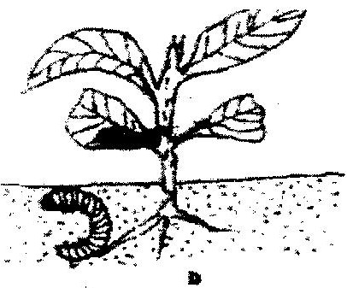

i)Identify the pest. (1 mark)
……………………………………………………………………………………………..
ii)What damage does the pest cause to the crop? (1 mark)
……………………………………………………………………………………………..
iii)State two methods of controlling the pest (2 marks)
………………………………………………………………………………………………………………………………………………………………………………………………………………………………………………………………………………………………………………………
18.A farmer applied a compound fertilizer 10:20:0 on a three hectares piece of land at a rate of 180kg N per hectare.
- Calculate the quantity of the compound fertilizer the farmer applied on
the piece of land. (3 marks)
……………………………………………………………………………………………………………………………………………………………………………………………………………………………………………………………………………………………………………………………………………………………………………………................................................................................................................................................
- What do the figures 10 and 20 stand for in the compound fertilizer? (2 marks)
………………………………………………………………………………………………………………………………………………………………………………………………………………………………………………………………………………………..
19.The diagram below shows crop establishment using a certain method of planting.
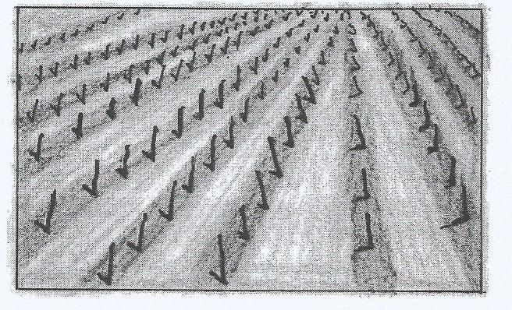

- Name the method of planting used for the crop (1mark)
……………………………………………………………………………………………………
- State three advantages of the plating method used for the crop (3marks)
…………………………………………………………………………………………………………………………………………………………………………………………………………………………………………………………………………………………………………………………………………………………………………………………………………………………………………………………………
- Explain three factors that determine the depth of planting (3marks)
……………………………………………………………………………………………………………………………………………………………………………………………………………………………………………………………………………………………………………………………………………………………………………………………………………………………………………………………………

SECTION C (40 MARKS)
Answer ANY TWO questions from this section in the spaces provided

20. In a maize production enterprise carried over a period of eight years, a farmerused one hectare of land each time and applied different quantities of DAP fertilizer. DAP fertilizer costs Ksh 2500 per 50kg bag and the harvested maize is sold at Ksh 3000 per 90kg bag. The quantities of DAP fertilizer applied and maize harvested are as shown in this table below.

DAP fertilizer input in 50 kgs bags | Maize yield in 90 kgs bag | Total revenue  kshs | Total cost  kshs | Marginal revenue  kshs | Marginal cost  kshs
0  1  2  3  4  5  6  7 | 15.0  15.6  52.0  68.5  71.0  71.5  71.5  68.6 | 45,000 | 0 | 0 | 0

a) Complete the table by determining the values of total revenue, total cost, and marginal
revenue and marginal cost (8 marks)

b) From the information in your table, how can the farmer determine the level of
production at which profit is maximum? (1 mark)

c) At the production level that yielded maximum profit, what was the value of each
of the following?
i)DAP Fertilizers input (1 mark)
ii)Marginal revenue
- Discuss five importance of budgeting in agricultural production (10 marks)

21.a) Explain five methods of harvesting water in a farm (10 marks)

b) Outline ten farming activities which may encourage soil erosion. (10 marks)

22 (a) Describe how the stem cuttings for propagating tea are prepared (9marks)
(b)Explain six factors that should be considered when selecting seeds for planting (6marks)
(c) State five advantages of timely planting in crop production (5 marks)
………………………………………………………………………………………………………………………………………………………………………………………………………………………………………………………………………………………………………………………………………………………………………………………………………………………………………………………………………………………………………………………………………………………………………………………………………………………………………………………………………………………………………………………………………………………………………….
………………………………………………………………………………………………………………………………………………………………………………………………………………………………………………………………………………………………………………………………………………………………………………………………………………………………………………………………………………………………………………………………………………………………………………………………………………………………………………………………………………………………………………………………………………………………………….
………………………………………………………………………………………………………………………………………………………………………………………………………………………………………………………………………………………………………………………………………………………………………………………………………………………………………………………………………………………………………………………………………………………………………………………………………………………………………………………………………………………………………………………………………………………………………….
………………………………………………………………………………………………………………………………………………………………………………………………………………………………………………………………………………………………………………………………………………………………………………………………………………………………………………………………………………………………………………………………………………………………………………………………………………………………………………………………………………………………………………………………………………………………………….
………………………………………………………………………………………………………………………………………………………………………………………………………………………………………………………………………………………………………………………………………………………………………………………………………………………………………………………………………………………………………………………………………………………………………………………………………………………………………………………………………………………………………………………………………………………………………….
………………………………………………………………………………………………………………………………………………………………………………………………………………………………………………………………………………………………………………………………………………………………………………………………………………………………………………………………………………………………………………………………………………………………………………………………………………………………………………………………………………………………………………………………………………………………………….
………………………………………………………………………………………………………………………………………………………………………………………………………………………………………………………………………………………………………………………………………………………………………………………………………………………………………………………………………………………………………………………………………………………………………………………………………………………………………………………………………………………………………………………………………………………………………….
………………………………………………………………………………………………………………………………………………………………………………………………………………………………………………………………………………………………………………………………………………………………………………………………………………………………………………………………………………………………………………………………………………………………………………………………………………………………………………………………………………………………………………………………………………………………………….
………………………………………………………………………………………………………………………………………………………………………………………………………………………………………………………………………………………………………………………………………………………………………………………………………………………………………………………………………………………………………………………………………………………………………………………………………………………………………………………………………………………………………………………………………………………………………….
………………………………………………………………………………………………………………………………………………………………………………………………………………………………………………………………………………………………………………………………………………………………………………………………………………………………………………………………………………………………………………………………………………………………………………………………………………………………………………………………………………………………………………………………………………………………………….
………………………………………………………………………………………………………………………………………………………………………………………………………………………………………………………………………………………………………………………………………………………………………………………………………………………………………………………………………………………………………………………………………………………………………………………………………………………………………………………………………………………………………………………………………………………………………….
………………………………………………………………………………………………………………………………………………………………………………………………………………………………………………………………………………………………………………………………………………………………………………………………………………………………………………………………………………………………………………………………………………………………………………………………………………………………………………………………………………………………………………………………………………………………………….
………………………………………………………………………………………………………………………………………………………………………………………………………………………………………………………………………………………………………………………………………………………………………………………………………………………………………………………………………………………………………………………………………………………………………………………………………………………………………………………………………………………………………………………………………………………………………….
………………………………………………………………………………………………………………………………………………………………………………………………………………………………………………………………………………………………………………………………………………………………………………………………………………………………………………………………………………………………………………………………………………………………………………………………………………………………………………………………………………………………………………………………………………………………………….
………………………………………………………………………………………………………………………………………………………………………………………………………………………………………………………………………………………………………………………………………………………………………………………………………………………………………………………………………………………………………………………………………………………………………………………………………………………………………………………………………………………………………………………………………………………………………….
………………………………………………………………………………………………………………………………………………………………………………………………………………………………………………………………………………………………………………………………………………………………………………………………………………………………………………………………………………………………………………………………………………………………………………………………………………………………………………………………………………………………………………………………………………………………………….
………………………………………………………………………………………………………………………………………………………………………………………………………………………………………………………………………………………………………………………………………………………………………………………………………………………………………………………………………………………………………………………………………………………………………………………………………………………………………………………………………………………………………………………………………………………………………….
………………………………………………………………………………………………………………………………………………………………………………………………………………………………………………………………………………………………………………………………………………………………………………………………………………………………………………………………………………………………………………………………………………………………………………………………………………………………………………………………………………………………………………………………………………………………………….

