TERM 2-2022 ART AND DESIGN
PAPER 1 (THEORY)
FORM FOUR (4)
TIME: 1 ½ HOURS
NAME: ………………………………………………………...INDEX NO: ……………….
SIGNATURE: ……………………………………………………..DATE: …………………...
Instructions to candidates
- Write your Name, Index No, Class and Date in the spaces provided above.
- Answer all the questions in sections A and B
- Answer only one question in Section C.
- All answers should be written in the spaces provided
- Where drawings and diagrams are appropriate, they should be included within the text of your answer.
- Candidate should answer the questions in English.
SECTION
QUESTION
MAXIMUM
MARKS
STUDENT’S
SCORE
A
1

20

B
2
-
6

25

c

9
/8/
7

15

TOTAL

60

Section A: 20mks

Answer all the questions in the questions in this section.
1. a) Study the illustration below and answer the questions that follow.
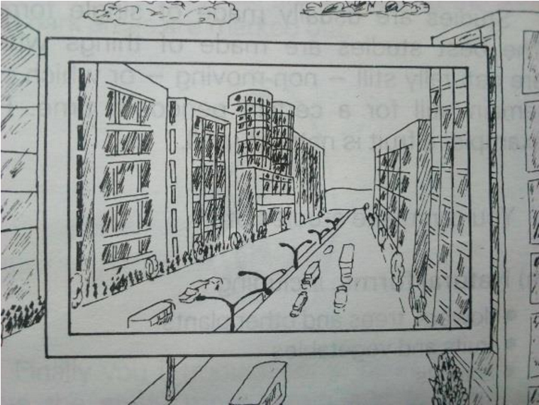
i) Identify the device in rectangular shape above and give its function 2mks.
……………………………………………………………………………………………………………………
…
……………………………………………………………………………………………………………………
…
(ii)What is the category of drawing above? (1mk)
…………………………………………………………………………………………………………………..
- Explain value as a property of colour. 1mk
……………………………………………………………………………………………………………………
…
……………………………………………………………………………………………………………………
…
……………………………………………………………………………………................................................
....
- Name any two serigraphy printing techniques 2mks
……………………………………………………………………………………………………………………
…
……………………………………………………….…………………………………………………………
……
……………………………………………………………………………………................................................
....
- The illustration shows a ceramic decoration technique of a pottery vessel.
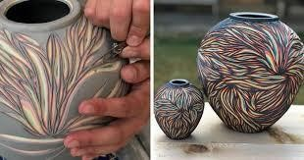
- Name the technique. 1mk
……………………………………………………………………………………………………………………
- Give any two reasons of firing clay items. 2mks
…………………………………………………………………………………………………………………
…………………………………………………………………………………………………………………
  - Below is an art activity in process, Give reasons of boiling wax in a double container (2mks)
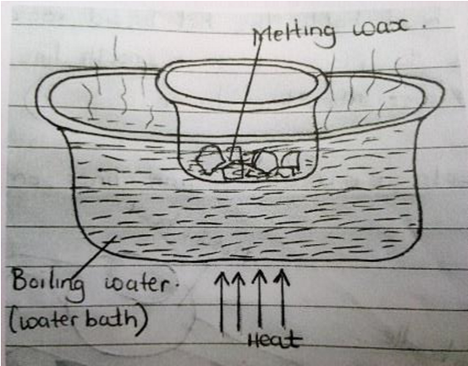
…………………………………………………………………………………………………………………
………………………………………………………………………………………………………………..
  - Differentiate between serif and san serifs in lettering. Use illustration 3mks
  - State and explain any two properties of clay. 2mk …………………………………………………………………………………………………………………
…………………………………………………………………………………………………………………
…………………………………………………………………………………………………………………
……………………………………………………………………………………………………………………
- Identify two most outstanding elements in the painting below 2mks
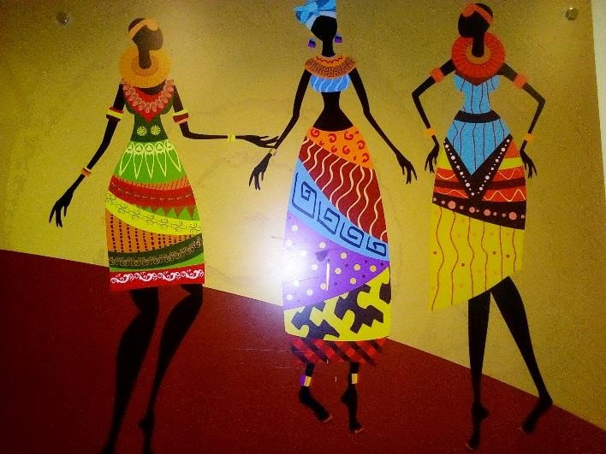
…………………………………………………………………………………………………………………
…………………………………………………………………………………………………………………
- Using illustration, explain the asymmetrical type of balance. 2mk
…………………………………………………………………………………………………………………
…………………………………………………………………………………………………………………
Section B

Answer all the questions in the questions in this section.
- Define ornamentry (2 mks )
a) Give four factors to consider when designing ornaments 4 mks
……………………………………………………………………………………………………………………
…………………………………………………………………………………………………………………… ……………………………………………………………………………………………………………………
……………………………………………………………………………………………………………………
- Using the word “Key’, Show, on the illustration, the following parts of a letter 2mks (i) Xh. (ii) ½ xh.
4) The work bellow shows an art work almost in completion,
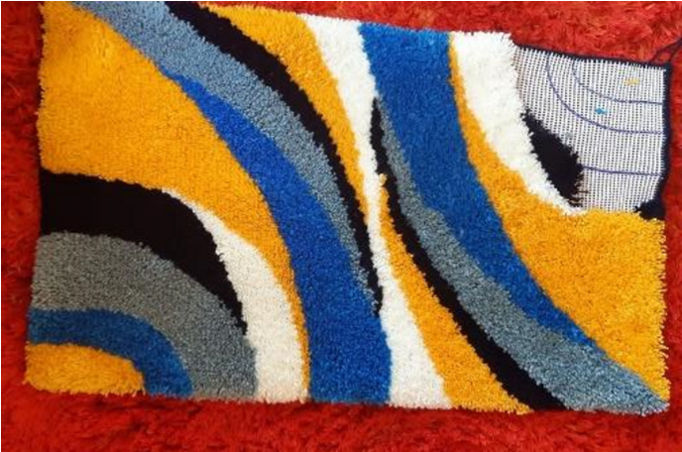
Name the technique used to create the weave structure above (2mks)
………………………………………………………………………………………………………………
b) Give any three visual symbols 3mks
……………………………………………………………………………………………………
……………………………………………………………………………………………………
……………………………………………………………………………………………………
5. a) Name two components and functions of a letterhead (4.mks)
Components……………………………………………………….
…………………………………………………………………..
Functions
…………………………………………………………………………………………………………
…………………………………………………………………………………………………………
b) Outline any four factors to consider when using lettering in Graphic design. (4 mks ) ---------------------------------------------------------------------------------------
……………………………………………………………………………
…………………………………………………………………………….
……………………………………………………………………………
6a) explain the term “wash” in reference to painting and give one function of the same (2mks)
……………………………………………………………………………………………………………………………
…………………………………………………………………………………………………………………………… b) List two types of wash.2mks)
……………………………………………………………………..… ………………………………………………………………………..
SECTION C (15 mks)
7. The illustration below shows weaving techniques:
- Identify the weave structure/techniques labeled A and B 2mks
A B
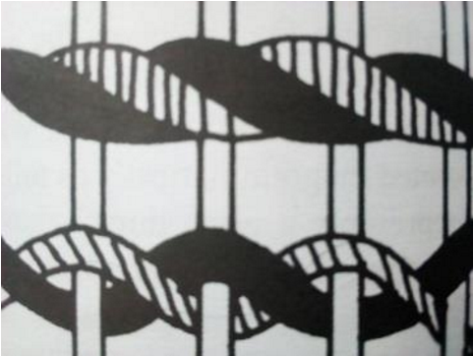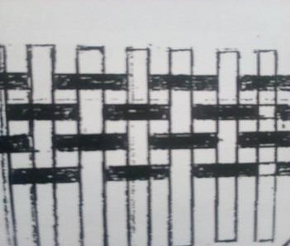
- Differentiate between sagging and waisting as weaving defects.(3 mks )
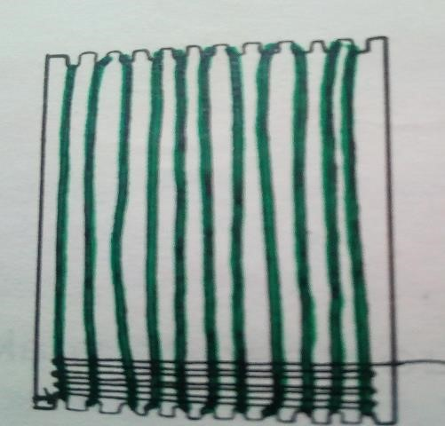 Y
- (i) Name the tool above and its function (2mks)
………………………………… ……………………………………………………………....
(ii)Describe the process of preparing the device above up to warping stage. (8mks)
8. a) Define sculpture(1mk)
- Describe different types of relief sculptures (4mks)
- i Explain the process of making a sculpture using papier mache(8mks) c (ii)What is the difference between molding and modelling?2mk)
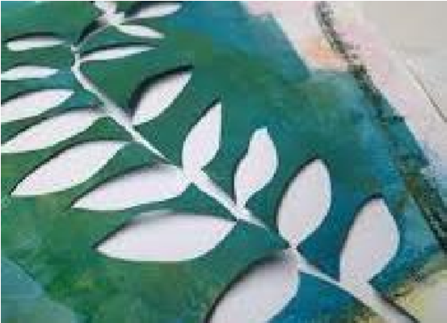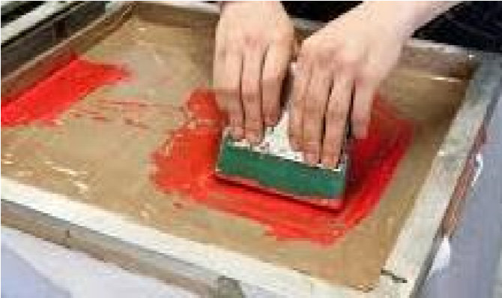
9
The Illustration
s

below represents an art and design technique
s

.

A
B

  - Identify the techniques A and B(2mks)
  - Describe the process of producing a design using a combination of tie-dye and any one of the above techniques.(14mks)
…………………………………………………………………………………………………………………… ……………………………………………………………………………………………………………………
……………………………………………………………………………………………………………………
……………………………………………………………………………………………………………………
……………………………………………………………………………………………………………………
…………………………………………………………………………………………………………………… …………………………………………………………………………………………………………………… ……………………………………………………………………………………………………………………
……………………………………………………………………………………………………………………
……………………………………………………………………………………………………………………
……………………………………………………………………………………………………………………
…………………………………………………………………………………………………………………… …………………………………………………………………………………………………………………… ……………………………………………………………………………………………………………………
……………………………………………………………………………………………………………………
……………………………………………………………………………………………………………………
……………………………………………………………………………………………………………………
…………………………………………………………………………………………………………………… …………………………………………………………………………………………………………………… ……………………………………………………………………………………………………………………
……………………………………………………………………………………………………………………
…………………………………………………………………………………………………………………… …………………………………………………………………………………………………………………....
.…………………………………………………………………………………………………………………
……………………………………………………………………………………………………………………
……………………………………………………………………………………………………………………
……………………………………………………………………………………………………………………
……………………………………………………………………………………………………………………
…………………………………………………………………………………………………………………… …………………………………………………………………………………………………………………… ……………………………………………………………………………………………………………………
……………………………………………………………………………………………………………………
……………………………………………………………………………………………………………………
……………………………………………………………………………………………………………………
…………………………………………………………………………………………………………………… …………………………………………………………………………………………………………………… ……………………………………………………………………………………………………………………
……………………………………………………………………………………………………………………
……………………………………………………………………………………………………………………
……………………………………………………………………………………………………………………
…………………………………………………………………………………………………………………… …………………………………………………………………………………………………………………… ……………………………………………………………………………………………………………………
……………………………………………………………………………………………………………………
……………………………………………………………………………………………………………………
……………………………………………………………………………………………………………………
.....
……………………………………………………………………………………………………………………
……………………………………………………………………………………………………………………
……………………………………………………………………………………………………………………
……………………………………………………………………………………………………………………
……………………………………………………………………………………………………………………
……………………………………………………………………………………………………………………

Page 8
……………………………………………………………………………………………………………………
……………………………………………………………………………………………………………………
……………………………………………………………………………………………………………………
……………………………………………………………………………………………………………………
…………………………………………………………………………………………………………………… …………………………………………………………………………………………………………………… ……………………………………………………………………………………………………………………
……………………………………………………………………………………………………………………
……………………………………………………………………………………………………………………
……………………………………………………………………………………………………………………
…………………………………………………………………………………………………………………… …………………………………………………………………………………………………………………… ……………………………………………………………………………………………………………………
……………………………………………………………………………………………………………………
……………………………………………………………………………………………………………………
……………………………………………………………………………………………………………………
…………………………………………………………………………………………………………………....
.
Page 9

