Term 2 - 2022
BIOLOGY
(QUESTION PAPER I ) FORM FOUR
TIME: 2 HOURS
Name: …………………………………………………………. Adm No: ……………….
School: ……………………………………………………….. Class: …………………..
Signature: …………………………………………………….. Date……………………..
INSTRUCTIONS
- All Questions are Compulsory
- Write your Answers in the Spaces Provided
- Wrong Spelling of Technical Terms shall be Penalized
Max  Score | Student’s Score
80
- The diagram shown below represents a nucleus
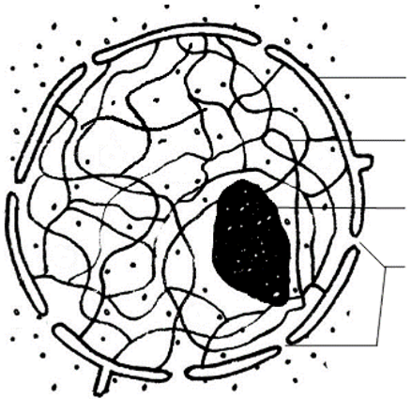
P

Q

  - State the role of the organelle labelled Q (1mk
………………………………………………………………………………………………
  - Name a Kingdom whose members lack structure labelled P (1mk
………………………………………………………………………………………………
  - Which is the general term given to organisms whose cells have structure P?
……………………………………………………………………………………..…(1mk
- a) Name the TWO components of a lipid molecule (1mk
………………………………………………………………………………………………
b) State TWO disadvantages of using fats as respiratory substrates (2mks
………………………………………………………………………………………………
………………………………………………………………………………………………
- a) Name the pigment that protects humans from the negative effect of Ultraviolet lights
……………………………………………………………………………………..….(1mk
b) Explain how sunlight contributes to stronger bones and teeth in human beings (2 mks
………………………………………………………………………………………………
………………………………………………………………………………………………
- Name the main target organ of the following hormones: (2mks
  - Aldosterone ….. ……………………………………………………………………….
  - Insulin ………………………………………………………………………………….
- a) What is asexual reproduction? (1mk ………………………………………………………………………………………………
………………………………………………………………………………………………
b) Give TWO disadvantages of sexual reproduction (2mks
………………………………………………………………………………………………
………………………………………………………………………………………………
- The diagram shown below represents a seeding. Use it to answer questions that follow
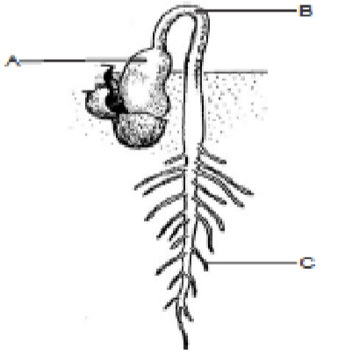
  - Give a reason why the plant above is a member of Class Dicotyledonae (1mk
………………………………………………………………………………………………
  - Explain why the biomass of part labelled A will be lower compared to the one found in the seed stage of the same plant (2 mks
………………………………………………………………………………………………
………………………………………………………………………………………………
- a) State TWO ways in which blood clotting is important to a human being (2mks
………………………………………………………………………………………………
………………………………………………………………………………………………
………………………………………………………………………………………………
b) What are the roles of thrombokinase enzyme during blood clotting? (2mks
………………………………………………………………………………………………
………………………………………………………………………………………………
- The diagram shown below represents a flower
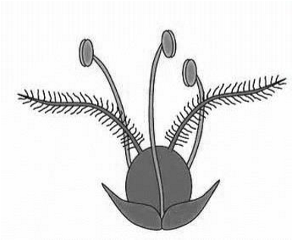
  - Name the agent of pollination for the flower shown above (1mk
………………………………………………………………………………………………
  - Give TWO reasons for your answer in a) above (2mks
………………………………………………………………………………………………
………………………………………………………………………………………………
………………………………………………………………………………………………
- State the differences between cones and rods in terms of the following (2mks
Feature | Cone | Rod
Visual acuity
Photochemical
- Use the diagram of a nerve cell shown below to answer questions that follow
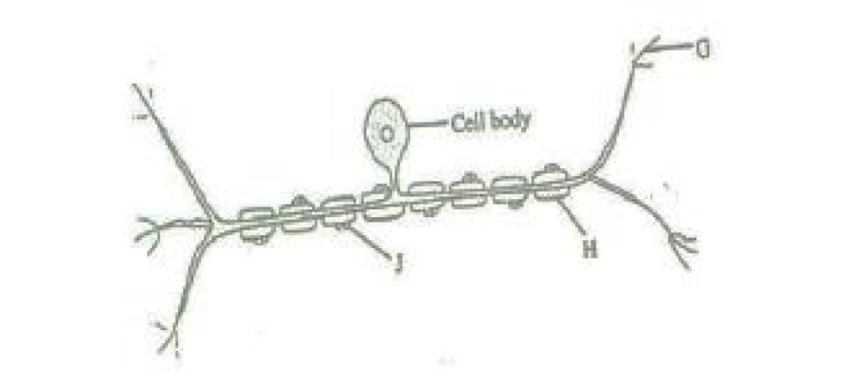
  - With a reason, give the identity of the nerve cell (2 mks
Identity …………………………………………………………………………………
Reason ………………………………………………………………………………….
  - Explain the significance of absence of part labelled H in nerve cells found in the brain.
……………………………………………………………………………………………… ……………………………………………………………………………………..…(2mks
- Give THREE features that make modern man to be more adaptable to the environment
…………………………………………………………………………………………………
…………………………………………………………………………………..……………… ………………………………………………………………………………………………….
……………………………………………………………………..………………….….(3mks
- The diagram below represents a living organism
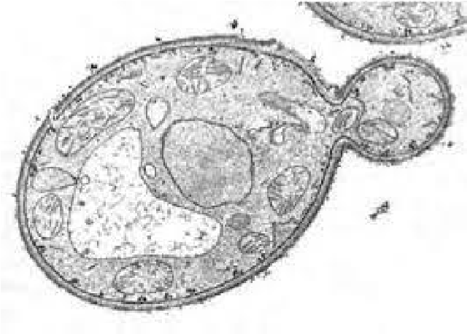
  - State TWO economic importance of the above organism in the food industry (2 mks
………………………………………………………………………………………………
……………………………………………………………………………………………… ……………………………………………………………………………………..…(2mks b) Why does the rate of respiration reduce under the following conditions? (2mks i) Low temperature
………………………………………………………………………………………..…
………………………………………………………………………………………….. ii) Metabolic poison
………………………………………………………………………………………..…
…………………………………………………………………………………………..
- State TWO reasons why Biotechnology is important in modern science (2 mks
……………………………………………………………………………………………… ……………………………………………………………………………………..………..
………………………………………………………………………………………………
- a) Fill in the table shown below to give differences between continuous and discontinuous variation (2mks
Continuous Variation | Discontinuous Variation
b) Explain how variation is important in the process of evolution? (3mks
……………………………………………………………………………………………… ……………………………………………………………………………………..……….
………………………………………………………………………………………………
- a) Define the term species (1mk
……………………………………………………………………………………………… ……………………………………………………………………………………..………..
b) State TWO contributions of Carolus Linnaeus (1708 – 1778) to taxonomy (2mks
……………………………………………………………………………………………… ……………………………………………………………………………………..………..
………………………………………………………………………………………………
- a) In an experiment, Peter counted 9 cells along the diameter of field of view of a light microscope measuring 3.0mm. Determine the diameter of one cell in micrometers (3mks
……………………………………………………………………………………………… ……………………………………………………………………………………..………..
………………………………………………………………………………………………
………………………………………………………………………………………………
……………………………………………………………………………………..………..
b) Why is electron microscope safer to the eye than light microscope during use? (1 mk
……………………………………………………………………………………………… ……………………………………………………………………………………..………..
………………………………………………………………………………………………
- The following diagram represents results of an experiment carried out on two sets of germinating seeds.
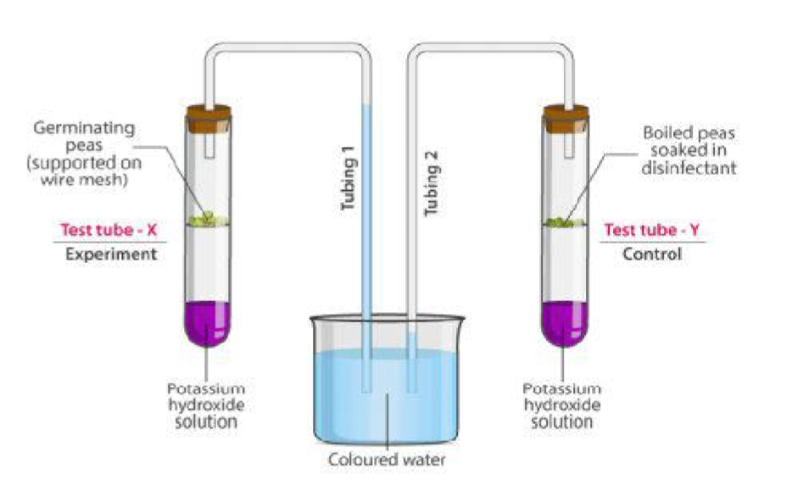
  - Account for the result shown in test tube X (2mks
……………………………………………………………………………………………… ……………………………………………………………………………………..……….. ………………………………………………………………………………………………
  - What is the importance of dipping the boiled seeds in a disinfectant in test tube Y?
………………………………………………………………………………………………
……………………………………………………………………………..….………(1mk
- The diagram shown below represents a section of the vertebral column
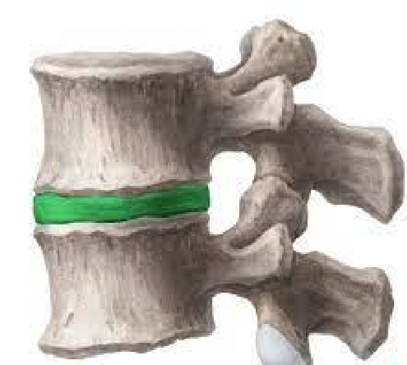
T

S

  - Name the part labelled S (1mk
……………………………………………………………………………………..………..
  - State TWO ways in which part T is important to movement in human beings (2 mks
……………………………………………………………………………………..………..
………………………………………………………………………………………………
- Describe how the following cells adapt the structures where they are found to their functions
  - Companion cell (2mks
……………………………………………………………………………………..……….. ………………………………………………………………………………………………
  - Schwann cell (2mks
……………………………………………………………………………………..………..
………………………………………………………………………………………………
- A mother had a still birth and the expelled foetus showed clear signs of anaemia and jaundice
  - Give the name of this disorder (1mk
……………………………………………………………………………………..………..
  - Describe how the disorder arose (3mks
……………………………………………………………………………………..……….. ………………………………………………………………………………………………
……………………………………………………………………………………..………..

21.
The following equation represents a section of the Nitrogen Cycle
a)
Name:
Bacterium labelled
i)
Y

…………………………………………
…
….(1mk
Ammonia

Nitrite

X

Process
Z

Y

ii) Compound X ……………………………………………………….(1 mk
b) Explain how Process Z affect plant growth in an area? (2mks
……………………………………………………………………………………………… ……………………………………………………………………………………..………..
- Samson had a road accident resulting in serious head injuries that left him with the following conditions: Loss of balance, low body temperature; poor speech, unregulated breathing and memory loss. Name the part of the brain affected that led to the following:
i) Low body temperature …………………………………………..…………….…,,..(1mk ii) Memory loss ……………………………………………………..………….……..(1mk iii) Unregulated breathing ………………………………………….…………………(1mk
- The graph shown below represents effect of substrate concentration on rate of enzymatic reaction
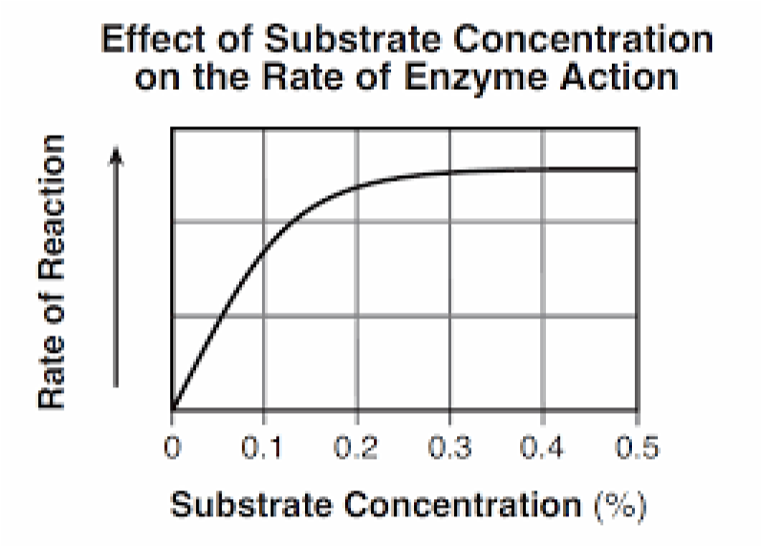
  - Account for the rate of enzymatic reaction when the substrate concentration was between 0.3 to 0.5%. (2 mks
……………………………………………………………………………………………… ……………………………………………………………………………………..………..
  - Name the substrates for the following enzymes
i) Carbonic anhydrase …………………….………………………………………(1mk ii) Thrombin ……………………………………………………………………....(1mk
- A tilapia fish has a full length of 300mm but measures 200mm from the mouth tip to its anus. Determine the tail power of the fish (2 mks
……………………………………………………………………………………………… ……………………………………………………………………………………..……….. ……………………………………………………………………………………………… ……………………………………………………………………………………..………..

