Term 2 - 2022
FORM 4
CHEMISTRY PAPER 1 (233/1)
Time: 2 Hours
Name: ……………………………………..…... Admission No: …………………………….
Candidate’s Signature: ………...………… Date: ……………………………………
INSTRUCTIONS TO CANDIDATES
- Write your Name, Index Number and School in the spaces provided above.
- Answer all the questions in the spaces provided after each question.
- KNEC Mathematical tables and silent non-programmable electronic calculators may be used.
- ALL working must be clearly shown where necessary.
- Candidate should check the question paper to ascertain that all the pages are printed and that no questions are missing.
- Candidates should answer the questions in English.
FOR EXAMINER’S USE ONLY
QUESTIONS | MAX SCORE | CANDIDATE’S SCORE
1 – 29 | 80

This paper consists of 13 printed pages. Candidates should check to ascertain that all pages are printed as indicated and that no questions are missing.

- (a) Give the name of the first member of the alkyne homologous series (1 mark)
………………………………………………………………………………….…………
  - Describe a chemical test that can be used to distinguish ethanol from ethanoic acid. (2 marks)
………………………………………………………………………………………….
…………………………………………………………………………………………
- (a) Name the raw material from which aluminium is extracted (l mark)
……………………………………………………………………………..…………..
  - Give a reason why aluminium is extracted using electrolysis. (1 mark)
………………………………………………………………………………………….
  - Give one use of aluminium metal. (l mark)
………………………………………………………………………………………..
- (a) What is meant by lattice energy? (1 mark)
………………………………………………………………………………………..
  - Study the energy level diagram below and answer the question that follows:
NaOH
(
aq
)

+
H
2
O
(
l
)

Na
+

(
aq
)

+
OH
-

(
aq
)

∆
H

What type of reaction is represented by the diagram? (1 mark)
…………………………………………………………………………………
- (a) Sketch a graphical representation of Boyles law on the axes below. (1 mark)

  - A gas occupies 400 cm³ at 25°C and 100,000 Pa. What will be its volume at 27°C and 101325 Pa? (2 marks)
……………………………………………………………………………………..……… ……………………………………………………………………………………………..
……………………………………………………………………………………………..
………………………………………………………………………………………………
- (a) What is half- life? (1 mark)
……………………………………………………………………………………………
……………………………………………………………………………………………
  - The half-life of protactinium - 234 is 1.17 minutes. Determine the mass that decays in 5.85 minutes starting with 100 g of the sample. (2 marks)
…………………………………………………………………………………………
…………………………………………………………………………………………
…………………………………………………………………………………………
…………………………………………………………………………………………
- State two disadvantages of hard water. (2 marks)
…………………………………………………………………………………………………… ………………………………………………………………………………………….………..
- Hydrogen chloride gas can be prepared by reacting sodium chloride with an acid.
(a) Name the acid. (1 mark)
……………………………………………………………………………………………..
(a) Write an equation for the reaction between sodium chloride and the acid. (1 mark)
………………………………………………………………………………………………
(c) State two uses of hydrogen chloride. (1 mark)
……………………………………………………………………………………………..
……………………………………………………………………………………………..
- When solid B was heated strongly, it gave off water and a solid residue. When water was added to the solid residue, the original solid B, was formed.
(a) What name is given to the process described? (1 mark)
………………………………………………………………………………………………
……………………………………………………………………………….……………. (b) Give one example of solid A. (1 mark)
…………………………………………………………………………………………….
…………………………………………………………………………………………….
- The set up below can be used to prepare oxygen gas. Study it and answer the questions
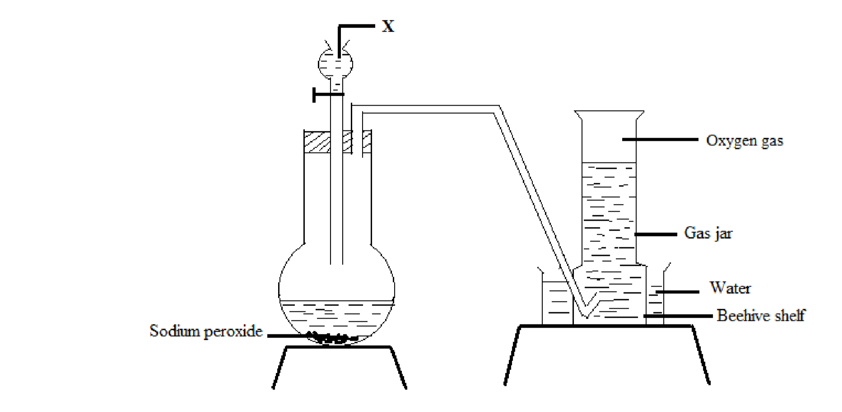
that follow.

(
a
)

Identify
X
.

(1
mark
)

Sodium peroxide

………………………………………………………………………………………………
  - Write the equation for the reaction which occurs in the flask. (1 mark)
………………………………………………………………………………………………
  - State one use of oxygen other than in welding (1 mark)
……………………………………………………………………………………………
- The atomic number of an element, M is 13.
  - Write the electronic configuration of the ion M³⁺. (1 mark)
…………………………………………………………………………………………
  - Write the formula of the chloride of M. (1 mark)
…………………………………………………………………………………………
…………………………………………………………………………………………
  - State the structure of the compound formed in (b) above (1 mark) ………………………………………………………………………………………..
- Concentrated sodium chloride was electrolysed using graphite electrodes. Name the product formed at the anode and give a reason for your answer. (2 marks)
……………………………………………………………………………………….
……………………………………………………………………………………….
……………………………………………………………………………………….
……………………………………………………………………………………….
- The curve shown below shows the variation of time against temperature for the reaction between sodium thiosulphate and hydrochloric acid.
Time(s)
Temperature
(
°
C)

  - Explain the shape of the curve. (2 marks)
……………………………………………………………………………………………
……………………………………………………………………………………………
……………………………………………………………………………………………
  - Other than temperature name one factor that affects the rate of reaction. (1 mark) …………………………………………………………………………………………….
- (a) Dry ammonia was passed over heated copper (II) oxide in a combustion tube.
    - State the observations made in the tube (1 mark)
………………………………………………………………………………………
    - Write an equation for the reaction that occurs. (1 mark)
……………………………………………………………………..………………
  - What products would be formed if red hot platinum is introduced into a mixture of ammonia and oxygen? (1 mark)
……………………………………………………………………………………………
- The table below shows behaviour of metals P, Q, R and S. Study it and answer the questions that follow:
Metal | Appearance on exposure to air | Reaction with water | Reaction with dilute sulphuric (VI) acid
P | Remains the same | Doesn’t react | Reacts moderately
Q | Remains the same | No reaction | Doesn’t react
R | Slowly tarnishes | Slow | Vigorous
S | Slowly turns white | Vigorous | Violent
(a) Arrange the metals in the order of reactivity starting with the most reactive.
(2 marks)
…………………………………………………………………………………………..
………………………………………………………………………………………….
  - Name a metal which is likely to be R (1 mark)
………………………………………………………………………………………….. ………………………………………………………………………………………….
- Given the following substances: sodium carbonate, orange juice and sodium bromide.
  - Name one commercial indicator that can be used to show whether sodium carbonate, orange juice and sodium bromide are acidic, basic or neutral. (1 mark)
…………………………………………………………………………………………….
…………………………………………………………………………………………….
  - Classify the substances in 15 (a) above as acids, bases or neutral. (2 marks)
Acid
Base
Neutral
- The flow chart below shows various reactions of zinc metal. Study it and answer the questions that follow:
Zinc
Zinc
oxide

Zinc

nitrate

HNO
3

)
aq
(

Heat

Step I

Step 2

Colourless
solution
Reagent

Q

Step 3

Zinc
chloride

Products
H
2
S
O
4

(
aq
)

Reagent
P

Step 4

Step 5

(a) (i) Other than water, name another reagent that could be Q. (1 mark) ……………………………………………………………………….………..
(ii) Write the formula of reagent P. (1 mark)
…………………………………………………………………………………
  - Write an equation for the reaction in step 4. (1 mark)
…………………………………………………………………………………………..
- (a) One of the allotropes of sulphur is monoclinic sulphur, name the other allotrope
(1 mark)
………………………………………………………………………..…………………..
  - Concentrated sulphuric (VI) acid reacts with copper and prapanol. State the
property of the acid shown in each case. (2 marks)
Copper …………..……………………………………………………………….…
Propanol ……………………………………………………………………………
- Study the standard electrode potentials in the table below and answer the questions that follow.
Half -reaction |  | E ^{θ}(V)
Ag⁺(aq) + e Ag(s) |  | + 0.80
Cu²⁺(aq) + 2e Cu(s) |  | + 0.34
Mg²⁺(aq) + 2e | Mg(s) | - 2.38
Ca²⁺(aq) + 2e | Ca(s) | - 2.87
  - Which of the metals is the strongest oxidising agent? (1 mark)
……………………………………………………………………………………………
  - What observations will be made if a copper coin was dropped into an aqueous solution of calcium nitrate? Explain. (2 marks)
…………………………………………………………………………………………..
………………………………………………………………………………………….. ………………………………………………………………………………………….
- Calculate the number of sulphate ions present in 22.5 cm³ of 2 M aluminium sulphate solution. (L=6.0 × 10²³) (3 marks)
………………………………………………………………………………………………
………………………………………………………………………………………………
………………………………………………………………………………………………
………………………………………………………………………………………………
………………………………………………………………………………………………
- (a) A crystal of iodine, heated gently in a test tube gave off a purple vapour.
(i) Write the formula of the substance responsible for the purple vapour.
(1 mark)
……………………………………………………………………………………..
(b) What type of bond is broken when the iodine crystal is heated gently?
(1 mark)
………………………………………………………………………………………
  - State one use of chlorine. (1 mark)
…………………………………………………………………………………………….
- Describe how samples of barium (II) sulphate, ammonium chloride and common salt can be obtained from a mixture of the three. (3 marks) ………………………………………………………………………………………………
………………………………………………………………………………………………
………………………………………………………………………………………………
………………………………………………………………………………………………
- (a) Give the name of the process which takes places place when maize flour is
converted to ethanol (1 mark)
…………………………………………………………………………………………
  - Write the formula of the compound formed when ethanol reacts with sodium metal. (1 mark)
…………..……………………………………………………………………………..
- (a) Study the graph below which shows variation of atomic radius with atomic number
Atomic radius

Atomic number

Lithium

Sodium
Potassium
State and explain the trend shown in the graph above. (2 marks)
………………………………………………………………………………………
………………………………………………………………………………………
………………………………………………………………………………………
………………………………………………………………………………………
  - State one use of sodium. (l mark)
………………………………………………………………………………………….
…………………………………………………………………………………………
- A farmer intended to plant blueberries in her farm. She first tested the pH of the soil and found it to be 10.0. In order to obtain high yield, what advice would be given to the
farmer if blueberries do well in acidic solution? (2 marks)
………………………………………………………………………………………………
………………………………………………………………………………………………
………………………………………………………………………………………………
………………………………………………………………………………………………
- Starting with calcium nitrate solution, describe how a pure dry sample of calcium
carbonate can be prepared in the laboratory. (3 marks)
………………………………………………………………………………………………
………………………………………………………………………………………………
………………………………………………………………………………………………
………………………………………………………………………………………………
………………………………………………………………………………………………
- A hydrocarbon contains 81.82% of carbon. If the molar mass of the hydrocarbon is 44, determine the molecular formula of the hydrocarbon. (C = 12.0; H = 1.0) (3 marks)
………………………………………………………………………………………….
………………………………………………………………………………………….
………………………………………………………………………………………….
…………………………………………………………………………………………..
………………………………………………………………………………………….
- (a) Describe how Carbon (II) Oxide can be distinguished from Carbon (IV) Oxide using calcium hydroxide solution. (2 marks)
………………………………………………………………………………………….
………………………………………………………………………………………….
………………………………………………………………………………………….
  - What is the role of carbon (IV) oxide in fire extinguishing? (l mark)
………………………………………………………………………………………….
………………………………………………………………………………………..
- (a) Name one source of alkanes. (1 mark)
……………………………………………………………………………………….
  - Methane gas was reacted with one mole of chlorine gas. State the condition necessary for this reaction. (1 mark)
………………………………………………………………………………… ………………………………………………………………………………... 29 (a) What is meant by heating value of a fuel? (1 mark)
…………………………………………………………………………………………..
(b) Other than heating value, name one factor to be considered when choosing a fuel.
(1 mark)
…………………………………………………………………………………………..
…………………………..THIS IS THE LAST PRINTED PAGE……………………………...

