1 Term 2 - 2022
COMPUTER STUDIES
(QUESTION PAPER I ) FORM FOUR
Name: …………………………………………………………. Adm No: ………………. School: ……………………………………………………….. Class: …………………..
Signature: …………………………………………………….. Date: ……………………
INSTRUCTION TO CANDIDATES
- Write your name and index number in the spaces provided above
- This paper consists of Two sections A and B
- Answer ALL questions in section A
- Answer question16 and any other THREE questions from section B
- All answers should be written in the spaces provided on the question paper
FOR EXAMINER’S USE ONLY
SECTION | QUSTIONS | CANDIDATE’S SCORE
A | 1 -15
B | 16
B | 17
B | 18
B | 19
B | 20
 | TOTAL SCORE
2
SECTION A (40 MARKS)
Answer ALL the questions in SECTION
  - Mention two devices that can connected to the computer via HDMI cable (2marks)
__________________________________________________________________________________
__________________________________________________________________________________
__________________________________________________________________________________
  - State three ways in which ICT can be used to enhance customer service delivery in a supermarket (3marks)
__________________________________________________________________________________ __________________________________________________________________________________
__________________________________________________________________________________
  - Describe two roles of a Web designer (2 marks )
__________________________________________________________________________________
__________________________________________________________________________________
__________________________________________________________________________________
  - Mr. Kamau is a teacher at Chianda High School used Ms-Excel to process the marks obtained by his student during the term. The table below shows the details entered in the Ms-Excel worksheet
 | A | B | C | D | E | F | G | H | I
1 | Name | CA  T1 | CAT  2 | CAT TOTAL | EXA  M | TOTAL MARKS | POSITI ON | GRA  DE | REMA  RK
2 | Mark Jama | 14 | 06 | 20 | 56 | 76 | 1
3 | Caleb Wekeza | 13 | 08 | 21 | 34 | 55 | 6
4 | Kanini Mulue | 10 | 04 | 14 | 59 | 73 | 3
5 | Justine Melanie | 11 | 07 | 18 | 57 | 75 | 2
6 | Julia  Wahome | 06 | 09 | 15 | 48 | 63 | 5
7 | Austin Kilome | 08 | 07 | 15 | 50 | 65 | 4
Hints
CAT1is out 15, CAT2 is out 15 and Exam is out 70
  - Give the formula used to calculate the Total Marks for Julia Wahome (1mark)
__________________________________________________________________________________
  - Write a function that give each student his position in class based on the performance (2marks)
__________________________________________________________________________________
__________________________________________________________________________________ 3
  - Write a logical function that will display the following remarks in column I (2marks)
Total Marks | Remark
0 - 49 | Fail
50 - 59 | Above Average
60 - 69 | Fair
70 - 79 | Good
80 - 100 | Excellent
__________________________________________________________________________________
__________________________________________________________________________________
  - Give two reasons to justify why SATA cables are used in modern computers to connect the hard disk to the motherboard (2marks)
__________________________________________________________________________________
__________________________________________________________________________________
  - Give three file systems supported by windows operating system (3marks)
__________________________________________________________________________________
__________________________________________________________________________________
__________________________________________________________________________________
  - Describe the use of the following keys found on a standard keyboard (2marks) (a) Esc
__________________________________________________________________________________
__________________________________________________________________________________
(b) Prt sc
__________________________________________________________________________________
__________________________________________________________________________________
  - Explain the following terms with references to algorithm
      - Definiteness (2marks)
__________________________________________________________________________________
__________________________________________________________________________________
      - Finiteness (2marks)
__________________________________________________________________________________
__________________________________________________________________________________
  - Mention two ICT related courses offered in Kenyan universities at undergraduate level (2marks)
__________________________________________________________________________________
__________________________________________________________________________________
__________________________________________________________________________________
  - What is flaming (2marks)
4
__________________________________________________________________________________
__________________________________________________________________________________
  - A computer operator was working with a computer using windows operating system. After sometimes he started experiencing the following problems
      - Abnormal restarting
      - Computer failing to load the operating system
      - Computer hangs
      - Computer displaying Fatal Exception error on the screen
State three possible causes of the problems mentioned above (3marks)
__________________________________________________________________________________
__________________________________________________________________________________ __________________________________________________________________________________
__________________________________________________________________________________
  - Identify two limitations of traditional approach to system development (2marks)
__________________________________________________________________________________
__________________________________________________________________________________
  - Use flowchart to demonstrate how IF THEN and REPEAT...... UNTIL can be implemented (2marks)
__________________________________________________________________________________
__________________________________________________________________________________ __________________________________________________________________________________ __________________________________________________________________________________ __________________________________________________________________________________
__________________________________________________________________________________
  - State three functions of Repeater stations in data communication (3marks)
__________________________________________________________________________________
__________________________________________________________________________________
__________________________________________________________________________________
  - Describe three layout guides available in DTP that assist a user to place an object in a preferred position (3 marks )
__________________________________________________________________________________
__________________________________________________________________________________
__________________________________________________________________________________
__________________________________________________________________________________ 5
SECTION B (60 MARKS)
16.
    - State three features of a compiler (3marks)
__________________________________________________________________________________
__________________________________________________________________________________
__________________________________________________________________________________
    - When writing a computer program programmers are always advised to use approaches and techniques that makes the program easy to follow and maintain. List four ways in which a programmer can make program code easy to follow (4marks)
__________________________________________________________________________________ __________________________________________________________________________________
__________________________________________________________________________________
__________________________________________________________________________________
    - Study the flowchart below and use it to answer the questions that follow
Start
Input a, b

T=a
2
b
+
2

T > 90
Add 1 to a

Add 1 to b

Print a, b
Stop

No

Yes

6
      - Given that the user keyed in 3 as the value of a and 1 as the value of b get the final output of the flowchart (3marks)
____________________________________________________________________________________ ____________________________________________________________________________________ ____________________________________________________________________________________
____________________________________________________________________________________ ____________________________________________________________________________________ ____________________________________________________________________________________
____________________________________________________________________________________ ____________________________________________________________________________________
____________________________________________________________________________________
      - Use a pseudo code to represent the flowchart in (c) (5marks )

7
17.
    - Briefly describe the three main coding schemes (3marks)
__________________________________________________________________________________
__________________________________________________________________________________
__________________________________________________________________________________ _________________________________________________________________________________
    - Convert the following numbers to binary number
      - B2.AAH (3marks)
__________________________________________________________________________________
__________________________________________________________________________________
__________________________________________________________________________________
__________________________________________________________________________________
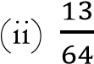 base 10 (3marks)
__________________________________________________________________________________
__________________________________________________________________________________ __________________________________________________________________________________
__________________________________________________________________________________
    - The table below was created using Ms-Access use it to answer the questions that follow
Table Name: Product
Product ID | Product  Name | Unit Cost | Quantity | Total
P00101 | Milk | 120 | 34 | 4080
P00201 | Bread | 100 | 56 | 5600
P00301 | Beans | 150 | 45 | 6750
        - State the most appropriate data type for Product ID and Total (2marks)
__________________________________________________________________________________
__________________________________________________________________________________
        - Suggest how you would set the input mask for the Product Name so that the data entered in that field appear the way they are in the table (2marks)
__________________________________________________________________________________
__________________________________________________________________________________
__________________________________________________________________________________ 8
        - Represent the dynaset shown below in a SQL form given that the table Name is product (2marks)
Product ID | Product  Name | Unit Cost | Quantity | Total
P00101 | Milk | 120 | 34 | 4080
__________________________________________________________________________________
__________________________________________________________________________________ __________________________________________________________________________________
18.
    - Describe four services available in the internet that support communication only (4marks)
__________________________________________________________________________________
__________________________________________________________________________________
__________________________________________________________________________________ __________________________________________________________________________________
__________________________________________________________________________________
    - Modern computing have embraced the use of drop box, google drive and OneDrive. These platforms are hosted by the internet and many computer users prefer backing up their data using these facilities. Give three reasons to justify this phenomenon (3marks)
__________________________________________________________________________________ __________________________________________________________________________________ __________________________________________________________________________________
__________________________________________________________________________________ (c) Janetitle a computer student from Maranda High school launched the browser to access the internet , the browser displayed an error message Server Not Found on the screen this didn’t
allow Janetitle to access the internet. State three possible causes of this anomaly (3marks)
__________________________________________________________________________________
__________________________________________________________________________________
__________________________________________________________________________________
__________________________________________________________________________________
- Briefly describe the following features of word processor (2marks)
  - Subscript
__________________________________________________________________________________ __________________________________________________________________________________
__________________________________________________________________________________
  - Drop cap
9
__________________________________________________________________________________ __________________________________________________________________________________
__________________________________________________________________________________
- State two arithmetic operation that can be performed on a row of a numeric data in a word processor table (1mak)
__________________________________________________________________________________
__________________________________________________________________________________
- In each case of (e) above give the expression used (2marks)
__________________________________________________________________________________ __________________________________________________________________________________ __________________________________________________________________________________
19.
- Enumerate four breakthrough in health care instigated by ICT (4marks)
__________________________________________________________________________________
__________________________________________________________________________________
__________________________________________________________________________________ __________________________________________________________________________________ __________________________________________________________________________________
__________________________________________________________________________________
- Mention four application areas of Artificial Intelligence (3marks)
__________________________________________________________________________________
__________________________________________________________________________________ __________________________________________________________________________________ __________________________________________________________________________________
__________________________________________________________________________________
- List three scanning devices available at Electronic Point Sale Terminal (3marks)
__________________________________________________________________________________
__________________________________________________________________________________
__________________________________________________________________________________
__________________________________________________________________________________
- Describe two ways of preventing eavesdropping (2marks)
__________________________________________________________________________________
__________________________________________________________________________________
__________________________________________________________________________________ 10
__________________________________________________________________________________
__________________________________________________________________________________
- System failure is considered as threat to data security. Describe three measures an organization should put in place to guard against system failure (3marks)
__________________________________________________________________________________
__________________________________________________________________________________ __________________________________________________________________________________ __________________________________________________________________________________
_________________________________________________________________________________
20.
- Identify modes of data communication represented in (i), (ii), (iii) and (iv) below (4marks)
    - Principal Addressing students in assembly using public address system
__________________________________________________________________________________
    - WhatsApp chat
__________________________________________________________________________________
    - Phone conversation
__________________________________________________________________________________
    - Walkie talkie conversation
__________________________________________________________________________________
- List three challenges experienced by computer networks that are set up using twisted pair cables (3marks)
__________________________________________________________________________________
__________________________________________________________________________________
__________________________________________________________________________________
_________________________________________________________________________________ (c) Study the diagram below and use it to answer the questions that follow
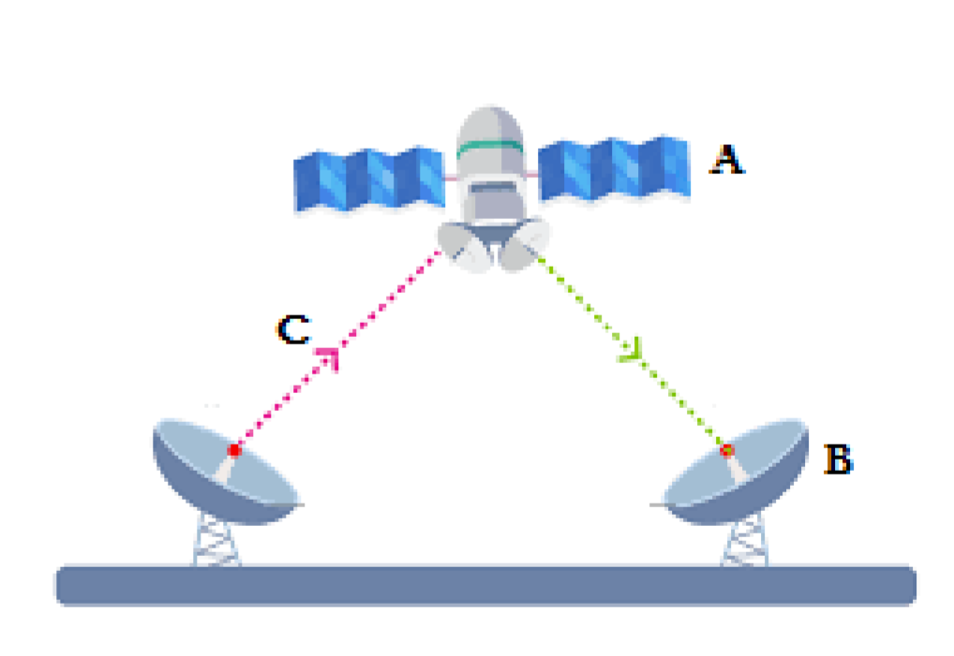
11
  - Identify the parts labelled A, B and C in the diagram above (3marks)
__________________________________________________________________________________
__________________________________________________________________________________
__________________________________________________________________________________
  - State function of the part labelled A (2marks)
__________________________________________________________________________________
__________________________________________________________________________________
(d) Name any three components of virtual reality (3marks)
__________________________________________________________________________________
__________________________________________________________________________________ __________________________________________________________________________________
_________________________________________________________________________________

