Term 2 - 2022
COMPUTER STUDIES
(QUESTION PAPER II ) FORM FOUR
TIME: 2 1/2 HOURS
INSTRUCTIONS TO CANDIDATES
- Indicate your name and index number at the right hand corner of each printout
- Write your name and index number on the CD/removable storage medium provided
- Write the name and version of the software used for each question attempted in the answer sheet provided
- Answer all the questions, All questions carry equal marks
- Passwords should not be used while saving in the CD/removable storage Medium
- Marked printout of the answers on the sheet
- Hand in all the printouts and the CD/removable storage medium used
1. The table below shows list of students admitted to Nyambaria High School under different sponsors.
- Open a database program and create a database named NHS.(1mark)
- Create three tables named Students, Sponsor and Fees. (3 marks )
- Using database file created in (a) above use the following field properties.
(6marks)
Student_Table
Field name | Data types and properties
School-Code | Default value = 427
AdmNo | Text (Size = 4, Required = Yes )
Student Name | Text (Size = 16)
Date of Birth | Date and time (Size = 10)
Amount paid | Text (Size = 4, Required = Yes )
SponsorID | LookUp -sponsor table
BankID | Text
Sponsor_Table
Field name | Data types and properties
SponsorID | Text (Size = 4, Required = Yes )
Sponsor Name | Text (Size = 16)
Amount_Table
Field name | Data types and properties
BankID | Text
BankName | Text (Size = 10)
Amount Per Student | Number (Size = 8, Decimal Place = 2)
Mode of payment | Text (Size = 12)
- Create the relationship between the tables. (2marks)
- Enforce referential integrity between the tables. (1mark)
- Create the three forms StudentForm, SponsorForm and AmountForm.
(3marks)
- Enter the following data in their respective tables using the respective forms.
(8 marks)
Table 1: SponsorTable
SponsorID | Sponsor Name
S1 | Wings
S2 | Majani
S3 | Elimu
Table 2: StudentTable
Sch-Code | AdmNo | SponsorID | StudName | BankID | DateOfBirth
427 | 444 | S1 | Lilian Mwende | 100 | 12/03/2000
427 | 443 | S3 | Ruth Akinyi | 200 | 23/01/1998
427 | 445 | S2 | Frida Omondi | 100 | 11/07/2002
427 | 442 | S1 | Bianca Godana | 300 | 12/05/2005
427 | 410 | S3 | Christine Awuor | 300 | 28/05/1999
427 | 413 | S2 | Baraka kalala | 200 | 30/09/1998
427 | 449 | S1 | Rael Mokaya | 100 | 18/02/2005
427 | 411 | S3 | Slivia Odanga | 100 | 17/04/2001
427 | 412 | S2 | Jane Kawaswa | 200 | 19/06/2004
427 | 415 | S2 | Jack Jake | 100 | 22/03/2003
Table 3: AmountTable
BankID | BankName | Amount Per Student | Mode of payment
100 | COOP | 550,000 | EFT
200 | KCB | 120,000 | M-banking
300 | EQUITY | 420,000 | Cheque
(d) Create a query to display the fields:
- AdmNo, Sponsor name, age and Students whose first name start with letter “B” and whose payment Bank is “COOP” Save query as B-query.
(5marks)
- StdName, Sponsor name, Mode of payment and Amount per student. Calculate the total amount received. Save query as AMount-query.
(5marks)
(iii)Create Amountreport from Amount query display all the records grouped by mode of payment and find the average per mode of payment
(4 marks)
- Create a bar chart to display students and their respective amount received. Save chart as S-
chart. (2 marks)
- Create S-report to display the fields as it appears in the figure below.
(5marks)
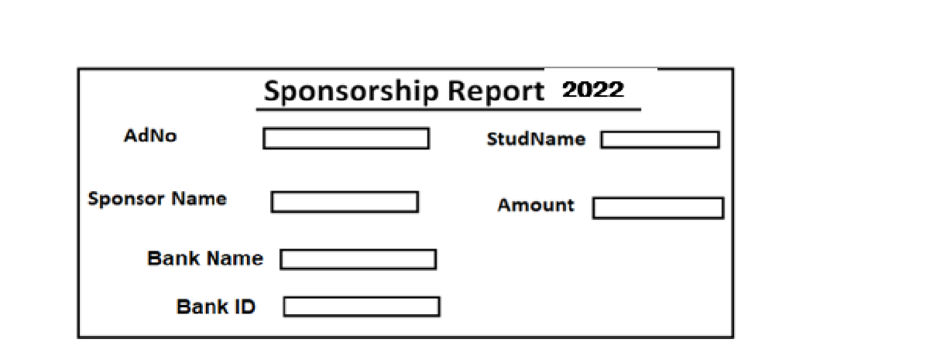
- Print the following: (4 marks)
  - The Student table
  - The B- query
  - The chart
  - The S-report
2. The following data was extracted from Applicants’ file for Maranda high school comp/Maths teacher recruitment
(a) (i) Enter the data as it appears in a spreadsheet. And save it as INTERVIEW
(13mks)
 | A | B | C | D | E | F | G | H | I
1 | NAME | ADDRESS | TOWN | comp | Math | Eng | MEA  N | APPLICANT’ S POSITION | REMARK
2 | Willington | 400 | Nairobi | 40 | 60 | 60
3 | Benjamin | 3201 | Kisumu | 55 | 50 | 40
4 | Nyambane T. | 5600 | Kisii | 70 | 60 | 50
5 | Grace | 1236 | Bungoma | 30 | 80 | 70
6 | Rebbeca | 48 | Eldoret | 75 | 70 | 80
7 | Fatuma A | 6032 | Mombasa | 40 | 30 | 50
8 | Kamau J. | 8021 | Nyeri | 50 | 40 | 55
9 | Achieng . | 209 | Siaya | 80 | 50 | 70
- Insert two blank rows at the top of the worksheet. (1 mark)
- Enter the following title and subtitle in the blank rows respectively; MARANDA HIGH
SCHOOL RECUIRTMENT FILE and APPLICANTS DETAILS.
(3marks)
- Centre the title and subtitle across the columns that contain data.
(2marks) (b) Using functions, compute:
- The mean for each Applicant and format it to 2 decimal places. (3marks)
- The position of each Applicant. (3marks)
(iv) The highest and lowest score for Benjamin, enter the answers in L3 and M3 respectively (3marks)
- The school wishes to analyze the applicants’ data in order to find those applicants who qualify for recruitment. Successful candidates MUST meet the following minimum requirements;
  - Must have scored a mean of 40 marks and above;
  - Must have scored 60 marks and above in Computer;
  - Must have scored 50 marks and above in either Mathematics or English. Use the above criteria to remark If the applicants qualifies, the function should display
‘Successful’. Otherwise it should display ‘Unsuccessful’.
(5marks)
- Using a function find the number of applicants who are successful.
(2marks)
- Copy the entire worksheet to sheet 2 and rename it as Successful Applicants.
(2marks)
- Filter the ‘Successful Applicants’ sheet to display the records of those applicants who are successful. (2marks)
- In a new worksheet Create a bar chart to compare the performance of mathematics and computer for all applicants (4marks)
- Insert SUBJECT PERFORMANCE as the heading of the chart (2 mark)
- Assign the appropriate LEGENDS to the chart (1 mars)
(v) Name the axis appropriately (2 marks)
(h) Print: (2 marks)
  - INTERVIEW;
  - Successful Applicants Sheet;

