Term 2 - 2022
DRAWING AND DESIGN (449/1)
FORM FOUR (4)
Time: 2½ Hours
Name: …………………………………………………………. Adm No: ………………. School: ……………………………………………………….. Class: ………………….. Signature: …………………………………………………….. Date: …………………...
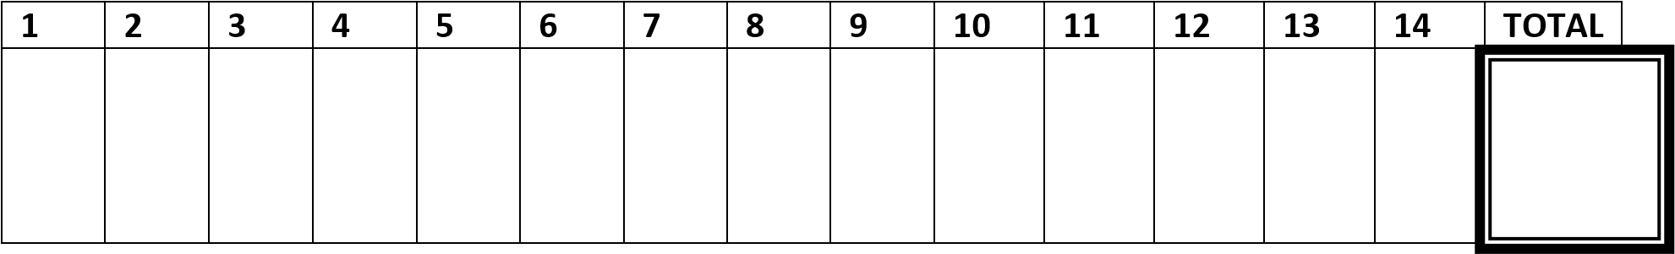
FOR EXAMINERS USE ONLY
INSTRUCTIONS TO CANDIDATES.
You should have the following for this examination:
- Drawing instruments
- 3 sheet of drawing paper size A3
This paper consists of THREE sections A, B and C.
Answer ALL the questions in section A and B and any TWO questions from section C.
Questions in section A must be answered on the answer sheets provided.
Questions in section B and C should be answered on the A3 drawing papers provided.
All dimensions are in millimeters unless otherwise stated.
Candidates may be penalized for not following the instructions given in this paper.
SECTION A (50 MARKS)
Answer All Questions In This Section
- ( a) Give the following information regarding parastatal organizations in Kenya
with regard to; (3 marks)
  - Ownership
  - Management
  - Services
- (a)State one disadvantage of using each of the following items to hold paper
on the drawing board.  i. Masking tape ii. Thumb pins | (2 marks)
(b) Describe each of the manufactured boards; | (3 marks)
i. Ply wood. ii. Chip board
iii. Block board.
- (a). State three factors to consider when choosing materials for engineering works
(3 marks)
(b). Explain the meaning of the term “alloy” as applied in materials and
give two examples ( 2marks)
- State the importance of following steps in the design process. (3 marks) a. Evaluation:
  - Final drawing:
  - Mock-up
- Construct an ellipse using the rectangle method whose sides are 80mm
by 45 mm. (5 marks)
- Construct a regular octagon inside a square whose sides are 80mm. ( 5 marks)
- Two views of a machine component are shown below in Figure 1. Sketch the block in oblique taking X-X as the lowest point (6 Marks)
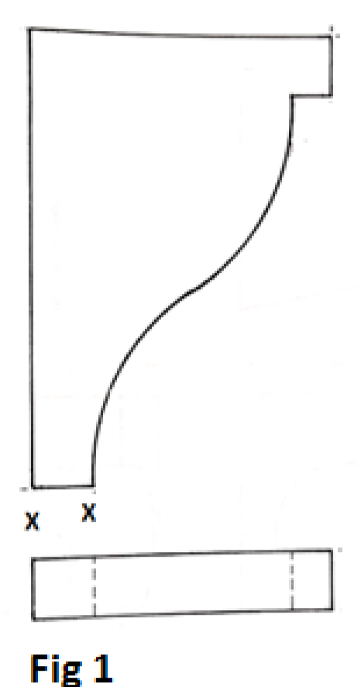
- Draw an isometric circle whose diameter is 60mm using ordinate method.
(4 marks)
- Front elevation of a pentagonal pyramid truncated by the cutting plane X_X is given in figure 2.
Sketch the auxiliary view and a plan. (8 marks )
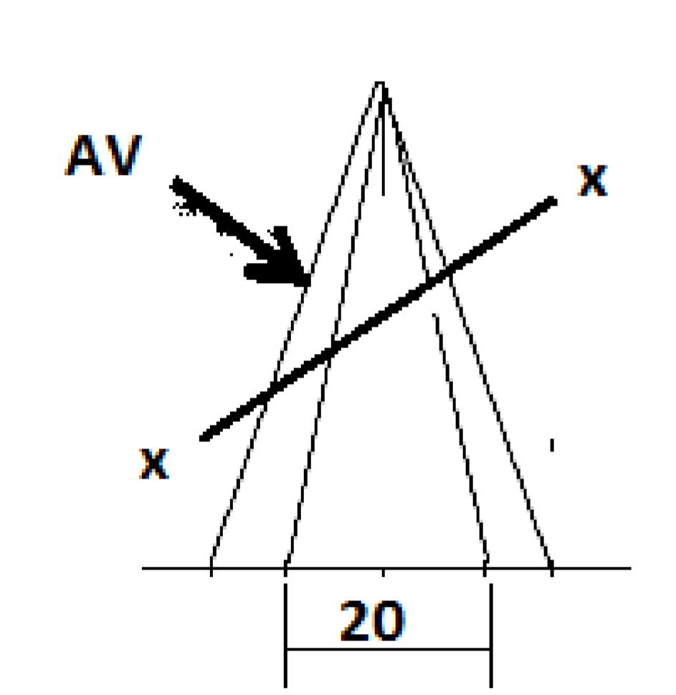
- Two views of a machine part are shown in figure 3. Sketch a two point perspective of the block. (8 marks )
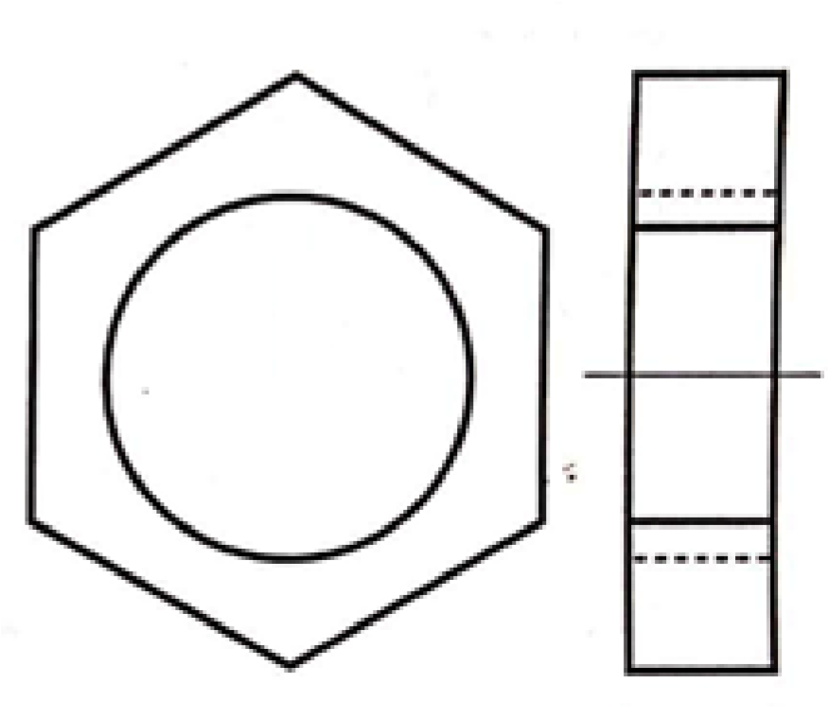
Section B (20 Marks)
This is a compulsory question.
Students are advised not to spend more than 1 hour answering this question 11.
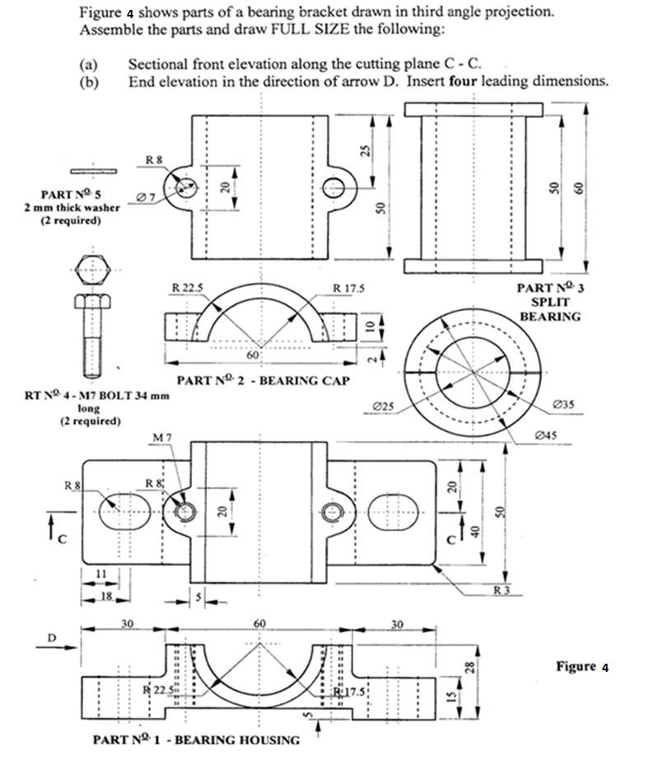
Section C (30 Marks)
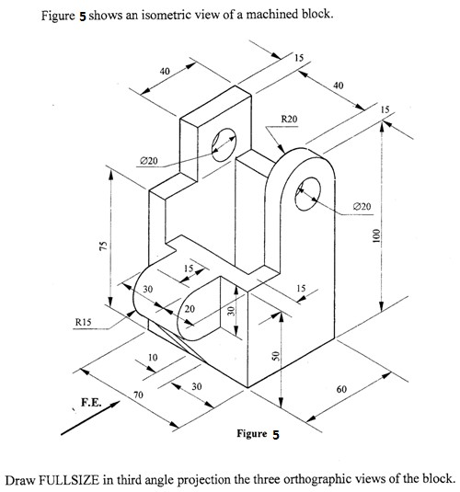
Answer any two questions from this section 12.
13.
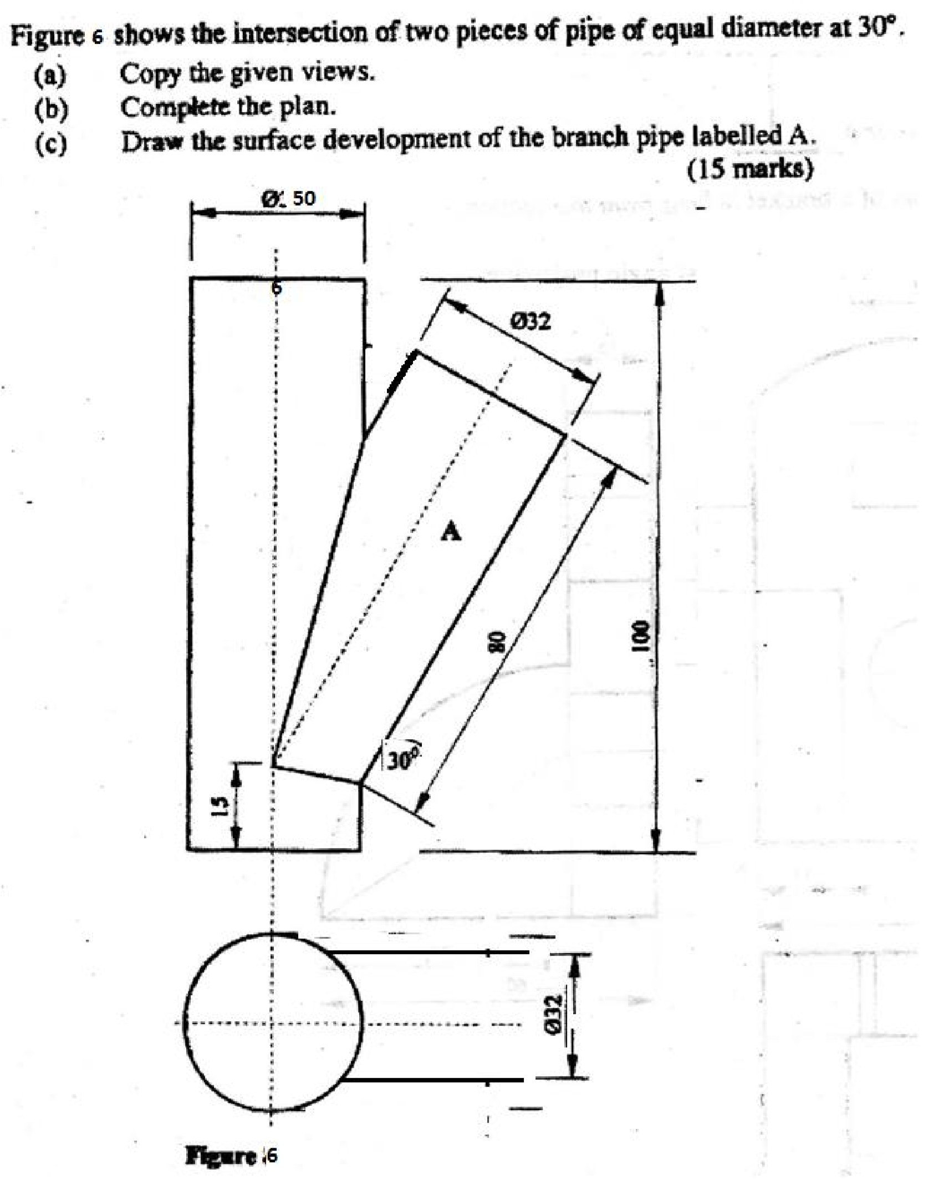
14. Define the term involute. (2 marks)
(b) Draw an involute to a circle of with a diameter of 30mm. (8 marks) (c) Draw a tangent to any point T on the involute. (5 marks)

