Term 2 - 2022
GEOGRAPHY
(QUESTION PAPER I ) FORM FOUR
TIME: 2 3/4 HOURS
Name: …………………………………………………………. Adm No: ………………. School: ……………………………………………………….. Class: …………………..
Signature: …………………………………………………….. Date:

Instructions to candidates
- Write your name, admission number and class in the spaces provided above.
- This paper has two sections: A and B
- Answer all the questions in section A
- Answer question 6 and any other two questions from section B
- All answers must be written in the spaces provided after Question 10.

(f) This paper consists of 14 printed pages.

(g) Candidates should check the question paper to ascertain that all the pages are printed as indicated and that no questions are missing.
For Examiner’s Use Only

Section

Questions

Candidate’s

Score

Maximum

Score

A

1
–

5

25

B

6

25

25

25

Total Score

100

SECTION A
Answer ALL questions in this section.
- Name the first two planets of the solar system. (2 marks)
……………………………………………………………………………………………………………………………………………………………………………………
…………………………………………………………………………………………………………………………………………………………………………………… ……………………………………………………………………………………………………………………………………………………………………………………
………………………………………………………………………………………………………………………………………………………………
- State three effects of the rotation of the earth on its axis.
……………………………………………………………………………………………………………………………………………………………………………………
…………………………………………………………………………………………………………………………………………………………………………………… ……………………………………………………………………………………………………………………………………………………………………………………
………………………………………………………………………………………………………………………………………………………………
(3 marks)
The diagram below shows the angles of the sun’s rays at different altitudes when the sun is overhead at the equator. Use it to answer question (a) and (b).
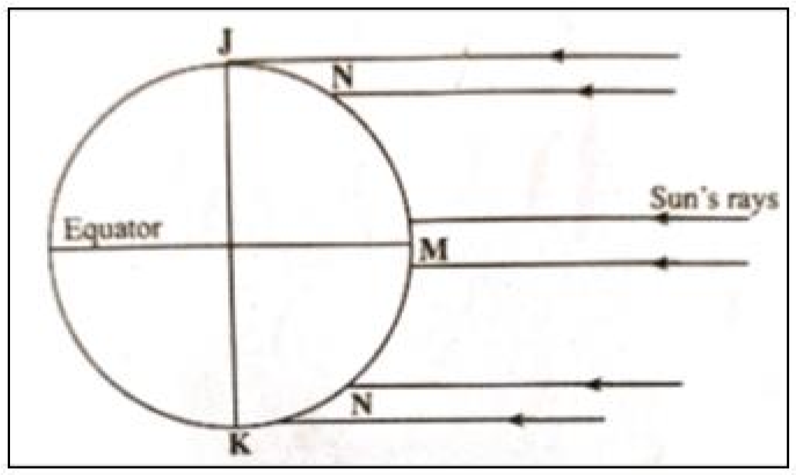
Name the parts of earth’s surface marked J and K. (2 marks)
……………………………………………………………………………………………………………………………………………………………………………………………
…………………………………………………………………………………………………………………………………………………………………………………………… ……………………………………………………………………………………………………………………………………………………………………………………………
………………………………………………………………………………………………………………………………………
Give two reasons why the intensity of insolation is higher at M than at N. (2 marks)
……………………………………………………………………………………………………………………………………………………………………………………
…………………………………………………………………………………………………………………………………………………………………………………… ……………………………………………………………………………………………………………………………………………………………………………………
………………………………………………………………………………………………………………………………………………………………
(a) Identify the temperate grasslands found in the following countries.
- Canada (1 mark)
……………………………………………………………………………………………………………………………………………………………………………………
…………………………………………………………………………………………………………………………………………………………………………………… ……………………………………………………………………………………………………………………………………………………………………………………
………………………………………………………………………………………………………………………………………………………………
- Russia (1 mark)
……………………………………………………………………………………………………………………………………………………………………………………
…………………………………………………………………………………………………………………………………………………………………………………… ……………………………………………………………………………………………………………………………………………………………………………………
………………………………………………………………………………………………………………………………………………………………
- Australia (1 mark)
……………………………………………………………………………………………………………………………………………………………………………………
…………………………………………………………………………………………………………………………………………………………………………………… ……………………………………………………………………………………………………………………………………………………………………………………
………………………………………………………………………………………………………………………………………………………………
(b) Give two reasons why the Tundra region has scanty vegetation. (2 marks)
……………………………………………………………………………………………………………………………………………………………………………………
…………………………………………………………………………………………………………………………………………………………………………………… ……………………………………………………………………………………………………………………………………………………………………………………
………………………………………………………………………………………………………………………………………………………………
- Identify two sources of water found in a lake. (2 marks)
……………………………………………………………………………………………………………………………………………………………………………………
…………………………………………………………………………………………………………………………………………………………………………………… ……………………………………………………………………………………………………………………………………………………………………………………
………………………………………………………………………………………………………………………………………………………………
- Give three ways through which lakes are formed. (3 marks)
……………………………………………………………………………………………………………………………………………………………………………………
…………………………………………………………………………………………………………………………………………………………………………………… ……………………………………………………………………………………………………………………………………………………………………………………
………………………………………………………………………………………………………………………………………………………………
(a) Give three factors that determine soil leaching. (3 marks)
……………………………………………………………………………………………………………………………………………………………………………………
…………………………………………………………………………………………………………………………………………………………………………………… ……………………………………………………………………………………………………………………………………………………………………………………
………………………………………………………………………………………………………………………………………………………………
(a) (b) State three ways in which mulching helps in soil conservation. (3 marks)
……………………………………………………………………………………………………………………………………………………………………………………
…………………………………………………………………………………………………………………………………………………………………………………… ……………………………………………………………………………………………………………………………………………………………………………………
………………………………………………………………………………………………………………………………………………………………

SECTION B
Answer question 6 and any other two questions from this section.
Study the map of Nyeri 1:50,000 (sheet 120/4) provided and answer the following questions.
(a) (i) Identify two map sheets to the eastern part of Nyeri. | (2 marks)
(ii) Name two administrative units found in Nyeri. | (2 marks)
(iii) Calculate the magnetic declination of the area covered by the map as at 1978. | (3 marks)
(b) (i) Give three types of natural vegetation found in the area covered by the map. | (3 marks)
(ii) Measure the length of the road D 432 in the southern part from Unjiru junction to Kangaita
market. Give your answer in kilometers.  (c) Using a vertical scale of 1cm to represent 50 metres; | (2 marks)
- Draw a cross section from grid reference 680630 to 730650.  - On the cross section, mark and name the following; | (4 marks)
• Hill | (1 mark)
• River | (1 mark)
• Road D 449 | (1 mark)
(d) Citing evidence from the map, identify three economic activities in the area covered by the map.
(6 marks)
1. | (a) (i) Define the term folding. | (2 marks)
 | (ii) Name two fold mountains that were formed during Alpine orogeny. | (2 marks)
 | (b) (i) Apart from fold mountains, give three other features resulting from folding. | (3 marks)
 | (ii) With the aid of a diagram, describe the formation of an overthrust fold. | (6 marks)
 | (a) Explain three positive effects of fold mountains on human activities. | (6 marks)
(b) Members of your class are planning to carry out a field study on an area that has undergone folding process.
 | (i) Give three ways you would prepare for the study. | (3 marks)
 | (ii) State three advantages of studying landforms through field work. | (3 marks)
2. | (a) (i) What is weathering? | (2 marks)
 | (ii) Apart from plants, give three other factors that influence the rate of weathering. |  | (3 marks)
 | (iii) Explain two ways in which plants cause weathering.  (b) Describe the following processes of weathering: |  | (4 marks)
 | (i) Block disintegration |  | (4 marks)
 | (ii) Carbonation |  | (4 marks)
 | (c) Explain four effects of mass wasting on the environment. |  | (8 marks)
3. | (a) (i) Apart from surface run off, give two other processes in the hydrological cycle. |  | (2 marks)
 | (ii) State three factors that determine the amount of surface run off. |  | (3 marks)
 | (b) Explain three factors that influence the transportation of materials by a river. |  | (6 marks)
 | (c) (i) What is river rejuvenation? |  | (2 marks)
 | (ii) Explain three conditions that lead to rejuvenation of a river. |  | (6 marks)
 | (d) Explain three negative effects of rivers to the human environment. |  | (6 marks)
4. | (a) (i) What is an ice sheet? |  | (2 marks)
(ii) Explain three factors that influence the movement of ice from the point of accumulation.
(6 marks)
- Describe how an arête is formed. (6 marks)
- The diagram below shows features resulting from glacial deposition on a lowland area.
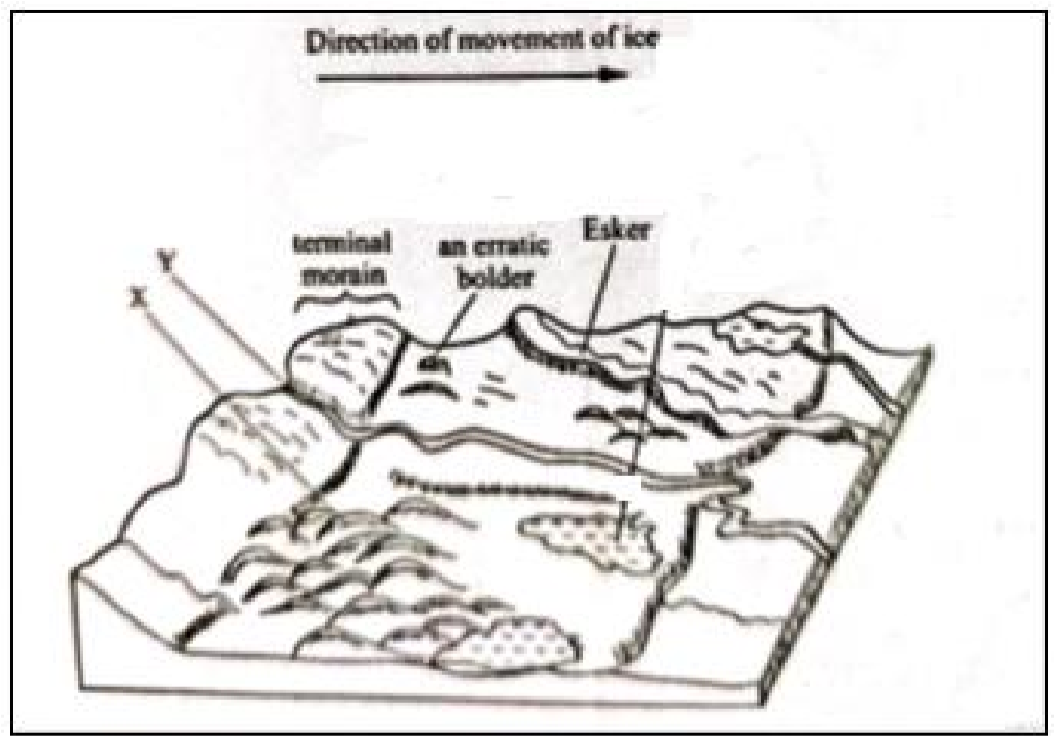
(i) Name the features marked X and Y. | (2 marks)
(ii) Describe how terminal moraine is formed. | (3 marks)
(d) Explain three positive effects of glaciation in lowland areas. | (6 marks)

………………………………………………………………………………………………………………………
………………………………………………………………………………………………………………………
………………………………………………………………………………………………………………………
………………………………………………………………………………………………………………………
………………………………………………………………………………………………………………………
………………………………………………………………………………………………………………………
………………………………………………………………………………………………………………………
………………………………………………………………………………………………………………………
………………………………………………………………………………………………………………………
………………………………………………………………………………………………………………………
………………………………………………………………………………………………………………………
………………………………………………………………………………………………………………………
………………………………………………………………………………………………………………………
………………………………………………………………………………………………………………………
………………………………………………………………………………………………………………………
………………………………………………………………………………………………………………………
……………………………………………………………………………………………………………………… ………………………………………………………………………………………………………………………
………………………………………………………………………………………………………………………
………………………………………………………………………………………………………………………
………………………………………………………………………………………………………………………
………………………………………………………………………………………………………………………
………………………………………………………………………………………………………………………
………………………………………………………………………………………………………………………
………………………………………………………………………………………………………………………
………………………………………………………………………………………………………………………
………………………………………………………………………………………………………………………
………………………………………………………………………………………………………………………
………………………………………………………………………………………………………………………
………………………………………………………………………………………………………………………
………………………………………………………………………………………………………………………
………………………………………………………………………………………………………………………
………………………………………………………………………………………………………………………
……………………………………………………………………………………………………………………… ………………………………………………………………………………………………………………………
………………………………………………………………………………………………………………………
………………………………………………………………………………………………………………………
………………………………………………………………………………………………………………………
………………………………………………………………………………………………………………………
………………………………………………………………………………………………………………………
………………………………………………………………………………………………………………………
………………………………………………………………………………………………………………………
………………………………………………………………………………………………………………………
………………………………………………………………………………………………………………………
………………………………………………………………………………………………………………………
………………………………………………………………………………………………………………………
………………………………………………………………………………………………………………………
………………………………………………………………………………………………………………………
………………………………………………………………………………………………………………………
………………………………………………………………………………………………………………………
……………………………………………………………………………………………………………………… ………………………………………………………………………………………………………………………
………………………………………………………………………………………………………………………
………………………………………………………………………………………………………………………
………………………………………………………………………………………………………………………
………………………………………………………………………………………………………………………
………………………………………………………………………………………………………………………
………………………………………………………………………………………………………………………
………………………………………………………………………………………………………………………
………………………………………………………………………………………………………………………
………………………………………………………………………………………………………………………
………………………………………………………………………………………………………………………
………………………………………………………………………………………………………………………
………………………………………………………………………………………………………………………
………………………………………………………………………………………………………………………
………………………………………………………………………………………………………………………
………………………………………………………………………………………………………………………
……………………………………………………………………………………………………………………… ………………………………………………………………………………………………………………………
………………………………………………………………………………………………………………………
………………………………………………………………………………………………………………………
………………………………………………………………………………………………………………………
………………………………………………………………………………………………………………………
………………………………………………………………………………………………………………………
………………………………………………………………………………………………………………………
………………………………………………………………………………………………………………………
………………………………………………………………………………………………………………………
………………………………………………………………………………………………………………………
………………………………………………………………………………………………………………………
………………………………………………………………………………………………………………………
………………………………………………………………………………………………………………………
………………………………………………………………………………………………………………………
………………………………………………………………………………………………………………………
………………………………………………………………………………………………………………………
………………………………………………………………………………………………………………………
………………………………………………………………………………………………………………………
………………………………………………………………………………………………………………………
………………………………………………………………………………………………………………………
………………………………………………………………………………………………………………………
………………………………………………………………………………………………………………………
………………………………………………………………………………………………………………………
………………………………………………………………………………………………………………………
………………………………………………………………………………………………………………………
………………………………………………………………………………………………………………………
………………………………………………………………………………………………………………………
………………………………………………………………………………………………………………………
………………………………………………………………………………………………………………………
………………………………………………………………………………………………………………………
………………………………………………………………………………………………………………………
………………………………………………………………………………………………………………………
………………………………………………………………………………………………………………………
……………………………………………………………………………………………………………………… ………………………………………………………………………………………………………………………
………………………………………………………………………………………………………………………
………………………………………………………………………………………………………………………
………………………………………………………………………………………………………………………
………………………………………………………………………………………………………………………
………………………………………………………………………………………………………………………
………………………………………………………………………………………………………………………
………………………………………………………………………………………………………………………
………………………………………………………………………………………………………………………
………………………………………………………………………………………………………………………
………………………………………………………………………………………………………………………
………………………………………………………………………………………………………………………
………………………………………………………………………………………………………………………
………………………………………………………………………………………………………………………
………………………………………………………………………………………………………………………
………………………………………………………………………………………………………………………
……………………………………………………………………………………………………………………… ………………………………………………………………………………………………………………………
………………………………………………………………………………………………………………………
………………………………………………………………………………………………………………………
………………………………………………………………………………………………………………………
………………………………………………………………………………………………………………………
………………………………………………………………………………………………………………………
………………………………………………………………………………………………………………………
………………………………………………………………………………………………………………………
………………………………………………………………………………………………………………………
………………………………………………………………………………………………………………………
………………………………………………………………………………………………………………………
………………………………………………………………………………………………………………………
………………………………………………………………………………………………………………………
………………………………………………………………………………………………………………………
………………………………………………………………………………………………………………………
………………………………………………………………………………………………………………………
……………………………………………………………………………………………………………………… ………………………………………………………………………………………………………………………
………………………………………………………………………………………………………………………
………………………………………………………………………………………………………………………
………………………………………………………………………………………………………………………
………………………………………………………………………………………………………………………
………………………………………………………………………………………………………………………
………………………………………………………………………………………………………………………
………………………………………………………………………………………………………………………
………………………………………………………………………………………………………………………
………………………………………………………………………………………………………………………
………………………………………………………………………………………………………………………
………………………………………………………………………………………………………………………
………………………………………………………………………………………………………………………
………………………………………………………………………………………………………………………
………………………………………………………………………………………………………………………
………………………………………………………………………………………………………………………
………………………………………………………………………………………………………………………
………………………………………………………………………………………………………………………
………………………………………………………………………………………………………………………
………………………………………………………………………………………………………………………
………………………………………………………………………………………………………………………
………………………………………………………………………………………………………………………
………………………………………………………………………………………………………………………
………………………………………………………………………………………………………………………
………………………………………………………………………………………………………………………

