Term 2 - 2022
GEOGRAPHY
(QUESTION PAPER II ) FORM FOUR
TIME: 2 3/4 HOURS
Name: …………………………………………………………. Adm No: ………………. School: ……………………………………………………….. Class: …………………..
Signature: …………………………………………………….. Date:
Instruction to the candidates,
- This paper has two Sections: A and B.
- Answer all questions in Section A.
- In Section B Answer question 6 and any other two questions.
- All Answers must be written on a separate answer sheet provided.
For Examiner’s Use Only
SECTION
QUESTION
MAXIMUM
SCORE
CANDIDATE’S

SCORE

A
1
–

5

25

B
6

25

25

25

100

SECTION A
1. a) Apart from fishing name two other economic activities that are practiced along the East
African coastal waters (2marks)
…………………………………………………………………………………………………
………………………………………………………………………………………………… ………………………………………………………………………………………………… …………………………………………………………………………………………………
………………………………………………………………………………………………… …………………………………………………………………………………………………
………………………………………………………………
b) Identify three methods of fishing from are used for deep area fishing (3marks)
…………………………………………………………………………………………………
………………………………………………………………………………………………… ………………………………………………………………………………………………… …………………………………………………………………………………………………
………………………………………………………………………………………………… …………………………………………………………………………………………………
………………………………………………………………
2a) Give physical tourists attractions found in the western region of Kenya (3marks)
…………………………………………………………………………………………………
………………………………………………………………………………………………… ………………………………………………………………………………………………… …………………………………………………………………………………………………
………………………………………………………………………………………………… …………………………………………………………………………………………………
………………………………………………………………
b) State two reasons why domestic tourism is encouraged in Kenya (2marks)
…………………………………………………………………………………………………
………………………………………………………………………………………………… ………………………………………………………………………………………………… …………………………………………………………………………………………………
………………………………………………………………………………………………… …………………………………………………………………………………………………
………………………………………………………………
3a) State two human problems facing HEP projects in Africa (2marks)
…………………………………………………………………………………………………
………………………………………………………………………………………………… ………………………………………………………………………………………………… …………………………………………………………………………………………………
………………………………………………………………………………………………… …………………………………………………………………………………………………
………………………………………………………………
b) State three physical factors that have favoured high hydro-electric power production in
Uganda (3marks)
…………………………………………………………………………………………………
………………………………………………………………………………………………… ………………………………………………………………………………………………… …………………………………………………………………………………………………
………………………………………………………………………………………………… …………………………………………………………………………………………………
………………………………………………………………
4a) Give two trading blocks in Africa (2marks)
…………………………………………………………………………………………………
………………………………………………………………………………………………… ………………………………………………………………………………………………… …………………………………………………………………………………………………
………………………………………………………………………………………………… …………………………………………………………………………………………………
………………………………………………………………
b) Identify three political problems facing regional trading blocs in Africa (3marks)
…………………………………………………………………………………………………
………………………………………………………………………………………………… ………………………………………………………………………………………………… …………………………………………………………………………………………………
………………………………………………………………………………………………… …………………………………………………………………………………………………
………………………………………………………………
5. a) Name two towns in Kenya where motor vehicle assembling plants are located (2marks)
…………………………………………………………………………………………………
………………………………………………………………………………………………… ………………………………………………………………………………………………… …………………………………………………………………………………………………
………………………………………………………………………………………………… …………………………………………………………………………………………………
………………………………………………………………
b) List three risks associated with the use of motor vehicles (3marks)
………………………………………………………………………………………………………………………………………………………… ………………………………………………………………………………………………………………………………………………………… ………………………………………………………………………………………………………………………………………………………… …………………………………………………………………………………………………………………………………………………………
……………………………………
SECTION B
Answer Question 6 and any other TWO Questions in this Section.
6. The photograph below shows cattle rearing in an area in Kenya. Use it to answer the following questions;
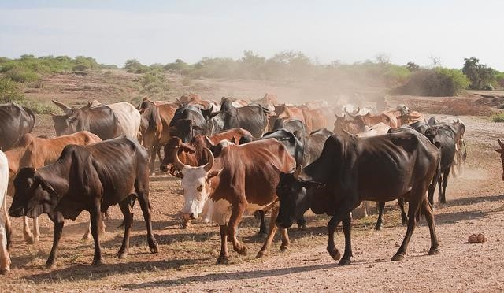
- Name the type of photograph shown above (1 mark)
…………………………………………………………………………………………………
………………………………………………………………………………………………… ………………………………………………………………………………………………… …………………………………………………………………………………………………
………………………………………………………………………………………………… …………………………………………………………………………………………………
………………………………………………………………
- What economic activity is carried out in the area shown by the photograph?
(1mark)
…………………………………………………………………………………………………
………………………………………………………………………………………………… ………………………………………………………………………………………………… …………………………………………………………………………………………………
………………………………………………………………………………………………… …………………………………………………………………………………………………
………………………………………………………………
- Give three counties where the economic activity you identified in (ii) above takes place in Kenya. (3marks)
…………………………………………………………………………………………………
………………………………………………………………………………………………… ………………………………………………………………………………………………… …………………………………………………………………………………………………
………………………………………………………………………………………………… …………………………………………………………………………………………………
………………………………………………………………
- Draw a rectangle measuring 16cm by 9cm to represent the area of the photograph. On it sketch and label the main features shown on the photograph (5 marks)
- From the photograph, give two indicators showing that the area is experiencing droughtlike conditions. (2 marks)
…………………………………………………………………………………………………
………………………………………………………………………………………………… ………………………………………………………………………………………………… …………………………………………………………………………………………………
………………………………………………………………………………………………… …………………………………………………………………………………………………
………………………………………………………………
- Name two exotic breeds of dairy cattle reared in Kenya. (2mark)
…………………………………………………………………………………………………
………………………………………………………………………………………………… ………………………………………………………………………………………………… …………………………………………………………………………………………………
………………………………………………………………………………………………… …………………………………………………………………………………………………
………………………………………………………………
State three physical factors which favour dairy farming in Kenya. (3 marks)
…………………………………………………………………………………………………
………………………………………………………………………………………………… ………………………………………………………………………………………………… …………………………………………………………………………………………………
………………………………………………………………………………………………… …………………………………………………………………………………………………
………………………………………………………………
1. Explain four benefits of dairy farming to the economy of Kenya. (8 marks )
…………………………………………………………………………………………………
………………………………………………………………………………………………… ………………………………………………………………………………………………… ………………………………………………………………………………………………… …………………………………………………………………………………………………
………………………………………………………………………………………………… ………………………………………………………………………………………………… …………………………………………………………………………………………………
………………………………………………………………………………………………… ………………………………………………………………………………………………… …………………………………………………………………………………………………
…………………………………………………………………………………………………
………………………………………………………………………………………………… ………………………………………………………………………………………………… …………………………………………………………………………………………………
………………………………………………………………………………………………… ………………………………………………………………………………………………… …………………………………………………………………………………………………
…………………………………………………………………………………………………
……………………………………………………………………………………………
7a) State four factors that influence the occurrence of minerals | (4marks)
b) Describe the open cast method of mining? | ( 5marks)
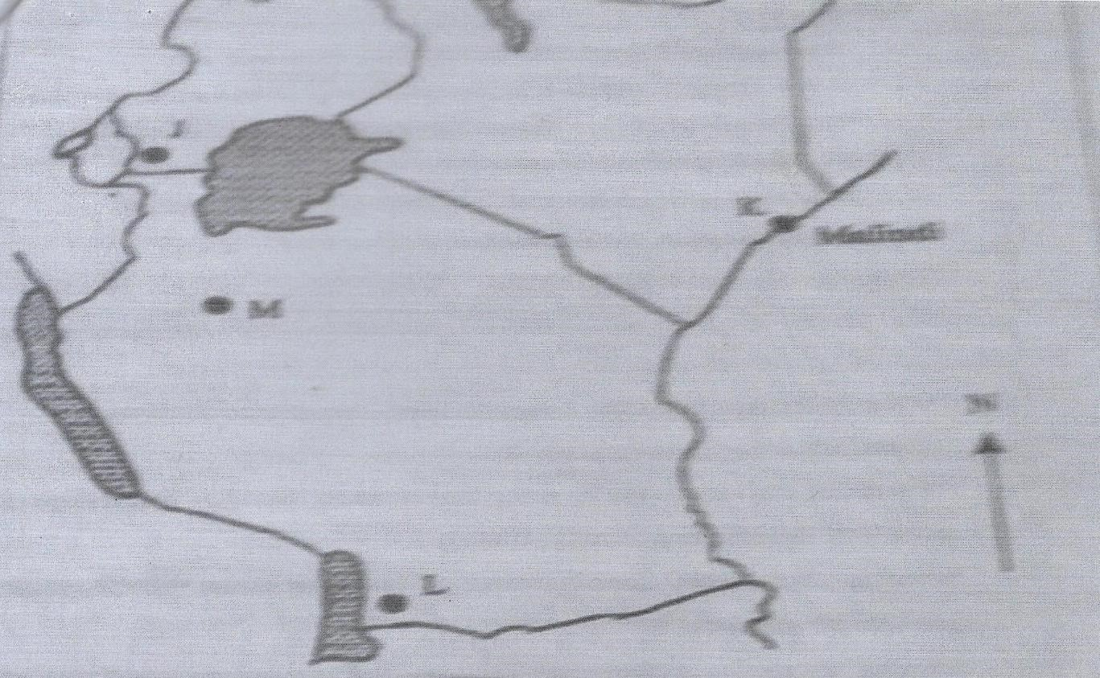
8 (a) Define the term forestry (2marks)
c)
Study the map below and answer the questions that follow
i)
Name the mineral found in areas marked I, K, L, and M
(4
marks
)

Explain three ways in which mining promotes industrialization in Kenya
d)

(6
marks

(
e) Students carried out a felid s
tudy about rocks and minerals

i)
State three problems they are likely to undergo during the field study

(3
marks
)

ii)
Give the follow
-
up activities they will undertake

(3
marks
)

(ii) Apart from tropical hardwood forest, name three other types of natural forests (3marks) iii) State the problems experienced in the exploitation of tropical hardwood forest (4marks)
10

- List the characteristics of planted forests in Kenya (5marks)
- Explain three factors that favour forests in Canada (6marks)
d)Give five measures that the government has taken to conserve and manage forests in Kenya (5marks)
9. a Describe the following
(i) Mulching (4marks) ii)Bunds and gabions (6marks)
- Give three ways in which the government of Kenya is trying to rehabilitate overgrazed lands
in Kenya | (3marks)
c (i) State examples of irrigation methods commonly used in Kenya | (4marks)
ii)Explain two conditions that favour irrigation farming in Kenya | (4 marks)
d) Give the characteristics of land reclamation in Kenya | (4marks)
10a) Describe the characteristics of population of the two countries as represented by the
pyramids (6marks)
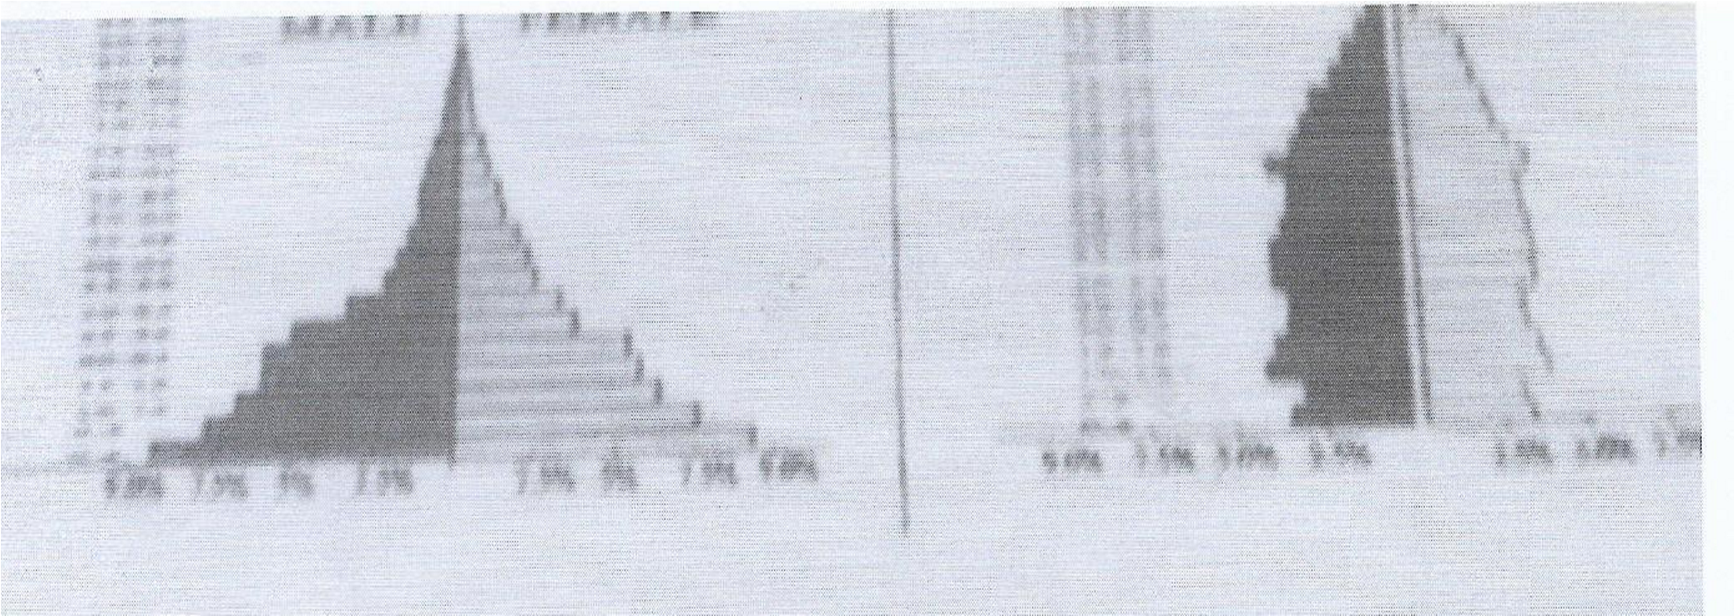
b(i) What is the meaning of fertility rate? (2 marks)
ii)Explain three factors that have contributed to the reduction in fertility rate in Kenya
11

(6marks)
- State three problems caused by the slow population growth rate in developed countries
(3marks) d) Explain four causes of rural–rural migration in Kenya (8marks)

