Term 2 - 2022
MATHEMATICS (121/2)
PAPER 2
FORM FOUR (4)
Time: 2 ½ Hours
Name: …………………………………………………………. Adm No: …………………………………… School: ……………………………………………………….. Class: ……………………………………....
Signature: …………………………………………………….. Date: ……………………………………….
INSTRUCTIONS TO CANDIDATES
- Write your name and index number in the spaces provided at the top of this page.
- Write your school name, sign and write the date of the examination in the spaces provided above.
- This paper consists of Two sections: Section I and Section II
- Answer ALL questions in Section I and any five questions from Section II
- Show all the steps in your calculations, giving your answers at each stage in the spaces provided below each question.
- Marks may be given for correct working even if the answer is wrong.
- Non-Programmable silent electronic calculators and KNEC Mathematical Tables may be used.
- This paper consists of 17 printed pages.
- Candidates should check the question paper to ensure that all the pages are printed as indicated and no questions are missing.
- Candidates should answer the questions in English.
For Examiners’ Use Only
SECTION I
1 | 2 | 3 | 4 | 5 | 6 | 7 | 8 | 9 | 10 | 11 | 12 | 13 | 14 | 15 | 16 | Total
SECTION II
17 | 18 | 19 | 20 | 21 | 22 | 23 | 24 | Total |  | Grand  Total
SECTION I (50 Marks)
Answer all the questions in this section
- Solve for x in the equation below without using a mathematical table or calculator. (4 marks) (log₁₀ 𝑥)² = 3 − log₁₀ 𝑥²
- The base of a right angled triangle is 4.1 cm and the height is 5.0 cm. Calculate the percentage error in the area of the triangle. (3 marks )
- Given that 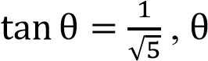 is an acute angle, without using a calculator or mathematical tables,
find sin(90 − θ), leaving your answer in simplified surd form. (2 marks)
- Find the interest on Ksh. 200,000 for 2 years at 14% per annum compounded semi-annually. (3 marks )
- Make the subject of the formula (3 marks)
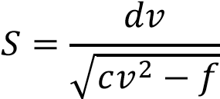
- A coffee trader buys two grades of coffee at Kshs. 80 and Kshs. 100 per packet. Find the ratio in which she should mix the two brands so that by selling the mixture at Kshs. 120 per packet, a 25% profit realized?
(3 marks)
- A bakery prepares cakes for sale. It has 80 eggs and 10 cups of sugar for use. It bakes two cake types: P and Q. Type P cake requires 6 eggs and 2 cups of sugar while type Q cake requires 12 eggs and three-quarters cup of sugar. By letting type P cakes to be x and type Q cakes to be y, form all the inequalities that represent
the above information. (3 marks )
- Find the radius and the centre of a circle whose equation is given by 3𝑥² + 3𝑦² + 6𝑥 − 12𝑦 − 12 = 0.
(3 marks)
- The equation of a trigonometric function is 𝑦 = 2 cos(𝑏𝑥 − 60)⁰. The period of the function is 120⁰.
  - Determine the value of (1 mark)
(b) Deduce the phase angle of the function. | (1 mark)
- A point R is 2100 nautical miles to the east of another point Q (60⁰N, 0⁰) , find the position of P.
(3 marks)
- An arithmetic progression is such that its first term is 200 and common difference 500. Given that
𝑆_{𝑛} = 80,100, find the value of (4 marks)
- (a) Expand (3 + 𝑥)⁵ in ascending powers of up to the term in 𝑥³. (1 mark)
(b) Use the expansion in (a) above to approximate the value of 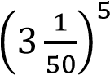 correct to 4 decimal places.
(2 marks)
- P varies as the cube of Q and inversely as the square root of R. If Q is reduced by 20% and R increased by
21%, find the percentage change in P. (3 marks)
- Use tables of squares, reciprocals and square roots only to evaluate (4 marks)
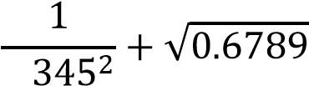
2.
- In the figure below, AD = 9 cm, AB = 11cm and angle BAD = 80⁰. BD is the diameter of the semi-circle
BCD.
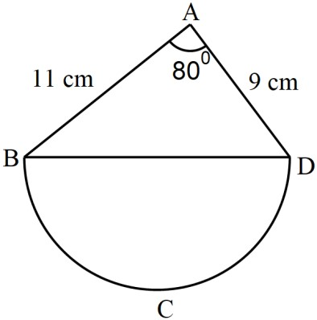
Calculate the area of the semi-circle, correct to 2 decimal places. Use π = 3.142 (4 marks)
- Two regular polygons have sides and 𝑛 + 3. Given that the ratio of the sum of their interior angles is 1: 2, calculate the value of . (3 marks ) SECTION II (50 Marks) Answer any five question in this section
- The table below shows income tax rates in a certain year.
Taxable Income (Ksh per month) | Tax Rate (%)
0 – 13 450 | 10
13 451 – 26 350 | 15
26 351 – 39 250 | 20
39 251 – 52 150 | 25
52 151 and above | 30
In that year, the monthly earnings for Amilo were as follows: basic salary Ksh 35 500, house allowance – Ksh 12 600 and other allowances that amount to Ksh. 5 872 were exempted from taxation.
Amilo contributes 12.5% of her basic salary to a pension scheme. She is entitled to a personal tax relief of Ksh 1 845 per month. Calculate:
  - Amilo’s taxable income in Ksh per month. (2 marks)
  - Amilo’s P.A.Y.E that month. (5 marks)
  - Amilo’s net pay that month, given that the following are deducted monthly from her salary; NHIF – Ksh
1 000, Union dues – Kshs 455 and BBF – Ksh 200. (3 marks)
- A mode is in the shape of a polygon with vertices A, B, C, D and E such that; AB=4.4 cm, AE=10 cm, ED=5.2 cm and BC=7.9 cm. The bearing of B from A is 030⁰ and A is due east of E, while D is due north of E and angle EDC=120⁰
  - Using a ruler and a pair of compasses only,
    - Construct the accurate plan of the model. (4 marks)
    - Measure DC. (1 mark)
  - A foundation plaque is to be placed closer to CD than CB, nearer to D than to E and not more than 6 cm from A.
    - Construct the locus of points equidistant from CB and CD. (1 mark)
    - Construct the locus of points equidistant from E and D. (1 mark)
(iii)Construct the locus of points 6 cm from A. (1 mark)
  - Shade and label as R, the region within which the foundation plaque could be placed in the garden.
(2 marks)

- The probability that it rains on a certain day is 0.8. If it rains the probability that a school bus will be stuck in a traffic jam is 0.7 but otherwise it is 0.4. If the bus is stuck in the jam, the probability that students using it to school will arrive late is 0.6, otherwise the probability of students using the bus to arrive late is 0.3.
  - Draw a tree diagram to represent this information. Use the letters R, J and L to represent the events of rain, jam and late respectively (2 marks)
  - Determine:
    - The probability that it rains, the bus isn’t held in the jam but the students arrive late in school.
(1 mark)
(ii) The probability that students arrive in school on time. | (3 marks)
(iii) The probability that the students arrive in school late. | (2 marks)
(iv) The probability that the bus is held in the jam. | (2 marks)
- The vertices of a triangle 𝐴𝐵𝐶 are 𝑃′(−1, 1), 𝐵′(−5, 4) and 𝐶′(−1, 2) under a transformation whose matrix is 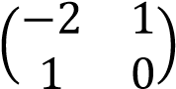
(a) Find the coordinates of 𝐴𝐵𝐶 | (3 marks)
(b) On the grid provided, draw triangles 𝐴𝐵𝐶 and 𝐴′𝐵′𝐶′. | (2 marks)

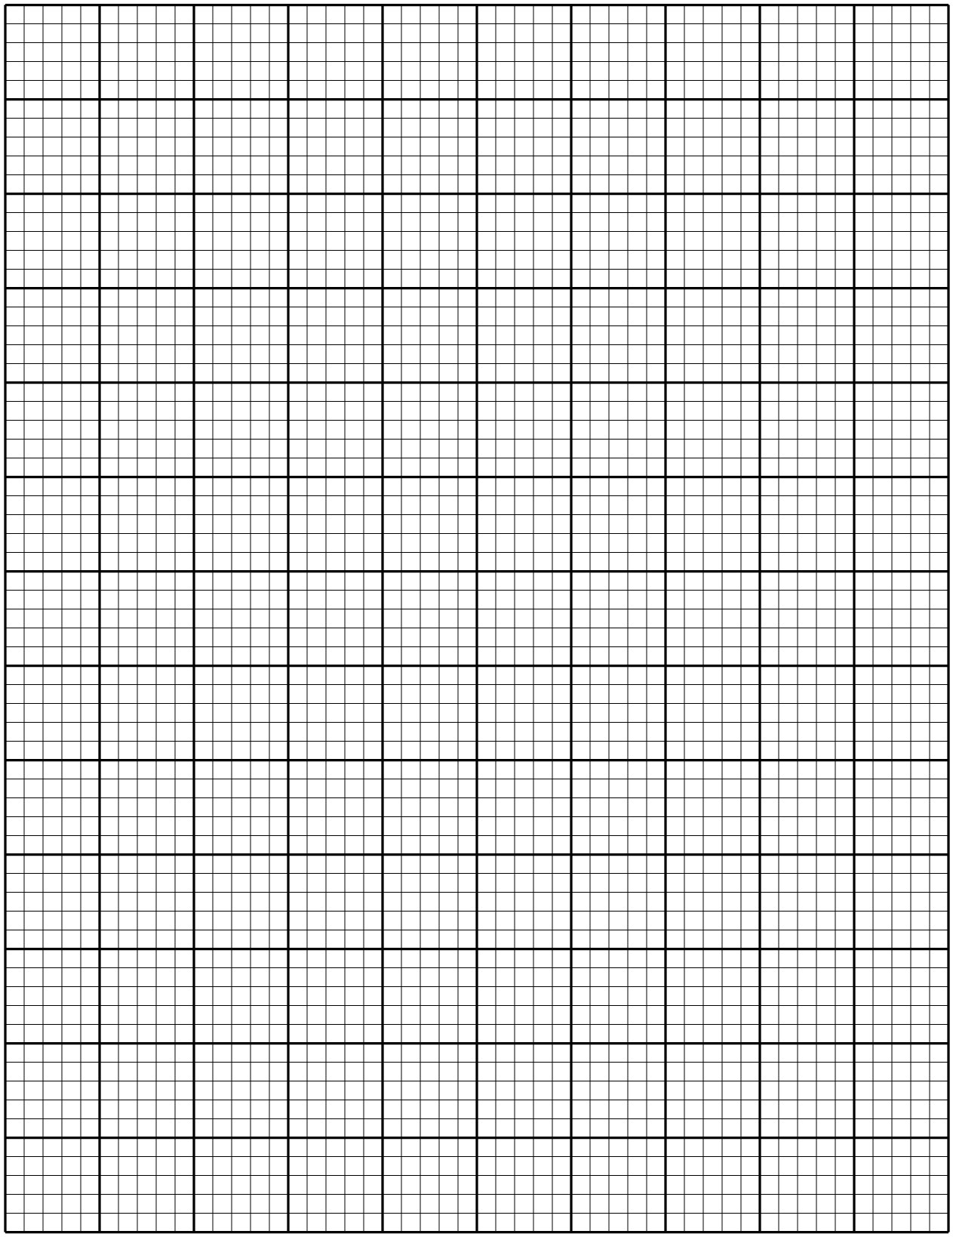
- Triangle 𝐴′′𝐵′′𝐶′′ is the image of triangle 𝐴′𝐵′𝐶′ under a transformation represented by the matrix
−1 0 )
0 −2
  - Determine the coordinates of 𝐴′′𝐵′′𝐶′′. (2 marks)
  - On the same grid, draw 𝐴′′𝐵′′𝐶′′. (1 mark)
- Another transformation maps 𝐴′′𝐵′′𝐶′′ on to 𝐴′′′𝐵′′′𝐶′′′ such that 𝐴′′′(−1, −2), 𝐵′′′(−5, −8) and
𝐶′′′(−1, −4). Describe fully. (2 marks )

21. The figure below shows a frequency polygon representing the scores of Form 4 Green students in a History contest.
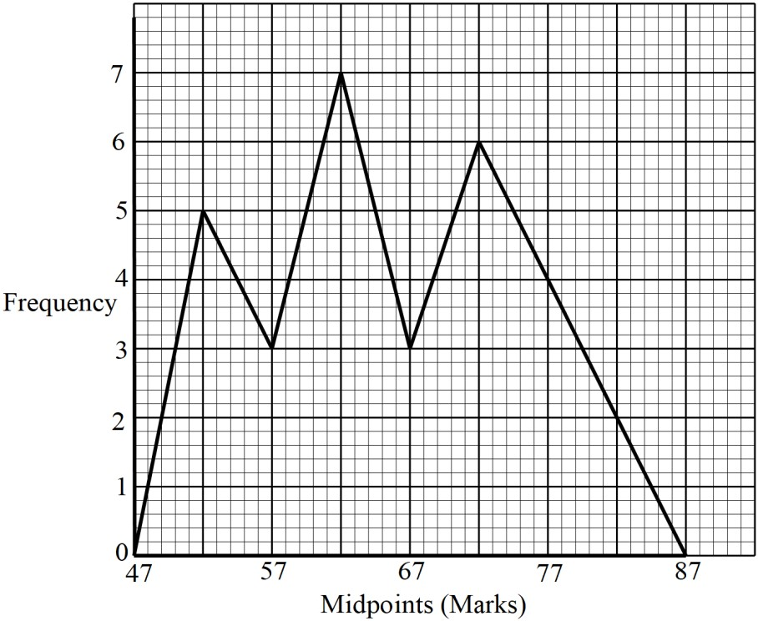
(a) Generate the frequency distribution table for the data under the headings given in the table below.
(5 marks)
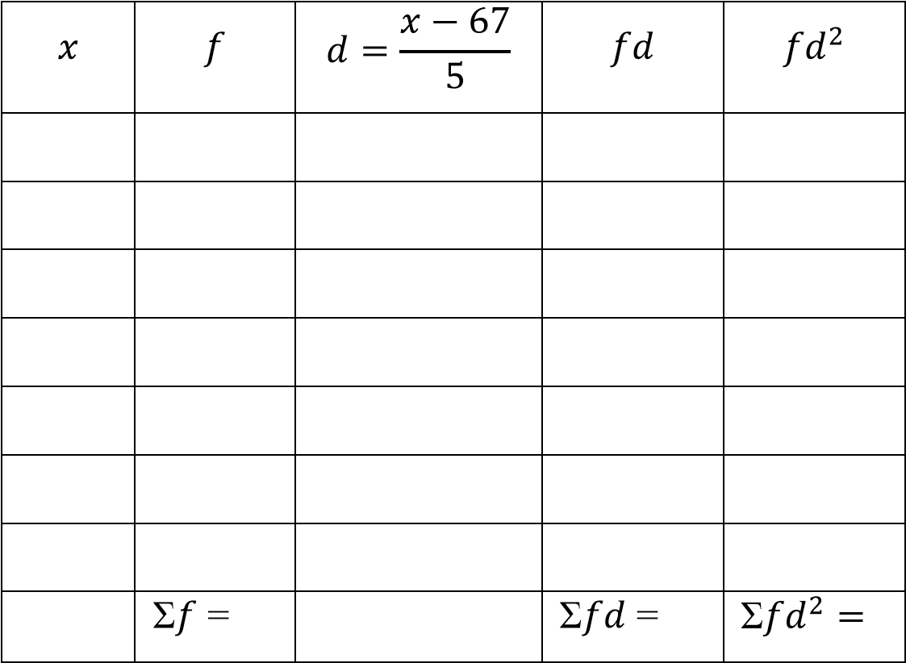
- Calculate the standard deviation of the marks. (3 marks)
- The mean weight of 11 babies in a clinic is 4.5 kg. If one more baby comes to the clinic, the total mass of the babies becomes 60 kg. Find the mass of the additional baby. (2 marks)

- In a triangle OAB, 𝑶𝑨 = 12𝒂, and 𝑶𝑩 = 12𝒃. P and Q are points on OA and OB respectively such that 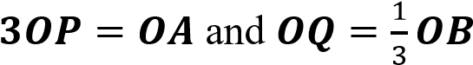. M is the midpoint of AB.
  - Express the following in terms of and
    - 𝑶𝑴 (1 mark)
    - 𝑷𝑴 (1 mark)
  - 𝑶𝑴 and 𝑩𝑷 intersect at R such that 𝑷𝑹 = 𝑘𝑷𝑩 and 𝑶𝑹 = ℎ𝑶𝑴.
  - Express 𝑷𝑹 in two ways (2 marks)
  - Hence find the values of and (3 marks)
(c) Show that A, R and Q are collinear. | (3 marks)

- The figure below represents a right pyramid with a vertex V and a rectangular base PQRS. VP=VQ=VR=VS=18 cm. PQ=16 cm and QR=12 cm. M and O are the midpoints of QR and PR respectively.
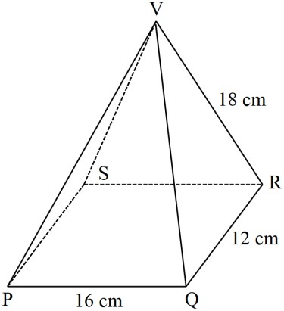
Calculate, correct to 2 decimal places;
  - The length of the projection of the line VP on the plane PQRS (2 marks)
  - The angle between the lines VP and the plane PQRS. (2 marks)
  - the angle between planes VQR and VPS. (4 marks)
  - The angle between the planes VQR and PQRS (2 marks)
- Two functions, 𝑥 + 𝑦 = 4 and 𝑦 = 𝑥² + 2, intersec at C and D
  - Determine the coordinates of C and D (4 marks)
  - Using the trapezium rule with 6 trapezia, estimate the area bound by 𝑦 = 𝑥² + 2, the x-axis and the vertical lines through C and D. (4 marks) (c) Find the exact area in (b) above. (3 marks)

