Term 2 - 2022
PHYSICS (232/3)
FORM FOUR (4)
Time: 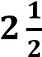 Hours
Name: …………………………………………………………. Adm No: ……………….
School: ……………………………………………………….. Class: ………………….. Signature: …………………………………………………….. Date: …………………...
INSTRUCTIONS:
- Answer all the questions in this paper
- You are supposed to spend the first 15 minutes of the 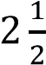 hours allowed for this paper reading the whole paper carefully before starting your work.
- Marks are given for clear record of the observations made, their suitability and accuracy and the use made of them.
- Candidates are advised to record observations as soon as they are made
- Mathematical table and electronic calculators may be used.
- The earth’s gravitational pull, 𝒈 = 𝟏𝟎𝑵𝒌𝒈^{−𝟏}
For Examiner’s use only:
QUESTION | TOTAL MARKS | CANDIDATE’S SCORE
1 | 20
2 | 20
GRAND TOTAL | 40
This paper consists of 7 printed pages. Candidates should check the question paper to ensure that all the pages are printed as indicated and no questions are missing.

QUESTION ONE
You are provided with the following apparatus: clips
 | Two new size ‘D’ dry-cells switch milli-ammeter voltmeter (0-3V) two enameled copper rods  rheostat (0 − 100Ω)  eight connecting wires with atleast 4 fitted with crocodile | - •  - • • | Micrometer screw-gauge ( to be shared )  50 ml beaker (labelled, A)  75 ml of distilled water (labelled, B) solid X  Measuring cylinder  Thermometer  Glass-rod for stirrer  Sand-paper
Proceed as follows:
- Measure the temperature of the distilled water in beaker, B
Temperature, = ............................ (1 mark)
- Place the provided solid X into the beaker labelled, A. measure 50 ml of the distilled water and gently pour it into beaker A and stir gently until all the solid X is dissolved to form solution, C.
- Measure the diameter, d of one of the copper rods.
i. | diameter, d = ............................ m | (1 mark)
ii. | determine the cross-section area, A of the copper rod | (2 marks)
A =








- Using the sand paper, remove the insulating coating at the both ends of each of the copper rods. Now set-up the apparatus as shown in figure 1 below.
support

m
A

V

Copper rod

Solution, C

Beaker, A

Figure
1

- With the help of the rheostat, set the current value to 30 mA and measure its corresponding voltage, V.
V = ............................ (1 mark)
- Repeat the above procedure for the values of current indicated in the table, 1 below and note their corresponding voltages. Complete the table. (5 marks)
Table 1
Current, I (mA) | 30 | 40 | 50 | 60 | 70
Current, (A)
Voltage, V
- In the grid provided, plot a graph of voltage (y-axis) against current (A) (X-axis) (5 marks)
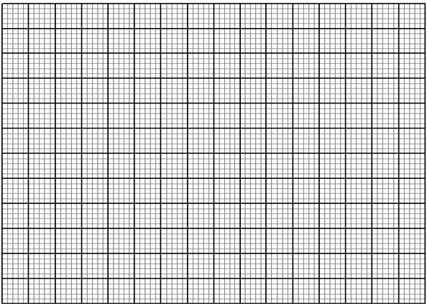
- Determine the slope, S of the graph (3 marks)
- The voltage and current are related by the equation: 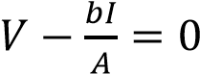
Determine the value of . (2 marks)
𝑏 = .............................................
QUESTION TWO
You are provided with the following apparatus:
- Complete retort-stand (clamp, boss and stand) • Four 100g masses (or its equivalent)
- Half metre-rule • Some celotape
- ^{Metre-rule} • Vernier calipers (to be shared)
- ^{G-clamp} • String/thread ( about 30 cm long )
- Office pin • One 50g mass
- Knife-edge
PART A
Proceed as follows:
- Arrange the apparatus as shown in figure 2, below. Ensure the 10 cm mark of the half metre-rule is at the edge of the table and firmly held by the G-clamp while the pin (pointer) is at the 90 cm mark on the scale of the metre-rule. (The clamp should not be removed for the entire duration of carrying-out this experiment)

X

Load

Metre
-
rule

Half metre
-
rule

G
-
clamp

Table
-
top

clamp

support

Retort stand

Figure
2
- Suspend one 100 g mass at the 49.5 cm mark and record the new pointer reading, 𝑃₁
𝑃₁ =............................... (1 mark)
- Continue adding the load in 100 g steps, each time recording the pointer position. Ensure that the half metre-rule is not overloaded.
- Determine the amount of sagging, X and complete the table, 2 below. (6 marks)
Table 2
Mass (g) | Load (N) | Pointer position (cm) | Amount of sagging, X (m)
100
200
300
400
PART B
Procedure
- Use the Vernier calipers to determine the width, a and breadth, b of the half metre-rule

b

a

Half metre
-
rule

Figure 3
Width, a = ......................... cm | (1 mark)
breadth, b = ........................ cm | (1 mark)
- Using a loop of thread suspend the 50g mass at the 49.5cm mark on the half-metre rule.
- With the 50g mass fixed at that position adjust the position of the half-metre rule on the knife edge until

it balances h
orizontally as shown in figure 4
.
0

49.5

cm

50

g
50

Half metre
-
rule

Knife
-
edge

Y

X

Figure 4
- At the balance position, read off the length x and y and record in table 3.
- Using the values of x and y obtained in ‘h’ above, determine the weight, W of the half metre-rule
(3 marks)
W = ................................
- Move the suspended mass 2cm towards the centre of the rule and repeat parts (g) and (h) to obtain other values of x and y so as to complete table 3. (4 marks)
Table 3
Position of the mass of 50g | X (cm) | Y (cm)
49.5 cm mark
47.5 cm mark
45.5 cm mark
43.5 cm mark
41.5 cm mark
- Given that quantity, P is given by: 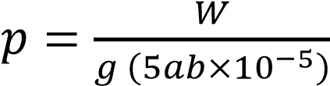; determine the value of P (3 marks)
- State the significance of the quantity, P (1 mark)
THIS IS THE LAST PRINTED PAGE

