Name: ………………………………………………………… Index No…………..…………….

Date………………Candidate’s Signature: ………..…….stream ....................Adm no..................

**232/1**

**PHYSICS**

**THEORY**

**Paper 1**

Time: 2 hours

**SEPTEMBER 2022**

**KIJISET 2022**

**Kenya Certificate of Secondary Education**

**PHYSICS**

**PAPER 1**

**Instructions to Candidates**

* *Write your name, admission number, class and signature in the spaces provided at the top of the page. This paper consists of two sections;* ***A*** *and* ***B.***
* *Answer* ***ALL*** *the questions in the spaces provided.*
* *Mathematical tables and electronic calculator may be used.*
* *All working MUST be clearly shown.*
* *This paper consists of* ***12*** *printed pages.*
* *Candidates should answer the questions in English and check to ensure that no question(s) is missing.*

**FOR EXAMINER’S USE ONLY**

|  |  |  |  |
| --- | --- | --- | --- |
| **SECTION** | **QUESTIONS** | **MAXIMUM SCORE** | **CANDIDATE’S SCORE** |
| **A** | 1 – 12 | 25 |  |
| **B** | 13 | 13 |  |
| 14 | 13 |  |
| 15 | 08 |  |
| 16 | 11 |  |
| 17 | 10 |  |
| **TOTAL SCORE** | | **80** |  |

***This paper consists of 12 printed pages. Candidates should check and ascertain that all questions are printed as indicated and that no questions are missing. TURN OVER***

**SECTION A (25 MARKS)**

***Answer all the questions in this section in the spaces provided.***

1. The Figure below shows part of a scale of vernier calipers. What is the reading indicted by the scale? (2 marks)

2 3

2. The Figure shows two match sticks placed on water in a basin a few centimeters apart.

**X**

Match sticks

State and explain the observation made when a drop of soap solution is placed at a point marked x. (2 marks)

………………………………………………………………………………………………………………………………………………………………………………………………………………………………………………………………………………………………………………………………………………………………………………………………………………………………………………………………

3. When a body of mass 0.35kg is acted upon by a force, its velocity changes from 3.5m/s to 6.0m/s.Determine the power developed by the force. (2marks)

………………………………………………………………………………………………………………………………………………………………………………………………………………………………………………………………………………………………………………………………………………

4. The figure below shows a path taken by a gas molecule moving from point x to z

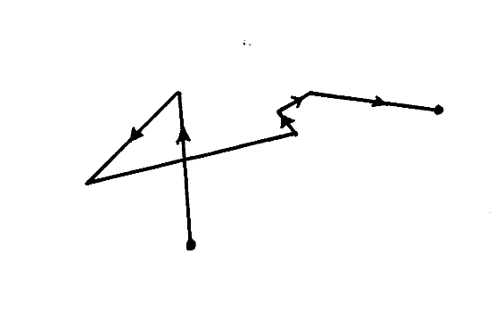

**X**

**Z**

(a) Explain how this movement can be observed (1 mark)

……………………………………………………………………………………………………………………………………………………………………………………………………………………………………………………………………………………………………………………………………

(b) State in full, the law of motion that governs movement from x to z (1 mark)

……………………………………………………………………………………………………………………………………………………………………………………………………………………………………………………………………………………………………………………………………

5. When the temperature of an enclosed gas at constant pressure is raised, the volume of the gas increases. Explain how the molecules of the gas causes the increase in volume. (2 marks)

………………………………………………………………………………………………………………………………………………………………………………………………………………………………………………………………………………………………………

6. State **two** factors that affect the spring constant of a spring. (2 marks)

…………………………………………………………………………………………………………………………………………………………………………………………………………………………………………………………………………………………………………………………………………………………………………………………………………………………………………………………………………………………………………………………………………………………………………………………………………………………………………………………………………

7.A crystal of potassium permanganate was carefully introduced at the bottom of water column held in a gas jar. After sometime, the whole volume of water was coloured. Explain this observation. (2 marks)

8. An empty density bottle weighs 25g when empty and 65g when full of a liquid of density 800kg/m3. Determine the volume of the bottle. (3 marks)

……………………………………………………………………………………………………………………………………………………………………………………………………………………………………………………………………………………………………………………………………………………………………………………………………………………………………………………………………………………………………………………………………………………

9. Figure below shows a uniform rod 4m long and of mass 2kg. It is pivoted 1m from one end and balanced horizontally by a string attached near the other end.



Determine the position where a mass of 5kg should be placed on the rod so that the rod remains horizontal and the tension in the string is zero. (3 marks)

………………………………………………………………………………………………………………………………………………………………………………………………………………………………………………………………………………………………………………………………………………………………………………………………………………………………………………………………

10.Water flows steadily along a horizontal pipe at a volume rate of m3/s. if the area of cross-section of the pipe is 20 cm2. Calculate the velocity of the fluid. (2mks)

………………………………………………………………………………………………………………………………………………………………………………………………………………………………………………………………………………………………………………………………………………………………………………………………………………………………………………………………

11. State anytwo states of equilibrium. (2 marks)

……………………………………………………………………………………………………………………………………………………………………………………………………………………………………………………………………………………………………………………………………

12.A stop watch started 0.5s after the start button was pressed. The time recorded using the stop watch for a ball falling through a liquid was 2.53s. Determine the time of fall. (1 mark)

……………………………………………………………………………………………………………………………………………………………………………………………………………………………………………………………………………………………………………….....................................................................................................................................................

**SECTION B (55 MARKS)**

***Answer all the questions in this section in the spaces provided.***

13.(a) The moon goes round the earth at constant speed. Explain why it is true to say that the moon is accelerating. (1 mark)

……………………………………………………………………………………………………………………………………………………………………………………………………

(b) A string of negligible mass has a bucket tied at the end. The string is 60cm long and the bucket has a mass of 45g. The bucket is swung horizontally making 6 revolutions per second.

Calculate:

(i) The angular velocity. (2 mark)

…………………………………………………………………………………………………………………………………………………………………………………………………………………………………………………………………………………………………………………………………………………………………………………………………………

(ii) The centripetal acceleration. (2 marks)

……………………………………………………………………………………………………………………………………………………………………………………………………

(iii) The tension on the string. (2 marks)

……………………………………………………………………………………………………………………………………………………………………………………………………

(iv) The linear velocity. (1 mark)

………………………………………………………………………………………………………………………………………………………………………………………………………………………………………………………………………………………………… (c) Figure below shows of mass m = 200g attached to the centre of a rotating table with a string. The radius of the spring was varied and different values of angular velocity recorded. The mass of the body remained constant throughout the experiment.

r

String

The results obtained for angular velocity and radius were used to plot the following graph.

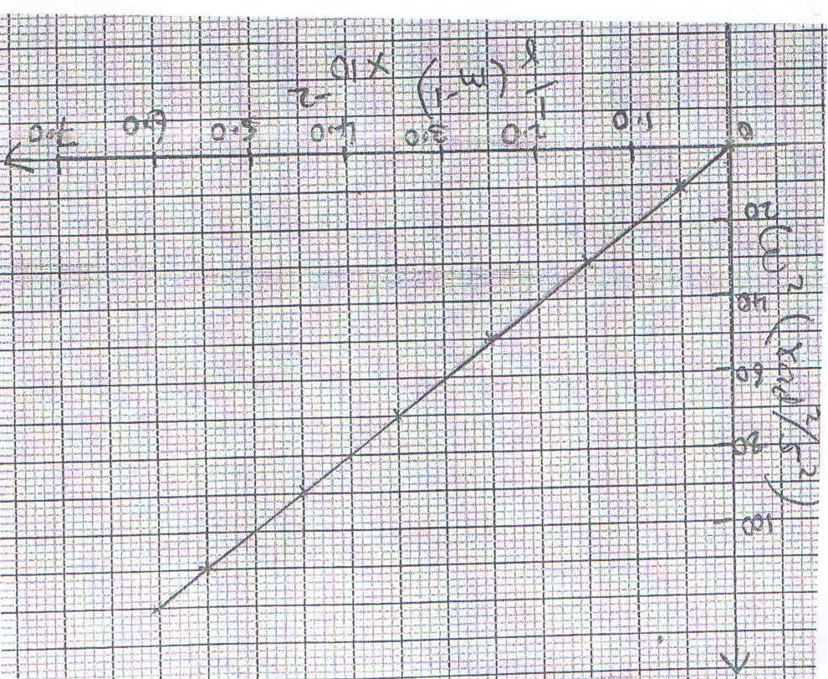

From the graph above;

(i) Calculate the value of the slope. (2 marks)

…………………………………………………………………………………………………………………………………………………………………………………………………………………………………………………………………………………………………………………………………………………………………………………………………………

(ii) If 2 and are related by the equation; $ω^{2}=\frac{p}{r} x\frac{1}{m},$ find the value of P. (2 marks)

…………………………………………………………………………………………………………………………………………………………………………………………………………………………………………………………………………………………………………………………………………………………………………………………………………

(iii) State the significance of **P**. (1 mark)

……………………………………………………………………………………………………………………………………………………………………………………………………....................................................................................................................................................

14. (a) Sketch a block and tackle pulley system with three movable pulleys in the lower block and two fixed pulleys in the upper block. (2marks)

(b) Find:

(i) Velocity ratio (V.R.) (1mark)

........................................................................................................................................................................................................................................................................................................................

(ii) An effort of 450 N is used to raise a load of 2700N.Determine:

1. Mechanical advantage (M.A) (2marks)

............................................................................................................................................................................................................................................................................................................................................................................................................

1. Efficiency of the pulley system. (2marks)

............................................................................................................................................................................................................................................................................................................................................................................................................

(iii) All the wasted energy is used to raise the lower block and to overcome frictional force between the pulleys and moving parts; determine the weight of the lower block if the frictional forceis 3.6N. (2marks)

....................................................................................................................................................................................................................................................................................................................................................................................................................................................................................

(c) If the load moved through a distance of 50cm, determine the useful work done by the effort. (3marks)

....................................................................................................................................................................................................................................................................................................................................................................................................................................................................................

(d) John applied a force of 400N in pushing a stationery wall. If he took one hour to push the wall, calculate the power developed. (1mk)

.............................................................................................................................................................................................................................................................................................................................................

15. (a) State the law of floatation (1 Mark)

..........................................................................................................................................................................................................................................................................................................................

(b) The diagram below shows a wooden block of dimensions 50cm by 40cm by 20cm held in a position by a string attached to the bottom of a swimming pool.

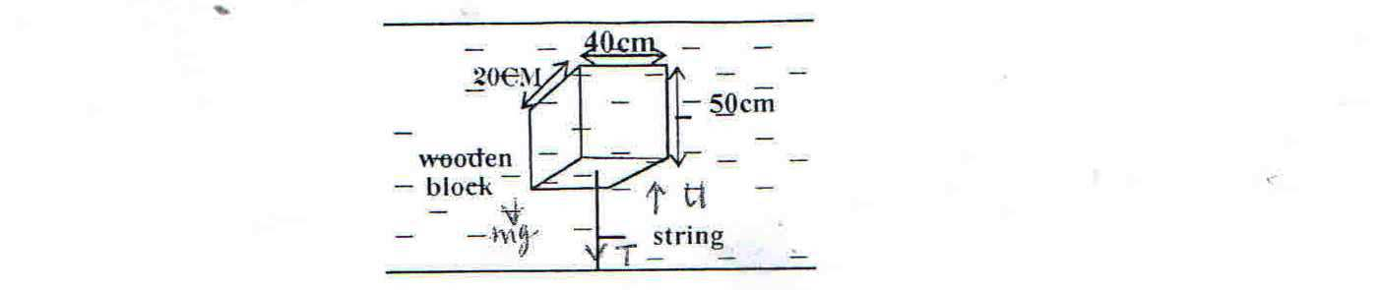

The three forces acting on the block are tension (T) in the string, the weight (W) of the block and upthrust (U) due to water.

1. Write an equation relating T, W and U when the block is at stationary. (1 Mark)

...................................................................................................................................................................................................................................................................................................................................

1. What is the weight of the block? (2 Mks)
2. What is the weight of the water displaced by the block? (3 Mks)
3. Determine the tension (T) on the string. (Density of the block is 600Kgm-3 and Density of water is 1000 Kgm-3) (1 Mark)

16. (a) The figure below shows a set-up that may be used to verify Charles’ law.

Dry air

Drop of sulphuric acid

Millimeter scale

Water bath

Thermometer

Heat

(i) State the measurements that should be taken in the experiment. (2 marks)

........................................................................................................................................................................................................................................................................................................................................................................................................................................................................................................................

(ii) Explain how the measurements taken in (i) above may be used to verify Charles’ law. (2 marks)

........................................................................................................................................................................................................................................................................................................................................................................................................................................................................................................................

(iii) A certain mass of hydrogen gas occupies a volume of 1.6cm3 at a pressure of 1.5 x 105 pa and temperature of 12o C. Determine its volume when the temperature is 0oC at a pressure of 1.0 x 105 pa. (2 marks)

................................................................................................................................................................................................................................................................................................................................................................................................................................................................................................................................................................................................................................................................................................

(b) (i) An electric kettle connected to a 250V mains supply draws a current of 4.0A. It contains 1 litre of water with 1 kg of ice, all at 00C. Neglecting all heat losses, including heat absorbed by the kettle, find the time taken for all the ice to be just melted. (Take specific latent heat of fusion to be 3.34 x 105 J/kg and latent heat of vaporization is 2.26 x 106 J/kg Specific heat capacity of water is 4.2J/g). (2 marks)

........................................................................................................................................................................................................................................................................................................................................................................................................................................................................................................................ ........................................................................................................................................................................

(ii) Determine the time taken until half the contents of the kettle boils away.(3 marks)

........................................................................................................................................................................................................................................................................................................................................................................................................................................................................................

17. (a) The figure below shows a velocity – time graph of a body.

B

Velocity m/s

A

O

Time (s)

Describe the motion of the body between;

1. OA (1 mark)

………………………………………………………………………………………………………....................................................................................................................................

1. AB (1 mark

………………………………………………………………………………………………………....................................................................................................................................

(b) A simple pendulum is set swinging and the string is cut when the bob is at the Centre of its oscillation and 10cm above the ground. If the velocity of the bob is then 3m/s;

1. How long does the bob take to reach the ground? (2 marks)

……………………………………………………………………………………………………………………………..……………………………………………………………….……………………………………………………………..……………………………….

1. How far does the bob travel horizontally? (Assume g = 10m/s)

(2 marks)

……………………………………………………………………………………………………………………………..……………………………………………………………….

1. A and B represents parts of the ticker tape of a trolley run. Each successive tick represents a time interval of $\frac{1}{100}th$ second.

3.8 cm

1.6 cm

B

A

⦁⦁⦁⦁⦁⦁

⦁⦁⦁⦁⦁⦁

40 ticks

4 ticks

5 ticks

(I) Find the initial velocity in region A. (1 mark)

……………………………………………………………………………………………………………………………..………………………………………………………………..

(II) Find the final velocity in region B. (1 mark)

……………………………………………………………………………………………………………………………..……………………………………………………………….……………………………………………………………..……………………………….

(III)Hence find the average acceleration of the trolley.(2 marks) ……………………………..……………………………………………………………….……………………………..……………………………………………………………….……………………………..……………………………………………………………….

**END.**