NAME:………………………………………………… ADMISSION NO. ………………

CLASS: ……………………… SIGN:……………………………

443/2
AGRICULTURE
PAPER 2
TIME: 2 HOURS.
FORM 4 SUKELLEMO JOINT PRE – MOCK EXAMS 2023

Kenya Certificate of Secondary Education (K.C.S.E)

INSTRUCTIONS TO CANDIDATES

Write your name and admission number in the spaces provided.

Answer ALL the questions in this question paper.

All your answers must be written in the spaces provided in this question paper.

Candidates should check the question paper to ensure that all pages are printed as indicated and no questions are missing.

For Examiners Use Only
SECTION | Maximum Score | Candidates Score
A | 30
B | 20
C | 40
Total Score 90

SECTION A (30 MARKS)

Answer all questions in this section in the spaces provided.

1. State four reasons why farmers should keep livestock healthy. (2marks)

-------------------------------------------------------------------------------------------------------------------------------

2. State four reasons for maintaining a panga in good working condition. (2marks)

-------------------------------------------------------------------------------------------------------------------------------

-------------------------------------------------------------------------------------------------------------------------------

-------------------------------------------------------------------------------------------------------------------------------

3. Give one function of each of the following tools
(a) Pipe wrench ---------------------------------------------------------------
(b) Milk churn------------------------------------------------------------------
(c) secateurs -------------------------------------------------------------------
(d) Bolus gun-------------------------------------------------------------------

4. State four advantages of deep litter system of rearing poultry. (2marks)
-------------------------------------------------------------------------------------------------------------------------------

-------------------------------------------------------------------------------------------------------------------------------
-------------------------------------------------------------------------------------------------------------------------------
5. Distinguish between carrying capacity and stocking rate as used in livestock production.(1mark)
-------------------------------------------------------------------------------------------------------------------------------
-------------------------------------------------------------------------------------------------------------------------------
6. Give two reasons for carrying out tooth clipping in piglets. (1mark)

-------------------------------------------------------------------------------------------------------------------------------
-------------------------------------------------------------------------------------------------------------------------------
7. Name the intermediate hosts in following parasites. (1mark)
(a) Tapeworm --------------------------------------------------------------------------------------------------

(b) Liver fluke.--------------------------------------------------------------------------------------------------

8. State four factors that determine amount of food given to an animal per day. (2marks)

-----------------------------------------------------------------------------------------------------------------------------

------------------------------------------------------------------------------------------------------------------------------

9. State four qualities of good wool (2marks)

-------------------------------------------------------------------------------------------------------------------------------

-------------------------------------------------------------------------------------------------------------------------------

10. Give two advantages of using spray race over plunge dips. (1mark)

-------------------------------------------------------------------------------------------------------------------------------

-------------------------------------------------------------------------------------------------------------------------------
11. State four characteristics of light breeds of poultry (2marks)

-------------------------------------------------------------------------------------------------------------------------------

-------------------------------------------------------------------------------------------------------------------------------

12. Define the term prepotency as used in livestock production. (2marks)

-------------------------------------------------------------------------------------------------------------------------------
-------------------------------------------------------------------------------------------------------------------------------
-------------------------------------------------------------------------------------------------------------------------------

13. State four properties of a good vaccine. (2marks)

-------------------------------------------------------------------------------------------------------------------------------
-------------------------------------------------------------------------------------------------------------------------------
-------------------------------------------------------------------------------------------------------------------------------
-------------------------------------------------------------------------------------------------------------------------------
14. Highlight four qualities of eggs for incubation. (3marks)

-------------------------------------------------------------------------------------------------------------------------------
-------------------------------------------------------------------------------------------------------------------------------
-------------------------------------------------------------------------------------------------------------------------------
-------------------------------------------------------------------------------------------------------------------------------
-------------------------------------------------------------------------------------------------------------------------------

15. State four post milking practices. (2marks)
-------------------------------------------------------------------------------------------------------------------------------
-------------------------------------------------------------------------------------------------------------------------------
-------------------------------------------------------------------------------------------------------------------------------
-------------------------------------------------------------------------------------------------------------------------------
16. State two predisposing factors of foot rot disease in sheep. (1mark)
-------------------------------------------------------------------------------------------------------------------------------
-------------------------------------------------------------------------------------------------------------------------------
-------------------------------------------------------------------------------------------------------------------------------
17. State four factors that influence the composition of milk. (2marks)
-------------------------------------------------------------------------------------------------------------------------------
-------------------------------------------------------------------------------------------------------------------------------
-------------------------------------------------------------------------------------------------------------------------------
-------------------------------------------------------------------------------------------------------------------------------
18. State four control measures of feats in poultry. (2marks)
-------------------------------------------------------------------------------------------------------------------------------
-------------------------------------------------------------------------------------------------------------------------------
-------------------------------------------------------------------------------------------------------------------------------

SECTION B (20MARKS)
Answer all questions in this section in the spaces provided.

19. The following diagram shows the productive system of a hen. Study it and answer the questions that follow.

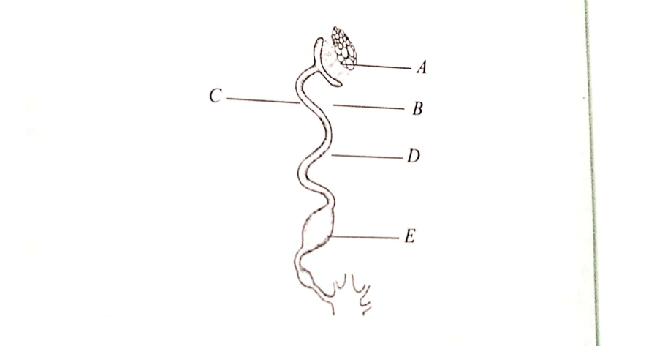
(a) Name the parts labelled A, C, D and E (2marks)

A -----------------------------------------------------------------

C -------------------------------------------------------------------

D -------------------------------------------------------------------

E -------------------------------------------------------------------

(b) State the function of the part labelled C and E (2marks)

C ------------------------------------------------------------------

E ------------------------------------------------------------------

(c) What is the role of the part labelled A (1mark)
-------------------------------------------------------------------------------------------------------------------------------
-------------------------------------------------------------------------------------------------------------------------------
-------------------------------------------------------------------------------------------------------------------------------
20. The following illustrations shows parasites which transmit diseases in livestock. Study them and answer the questions that follow.

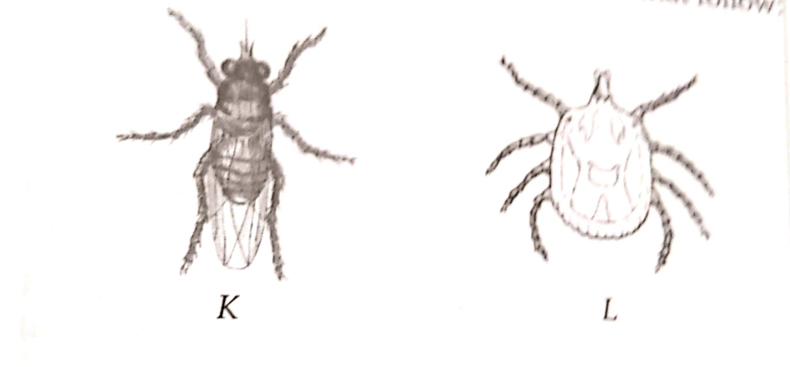

(a) Identify the parasites labelled K and L (2marks)

K -----------------------------------------------------------

L -------------------------------------------------------------
(B) In each case, name one disease transmitted by the parasites K and L in cattle. (2marks)

K ---------------------------------------------------------------

L ----------------------------------------------------------------
(c) State two control measures of parasite labelled K. (2marks)
-------------------------------------------------------------------------------------------------------------------------------
------------------------------------------------------------------------------------------------------------------------------
-------------------------------------------------------------------------------------------------------------------------------
-------------------------------------------------------------------------------------------------------------------------------

21. Use the information to answer the questions that follow.

Feed stuff | Protein
Q | 10%
Y | 60%

(A) Formulate a ration of 200kg containing 15% protein using Q and Y as ingredients using the persons square method. (4marks)
-------------------------------------------------------------------------------------------------------------------------------------------------------------------------------------------------------------------------------------------------------------
----------------------------------------------------------------------------------------------------------------------------------------------------------------------------------------------------------------------------------------------------------------------------------------------------------------------------------------------------------------------------------------------------------------------------------------------------------------------------------------------------------------------------------------------------------------------------------------------------------------------------------------------------------------------------------------------------------------------------------------------------------
22. The diagram below shows activity carried out by a poultry farmer keeping layers. Study the diagram carefully and answer the questions that follow.
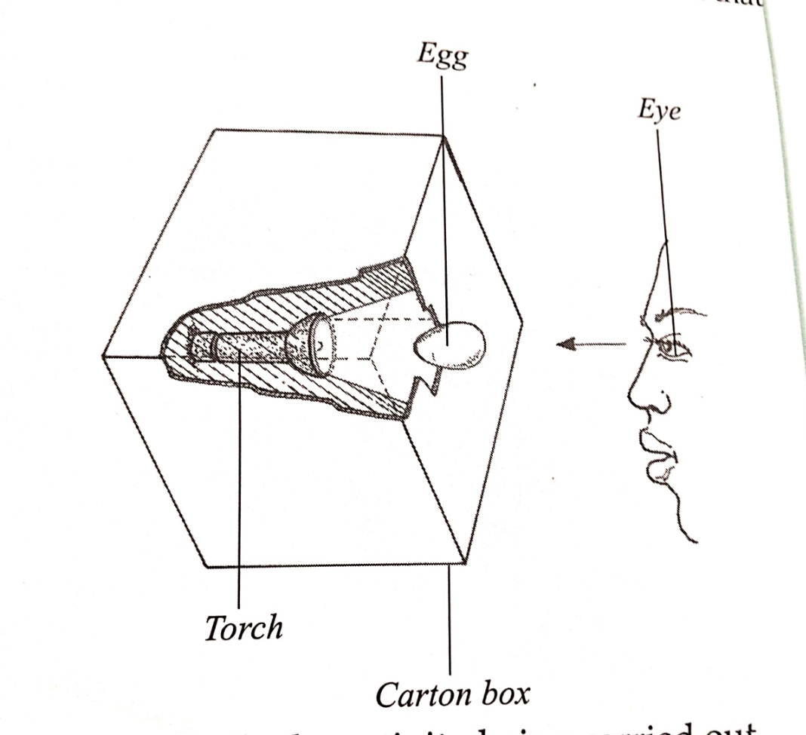

(a) Identify the activity being carried out (1mark)
----------------------------------------------------------------------------------------------------------------------------------------
--------------------------------------------------------------------------------------------------------------------------------------------
(b) Give four abnormalities in the eggs that can be detected during the above activity. (4marks)
--------------------------------------------------------------------------------------------------------------------------------------------------------------------------------------------------------------------------------------------------------------------------------------------------------------------------------------------------------------------------------------------------------------------------------------------------------------------------------------------------------------------------------------------------------------------------------------------------------------------------------------------------------------------------------------------------------------------------------------------------------------------------------------------------------------------------------------------------------------------------------------------------------------------------------------------------------------------------------------------------------------------------------------------------------------

SECTION C ( 40 marks)
ANSWER ANY TWO QUESTIONS IN THIS SECTION IN THE PACES PROVIDED.
23(A) Describe the outline management practices carried out on calves up to wearing (12marks)

(b) Explain the practices observed in clean milk production. (8marks)

24. (a) Describe the procedure of harvesting fish in a fish pond. (7marks)
(b)Give five practices carried out on fish before preservation (5marks)
(c) Describe the feeding of fish in a fish pond. (4marks)
(d) Explain the stocking of fish in fish pond (4marks)

25.a) Discuss the fowl typhoid disease under the following sub headings.
(i) Causal organism (1mark)
(ii) Animal attacked (1mark)
(iii) Symptoms (6marks)
(iv)Control measures (2marks)
(b) (i) Explain six precautions observed when handling bees. (6marks)
(ii) Explain four factors considered when siting an apiary. (4marks)

------------------------------------------------------------------------------------------------------------------------------------------------------------------------------------------------------------------------------------------------------------------------------------------------------------------------------------------------------------------------------------------------------------------------------------------------------------------------------------------------------------------------------------------------------------------------------------------------------------------------------------------------------------------------------------------------------------------------------------------------------------------------------------------------------------------------------------------------------------------------------------------------------------------------------------------------------------------------------------------------------------------------------------------------------------------------------------------------------------------------------------------------------------------------------------------------------------------------------------------------------------------------------------------------------------------------------------------------------------------------------------------------------------------------------------------------------------------------------------------------------------------------------------------------------------------------------------------------------------------------------------------------------------------------------------------------------------------------------------------------------------------------------------------------------------------------------------------------------------------------------------------------------------------------------------------------------------------------------------------------------------------------------------------------------------------------------------------------------------------------------------------------------------------------------------------------------------------------------------------------------------------------------------------------------------------------------------------------------------------------------------------------------------------------------------------------------------------------------------------------------------------------------------------------------------------------------------------------------------------------------------------------------------------------------------------------------------------------------------------------------------------------------------------------------------------------------------------------------------------------------------------------------------------------------------------------------------------------------------------------------------------------------------------------------------------------------------------------------------------------------------------------------------------------------------------------------------------------------------------------------------------------------------------------------------------------------------------------------------------------------------------------------------------------------------------------------------------------------------------------------------------------------------------------------------------------------------------------------------------------------------------------------------------------------------------------------------------------------------------------------------------------------------------------------------------------------------------------------------------------------------------------------------------------------------------------------------------------------------------------------------------------------------------------------------------------------------------------------------------------------------------------------------------------------------------------------------------------------------------------------------------------------------------------------------------------------------------------------------------------------------------------------------------------------------------------------------------------------------------------------------------------------------------------------------------------------------------------------------------------------------------------------------------------------------------------------------------------------------------------------------------------------------------------------------------------------------------------------------------------------------------------------------------------------------------------------------------------------------------------------------------------------------------------------------------------------------------------------------------------------------------------------------------------------------------------------------------------------------------------------------------------------------------------------------------------------------------------------------------------------------------------------------------------------------------------------------------------------------------------------------------------------------------------------------------------------------------------------------------------------------------------------------------------------------------------------------------------------------------------------------------------------------------------------------------------------------------------------------------------------------------------------------------------------------------------------------------------------------------------------------------------------------------------------------------------------------------------------------------------------------------------------------------------------------------------------------------------------------------------------------------------------------------------------------------------------------------------------------------------------------------------------------------------------------------------------------------------------------------------------------------------------------------------------------------------------------------------------------------------------------------------------------------------------------------------------------------------------------------------------------------------------------------------------------------------------------------------------------------------------------------------------------------------------------------------------------------------------------------------------------------------------------------------------------------------------------------------------------------------------------------------------------------------------------------------------------------------------------------------------------------------------------------------------------------------------------------------------------------------------------------------------------------------------------------------------------------------------------------------------------------------------------------------------------------------------------------------------------------------------------------------------------------------------------------------------------------------------------------------------------------------------------------------------------------------------------------------------------------------------------------------------------------------------------------------------------------------------------------------------------------------------------------------------------------------------------------------------------------------------------------------------------------------------------------------------------------------------------------------------------------------------------------------------------------------------------------------------------------------------------------------------------------------------------------------------------------------------------------------------------------------------------------------------------------------------------------------------------------------------------------------------------------------------------------------------------------------------------------------------------------------------------------------------------------------------------------------------------------------------------------------------------------------------------------------------------------------------------------------------------------------------------------------------------------------------------------------------------------------------------------------------------------------------------------------------------------------------------------------------------------------------------------------------------------------------------------------------------------------------------------------------------------------------------------------------------------------------------------------------------------------------------------------------------------------------------------------------------------------------------------------------------------------------------------------------------------------------------------------------------------------------------------------------------------------------------------------------------------------------------------------------------------------------------------------------------------------------------------------------------------------------------------------------------------------------------------------------------------------------------------------------------------------------------------------------------------------------------------------------------------------------------------------------------------

