Name……………………………………………………… Index No………………………..
231/1
BIOLOGY Date……………………………
(Theory)S
Sign……………………………
2 hours

SUKELEMO JOINT EXAMINATIONS–2023

(Kenya Certificate of Secondary Education)

Instructions

- Write your Name and Index Number in the spaces provided above.
- Write the date of the examination in the space provided above.
- Answer all the questions in the spaces provided.

For Examiner’s use only

Question | Maximum Score | Candidate’s Score
1-29 | 80

This paper consists of 9 printed pages.
Candidates should check the question paper to ascertain that all the pages are printed as indicated and no questions are missing.

1.Students at Ikumbi high school observed that when sodium chloride was poured onto grass ,the grass dried up. Explain this this observation. (2mks)
The external environment becomes hypertonic compared to the internal tissues of the leaves ;the leaves looses water by osmosis making them unable to carry out vital biological processes such as photosynthesis(hence dry up)
2.Explain why food is stored in an insoluble form in the cells of living things. (2mks)
To prevent formation of solution ;which would interfere with osmotic osmotic pressure of tissues.
3. (a)Name the blood vessel that connects arteries to vein. (1mk)
Cappilaries
(b) Explain three ways in which the vessel named in (a) above are adapted to carry out their functions. (3mks)
Numerous to increase the surface area over which diffusion and active transport of substances occur
Thin walled/one cell thick to reduce distance over which exchange of substances occur
Narrow lumen to enhance ultra-filtration
Have small pores for the passage of materials
(TIED TO PART (a))

4. How does hot water of about 35⁰C act as a pollutant when it is discharged from industries into rivers? (2mks)
It reduces the solubility of gases in water/reduces amount of dissolved gases.
5. Explain how the following factors hinder self pollination in plants:
(i) Protogyny (1mk)
Stigma matures earlier and is ready to receive pollen grains before the anthers ready .
(ii) Dioecism (1mk)
Male and female gametes occur in separate plants
6. Name the causative agents of the following diseases in humans. (2mks)
(a). Amoebic dysentery.
Entamoba histolitica;
(b). Candidiasis.
Candida albicans

7. a) Define the term immunity. (1mk)
Ability of the body to identify /recognize foreign antigens and develop mechanisms of destroying them/ability to resist infection;
b) Distinguish between natural immunity and acquired immunity. (1mk)
Natural immunity is inborn/inherited/passed from parents to offspring while acquired immunity is obtained in life
c) Identify one immunizable disease in Kenya. (1mk)
Tuberculosis;poliomyelitis;diphtheria;whooping cough;measles;
8. What happens to glucose synthesized during photosynthesis. (2mks).
Used in respiration /produce energy
Converted to starch/lipids/sucrose/proteins and stored
9. Give two advantages of polyploidy in plants. (2mks).
Early maturity
High yields
Resistant to pests and diseases/drought
10. The diagram below illustrates part of a nephron from a mammalian kidney.
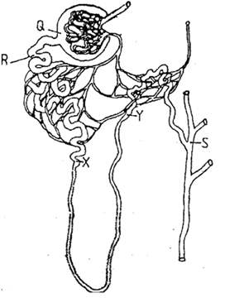

a) Name the fluid found in the part labeled Q. (1mk)
Glomerular filtrate;
b) Identify the process responsible for the formation of the fluid named in (a) above. (1mk)
Ultra- filtration/pressure filtration

c) Which two hormones exert their effect in the nephron? (2mks)
Antidiuretic hormone/vasopressin;
Aldosterone;
11.Describe double fertilization in flowering plants. (4mks)
One male nucleus fuse with an egg cell;to form a diploid zygote;while the other fuse with the two polar nuclei;to form a triploid endosperm nucleus;
12. Explain how blood sugar level is maintained constant in human blood (3mks)
When in excess, insulin,is produced to make liver cells convert the excess to glycogen
When less,glucagon,is produced to make liver cells convert stored glycogen to glucose
13. State two unique characteristics of members of the class crustacea . (2mks)
Two pairs of antennae
Body covered with carapace
14. How is mammalian skin adapted for excretion (3mks)
Has sweat glands which collects water and salts;
Has sweat pores through which water,salts and urea pass out;
15.The paddles of whales and the fins of fish adapt these organisms to aquatic habitats.

a) Name the evolutionary process that may have given rise to these structures. (1mk)
Convergent evolution
b) What is the name given to such structures? (1mk)
Analogous structures
16. The diagram below show part of a food relationship in an ecosystem
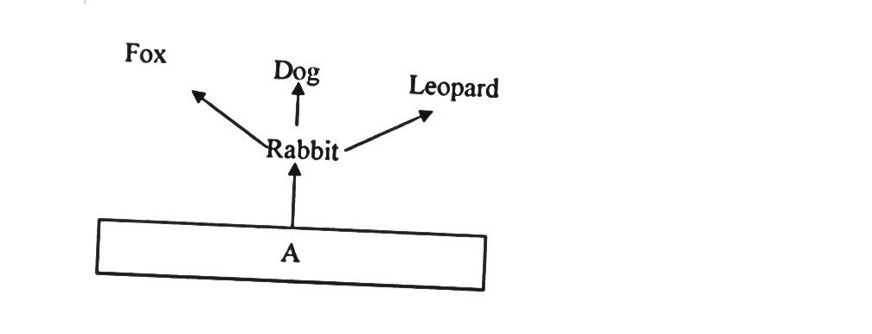

- Name the food relationship shown in the diagram (1mk)
Food chain
- Name the trophic level occupied by organism A (1mk)
Primary consumer

What is the main source of energy in the ecosystem shown in the diagram above (1mk)
The sun/sunlight

17.a) Name a protein and vitamin involved in blood clotting.
i) Protein. (1mk)
Fibrinogen
ii) Vitamin (1mk)
Vitamin K

( b ). Explain why blood from a donor whose blood group is A cannot be transfused into the recipient whose blood group is B. (2mks)
Recipient has antibody a in the blood plasma and will correspond with antigen A in the donors;hence there will be antigen –antibody reaction/agglutination;
18.(a). State two effects of Gibberellins on shoots of plants. (2mks)
Promotes cell division;
Promotes cell elongation;
Promotes parthenocarpy

(b). Account for loss in dry weight of cotyledons in a germinating bean seed. (1mk).
Food stored is used for respiration /growth;
19. Explain why a pregnant woman excretes less urea compared to a woman who is non pregnant. (2mks)
Amino acids are used in the formation of foetal tissues;thus has less excess to be eliminated;
20.Study the reaction below and answer the questions that follow.
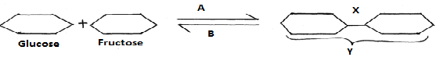
a) What biological processes are represented by A and B? (2mks)
A Condensation
B Hydrolysis
b) Identify the product Y. (1mk)
Sucrose;

c) State the bond represented by X. (1mk)
Glycosidic;

21.Explain what happens during the light stage of photosynthesis. (3mks)
Light energy is absorbed by chlorophyll molecules ;used to split water molecules into oxygen and hydrogen atoms/ions ;light energy is converted into chemical energy(ATP) and stored;

22. State two characteristics of aerenchyma tissue. (2mks).
Has thin cell wall;
Has large air spaces;
23. (a). Name the substance that accumulates in muscles when respiration occurs with insufficient oxygen. (1mk).
Lactic acid;
(b). Give the end products of anaerobic respiration in plants. (2mks).
Ethanol; rej Alcohol
Carbon (IV) Oxide;
Energy;
24. What is the importance of carrying out the following procedures when preparing temporary slides in the laboratory? (3mks).
(a). Adding water to the specimen.
To make the specimen turgid;/prevent dehydration
(b).Staining the specimen.
To make cell dinstinct/more clearer
(c ). Using a sharp blade to make sections.
To prevent distortation of tissues

25. In an experiment the shoot tip of a young tomato plant was decapitated as shown in the diagram below
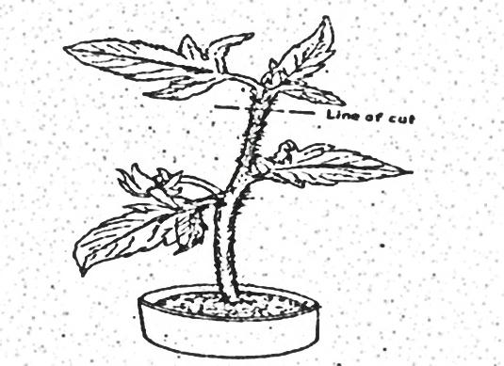

- State the expected results after 2 weeks (1mk)
Auxillary/lateral buds sprot/branches will be formed
- Give a reason for your answer in (a) above (2mks)
Decapitation removes the hormone /auxins/IAA which is produced in the terminal bud/the stem tip;remove of the auxin/hormone/IAA promote branch/development of auxillary lateral buds.
26. Name two internal factors that necessary for seed germination. (2mks)
Enzymes;
Hormones;
Viability
27.Certain animals have the following dental formula
A; i 3/3, c 1/1, pm 4/4, m 2/3 B. i 0/3 , c 0/1 , pm 2/2 , m 3/3
- What is the most likely mode of feeding for animals A and B. (2mks)
A .Carnivorous; reject carnivore
B .Herbivorous;rej,herbivore
- Give a reason for your answer in (i) above. (1mk)
Absence of upper insisors
28. Name the components of a DNA molecule. (3mks)
A five carbon sugar/Deoxyribose sugar
A phosphate molecule
A nitrogenous base
29. A horse has 64 chromosomes in its somatic cells while a donkey has 62.A mule is produced produced when a horse mates with a donkey.
a. Work out the number of chromosomes in a mule ,show your working. (2mks)

b. Why is a mule sterile (1mk)
……………………………………………………………………………………………………………………………………………………………………………………………………………………

