Name……………………………………………………… Index No………………………..
231/1
BIOLOGY Date……………………………
(Theory)S
Sign……………………………
2 hours

SUKELEMO JOINT EXAMINATIONS–2023

(Kenya Certificate of Secondary Education)

Instructions

- Write your Name and Index Number in the spaces provided above.
- Write the date of the examination in the space provided above.
- Answer all the questions in the spaces provided.

For Examiner’s use only

Question | Maximum Score | Candidate’s Score
1-29 | 80

This paper consists of 9 printed pages.
Candidates should check the question paper to ascertain that all the pages are printed as indicated and no questions are missing.

1.Students at Ikumbi high school observed that when sodium chloride was poured onto grass ,the grass dried up. Explain this this observation. (2mks)
………………………………………………………………………………………………………………………………………………………………………………………………………………………………………………………………………………………………………………………
2.Explain why food is stored in an insoluble form in the cells of living things. (2mks)
………………………………………………………………………………………………………………………………………………………………………………………………………………
3. (a)Name the blood vessel that connects arteries to vein. (1mk)
………………………………………………………………………………………………………
(b) Explain three ways in which the vessel named in (a) above are adapted to carry out their functions. (3mks)
………………………………………………………………………………………………………………………………………………………………………………………………………………………………………………………………………………………………………………………………………………………………………………………………………………………………………………………………………………………………………………………………………………………………………………………………………………………………………………

4. How does hot water of about 35⁰C act as a pollutant when it is discharged from industries into rivers? (2mks)
………………………………………………………………………………………………………………………………………………………………………………………………………………………………………………………………………………………………………………………

5. Explain how the following factors hinder self pollination in plants:
(i) Protogyny (1mk)
………………………………………………………………………………………………………………………………………………………………………………………………
(ii) Dioecism (1mk)
………………………………………………………………………………………………………………………………………………………………………………………………
6. Name the causative agents of the following diseases in humans. (2mks)
(a). Amoebic dysentery.
………………………………………………………………………………………………………
(b). Candidiasis.
……………………………………………………………………………………………………….

7. a) Define the term immunity. (1mk)
………………………………………………………………………………………………………...............................................................................................................................................
b) Distinguish between natural immunity and acquired immunity. (1mk)
……………………………………………………………………………………………………………………………………………………………………………………………………………………………………………………………………………………………………..
c) Identify one immunizable disease in Kenya. (1mk)
…………………………………………………………………………………………….
8. What happens to glucose synthesized during photosynthesis. (2mks).
……………………………………………………………………………………………………………………………………………………………………………………………………………………………………………………………………………………………………………………………
9. Give two advantages of polyploidy in plants. (2mks).
…………………………………………………………………………………………………………………………………………………………………………………………………………………………………………………………………………………………………………………
10. The diagram below illustrates part of a nephron from a mammalian kidney.
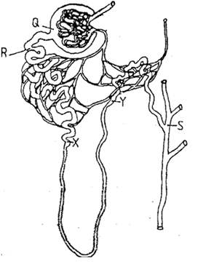

a) Name the fluid found in the part labeled Q. (1mk)
……………………………………………………………………………………
b) Identify the process responsible for the formation of the fluid named in (a) above. (1mk)
………………………………………………………………………………………………………
c) Which two hormones exert their effect in the nephron? (2mks)
…………………………………………………………………………………………………………………………………………………………………………………………………………………………………………………………
11.Describe double fertilization in flowering plants. (4mks)
………………………………………………………………………………………………………………………………………………………………………………………………………………………………………………………………………………………………………………………………………………………………………………………………………………………………………………………………………………………………………………………………………………………………………………………………………………………………………………………………………………………………………………………………………………………
12. Explain how blood sugar level is maintained constant in human blood (3mks)
………………………………………………………………………………………………………………………………………………………………………………………………………………………………………………………………………………………………………………………………………………………………………………………………………………………………………………………………………………………………………………………………………
13. State two unique characteristics of members of the class crustacea . (2mks)
………………………………………………………………………………………………………………………………………………………………………………………………………………
14. How is mammalian skin adapted for excretion (3mks)
………………………………………………………………………………………………………………………………………………………………………………………………………………………………………………………………………………………………………………………………………………………………………………………………………………………………

15.The paddles of whales and the fins of fish adapt these organisms to aquatic habitats.

a) Name the evolutionary process that may have given rise to these structures. (1mk)
……………………………………………………………………………………………
……………………………………………………………………………………………
b) What is the name given to such structures? (1mk)
………………………………………………………………………………………………
………………………………………………………………………………………………16. The diagram below show part of a food relationship in an ecosystem
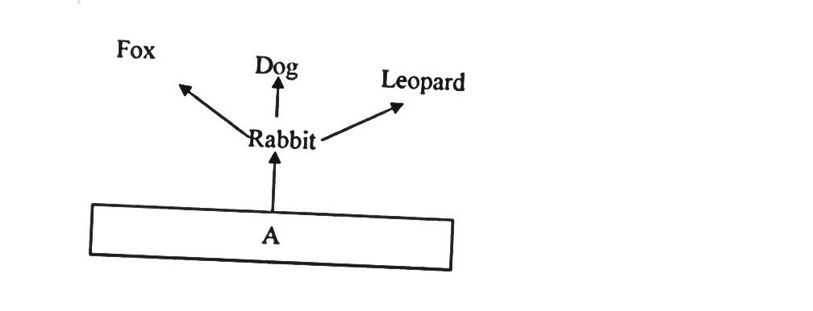

- Name the food relationship shown in the diagram (1mk)
..…………………………………………………………………………………
- Name the trophic level occupied by organism A (1mk)
………………………………………………………………………………………
- What is the main source of energy in the ecosystem shown in the diagram above (1mk)
............................................................................................................................................................
17.a) Name a protein and vitamin involved in blood clotting.
i) Protein. (1mk)
………………………………………………………………………………………………
ii) Vitamin (1mk)
………………………………………………………………………………………………

( b ). Explain why blood from a donor whose blood group is A cannot be transfused into the recipient whose blood group is B. (2mks)
……………………………………………………………………………………………..
……………………………………………………………………………………………..
……………………………………………………………………………………………..

18.(a). State two effects of Gibberellins on shoots of plants. (2mks)
………………………………………………………………………………………………………………………………………………………………………………………………………………………………………………………………………………………………………………………………………………………………………………………………………………………………………
(b). Account for loss in dry weight of cotyledons in a germinating bean seed. (1mk).
………………………………………………………………………………………………………………………………………………………………………………………………………………………………………………………………………………………………………………………

19. Explain why a pregnant woman excretes less urea compared to a woman who is non pregnant. (2mks)
................................................................................................................................................
................................................................................................................................................
...............................................................................................................................................
………………………………………………………………………………………………
20.Study the reaction below and answer the questions that follow.
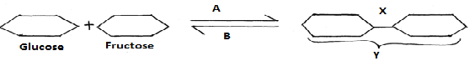
a) What biological processes are represented by A and B? (2mks)
A ................................................................................................................................
B .............................................................................................................................
b) Identify the product Y. (1mk)
................................................................................................................................................

c) State the bond represented by X. (1mk)
................................................................................................................................................

21.Explain what happens during the light stage of photosynthesis. (3mks)
................................................................................................................................................
................................................................................................................................................
................................................................................................................................................
................................................................................................................................................
................................................................................................................................................
22. State two characteristics of aerenchyma tissue. (2mks).
....................................................................................................................................................................................................................................................................................................................................................................................................................................................................................
23. (a). Name the substance that accumulates in muscles when respiration occurs with insufficient oxygen. (1mk). .……………………………………………………………………………………………
(b). Give the end products of anaerobic respiration in plants. (2mks).
………………………………………………………………………………………………………………………………………………………………………………………………………
24. What is the importance of carrying out the following procedures when preparing temporary slides in the laboratory? (3mks).
(a). Adding water to the specimen.
……………………………………………………………………………………………………
(b).Staining the specimen.
………………………………………………………………………………………………………
(c ). Using a sharp blade to make sections.
………………………………………………………………………………………………………

25. In an experiment the shoot tip of a young tomato plant was decapitated as shown in the diagram below
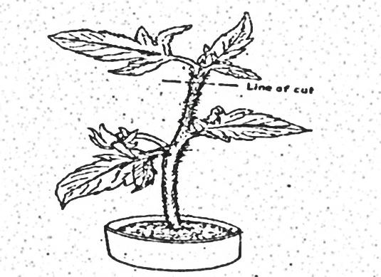

- State the expected results after 2 weeks (1mk)
………………………………………………………………………………………………
- Give a reason for your answer in (a) above (2mks)
………………………………………………………………………………………………………………………………………………………………………………………………
26. Name two internal factors that necessary for seed germination. (2mks)
………………………………………………………………………………………………………………………………………………………………………………………………………………………………………………………………………………………………………………………
27.Certain animals have the following dental formula
A; i 3/3, c 1/1, pm 4/4, m 2/3 B. i 0/3 , c 0/1 , pm 2/2 , m 3/3
- What is the most likely mode of feeding for animals A and B. (2mks)
………………………………………………………………………………………………………………………………………………………………………………………………………………………………………………………………………………
- Give a reason for your answer in (i) above. (1mk)
………………………………………………………………………………………………………………………………………………………………………………………………………………………………………………………………………………
28. Name the components of a DNA molecule. (3mks)
…………………………………………………………………………………………………………………………………………………………………………………………………………………………………………………………………………………………………………………………………………………………………………………………………………………..

29. A horse has 64 chromosomes in its somatic cells while a donkey has 62.A mule is produced produced when a horse mates with a donkey.
a. Work out the number of chromosomes in a mule ,show your working. (2mks)

b. Why is a mule sterile (1mk)
………………………………………………………………………………………………………………………………………………………………………………………………………………

