Name____________________________________________________ Index No. __________________
Candidate’s signature ________
Date _______________________

231/3
BIOLOGY
PAPER 3
PRACTICAL
1 ¾ HOURS

FORM 4 SUKELLEMO JOINT PRE-MOCK EXAMS 2023
Kenya Certificate of Secondary Education (K.C.S.E)

INSTRUCTIONS TO CANDIDATES
Answer ALL the questions in the spaces provided in the question paper.
You are supposed to spend the first 15 minutes to read the whole paper carefully before commencing your work.

FOR EXAMINERS USE ONLY
Questions | Total marks | Candidates score
1 | 16
2 | 13
3 | 11
Total score | 40

This paper consists of 5 printed pages

Turn Over

1. You are provided with solution labelled L, a piece of visking tubing, some string, four
test tubes, a beaker a white tile and these reagents iodine solution and Benedict’s solution.

- Using the appropriate reagents, carry out food tests to identify the food substances
contained in L. Outline procedure used and record your observation and conclusions
in the table below. (6 marks)

Food substance | Procedure | Observations | Conclusion

Securely tie one end of the visking tubing with the string and place solution L into it
until it is about full. Ensure that it is not leaking and tie up the other end securely.
Wash away all traces of solution L from the outside of the visking tubing. Place the
visking tubing in the beaker and submerge in distilled water. Note the time and allow
the set up to stand for at least 30 minutes. After 30 minutes take some of the water
from the beaker and carry out similar food tests on it.
(b) Record your observation and conclusions in table below. (4mks)

Food substance | Procedure | Observations | Conclusion

(c) Account for the results obtained (a) and (b) (3 marks)

______________________________________________________________________

______________________________________________________________________

______________________________________________________________________

______________________________________________________________________

(d) What physiological process is demonstrated by this experiment? (1 mark)

_____________________________________________________________________

(e) (i) Name one part of the body where a similar process takes place. (1 mark)

________________________________________________________________

_________________________________________________________________

_________________________________________________________________

(ii) What is the process you have named in e(i) above called? (1 mark)

________________________________________________________________

Q2. You are provided with photographs of specimens labeled K and L. examine them and answer the questions that follow.

(a) Identify each specimen and name the class of the organism from which they were obtained. (2mks)

Specimen Identity Class

K ___________________ ______________

L ___________________ ______________

(b) Label all the parts of specimen K, on the photograph. (3mks)
____________________________________________________________________________________________________________________________________________________________________
__________________________________________________________________________________
__________________________________________________________________________________

(c) State the functions of each of the parts you have labeled in (b) above. (3mks)
____________________________________________________________________________________________________________________________________________________________________
__________________________________________________________________________________
__________________________________________________________________________________
__________________________________________________________________________________

(d) State two ways in which the part labeled L is adapted to its functions. (2mks)

__________________________________________________________________________________
(e) State the functional relationship between
(i) Specimen K and L (1mk)

__________________________________________________________________________________
(ii) State two adaptations of the part labeled N to its function. (2mks)

_______________________________________________________________________________
_____________________________________________________________________________________
Q3. You are provided with specimens labeled R1, R2 and R3 representing different stages of plant development. Study the specimens carefully and answer questions related to them.

- The chart below shows relationship between the specimens

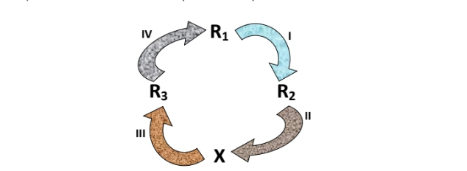

- Identify process 1 (1mark)

_________________________________________________________________________________

- state one internal and one external condition necessary for the process identified in (1) above
(2 marks)

_________________________________________________________________________________

- Name the: (2 marks)
Stage of development R2

____________________________________________________________________________
Process immediately before R3 in process (III)

____________________________________________________________________________
- Dissect specimen R3 logitudinally and open it out
- Make a drawing section and labeled it (4 marks)

- Explain two adaptations of the specimen to its function (2marks)

_________________________________________________________________________________

_________________________________________________________________________________

