BUSINESS STUDIES
PAPER 2
565/2

SUKELLEMO PREMOCK TERM l

FORM 4

MARKING SCHEME
1.a) Explain five factors that may promote entrepreneurship in Kenya. (10 marks)
- Availability of finances which supports the growth / expansion / operation of the business
- Availability of security that ensures safety of business property
• Availability of market / demand where people can sell goods/services to satisfy their needs
- Good infrastructure / roads that facilitate movement of goods to the market
- Political stability that creates a conducive environment for starting / running a business
- Healthy / fair competition that the owner of the business can cope with / withstand
- Favourable government policies / government support that may encourage starting / expansion of business venture
- Presence of role models / successful business people that inspires the youths to go into business
- Development of positive entrepreneurial culture through early exposure to business activities / that values individuals who are successful entrepreneurs
- Relevant education / training in the curriculum which prepares the youths to become entrepreneurs
- Good governance that ensures accountability / transparency in conduct of business activities
- Availability of appropriate technology that can lead to production of desired quality /quantity of goods - Need for independence / self-reliance through earning of income / livelihood
1 (b) Explain 5 services that commercial banks offer to their customers.(10mks)
- Accepting deposits
People with excess money and no immediate use can deposit it for safekeeping in a bank until need arises. This is done by providing accounts e.g savings, current and fixed deposit accounts
- Money transfers
They provide various ways of transferring money from one place to another safely and fast such as standing orders, credit transfers, bank draft, telegraphic transfers, electronic funds transfer (EFT) and different kinds of cheques
- Lending money
They give loans to people who can provide security and repay the loan with interest e.g long term loans, overdrafts, discounting bills of exchange
- Safekeeping of valuable items
Customers are provided on request with safety lockers they can safely deposit valuable items e.g jewelry, certificates, wills
- Provision of foreign exchange
Banks exchange local currency with foreign currency for those who intend to buy goods from other countries or those with excess foreign currencies
- Advice on investments and financial management
They advise their customers on investment opportunities and how to manage their finances
- Advice on taxation
They advise or assist their customers in preparing and making tax payments to the govt
- Trustees
They manage their customer’s estate business resources) in his / her absence if requested to do so. This may happen in death or where the heir is not of age yet.
- Guarantor or referee
They give financial information to support their customer’s creditworthiness if requested to do so by e.g suppliers or lenders

2a) Three Column Cash Book
Date | Details | D.all | Bank | Date | Date | Details | D.Rec | Cash | Bank
2018 |  |  |  |  | 2018
Sept | Bal b/d |  | 55,000 |  | Sept | Bal b/d |  |  | 250,000
1 | Sales |  |  | 535,250 | 1 | Ribbons |  | 4,500
2 | Winnie | 1200 |  | 58,800 | 3 | Nyongesa | 6,000 |  | 94,000
12 | Bank |  | 50,000 |  | 8 | Salaries |  | 34,000
25 | Anyango | 7500 |  | 67,500 | 15 | Cash |  |  | 50,000
28 | cash |  |  | 52,800 | 25 | Bank |  | 52,000
30 |  |  |  |  | 30 | Bal c/d |  | 13,700
 |  |  |  |  | 30 |  |  |  | 320,360
 |  | 8,700 | 105,000 | 714,360 |  |  | 6,000 | 105,000 | 714,360

2.b) Explain five factors to consider when choosing office equipment. (10marks)
- Cost; Organization will choose an equipment they can afford based on amount of capital available.
- Adaptability; An organization will choose an equipment that will adjust to any future changes without becoming obsolete.
- Possibility of hiring rather than buying; one has to consider the cost and convenience of buying an equipment as opposed to hiring. If hiring is expensive than buying, then the organization will have to buy.
- Durability; The organization will acquire an equipment that will last long.
- Effect on staff morale; The organization will acquire an equipment that will motivate the staff to use. Staff members should be involved in deciding which equipment to acquire.
- Availability of complimentary resources; this refers accessories required in order to operate the equipment. I.e. the availability of power, spare parts
- Availability of manpower; it is personnel required to run and operate an equipment. A business should consider the availability and cost of skills required.
- Availability of room; where the equipment will be kept safely.
- Security of the equipment; one has to consider whether the available resources are adequate to offer enough security for the equipment
3a) Measures to protect consumers from unscrupulous business practices.
- Maintaining standards through KEBS - This ensures that the customers are provided with high quality goods and services.
- Licencing business - To ensure that only legal business are licensed thus guarding against dangerous products and substandard products that are harmful to the consumers.
- Enacting weights and measures act - To ensure that goods are if correct weights and that the machines used in measuring are accurate.
- Enacting foods and drugs act - To ensure that goods sold to customers do not contain any harmful products that may affect their health.
- Enacting rent restriction act and landlord and tenants act - The act prohibits landlords from overcharging their tenants.
- Enacting public health act - To ensure that public health officers inspect the level of hygiene in all businesses and that people selling are in good health and offering safe products to consumers.
3b) - types of unemployment
- Cyclical unemployment - this is due to relatively low demand for goods
- Structural unemployment - This is caused by low factor mobility.
- Seasonal unemployment - caused by relatively low demand for labour at certain times of the year.
- Frictional unemployment - this is tue to time lags is time taken in changing jobs.
- Disguised unemployment - occurs when there are more employees than required.
- Involuntary unemployment - this occurs when one wants a job at the prevailing wage rate but cannot get one.
- Residue unemployment - this is due to physical disability of the individual.
(10mks)
4a Five channels of distribution
Foreign producer local consumer
Foreign producer wholesaler local consumer
Foreign producer retailer local consumer
Foreign producer agent wholesaler retailer local consumer
Foreign producer manufacturer’s representative wholesale retailer local consumer

4b) Choice of appropriate means of transport.
- Nature of goods - Bulky and heavy goods are appropriately transported by sea and rail while light goods can be handled by air transport. Perishable goods should be transported using a quick means while non-perishable can be transported by a slower means.
- Availability of terminals - Choose a means of transport that provides the required loading and offloading facilities.
- Distance to be covered - Air and sea transport are most suitable for long distance while road transport is suitable for short distance.
- Speed (Urgency) at which goods are needed - If goods are required quickly a faster means like air should be used while less urgently required goods can be handled by a slower means like rail and sea.
- Cost of transport (Freight) - A business should always choose the most cost effective means of transport.
- Security of the means - Air transport is more secure than other means hence most suitable in delivering valuable items like jewelries and cash money.
- Need for specialized facilities - Some goods may require specialized handling that can only be available in certain means of transport only.
- Flexibility of the means - This is the ability of a means of transport to deliver goods to the desired destination without having to keep changing the means.
- Availability of the means - The choice is limited to what means are available at one's disposal.
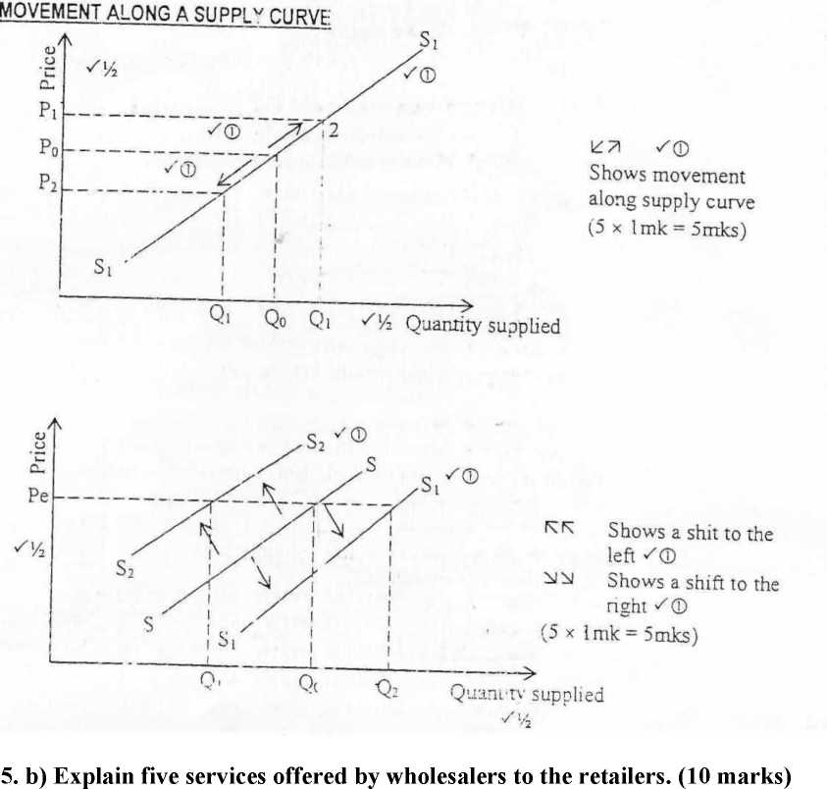
- They provide finance/credit, which act as a source of capital / enables retailers to expand their business
5.a)
- They offer storage / warehousing facilities, which reduces the cost of storage incurred by retailers / relieves retailers risk of damage
- They break bulk, hence retailers are able to buy quantities they can afford
- Avail variety of goods hence retailers are relieved the burden of visiting producers’ premises
- They offer transport which relieves retailers the cost of transportation
- They advice retailers on available offer for some commodities / ways of improving profit margins
- They conduct product promotion / advertise goods which enables retailers obtain ready market / relieving them the cost of advertising
- Ensure steady supply of goods hence retailers do not experience shortage
- Act as a link between producers and retailers hence bring goods closer to the retailers
- They prepare goods for sale through blending / packing / sorting / grading
6 (a) Explain 5 disadvantages that a country may suffer out of international trade.( 10mks)
- Hinder the growth of local industries as people buy more of imported than locally produced goods
- Importation of unwanted and harmful goods that may interfere with people’s way of life and health
- Unhealthy competition may cause local industries to collapse leading to cases of unemployment
- A country may import more than it exports thus experiencing unfavourable balance of trade
- A country may experience imported inflation which may lower the standards of living
Importation of foreign cultural values that may be inappropriate to the country
- A country may suffer trade restrictions in case it disagrees with its trading partners
Overdependence on imports makes a country suffer if the goods are not forthcoming
- Over reliance on imported essential goods may make the country suffer unpleasant treatment by trading partners
- Exhaustion of a resource that a country depends on for exports may leave her with high international debts

6 b).
- . Turnover = sales - Return inwards
- - 30,000 =sh 1,175,000 1 x 1 = 1 mark
- . Rate of stock turnover = cost of goods sold
Average stock
c.o.g.s =430,000 + 930,000 + 10,000 - 20,000 - 470,000
= 880,000
Average stock = 430,000 + 47,000
2
= 450,000
880,000
- = 1.96 = 2 times 3 x 1 = 3mks

- . Mark-up = G.P = 1,125,000 - 880,000
cost of sales 880,000
= 245,000 x 100 = 27.84%
880,000
= 2 x 1 = 2mks
- . Margins = G.P x 100
Returns
= 245,000 x 100 = 21.8%
1,125,000
2x1 = 2mks
- . Net profit = G.P + Revenue - Expenses
- + 15,000 - (25,000 + 100,000 + 25,000)
= 110,000
2 x 1 = 2mks

