SECTION A
1a) Define the term rotation of the earth ( 2 mks)
The spinning of the earth on its axis from west to east. ( takes 24 hrs to complete one rotation)
b) State three effects of revolution ( 3 mks)
- Revolution causes lunar eclipse
- Revolution causes the four seasons
- Revolution causes changes in midday sun in different times of the year
- Revolution causes changes in length of the day at different times of the year
2a) Apart from simple symmetrical fold, Name three types of folds ( 3 mks)
- Asymmetrical fold
- Overfold
- Isoclinal fold
- Recumbent fold
- Overthrust fold/Nappe
- Anticlinorium-synclinorium complex
b) Name two fold mountains in Africa ( 2 mks)
- Atlas
- Cape ranges
3a) Use the diagram below to answer the following question.
Identify and name the parts labelled P, Q & R ( 3mks)
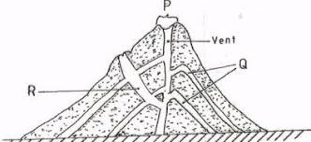
P- Crater
Q- Lava layers
R- subsidiary/side vent
b) List two intrusive features as a result of vulcanicity ( 2 mks)
- Dyke
- Sill
- Laccolith/laccolite
- Lopolith
- Phaccolith/phacolite
- Batholith
4a) Give the three main types of river erosion ( 3 mks)
- Vertical erosion
- Lateral erosion
- Headward erosion
b) State two conditions for river capture to take place ( 2 mks)
- The powerful river and misfit river must flow in adjacent valleys
- The pirate river should have a wider valley than the misfit river
- The pirate river must have more active headward erosion than the neighbouring river.
- The pirate river ought to be flowing at a lower level
5a) Define the term Ice berg ( 2 mks)
Permanent floating ice in large waterbodies
b) List three types of moraine ( 3 mks)
- Recessional moraine
- Ground moraine
- Lateral moraine
- Medial moraine
- Terminal moraine
Q6 Study the Map of Kisumu East 1: 50 000 (sheet 116/2) provided and answer the following questions
ai.Apart from topographical maps name two other types of maps. (2m)
- Sketch maps
- Atlas maps
(1 X2=2m)
ii. What is the trigonometrically station at grid reference 081980 from the rock outcrop at grid reference 091992. (2m)
- 139⁰ (+ or – 1⁰) (138⁰ – 140⁰) (2 X1=2m)
iii. Measure the length of the all-weather road bound surface B from the grid reference 974911 to the edge of the map, grid reference 947967. Give your answer in Kilometers. (2m)
- 7.2km (7.1km – 7.3km) Accept 7km 200m (2 X1=2m)
bi. Describe the relief of the area covered by the map (5m)
- The highest area is Nandi escarpment/1872m above sea level
- The lowest area is to the south west/about 1140m above sea level
- The East is a plain/plateau/kano plains evidenced by spaced contours
- The North Western part is hilly, with some steep slopes evidenced by close contours
- To the North East is Nandi Escarpment evidenced by close contours
- The landscape on the northern part is dissected by rivers
- To the south west is a basin occupied by a lake
- There are numerous river valleys
- The river valleys are steep sided in the highlands
- The river valleys are broad in the lowland (1 X 5=5m)
c. Citing evidence from the map give three economic activities apart from crop growing carried out in the area covered by the map. (4m)
- Quarrying - Quarry
- Trading -Markets/trading centers
- Processing - Sisal factory/Cotton ginnery/Flour mills
- Transportation - Roads/Railway/Main tracks/foot path (1 X4= 4m)
di Students from the school at Masogo (grid square 0681) carried out a field study of the course of river Ombeyi
i. State four findings they are likely to come up with. (4m)
- The river has many meanders
- The river has tributaries/confluence
- The river disappears into a swamp
- The river has a wide flood plain
- The river is at its old stage
(Any four points 1 X 4 =4m)
ii. State three advantages of studying rivers through fieldwork. (3m)
- It enables students to relate what is learnt in the classroom to what is in the field/firsthand information/makes Geography real
- Students are able to measure and calculate the velocity of a river and its size
- Students are able to count the number of tributaries therefore understand their environment
- It allows students to use their observation skills to make conclusion/analyzing skills/presenting skills
- It breaks the classroom monotony for the students and teachers
- The students are able to find out for themselves the uses of rivers
- Students can reason out and make objective judgment
- Fieldwork in groups encourages human relations(1 X 3=3m)
iii. What problems were the students likely to face during their field study? (3m)
- Slippery banks of the river can cause accidental falls
- Heavy rainfall may interfere with data collection
- Glare of the sun may interfere with data collection
- Fatigue and tiredness
- Sickness such as nose bleed due to high temperatures
- Thick vegetation causes problems of accessibility (1 X3=3m)

7 (a) (i) Describe the following characteristics of minerals:
- Texture (1mk) − the sizes and shapes of individual mineral particles vary/differs.
- Tenacity (1mk) − the ability of a mineral to resist/to withstand tearing, crushing or breaking differs/vary.
(ii) Describe how mechanically formed sedimentary rocks are formed. (4mks)
- Sediments used to form the rocks are derived from weathering of existing rocks.
- The weathered materials are transported by wind/ice/water.
- The weathered materials are deposited in layers on land or sea.
- They are then compacted, and cemented into sedimentary rocks.
(b) For each of the following rocks, name the resultant rock that forms after
metamorphism.
(i) Sandstone (1mk)
- Quartzite
(ii) Limestone (1mk)
-Marble
(iii) Granite (1mk)
-Gneiss

c) The diagram shows the rock cycle. Study it and answer the questions that follow.
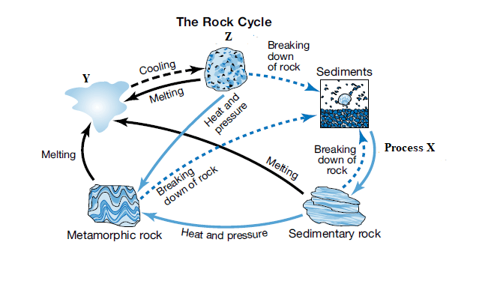
Identify the following:
i) Process X (1mk)
- Compaction and cementation
ii) Material Y (1mk)
-Magma
b) State three characteristics of rock Z (3mks)

(c) Explain the economic significance of rocks in Kenya under the following sub-headings.
i) Tourism (2mks)
-Granitic tors of W. Kenya and high volcanic peaks such as those of Mt. Kenya are a tourist attraction which brings foreign exchange.
ii) Agriculture (2mks)
-Volcanic Rocks weather to form soil which is important in crop production
-Phosphate and nitrate rocks are used to make fertiliser used in agriculture.
iii) Industry (2mks)
-Some rocks such limestone is used in industry in the manufacture of cement
(d) Students carried out a field study on rocks around their school.
(i) State two importance of stating the objectives for their study. (2mks)
− They direct the actual activities to be carried out during the study.
− They guide the possible areas of data collection to obtain required information.
− They give the aims/purposes for carrying out the field study.
− They guide on the appropriate methods/tools for data collection.
(ii) Give three reasons why they prepared a route map of the study area.(3mks)
− To identify direction they would take
− To show the features/rocks they are likely to see.
− To help estimate the distance to be carried
− To help estimate the time to be taken.
− To help make/prepare time schedule.
Q8.ai. Define the term vegetation (2m)
- Vegetation is the collective plant cover growing in a region.
ii. Draw a well labelled diagram showing the vegetation zones found on the mountain zone. (5m)

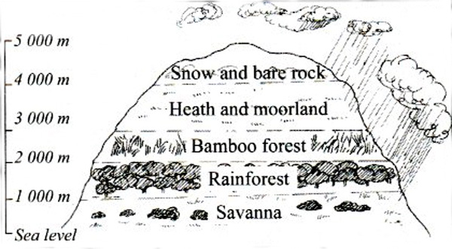
(1 X 5=5m)
b. Describe four adaptations of succulent perennials of tropical desert vegetation. (4m)
-Plants are leafless and have fibrous stems due to low photosynthesis and slow growth
-Plants have shallow root systems to absorb water from the top soil
-Plants have spines to protect them from destruction by animals
-Some swell to cylindrical shape during short rainy periods to survive the long drought
-The plants outer surfaces are hard, waxy to protect water storage cells/thick cuticle (1 X 4=4m)

c. The Map below shows the distribution of major grassland vegetation zones of the world. Study it and answer the questions that follow
i. Identify and name the grassland vegetation zone marked 1 to 5 (5m)
-1 Steppes
-2 Prairies
-3 Pampas
-4 Downs
-5 Veldt
(1 X 5=5m)
ii. Identify the line of longitude marked D (1M)
- Prime Meridian/Greenwich Meridian
(1 X 1=1m)
d. Form four students carried out a field study on a tropical rain forest in a certain area in Africa.
i. Name three hardwood tree species they are likely to observe. (3m)
- Sapele -Teak - Mahore
- Camphor - Ebony - Dahoma
- Okoume - Rosewood - Green heart
- Mahogany - Azobe - Guarea
- Iroko -Zebrano
(1 X 3=3m)
ii. Formulate a hypothesis for their study. (2m)
- Most of the trees in the forest have canopies
- The trees are mainly exploited for fuel
- The main problem experienced in exploiting trees is inaccessibility
(2 X 1=2m)
iii. State three methods of recording data that the students used in their field study. (3m)
-Taking photographs/video taping of trees
- Note taking form observation of vegetation done
- Tape recording of resource persons/local community
- Tallying of tree species counted
- Drawing/sketching of trees in the forest
- Mapping of the forest
9. a) Define the term Oceans ( 2 mks)
A vast body of salty water on the earth surface that surrounds the land or continent
b) Name four features formed as a result of wave deposition ( 4 mks)
- Beaches
- Spits
- Mudflats
- Cuspate foreland
- Dune belts
- Bars
- Tombolo
- Salt-Marshes
c) State five differences between oceans and seas ( 5 mks)
- Oceans are affected by tides while only marginal seas are affected by tides
- Oceans have strong ocean currents while only marginal seas are affected by ocean currents
- Oceans experience strong winds which cause hurricanes /tornadoes while only a few marginal seas experience strong winds which cause whirl winds called waterspouts.
- Sunlit eastern coasts of oceans lead to coral formation while in seas there is no coral formation.
- Oceans surround continents or vast lands while seas are surrounded by land / marginal seas bound continents.
d) Describe the formation of a cave ( 4 mks)
- It mainly forms at the base of a cliff;
- Abrasion and hydraulic force enlarge initial hollow/line of weakness in the coastal rock;
- Corrosion at the base of cliff enlarges the hollow which extends inward into the cliff;
- The process continues until the hollow is transformed into a cylindrical chamber called a cave;
e) Identify and name the features marked P, Q, & R ( 3 mks)
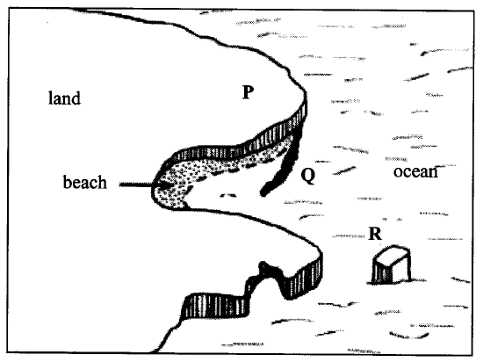
P- headland
Q-Spit
R-Stack
f) Give three main types of submerged upland coasts ( 3 mks)
- Rias
- Fjords/fiords
- Dalmatian coasts
g) Explain two negative significance of coasts and coastal features ( 4 mks)
- Coasts that have emerged recently generally have poor sandy soils which are unsuitable for growing variety of crops.
- Sand and formation of corals inhibits water transport and development of ports / tankers which hit coral reefs causes oil spills.

10. i. Soil is a naturally occurring thin layer of loose or unconsolidated materials which overlies the crustal rocks and on which plants grow.
ii. Mineral particles/inorganic materials
Humus/organic matter.
Water.
Air (choose any 2x1)
b. Hydration.
It means chemical combination of molecules with a particular mineral. Soil forming minerals occurring in rocks undergo hydration when exposed o humid conditions.
2Fe₂O₃ ₊ 3HOH _______ 2Fe₂O₃ 3H₂O
Oxidation
Means addition of oxygen is more active in the presence of moisture and results in hydrated oxides. Soil forming minerals containing irons, manganese etc. are more subjected to oxidation.eg a rusty – looking (red0 crust is formed on the surface of the rock. As the process continues where crust thickens and slowly separates from the parent rock, the mineral weakens the rock and ultimately the rock crumbles to pieces.
c a Platy
b Columnar
ii X- Top leached soils
Y – light/thick fertile soils
Z – Poorly drained soils.
d. Leaching
Due to heavy rainfall which leads to percolation of soil nutrients to the lower horizons leading to deficiency of the top soil.
Mono cropping
Protracted growing of a single crop such as maize or pineapples remove crop specific mineral salts from the soil making it infertile and less useless.
Burning of land
Slash and burn methods used in shifting cultivation leads to robbing of the soils of the organic matter through killing of microorganisms the soil structure deteriorates as soils become void of nitrogen as the nitrogen fixing bacteria are killed. Humus is burned.

