312/1
SUKELLEMO JOINT EXAMINATIOS
GEOGRAPHY PAPER 1
PRE - MOCK EXAMINATION
TERM 1 2023
TIME: 2³/₄ HOURS

INSTRUCTIONS:
This paper has two sections: A and B
Answer all questions in section A
In section B answer question 6 and any other two questions

FOR EXAMINER’S USE ONLY
QUESTION | SECTION A | 6 | 7 | 8 | 9 | 10 | TOTAL
MARKS

SECTION A
1a) Define the term rotation of the earth (2mks)
b) State three effects of revolution (3mks)
2a) Apart from simple symmetrical fold, Name three types of folds (3mks)
b) Name two fold mountains in Africa (2mks)
3a) Use the diagram below to answer the following question.
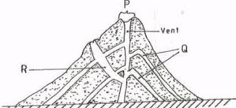
Identify and name the parts labelled P, Q & R (3mks)
b) List two intrusive features as a result of vulcanicity (2mks)
4a) Give the three main types of river erosion (3mks)
b) State two conditions for river capture to take place (2mks)
5a) Define the term Ice berg (2mks)
b) List three types of moraine (3mks)

SECTION B
6 Study the Map of Kisumu East 1: 50 000 (sheet 116/2) provided and answer the following questions
ai.Apart from Topographical maps name two other types of maps. (2m)
ii. What is the trigonometrical station at grid reference 081980 from the rock outcrop at grid reference 071992. (2m)
iii. Measure the length of the all-weather road bound surface B from the grid reference 974911 to the edge of the map, grid reference 947967.Give your answer in Kilometers. (2m)
bi. Describe the relief of the area covered by the map (5m)
c. Citing evidence from the map give three economic activities apart from crop growing carried out in the area covered by the map. (4m)
di Students from the school at Masogo (grid square 0681) carried out a field study of the course of river Ombeyi
i. State four findings they are likely to come up with. (4m)
ii. Give three advantages of studying rivers through fieldwork. (3m)
iii. What problems were the students likely to face during their field study? (3m)

7 (a) (i) Describe the following characteristics of minerals:
- Texture (1mk)
- Tenacity (1mk)
(ii) Describe how mechanically formed sedimentary rocks are formed. (4mks)
(b) For each of the following rocks, name the resultant rock that forms after
metamorphism.
(i) Sandstone (1mk)
(ii) Limestone (1mk)
(iii) Granite (1mk)

c) The diagram shows the rock cycle. Study it and answer the questions that follow.
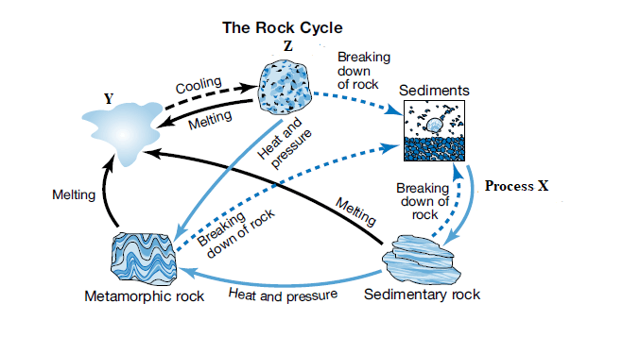
Idntify the following:
i) Process X (1mk)
ii) Material Y (1mk)
b) State three characteristics of rock Z (3mks)
(c) Explain the economic significance of rocks in Kenya under the following sub-headings.
i) Tourism (2mks)
ii) Agriculture (2mks)
iii) Industry (2mks)
(d) Students carried out a field study on rocks around their school.
(i) State two importance of stating the objectives for their study. (2mks)
(ii) Give three reasons why they prepared a route map of the study area.(3mks)

8.ai. Define the term vegetation (2m)
ii. Draw a well labelled diagram showing the vegetation zones found on the mountain zone. (5m)
b. Describe four adaptations of succulent perennials of tropical desert vegetation. (4m)
c. The Map below shows the distribution of major grassland vegetation zones of the world. Study it and answer the questions that follow
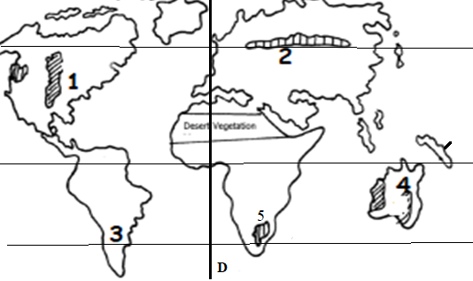 i.Identify and name the grassland vegetation zone marked 1 to 5 (5m)
ii.Identify and name the line of longitude marked D (1m)
d. Form four students carried out a field study on a tropical rain forest in a certain area in Africa.
i. Name three hardwood tree species they are likely to observe. (3m)
ii. Formulate one hypothesis for their study. (2m)
iii. State three methods of recording data that the students used in their field study. (3m)

9. a) Define the term Oceans (2mks)
b) Apart from beach, name four features formed as a result of wave deposition (4mks)
c) State three differences between oceans and seas (3mks)
d) With aid of a well labeled diagram, describe the formation of a cave. (6mks)
e) Identify and name the features marked P, Q, & R (3mks)
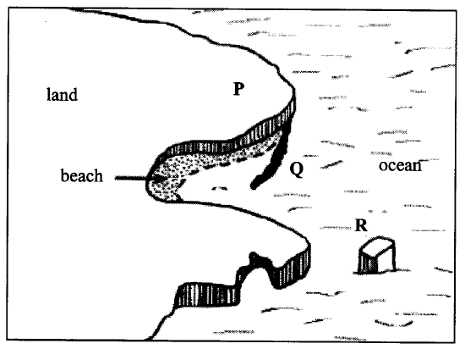
f) Give three main types of submerged upland coasts (3mks)
g) Explain two negative significance of coasts and coastal features (4mks)
10.(a) (i) What is soil (2mks)
(ii) State three main components of soil (3mks)
(b) Explain how the following weathering processes contributes to the formation of soil
(i) Hydration (3mks)
(ii) Oxidation (4mks)
(c) (i) Name the type of soil structures which fits the following descriptions
• Soil particles are arranged in thin sheets on top of each other. (2mk)
• Soil particles are arranged vertically in cylindrical manner (2mk)
(ii) The diagram below represents soil catena. Identify the nature of soils in the stages
marked X, Y and Z. (3mks)
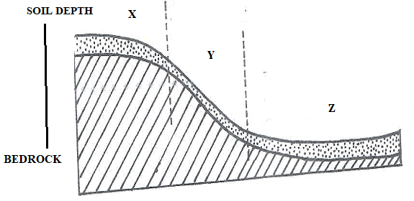
(d) Explain how the following factors cause soil degradation
(i) Leaching (2mks)
(ii) Mono cropping (2mks)
(iii) Burning of land (2mks)

