SUKELLEMO PRE-MOCK JOINT EXAMINATION
GEOGRAPHY PP2 - MARKING SCHEME 2023
SECTION A
Answer all the questions in this section.

1. (a) What is the relationship between Geography and History? (2 marks)
- Geography attempts to explain where historical events took place. History uses geographical tools like maps charts and graphs to show movement of people in the past.
(b) Identify three sub-branches of Geography in human and social sciences. (3 marks)
- Political Geography
- Historical Geography
- Economic Geography
- Population Geography
2. (a) Distinguish between a forest and forestry. (2 marks)
- Forest refers to a continuous growth of trees and undergrowth covering large tracts of land while forestry is the science of developing and managing forests including cultivating them.
(b) State three problems that affect forestry in Canada. (3 marks)
- Forest fires, pets and diseases that destroy large tract of land reducing under forests.
- Severe winters lead to the retarded growth of softwood trees in Canada.
- Inaccessibility of forests in the northern part of Canada in winter because of snow while other parts have rugged terrain.
3. (a) What is nomadic pastoralism? (2 marks)
- It refers to the extensive grazing on natural pastures involving constant or seasonal migration of nomads and their livestock.
(b) Give three reasons why nomadic pastoralists keep large herds of animals. (3 marks)
- It is a sign of wealth, prestige and social status, the more cattle, the better.
- To pay dowry.
- It is a source of food, milk, meat and blood.
- It is a source of income if and when they are sold.
- It is a form of insurance against natural calamities such as diseases and drought.
4. (a) (i) Give the source of nuclear power. (1 mark)
- Uranium.
(ii) Name a country in Africa where nuclear power is produced. (1 mark)
- South Africa
(b) State three methods that can be used to conserve energy in Kenya. (3 marks)
- Improving on public transport to encourage more people to use it.
- Create awareness by educating the community on the importance of conserving energy.
- Control of the importation of vehicles with more engine capacities and high consumption rates.
- Use of alternative sources of energy particularly biomass, wind and sun.
- Development of wood fuel programs through afforestation.
5. (a) Name two types of environments. (2 marks)
- Physical Geography
- Human and Economic Geography.
(b) State three consequences of environmental degradation. (3 marks)
- It may lead to loss of biodiversity.
- Loss of aesthetic value.
- May lead to extinction of wildlife.
- Causes health hazards to human beings.
SECTION B
6.
- (i) Identify the type of photograph. (1 mk)

- Ground general view

(ii) Describe the features shown on the photograph. (3 mks)

- High quality cattle breeds in the foreground.
- Continuous luxuriant growth of grass from the foreground to the background.
- Extension undulating landscape.

(iii) What indicators show that the area of suitable for beef farming. (3 mks)

- Extensive flat landscape be favouring cattle growing
- Enough pasture for beef cattle
- Sunshine for the growth of pasture.

- Explain four measures taken by the Kenyan government to improve beef farming in Kenya.

- Construction of access roads making easier for farmers to transport beef animals to the markets
- Sinking of boreholes, wells and dams to provide water for the animals.
- Reviving of the Kenya Meet Commission that buys animals from the farmers for slaughtering.
- Encouraging formation of group ranches for easier provisions of vetenary services.
- Encouraging research on cross-breeding of traditional cattle breeds with exotic to improve the quality of the animals.
- Strengthening community education so as to teach beef farmers better management practices.
- Construction of cattle dips to control pests such as ticks reducing quality of animals.
- Organizing forums to educate the farmers on strategies to improve their systems of livestock farming.

- (i) Name two exotic beef cattle kept in Kenya. (2 mks)
- Hereford
- Short horn

(ii) List two areas in Argentina where beef cattle rearing is done. (2 mks)

- Buenos Aires
- Ba Blanca
- La plata
- Rosario

(iii) Explain three factors favouring beef farming in Argentina. (6 mks)

- Replacement of coarse grasses that were of low quality with alfalfa or corn has improved the quality of pasture
- High and well distributed rainfall about 1000 mm annually ensuring constant growth of pasture,
- Availability of fertile loose soils supporting the growth of quality / nutritious pasture
- Well developed transport network making easier transportation of beef products both local and export market.
- Temperature ranging from 10⁰c – 24⁰C favouring breeding of beef cattle.
- Gently sloping pampas plains providing good natural grazing land for beef cattle.
- Availability of water supplied using wind pumps / high rainfalls

7. (a) Name two countries in Africa South of the equator where petroleum is mined. (2 marks)
- Angola
- South Africa
(b) The diagram below shows the occurrence of petroleum in the earth’s crust.
U
W
V
Porous rock

(i) Name the parts marked U, V and W. (3 marks)
- U- Natural Gas
- V-Petroleum
- W-Impermeable rock

(ii) State three conditions necessary for the formation of petroleum. (3 marks)
- There should be a source rock rich in hydrocarbon material and buried deep enough for subterranean heat to cook the hydrocarbon material into oil.
- A cap rock to prevent the oil from escaping to the surface.
- Porous and permeable rock for oil to accumulate in it.
(c) Explain four effects of increased oil prices on the economies of oil importing countries. (8 marks)
- The cost of transport and production rise, leading to an increase in the cost of finished goods, including common household products.
- Exhaustion of wood fuel due to its high demand.
- Depletion of foreign exchange reserves.
- Reduced tourist activities since hike in oil prices result in higher transport costs the sector the countries are likely to suffer more tourists.
- Decline agricultural production due to the increase in cost of transporting agricultural inputs.
- Increase in the prices of other sources of energy.
(d) (i) Name the hydro-electric power projects found on the following rivers.
- River Niger
The Kaiji power project
- River Volta
Akasombo Dam Power Project
- River Nile
Aswan High Dam power project/Sennar Power project.(3 marks)
(ii) Explain three physical factors that influence the establishment of hydro- electric power dams. (6 marks)
- Large volumes of water favouring continuous generation of HEP.
- Hard basement rock which offers a fir foundation for the construction of the dams.
- Presence of a deep narrow valley to provide large space for construction of the dam.
- Presence of water falls rapids and knick points along a river to offer massive hydraulic head for turning the turbines.

8. (a)(i)Give two methods used to reclaim land in Kenya (2marks)
- Draining of swamps.
- Irrigating dry lands.
- Control of pests .
- Filling In querries.
- Afforestation.
- Draining a portion of the sea.
(ii)State three benefits that resulted from the reclamation of the Yala swamp. (3marks)
- Floods in the region have been controlled, saving peoples’ lives.
- Pests and waterborne diseases have been controlled.
- Land for agriculture became available.
- People have been settled in the scheme.
- There has been an increase in employment raising their standards of living.
(b) (i)Explain four physical factors that made Mwea Tebere a suitable location for irrigation. (8marks)
- There was availability of water from rivers Thiba, Nyamindi, Wamumu and Murubara to be used for irrigation.
- There was the presence of black cotton soils which were suitable for irrigation as they retain water.
- The soils had nutrients and were suitable for crop production.
- There was extensive land which was not occupied and thus available for use and for future expansion.
- The land was gentle and sloppy which would allow water to flow by gravity thus no need for expensive pumping.
- The low and unreliable rainfall received in the area made it necessary for irrigation to be used.
(ii)Name two major rivers that supply water to the Mwea Tebere irrigation
Scheme. (2marks)
- R.Thiba, R. Nyamindi, R. Wamumu and R. Murubara

- (i)Describe the stages in the reclamation of land from the sea in the Netherlands. (6marks)
- Protective dykes and sea walls are constructed enclosing the part of the sea to be reclaimed.
- Ring canals are constructed.
- Pumping stations are installed to pump out the sea water from the area enclosed by the dykes.
- Reeds are sown to help dry out the soil.
- Drainage ditches are constructed and more pumping stations installed on the land being reclaimed.
- Drainage pipes are laid below the soil.
- Soils are treated with chemicals to lower salinity.
- The drained land or polder is flushed with fresh water to remove salt.
- Pumping out of water from the polder is a continuous process to prevent water from accumulating again.
(iii)Explain two differences between land reclamation in Kenya and the Netherlands. (4marks)
- In Kenya, the land reclaimed is relatively small while in the Netherlands, the land reclaimed is large.
- In Kenya, land is mainly reclaimed from swamps and marginal areas while in the Netherlands the land is reclaimed from the sea.
- In Kenya, irrigation is used to reclaim dry lands while in the Netherlands; irrigation is used to lower the salinity of the soil in the polders before crops are introduced.
9.(a)(i)What is eco-tourism? (2marks)
- It refers to a friendly tourism whereby tourists enjoy watching what nature has provided while protecting/conserving the environment as well.
(ii)Differentiate between domestic tourism and international tourism (2marks)
- Domestic tourism refers to visits within a country by residents of that country while international tourism is the movement of persons from ones country to another for holiday or other purposes.
(b)(i)Explain four reasons why Kenya attracts more tourists than other East African countries. (8marks)
- Publicity-the government through the Ministry of Tourism and Information have made vigorous campaigns abroad to create awareness on the tourists attractions in Kenya.
- Kenya has been enjoying relative peace compared to her neighbors and has earned that reputation internationally.
- Presence of numerous tourists’ hotels and game lodges in the parks that offer excellent accommodation facilities to the tourists.
- Trained personnel in the tourism industry.
- Well-developed transport network leading to the tourist destinations.
- Involvement of the government in promotion of tourism and close collaboration with other stakeholders in the private sector has contributed to the flourishing of the industry.
(ii)Apart from encouraging domestic tourism describe three other measures which the government has taken to promote tourism in Kenya. (3marks)
- Lowering tariffs.
- Improving security.
- Aggressive promotion.
- Improving the transport links to the tourist destinations.
(iii) Outline four tourism attractions that exist in Switzerland but not found in East Africa. (4marks)
- Climatic seasons that is summer for sun-bathing and winter for winter sports.
- Efficient transport systems made of electrified railways and cable cars.
- Large areas of smooth slopes covered with snow during winter.
- Switzerland has glaciated peaks and slopes of Alps Mountains.

(c)You are supposed to carry out a field study on the effect of tourism at the coast.
(i)State two methods you would use to collect the information. (2marks)
- Administering questionnaires.
- Contacting interviews.
- Content analysis.
- Observing
(ii)State two reasons why you would need a time schedule. (2marks)
- To ensure proper time management thus reducing time wastage.
- To ensure that all important areas are adequately covered.
- To ensure that one remains in courser during the study.
- To help gauge on the success of the study as it is carried out.
(iii)State two negative problems associated with tourism that you would observe. (2marks)
- Apeing of foreign cultures.
- Scaring of animals
- Trafficking of drugs.
- School drop outs(beach boys)

10. (a) (i) What is a cottage industry? (2 marks)
- It is an industry in which people work from their homes making products using their hand and simple tools or machines.
(ii) Give four reasons why the government of Kenya encourages the establishment of Jua kali industries. (4 marks)
- It has created employment opportunities to thousands of people who could otherwise be jobless.
- Has helped raise the living standards of Kenyans who rely on it for income.
- It saves then country foreign exchange.
- Earns the country a substantial foreign exchange.
- Uses locally available raw materials.
- Produces cheaper goods than those produced in then formal industries.

(b) Study the sketch map shown below of the Ruhr industrial region . Use it to answer question (i).
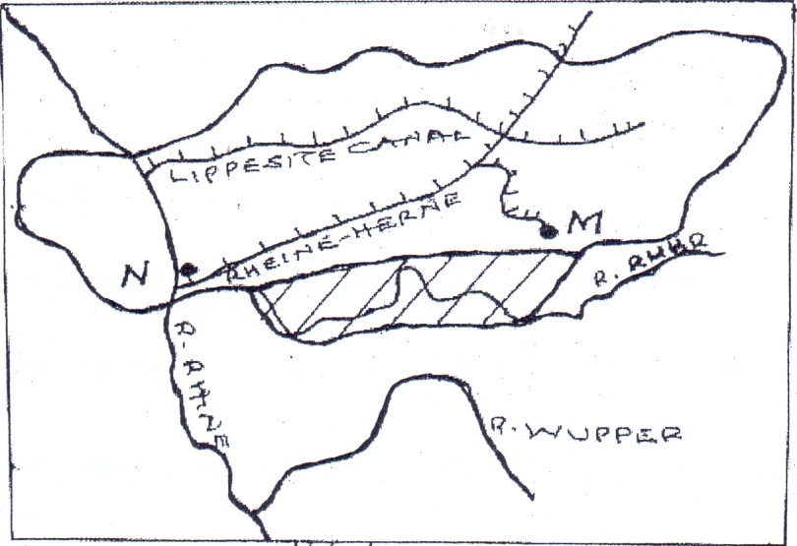
W
X
Y
R. Rhine

(i) Name the canal marked X. (1 mark)
- Dortmund-Ems Canal
(ii) Name the river marked Y. (1 mark)
- R. Rhur
(iii) Name the town marked W. (1 mark)
- Duisburg

(c) (i) Show how the government may solve the following problems facing industries in Kenya.
- Competition from cheap imports. (1 mark)
- Raising tariffs or increasing quotas on the cheaply imported goods.
- High cost of energy/electricity (1 mark)
- Encouraging use of alternative sources of energy.
- Limited market. (1 mark)
- Encouraging Kenyan entrepreneurs to open branches of businesses in other parts of the world./Vigorous advertisement of Kenyas products to the international market.
(ii) Explain three factors that favored car manufacturing industry in Japan. (6 marks)
- Availability of power. Japan has developed HEP and nuclear energy that is used in the car manufacturing.
- Availability of manpower. It has highly skilled labour force needed in the automobiles industries.
- Abundance of water from numerous rivers and small lakes which is used in the iron and steel industry whose products are used to make components of the automobiles.
- Advanced technology. Automobile industries are computerized in order to increase efficiency.
(d) Form four Geography students carried out a field study at a paper mill.
(i) State three ways in which they prepared for the field study. (3 marks)
- Preparing a working schedule.
- Preparation of questionnaires.
- Seeking permission.
- Conducting pre-visit.
- Formulate hypothesis.
- Statement of objectives.
(ii) Give four reasons why the industry was located near a source of water the student could have established. (4 marks)
- For cleaning machines.
- Water is used as an ingredient.
- Cooling machines.

