- A fertilizer has the following characteristics
- White crystalline like sugar
- Highly volatile
- Acidic
- Highly soluble in water

- Identify the fertilizer (1mk)
Nitrogeneous fertilizer

- Give two reasons why this fertilizer should not be used for planting crops (2mks)
Scorching effect
Absorb water
- Mention three types of records a farmer growing maize should keep (3mks)
- Inventory
- Labour
- Production
- Health
- Marketing
- Give three factors that make camels suit for semi-arid areas of Kenya (3mks)
- Can stay for long period without water
- Can withstand extreme temperature
- Able to eat dry feeds
- Paddy feet to prevent sinking in sand
- Thick hide to insulate against radiant heat
- Name the tools used for the following operations
- Cutting wool form sheep ( ½ mk)
Wool shears
- Pruning hard branches of coffee ( ½ mk)
Pruning saw

- Tooth clipping ( ½ mk)
Teeth clipper / teeth nipper

- Cutting galvanized iron sheets ( ½ mk)
Tinsnips
- List four farming practices that can be carried out to increase the amount of light harnessed by crops ( 4 x ½ = 2 marks)
- Prunning
- Thinning
- Weeding
- Wider spacing
- Two ways of preparing planting materials before planting. (2 x ½ = 1mark)
- Breaking seed dormancy
- Seed dressing
- Chitting/ sprouting
- Seed inoculation
- a) Identify the farm practice represented by B. (1mark )
Earthing up
b) State one the importance of the above practice in the following crops. (3marks)
- Maize - provides support to prevent lodging
- Irish potatoes - Improves tuber formation/expansion
- Tobacco – Improves drainage around the plant
c) At what stage of growth should the above practice be carried out in maize. (1mark )
- During second weeding /knee high/45 cm in height.
- Explain THREE ways government policy contributes to Agriculture. (3 x1=5marks)
- Subsidize the price of inputs to ensure production is affordable.
- Conservation of natural resources to ensure sustainability
- Imposition of high tax imports to promote local products
- Stepping up control of diseases and pest to prevent spread and high quality products
- Quality control to ensure effective competition in both local and international market
- Give one reason why fresian’s milk is more whitish while jersey milk is yellowish (1mark)
- Jersey milk has a higher butter fat content hence the yellowish colour/freshian milk has less butter content hence whitish in colour
- Differentiate between drift and pen lambing (1mark) mark as whole
- Drift lambing is where all the pregnant ewes are put together in one paddock and separated as they lamb down while pen lambing is where the ewes are only separated from the others after showing signs of lambing.
- The diagram labelled A and B below show the teeth arrangements in workshop tools.
a) Identify the tool represented by the teeth arrangement. A and B (2marks)
- A - Cross cut saw
- B - Rip saw
b) State one functional difference between tools represented by the teeth arrangement
A and B (1mark)
- A – Used for cutting across the grain.
- B – Used for cutting along the grain.
12. Study the illustration of fences below and answer the questions that follow
(a) Name the type of fences illustrated (2 mark)
- X – Dead fence/ Chain link
- Y -- Live fence
b) Name the correct tool used in maintenance of the fence Y. 1mark
- Pruning shears
c) State two advantages that fence Y may have over fence X (2marks)
- Thorny species keep off intruders
- Tall varieties act as wind breakers
- Some species act as livestock feed
- They provide shade to livestock.
- Legumes increase soil fertility by fixing nitrogen
- Roots bind soil particle together controlling soil erosion

- State four steps followed in land adjudication. (2 marks)
(i) Establishment of ownership.
(ii) Measurement of land.
(iii) Description of land.
(iv) Recording of land. (4 X ½ = 2 marks)
- Below is a diagram of a cow. Study it carefully and answer the questions that follow.
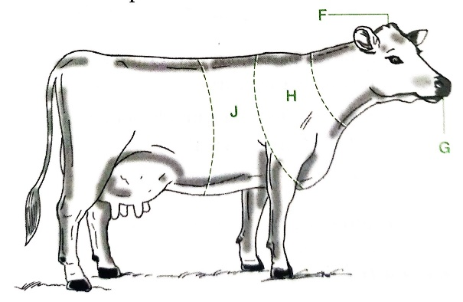
- Name the parts of the animal labelled F, G, H and J. 2 marks
F Poll
G Muzzle
H Wuthers
J Heart girth
- On the same illustration, mark with letters indicated in brackets, where;
- Branding should be done (B)
- Vaccination should be carried out (V)
- Body temperature should be taken (T)
- Mastitis infection may occur (M)

- The diagram below illustrates a special state of the reproductive cycle of the cow.
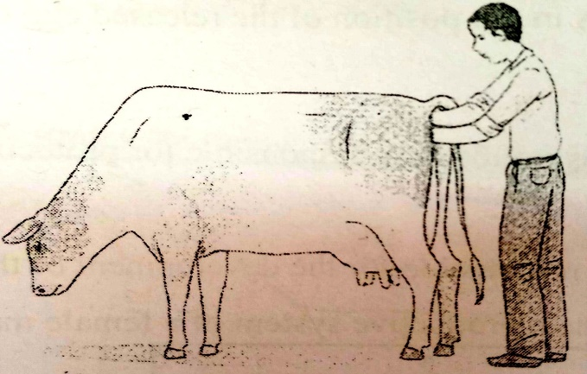
- Name the process demonstrated above in this diagram. 1 mark
Pregnancy testing/ Artificial insemination/Removal of retained plaenta
- Predict the part or instrument in the digestive and reproductive systems respectively touched or held by the;
- Right hand Cervix/ large intestine/developing foetus/ovary 1 mark
- Left hand Pistoulette (pipette)/vulva/vagina 1 mark
- Describe concession as a land tenure system. 1 mark
This is an agreement between a company and a government on the use of land for a specified period of time.
- The diagram below illustrates a livestock handling structure.
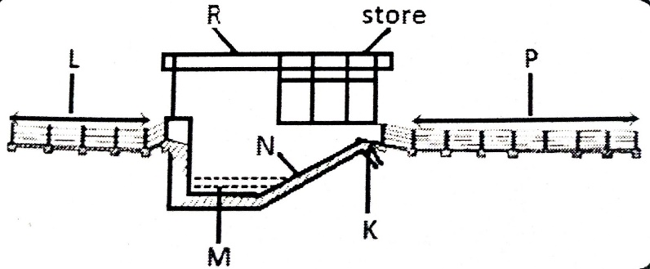
- Identify the structure. 1 mark
Plunge dip
- Name parts K, M, N and P. 2 marks
K – Silt trap outlet M – Dip tank
N – Exit steps P – Draining race
- State three methods of chemical treatment of timber. 3 mks
- Hot and cold soaking
- Sap displacement
- Vacuum treatment

