AGRICULTURE |  | NAME………………………………………  CODE……………  JUMBO CATEGORY  Male ( ) Female ( )  ALLIANCE GIRLS’ HIGH SCHOOL TEACHNICALS CONTEST 2023  Kenya Certificate of Secondary Education  Instructions to Students
FORM 3  AGRICULTURE  DURATION: 1 Hour |  | - Write ALL the details in the spaces provided above.  - Answer ALL the questions in the spaces provided.  - Non-programmable calculators may be used.  - All working must be shown within the working spaces provided.  - This paper consists of 7 printed pages.  - Candidates should check and ascertain that ALL the pages are printed and that no question is missing.  For Examiner’s Use Only  Questions Max. Score Candidate’s Score  1-18 50

- A fertilizer has the following characteristics
- White crystalline like sugar
- Highly volatile
- Acidic
- Highly soluble in water
- Identify the fertilizer (1 mark)

- Give two reasons why this fertilizer should not be used for planting crops (2 marks)

- Mention three types of records a farmer growing maize should keep (3 marks)

- Give three factors that make camels suit for semi-arid areas of Kenya (3 marks)

- Name the tools used for the following operations
- Cutting wool from sheep ( ½ mark)

- Pruning hard branches of coffee ( ½ mark)

- Tooth clipping (½ mark)

- Cutting galvanized iron sheets ( ½ mark)

- List four farming practices that can be carried out to increase the amount of light harnessed by crops. (2 marks)
……………………………………………………………………………………………………………………………………………………………………………………………………………………………………………………………………………………………………………………………………………
- State two ways of preparing planting materials before planting (1 mark) …………………………………………………………………………………………………………………………………………………………………………………………………………………………………………………………………………………………………………………………………………….
- The diagrams below show a practice carried out on various crops on the farm. Study them carefully and answer the questions that follow.
B
A
Before After
a) Identify the farm practice represented by B. (1 mark )
……………………………………………………………………………………………………………………
b) State one the importance of the above practice in the following crops. (3 marks)
(i) Maize
…………………………………………………………………………………………………………………
(ii) Irish Potatoes
…………………………………………………………………………………………………………………
(iii) Tobacco
……………………………………………………………………………………………………..................
c) At what stage of growth should the above practice be carried out in maize. (1 mark)
………………………………………………………………………………………………………
- Explain three ways government policy contributes to Agriculture. (3 marks)
………………………………………………………………………………………………………………………………………………………………………………………………………………………………………………………………………………………………………………………………………………………………………………………………………………………………………………………………………………………………………………………………………………………………………………………………………………………………………………………………………………………………………………………………………………………………………………………………………………………………………………………………………………………………………………………….
- Give one reason why fresian’s milk is more whitish while jersey milk is yellowish. (1 mark)
…………………………………………………………………………………………………………………………………………………………………………………………………………………………………………………………………………………………………………………………………………..
- Differentiate between drift and pen lambing. (1 mark)
…………………………………………………………………………………………………………………………………………………………………………………………………………………………………………………………………………………………………………………………………………………………………………………………….........................................................................................
- The diagram labelled A and B below show the teeth arrangements in workshop tools.
(a) Identify the tools represented by the teeth arrangement. A and B. (2marks)
A - ……………………………………………………………………………………………………………
B - ……………………………………………………………………………………………………………
b) State one functional difference between tools represented by the teeth arrangement A and B. (1 marks)
………………………………………………………………………………………………………………………………………………………………………………………………………………………………………………………………………………………………………………………………………………
- Study the illustration of fences below and answer the questions that follow
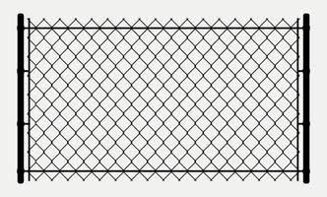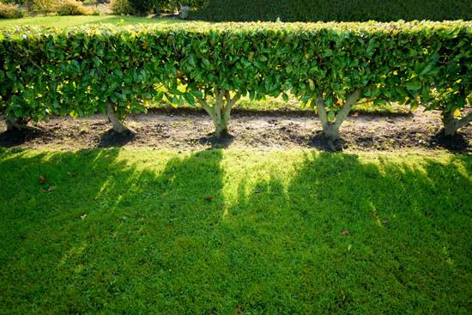
X Y
(a) Name the type of fences illustrated above (2 marks)
X – ……………………………………………………………………………………………………………
Y- ……………………………………………………………………………………………………………..………
b) Name the correct tool used in maintenance of the fence Y. (1mark)
…………………………………………………………………………………………………………………………………………………………………………………………………………………………

c) State two advantages that fence Y may have over fence X. (2mark)
………………………………………………………………………………………………………………………………………………………………………………………………………………………………………………………………………………………………………………………………………………………………………………………………………………………………………………………………………………………..
- State four steps followed in land adjudication. (2 marks)
.............................................................................................................................................................................................................................................................................................................................................................................................................................................................................................................................................................................................................................................................................................................................................................................................................................................................................................................................
- Below is a diagram of a cow. Study it carefully and answer the questions that follow.
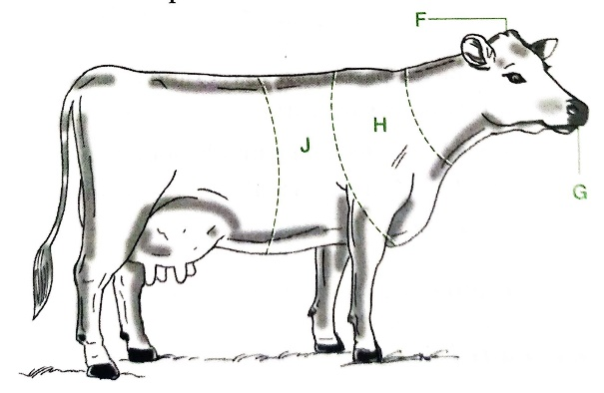
- Name the parts of the animal labelled F, G, H and J. (2 marks)
……………………………………………………………………………………………………………………………………………………………………………………………………………………………………………………………………………………………………………………………………………………………………………………………………………………………………….
- On the same illustration, mark with letters indicated in brackets, where; (4 marks)
- Branding should be done (B)
- Vaccination should be carried out (V)
- Body temperature should be taken (T)
- Mastitis infection may occur (M)

- The diagram below illustrates a special state of the reproductive cycle of the cow.
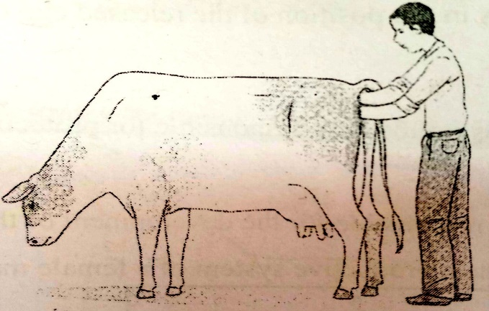
- Name the process demonstrated above in this diagram. (1 mark)
……………………………………………………………………………………………………………………………………………………………………………………………………………………………………………………………
- Predict the part or instrument in the digestive and reproductive systems respectively touched or held by the;
- Right hand………………………………………………………… (1 mark)
- Left hand…………………………………………………………… (1 mark)

- The diagram below illustrates a livestock handling structure.
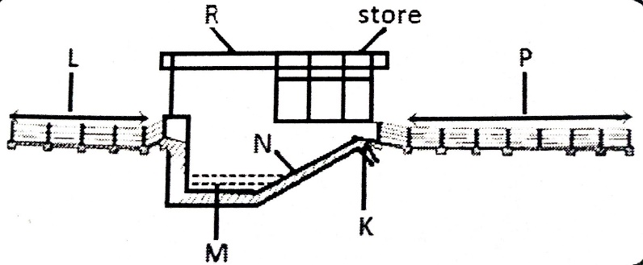
- Identify the structure. (1 mark)
- Name parts K, M, N and P. (2 marks)
…………………………………………………………………………………………………………………………………………………………………………………………………………………………………………………………………………………………………………………………………………………………………………………………………………………………………..

- Describe concession as a land tenure system. (1 mark)
…………………………………………………………………………………………………………………………………………………………………………………………………………………………………………………………………………………………………………………………………………
- State three methods of chemical treatment of timber. (3 marks)
………………………………………………………………………………………………………………………………………………………………………………………………………………………………………………………………………………………………………………………………………………………….,………………………………………………………..……………

This is the LAST printed page.

