F4 workbook scheme
- What is the role of a footbath in a poultry house? 1 mark
Prevents the introduction of pathogens in the poultry house

. Below is a diagram showing a house and a brooder set up for brooding chicks.
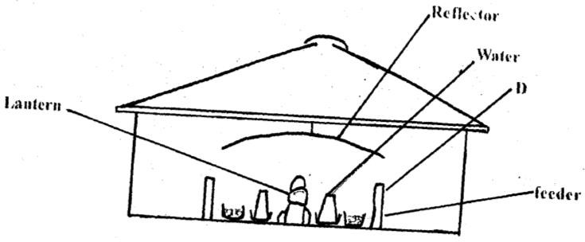
- What is the purpose of the part labelled D.
Confine the chicks around the source of heat.
Conserve/ maintain heat within the brooder
- State two ways in which the temperature in this brooder may be raised
-Lower the reflector
-Add another source of heat/ lantern

c) State two observations that would be made on the behaviour of chicks to determine when the temperature in the brooder is too high for chicks.
  - Frequent intake of water.
  - Move away from heat source
  - Lie on their belly with their wings spread
  - Frequent gulping
- Give any five examples of joint product in livestock production. 5 mks
Milk and butter
Beef and hide
Mutton and wool
Pork and bristle
- A deep litter poultry house measures 9m x 3m, Suppose the amount of space allowed for one bird is 0.27m², calculate the number of birds that can be kept comfortably in this house. Show your working

- State four pre-milking practices in a dairy herd.
-Restrain cow in a crush
-Assemble milking equipment
-Provide dairy meal feed
-Wash udder with warm water/dry udder
-Test presence of mastitis using strip cup. (4x ½ =2mks)

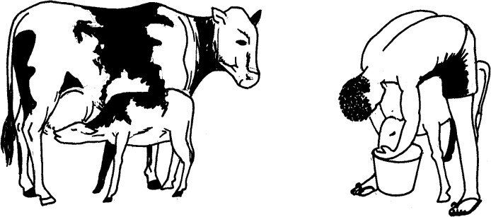
- The diagrams below show two methods of calf rearing. Study them carefully and answer the questions that follow.

A B
  - Identify method of feeding calf shown in the diagram A and B. 2 mks
    - Natural
    - Artificial/Bucket feeding
  - Give three disadvantages of calf rearing using method A. 1 ½ mks

Underfeeding of the calf

Can lead to overfeeding

No milk let down in case of absence of calf

Difficult to keep record
- Give two examples of one-host tick.
- The blue tick (boophilus decoloratus)
- The Texas fever tick (Boophilus annulatus)
- The cattle tick(Boophilus microplus)

- State two characteristics of a good acaricide
  - be stable — should not react
  - persistent — last long after application
  - harmless to the animal — not cause damage to the skin of the animal ability to kill ticks
- Name three larval stages of a liverfluke
  - sporocysts
  - rediae
  - cercaria

- Complete the following table; 4 mks
Fixed input (Layers) | Variable input (layers mash) | Total Physical Product (eggs) | Marginal product
100 | 0 | 140 | 0
100 | 10 | 155 | 15
100 | 20 | 180 | 25
100 | 30 | 240 | 35
100 | 40 | 340 | 100
100 | 50 | 470 | 570

Explain ways in which infectious diseases can be spread from one Livestock to another in a farm.
  - Through vectors
  - Through ingestion of contaminated food and water
  - Through contact / surface contact
  - Through inhalation of contaminated air. (3x1=3mks)

Study the diagram of livestock below and answer questions that follow.
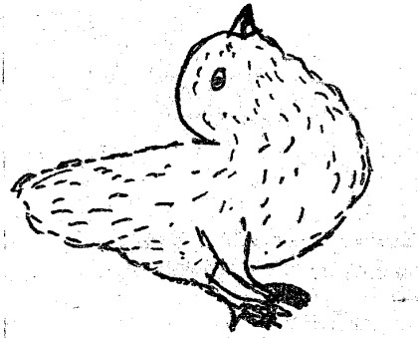

What has led to the above condition. 1 mark
Lack of manganese

State two effects of the above condition in poultry management.
  - Reduced shell thickness
  - Sterility 2x ½ =1mk

The diagram below shows two different livestock families. Use it to answer the following questions.
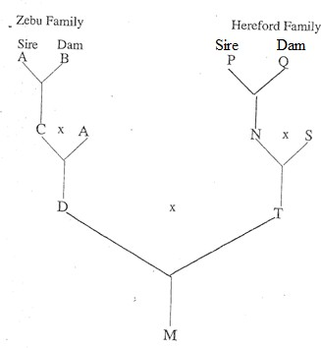

Identify the breeding system between:

C and A
. Close breeding

D and T
Cross breeding

State two advantages of breeding system identified in a (ii) above
-Offspring exhibit hybrid vigour
    - Introduce new genes to the herd

- The diagram below shows the relationship between feed requirements and foetal development in sheep. Use the graph to answer the questions.
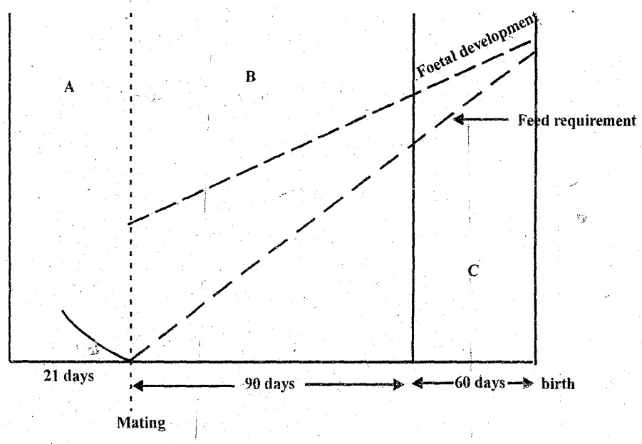
- What are the feeding management practices in sections A, B andC ? Give a reason for each.

A- Flushing
Reason;Ensure successful tupping/ enhancing twinning percentage/ induce ovulation.

B- Maintenance Ration
Reason; To maintain health condition
-Avoid complications at lambing

C- Steaming up
Reasons;- Ewes build body reserves for lambing
- Encourage foetal development
- Increase milk production/ colostrums production
- Use the graph to estimate the gestation period in sheep.
- days + 60 days = 150 days
- Study the diagram below shows the power transmission mechanism of a tractor engine.

- Name the parts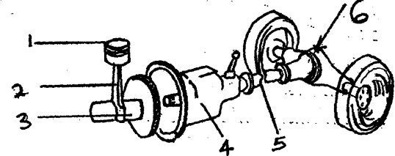
1-Piston
2-Connecting rod
3-Cranshaft
4-Gear box
5-Propeller shaft.
6-Differential.
- What technical term refers to attaching an implement to a tractor
Hitching
- Distinguish between silvopasture and agrisilviculture as used in agroforestry.(1 mark)
………………………………………………………………………………………………………..
b) Identify the following methods of harvesting trees. (2 marks)
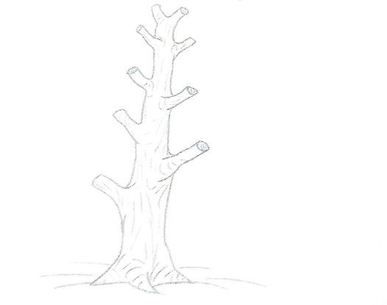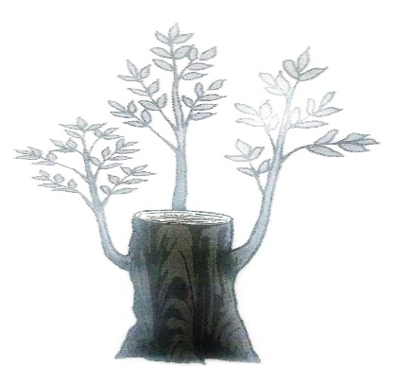
A Pollarding B Coppicing
- State six ways in which a farmer can adjust to risks and uncertainties. (6 marks)
- Adopting modern methods of production
- Having flexibility in production methods
- Through input rationing
- Taking insurance cover
- Selecting more reliable enterprises
- Through diversification of enterprises any 6 x 1 = 6 marks

