AGRICULTURE |  | NAME………………………………………  CODE……………  JUMBO CATEGORY  Male ( ) Female ( )  ALLIANCE GIRLS’ HIGH SCHOOL TECHNICALS CONTEST 2023  Kenya Certificate of Secondary Education  Instructions to Candidates
FORM 4  AGRICULTURE  DURATION: 1 Hour |  | - Write ALL the details in the spaces provided above.  - Answer ALL the questions in the spaces provided.  - Non-programmable calculators may be used.  - All working must be shown within the working spaces provided.  - This paper consists of 7 printed pages.  - Candidates should check and ascertain that ALL the pages are printed that no question is missing.  For Examiner’s Use Only  Questions Max. Score Candidate’s Score  1-17 50

- What is the role of a footbath in a poultry house? (1 mark)
………………………………………………………………………………………………………………………………………………………………………………………………………………………………………………………………………………………………………
- Below is a diagram showing a house and a brooder set up for brooding chicks.
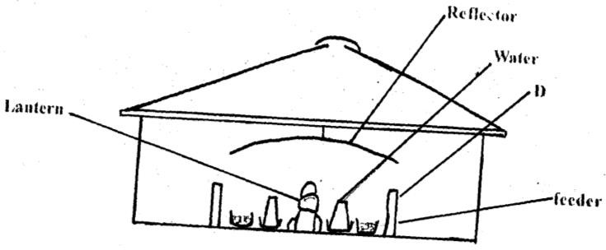
- What is the purpose of the part labelled D. (1 mark)

…………………………………………………………………………………………………………………………………………………………………………………………………………………………………………..
- State two ways in which the temperature in this brooder may be raised. (1 mark)
……………………………………………………………………………………………………………………………………………………………………………………………………………………………………………………………………………………………………………………………………………
- State four observations that would be made on the behaviour of chicks to determine when the temperature in the brooder is too high for chicks. (2 marks)
…………………………………………………………………………………………………………………………………………………………………………………………………………………………………………………………………………………………………………………………………………………………………………………………………………………………………………………………………………………………………………………………………………………………………………….
- Give any three examples of joint product in livestock production. (3 marks)
………………………………………………………………………………………………………………………………………………………………………………………………………………………………………………………………………………………………………………………………………………………………………………………………………………………………………………………………………………………………………………………………………………………………………………
- A deep litter poultry house measures 900cm x 300cm. Suppose the amount of space allowed for one bird is 0.27m², calculate the number of birds that can be kept comfortably in this house. Show your working .

3 marks

- State four pre-milking practices in a dairy herd. (2 marks)
………………………………………………………………………………………………………………………………………………………………………………………………………………………………………………………………………………………………………………………………………………………………………………………………………………………………………………………………
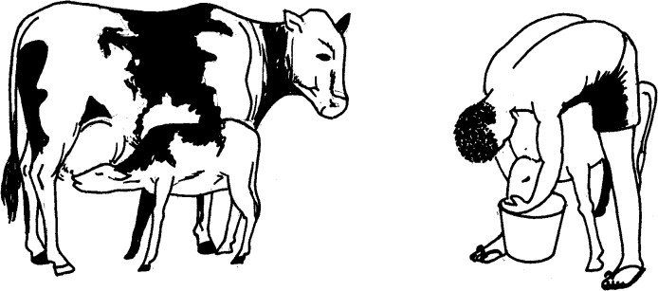
- The diagrams below show two methods of calf rearing. Study them carefully and answer the questions that follow.

A B
  - Identify method of feeding calf shown in the diagram A and B. (2 marks)
A………………………………………………………………
B….…………………………………………………………..
  - Give two disadvantages of calf rearing using method A. (1 mark)
……………………………………………………………………………………………………………………………………………………………………………………………………………………………………………………………………………………………………………………………………………………………………………………………………………………………………………………………

Give two examples of one-host tick. (2 marks)

…………………………………………………………………………………………………………………………………………………………………………………………………………………………………………………………………………………………………………………………………………………………………………………...

Explain three characteristics of a good acaricide. (1 ½ marks)

…………………………………………………………………………………………………………………………………………………………………………………………………………………………………………………………………………………………………………………………………………………………………………………………………………………………………………………………………………………………………………………..

Name three larval stages of a liverfluke. (1 ½ marks) ……………………………………………………………………………………………………………………………………………………………………………………………………………………………………………………………………………………………………………………………………………………………………..
- Complete the following table; (4 marks)
Fixed input (Layers) | Variable input (layers mash) | Total Physical Product (eggs) | Marginal product
100 | 0 | 140 | 0
100 | 10 | ………………….. | 15
100 | 20 | 180 | ………………
100 | 30 | 240 | 35
100 | 40 |  | 100
100 | 50 | 470 | ………………

Explain ways in which infectious diseases can be spread from one Livestock to another in a farm. (3 marks)

……………………………………………………………………………………………………………………………………………………………………………………………………………………………………………………………………………….………………………………………………………………………………………………………………………………………………………………………………………………………………………………………………………………………………………………………………………………………………………………

- Study the diagram of livestock below and answer questions that follow.
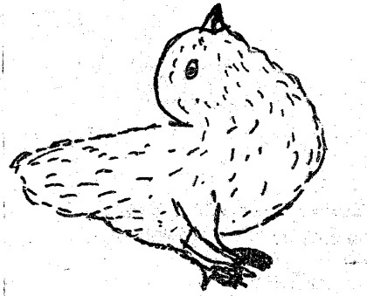
- What has led to the above condition. (1 mark)

…………………………………………………………………………………………………………………………………………………………………………………………………..
- State two effects of the above condition in poultry management. (1 mark)

……………………………………………………………………………………………………………………………………………………………………………………………………………………………………………………………………………………………………………
- The diagram below shows two different livestock families. Use it to answer the following questions.
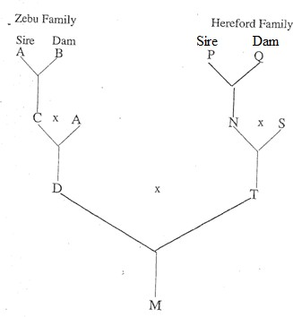
  - Identify the breeding system between:
- C and A (1 mark)
………………………………………………………………………………………………………………………………………………………………………
- D and T (1 mark)

………………………………………………………………………………………………………………………………………………………
  - State two advantages of breeding system identified in a (ii) above. (1 mark)

…………………………………………………………………………………………………………………………………………………………………………………………………………………………………………………………………………………………

The diagram below shows the relationship between feed requirements and foetal development in sheep. Use the graph to answer the questions.
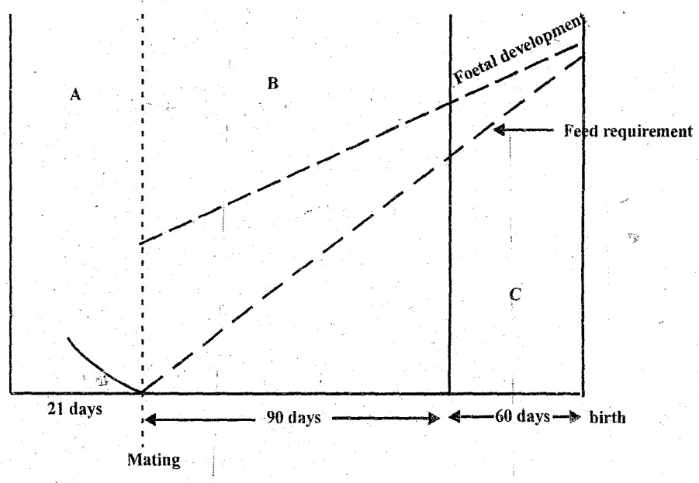

What are the feeding management practices in sections A, B and C? Give a reason for each. (3 marks)

A-

.

B-

C-

Use the graph to estimate the gestation period in sheep. (1 mark)

……………………………………………………………………………………………………………………………………………………………………………………..……………………………………………

Study the diagram below shows the power transmission mechanism of a tractor engine.

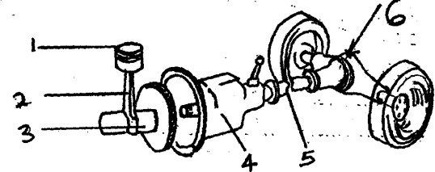

Name the parts 1 – 6. (3 marks)

……………………………………………………………………………………………………………………………………………………………………………………………………………………………………………………………………………………………………………………………………………………………………………………………………………………………

What technical term refers to attaching an implement to a tractor. (1 mark)
………………………………………………………………………………………………………………………………………………………………………………………………….
- a) Distinguish between silvopasture and agrisilviculture as used in agroforestry. (1 mark)
………………………………………………………………………………………………………..
b) Identify the following methods of harvesting trees. (2 marks)
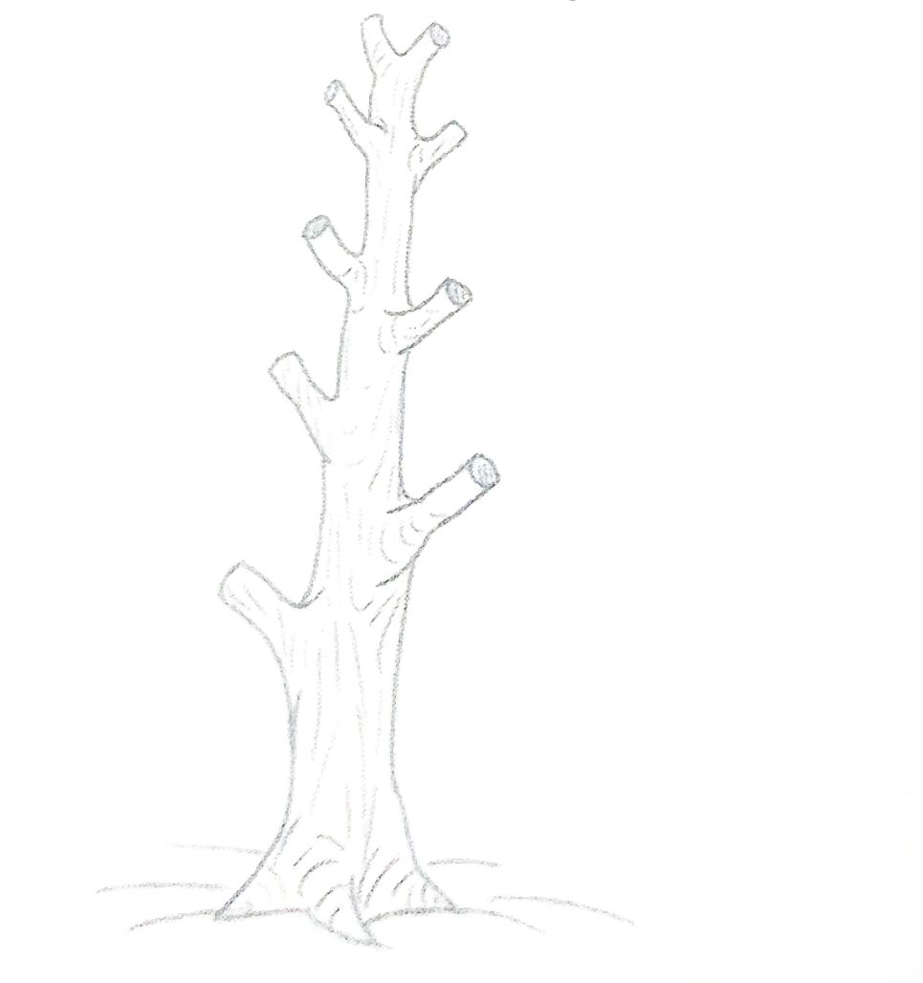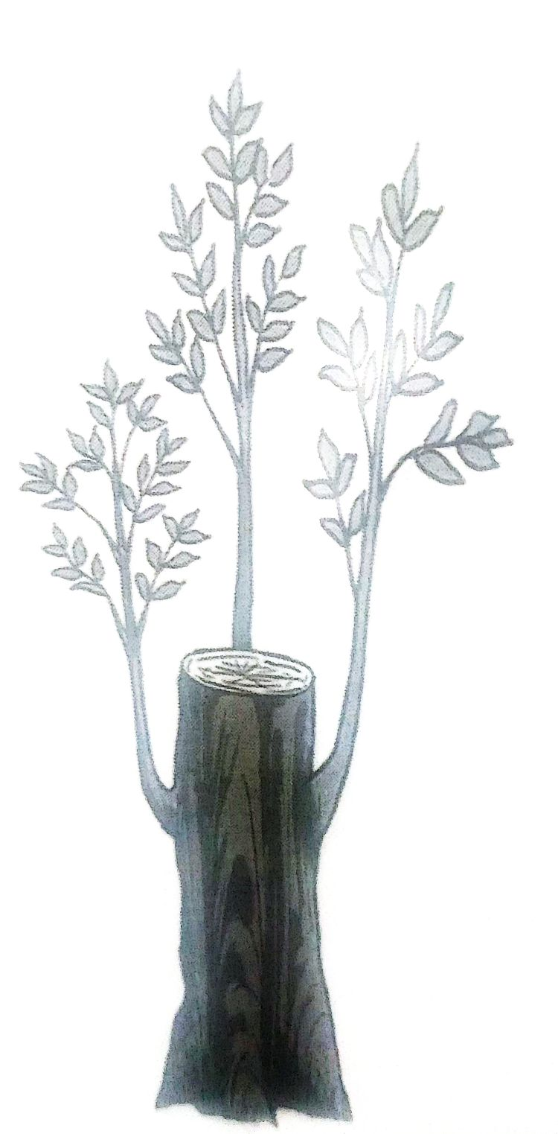
A………………………. B……………………………………
- State six ways in which a farmer can adjust to risks and uncertainties. (6 marks)
…………………………………………………………………………………………………………………………………………………………………………………………………………………………………………………………………………………………………………………………………………………………………………………………………………………………………………………………………………………………………………………………………………………………………………………………………………………………………………………………………………………..
This is the LAST Printed Page.

