**KENYA CERTIFICATE OF SECONDARY EDUCATION 2023**

* **Geography Teachers’ Panel.**

** 312/ 1 Geography Paper 1**

**Geography Teachers’ Panel Examination.**

**TERM 2 Exam**

**June 2023**

***2 ¾ hours school***

***MARKING SCHEME***

|  |  |
| --- | --- |
|  | Turn over |

***This paper consists of 12 printed page***

***SECTION A***

***Answer all the questions in this section***

1. **a. Define an orbit (2mks)**

* it is a path followed by the planets and other heavenly bodies as it goes round the sun.

**b. What is the longitudinal of a place X whose local time is 8.00am, when the local time at** **Greenwich meridian (0o) at noon? (3mks)**

* the difference in time of longitude between the two towns

12-8=4hours

The difference in time between 1o longitude is 4min.

1 hr = 15 o

4 hrs = ?

4 ×15/1 =60o

X is west of the **Greenwich meridian**, it is behind. Therefore the longitude of X is =**600 W**

**2. (a) Name three transitional zones of the atmosphere. (3mks)**

- Tropopause

-Stratopause

-Mesopause

**b) (i) State any one reason why the stratosphere experiences negative lapse rate. (1mks)**

-The presence ozone layer at the coiling which traps the short energy radiation rays/isolation thereby raising the temperature of the upper layer/ceiling of the stratosphere

**(ii) Name the weather instruments used in measuring the rate of evaporation in a weather station. (1mk)**

-Evaporimeter

**3. a)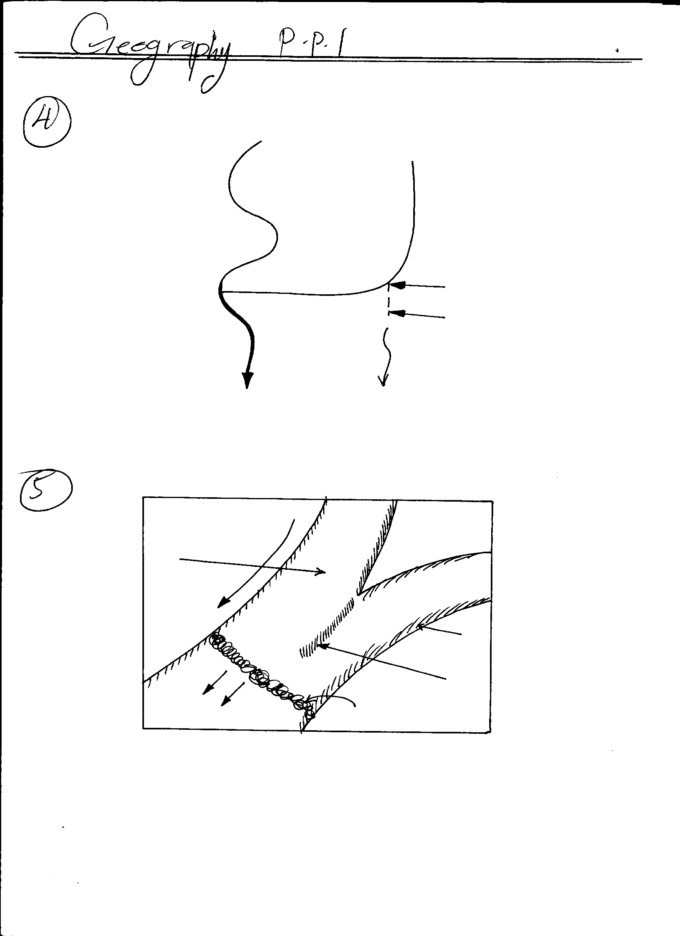The diagram below shows the movement of the glacier.**

**Y**

**Z**

**X**

Melt water

Movement of glacier

Glacier

**Identify the moraines marked X, Y, and Z (3mks)**

X – Terminal moraine (1mk)

Y – Lateral moraine (1mk)

Z - Middle / medial moraine (1mk)

1. **State two factors that influence the movement of glacier. (2mks)**
   * Gradient of the slope
   * The thickness and weight of ice
   * Friction along the floor
   * The season, whether summer or winter.

**4. a) i) What is a lake (2mks)**

* A lake is a body of water that occupies a basin, depression or hollow on the earth surface*.*

**ii) Give three characteristics of Rift valley lakes. (3mks)**

* some lakes are deep
* some lakes are narrow and elongated
* some lakes are saline
* some are fresh water lakes
* some contain hot springs
* some are shallow

**5. a) What is soil catena? (2 mks)**

* It is the arrangement of soil along a slope from top to bottom.

**b) State three factors that determine the colour of soil. (3 mks)**

* Humus content/ content of organic matter present in the soil: black/dark brown colour indicates a soil rich in humus
* Drainage of the area in which the soil is found: grey colour denotes a poorly drained and water logged soil
* Acidity/salinity/soil PH/ chemical composition of the soil: White colour denotes a soil with high salts concentration
* Type of parent material from which a soil has developed.

***SECTION B***

**6. Study the map of Kisumu East 1:50,000 (sheet 116/2) provided and answer the following questions.**

**(a) (i) Give the longitudinal extent of the Kisumu East map extract. (2mks)**

340 45’ to 35000’

**(ii) Give two methods used to show relief on the map (2mks)**

Contours

Trigonometrical stations

Rock drawing

**(iii State the approximate height of the hill in grid reference 9999 in the map. (2mks)**

(1441m -1459 m)

**(iv) Calculate the area of the area enclosed by the regional boundary towards the north west of the map extract (give your answer in square kilometres) (2mks)**

Full squares=4

Incomplete squares=12/2=6

=4+6=10 km2

1. **(i) Name two physical features found in grid square 0698 (2mk)**
   * + Hill
     + Steep slopes
       - River valleys
       - Saddles
       - Escarpment

**(iii) Draw a rectangle measuring 10cm by 6cm to represent the area enclosed by**

**Easting’s 00 to 05 and Northings 82 to 85 (1mk)**

**On the rectangle mark and name the following features:**

* **The river Ombenyi (1mk)**
* **The villages (1mk)**
* **Dry weather road (1mk)**

1. **Describe the relief of the area covered by the map (3mks)**

* The are many hills
* There are river valleys
* There are steep slopes
* There are escarpments (Nyando esacarpment)
* There are gentle slopes
* The highest point is 1872 m.

1. **Citing evidence from the map, identify two functions of the area covered by the map.**
   * Trading centre as evidenced by markets
   * Transportation centre as evidenced by roads
   * educational centre as evidenced by schools
   * admnistration centre as evidenced by DC ‘S office
   * health centre as evidenced by hospitals **( 4mks)**
2. **Citing evidence from the map, explain two factors that influence the distribution of**

**settlements in the area covered by the map. (4mks)**

* + There is linear settlement along the major transport routes especially the roads.
  + There are no settlements close to the swampy area for fear of diseases//difficult to construct houses.
* steep slopes evidenced by close contours few settlements because it is difficult to construct
  + River valleys have few /nil settlement e.g along the rivers because of fear of flooding /water born diseases
  + Market/shopping centers e.g Kisumu municipality have dense settlement attracted by social amenities/commercial activities

**7. (a) Give two types of volcanoes. (2mks)**

* Active volcanoes
* Dormant volcanoes
* Extinct volcanoes

**(b) The diagram below represents features of vulcanicity. Use it to answer the questions that follow.**

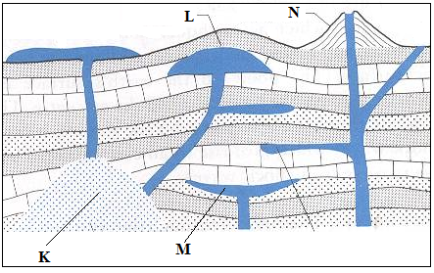

**Name the features labeled K, L and M. (3 mks)**

* **K** – Batholith.
* **L** – Laccolith.

**- M** – Lopolith.

**(b) Describe how a lava plateau is formed. (3mks)** ) – --Lava that is basic reaches the surface through fissure eruption

* Flows over long distance spreading evenly over large area.
* Cools slowly forming an extensive plateau
* Series of eruptions may form additional layers
* An extensive flat land consisting of layers of lava known as lava plateau is formed

**(c) (i) Name three volcanic features found in the rift valley of Kenya. (3mks)**

***Features formed***

* Hot springs
* Crater lakes
* Crater/caldera/crater lake
* Volcanic cones /volcanic mountains
* Lava plateau/plains lava
* Ash and cinder cones
* Plug domes /spines
* Fumaroles/solfatara

**(ii) Explain four negative effects of vulcanicity in Kenya. (8mks)**

* Volcanic features like mountains create barriers making constructing of transport lines expensive
* Rugged landscape hamper settlement and agriculture
* Volcanic mountains create rain shadow effect leading to aridity
* Volcanic eruption produces poisonous gases causing pollution of environment

Recent eruptions created poorly developed soils hindering agriculture

**(d) You intend to carry out a field study of a volcanic landscape.**

**(i) State four reasons why it is necessary to conduct a reconnaissance of the area of study.**

* Design research methods
* To prepare working schedule
* Helps in identifying the equipment to be used
* Helps in identifying features and their location
* To get guides
* To help identify possible problems likely to be experienced and their solutions (4x1=4mk

**(ii) State why you would need the following items.**

**Hammer (1mk)**

- Break rocks for closer examination

- to test the hardness of the rocks

**Polythene bag (1mk)**

-To carry the rock samples collected for further study

**8. (a) (i) What is a rock?**

An aggregate of mineral particles forming the solid part of the earths crust (2 mks)

1. **Explain the process of formation of mechanically formed**

**sedimentary rocks. (5 mks)**

* 1. Weathering or erosion takes place previously existing rock.
  2. The sediments are then transported by wind, water or moving ice.
  3. They are then deposited in layers; strata.
  4. Fine particles fill in between large particles.
  5. Overtime particles are compressed and consolidated due to weight of materials to form a hard compact rock

**(b) Explain four ways in which rocks are significant to economy of Kenya.**

**(8 mks)**

* Some rocks formation are tourists attraction e.g. Kti Mikai and hence earn foreign exchange.
* Provide employment and are source of income to man people in activities

e.g. quarrying and mining.

* Rocks contain minerals which when mined earn income hence raising living standards
* Some rocks are used in building and construction.
* Some stones such as Kisii soapstone, marble are used to make beautiful carving. These are sold to earn income.
* Act as source of rivers
* Source of soil formation.

**(c) Students from your school carried out a field study on the type of rocks:**

**(i) One of the rock samples they collected is coral.**

**Give three uses of this type of rock. (3 marks)**

* Calcium carbonate is a raw material for cement.
* Used by polyps to build exoskeleton which leads for formation

of petroleum underneath.

* Making of Ornaments.

1. **Give three methods of data collection they may have used during**

**their study. (3 mks)**

* Direct observation.
* Secondary source / Content analysis
* Administering questionnaire.
* Interviewing.
* Experimentation
* Photographing.
* Sampling.

1. **State four problems they are likely to have encountered during**

**the field study. (4mks)**

* Slipping and falling.
* Bad weather e.g. heavy rainfall.
* Attacks by wild animals such as snakes.
* Poor transport due to impassable roads.
* Tiredness/fatigue due to steepness of the area.
* Students are likely to fall sick.

**9. a) i) Define Karst Scenery (2mks)**

An area of limestone diatomite or salt which is associated with uniquely developed features.

**ii) State three conditions necessary for the development of karst landforms (3mks)**

* The surface rock and the rock beneath should be thick limestone, dolomite or chalk
* The rock should be more resistant and well jointed
* The climate should be hot and humid to enhance chemical weathering
* The water table in the limestone rocks should be deep below the surface

**b) i) With the aid of well labelled diagrams explain how Grikes and clints are formed** Rain water absorbs carbon dioxide in the atmosphere forming weak carbonic acidOn reaching the surface of the earth it reacts with calcium carbonate leading to calcium bicarbonate or calcium hydrogen carbonate which is soluble in waterThe water solution enters the rock through the joints and dissolves the limestone through solutionThe joints are enlarged and deepened forming a surface criss-crossed with a wide irregular galleys called grikes

The galleys are separated by ridges or blocks of limestone called clints

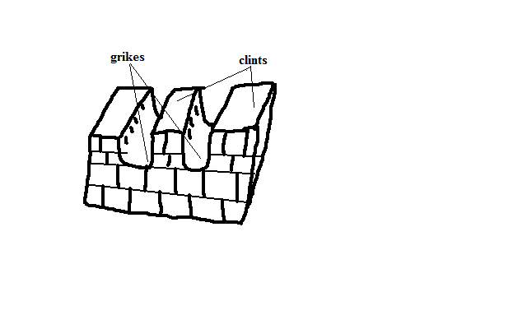

**(4mks)**

**ii) Apart from Grikes and clints name two other surface features. (2mks)**

* limestone pavements
* swallow holes
* dolines/ collapse dolines
* uvalas
* polje
* dry valleys
* blind valleys
* sink holes
* scarp hills & Mt ranges

**c) i) State three reasons why there are few settlements in karst landscapes. (3mks)**

Grikes and clints create rugged landscapes hence hindering farming.

Karst scenery has thin soil which don’t favor crop farming

This area also experiences inadequate water because much of the water is subterranean

**d) 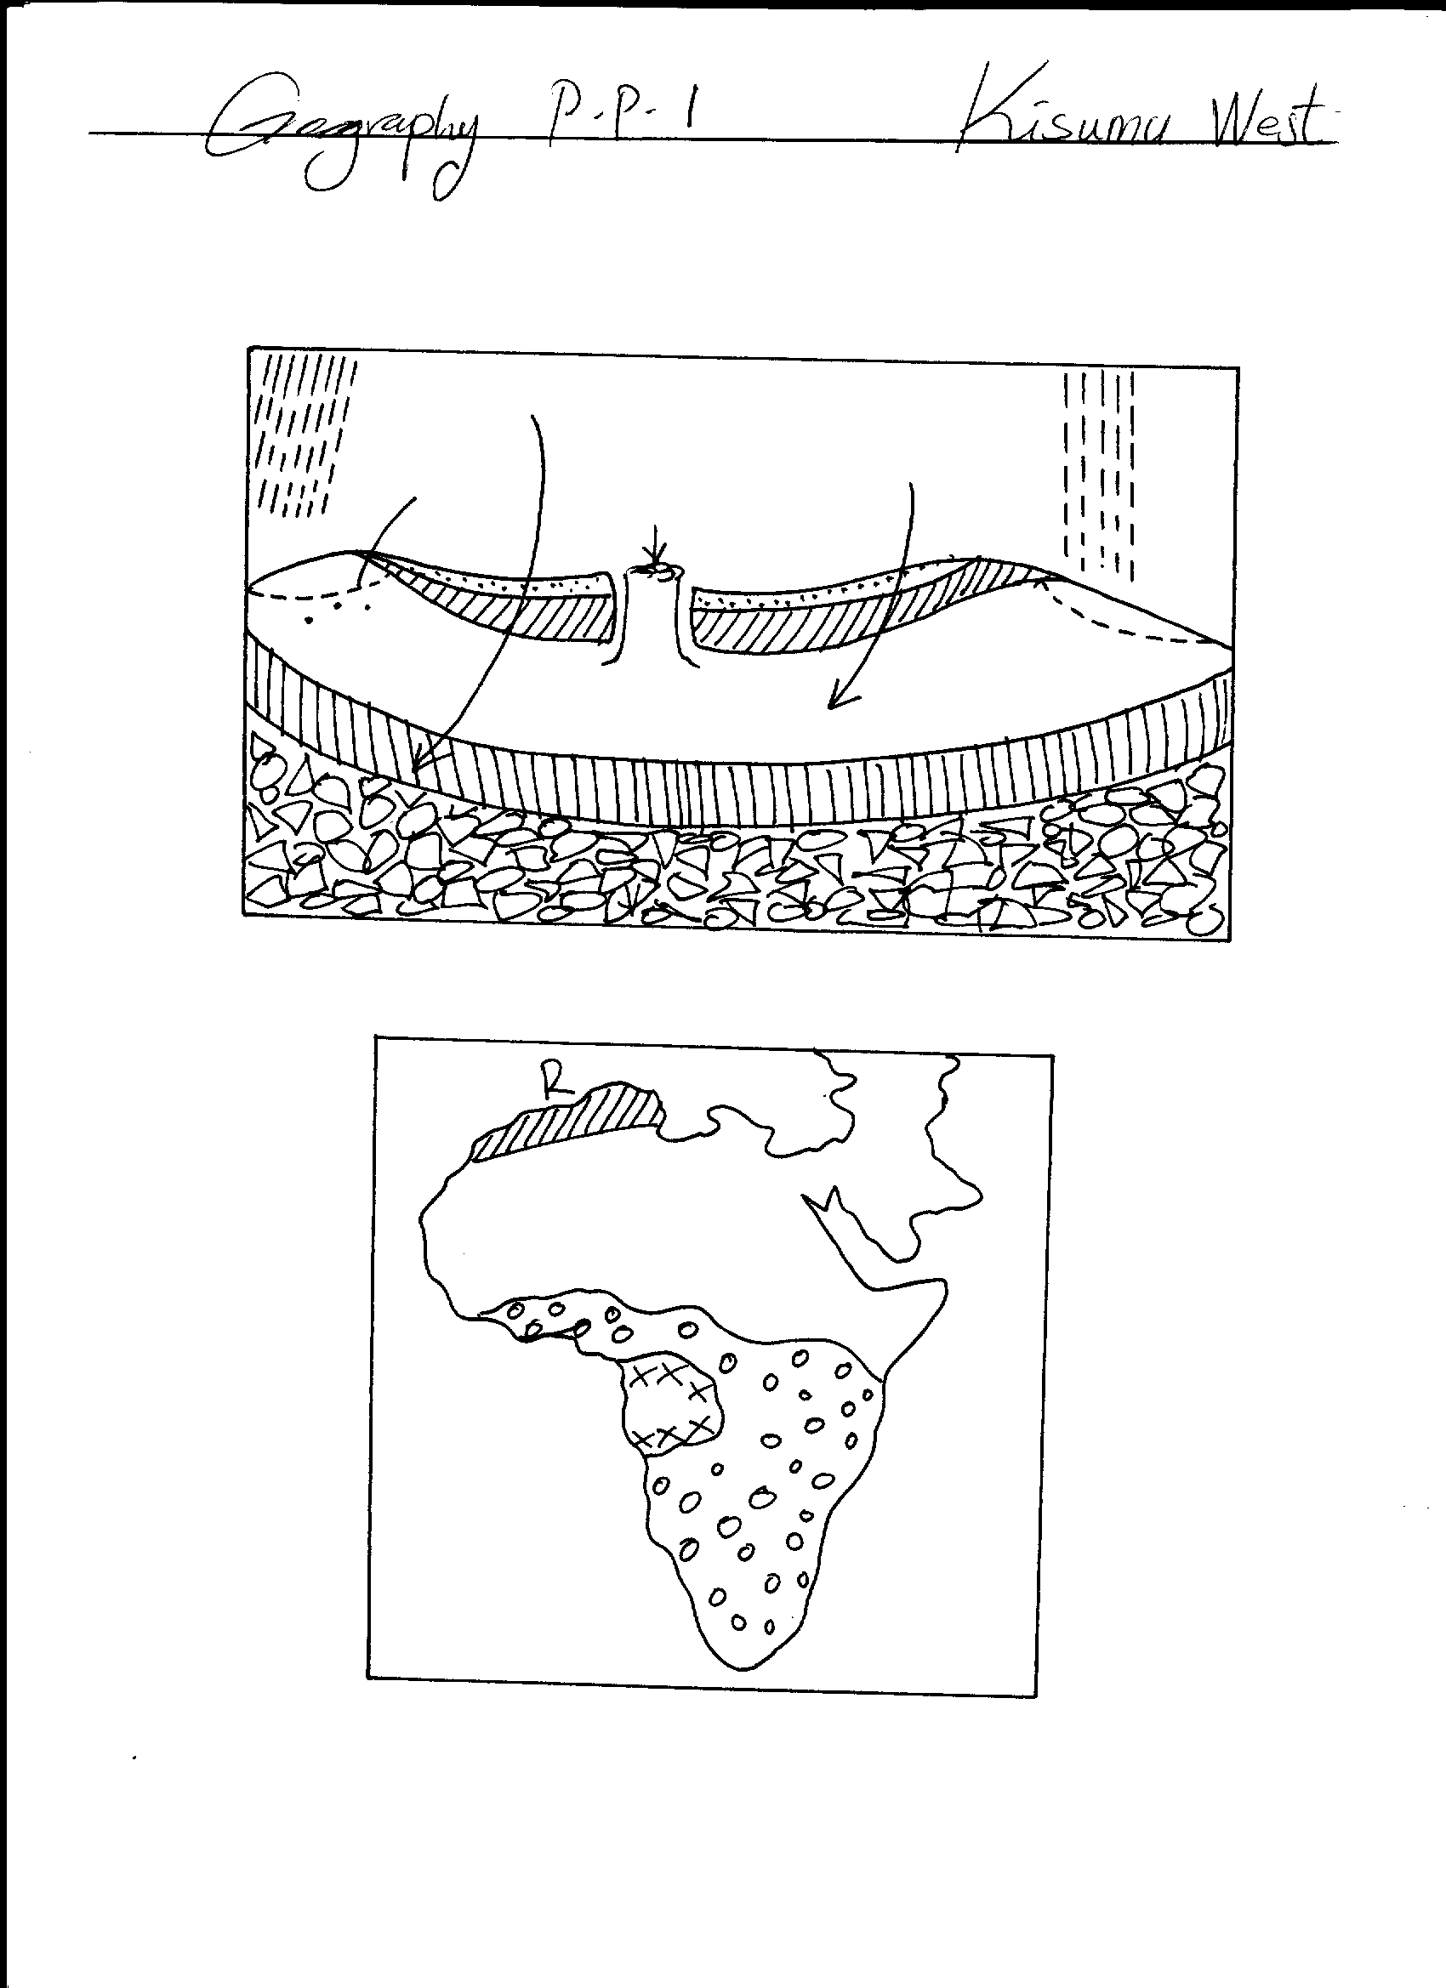Use the diagram below to answer the questions that follow**

**Rain**

**A**

**Rain**

**Water table**

**B**

**C**

1. **Name the parts marked A, B and C. (3mks)**

**A-** Impermeable/aquifuge

**B-** Artesian well

**C-** Aquifer

**ii. Give four conditions necessary for the formation of the above feature (4mks)**

* The acquifer must be sandwitched between impermeable rocks so that it can retain water.
* The acquifer must outcrop in a region which is a source of water.
* The acquier must dip from a region of water intake and the rock layers must

form a broad syncline or basin.

* The mouth of the well must be lower than the intake area.

**e) Explain two significance of karst scenery to man. (4mks)**

* The surface and underground features attract tourists who in turn bring revenue or foreign exchange for a country’s development
* Limestone landscapes discourages settlements due to their rugged nature and thin soils
* Limestone rocks/blocks are used as building materials and for cement manufacture
* Limestone areas have thin soils hat are suitable for sheep farming/grazing

**10. (a) What is the hydrological cycle? (2mks)** -The hydrological cycle refers to the endless interchange of water between the sea, atmosphere and land.

**(b) Describe the following processes of the hydrological cycle. (6mks)**

**Surface runoff**: Some of the water from precipitation that flows on the surface into valleys, ponds, lakes, etc.

**Percolation**: Downwards and sideways movement of water that has entered into the ground.

**Evapotranspiration**: Combined loss of water from the soil through direct evaporation and transpiration by plants.

**(c) (i) Explain three processes of river transportation. (6mks)**

**- Solution**- this occurs where soluble minerals dissolve in the water and are carried in solution form

- **Suspension** – light materials are carried within the water currents

**- Saltation** medium sized materials are carried in series at hops/jumps

- **Traction** – heavy materials are pushed/rolled or slide along the river bed down stream

**(ii) State four factors that lead to river deposition. (4mks)**

- Reduced river gradient

- Reduced river volume

- Increased amount of the load

- Presence of obstacles/increased resistance along the river bed

- Freezing at the river water

- River entering into a calm water body

**(d) Your class conducted a field study on the work of rivers around your school compound.**

**(i) State three preparations you made before the field study. (3mks)**

- Identify the area/place to conduct the field work

- Seek permission from the school administration

- Conduct reconnaissance visit after writing a permission letter

- Collect relevant tools and equipment for the field work.

**(ii). Give two examples of rivers in Kenya you identified to conduct the field study on river capture. (2mks)**

1. River Miriu / Sondu –Miriu
2. River Tiva /Galana

**(iii) Identify two problems you might have encountered during the field study. (2mks**

**-**High temperature/scorching sun/rainy weather that may hinder the study

- Fear of being attacked by wild animals

- Inaccessibility of some parts of the river

***End!***