SIAYA GEOGRAPHY ASSOCIATIONJOINT EXAMINATION (SIGEA) 2023
Kenya Certificate of Secondary Education
312/1 – GEOGRAPHY – Paper 1
JUNE - 2023
2 ¾ Hours
Name…………………………………………..School…………………………………………..

Class…….… Index Number………………….. Adm No…………. Date……….……..

INSTRUCTION TO CANDIDATES
- Write your name and Index number in the spaces provided at the top of the page.
- Answer all the questions in Section A. In section B answer question six and any other two questions from this section.
- All answers must be written in the answer booklet provided.
- This paper consists of five printed pages.
- Candidates should check the question paper to ascertain that all page are printed as indicated and that no question is missing.
SECTION A
Sub- Total
Question Number | 1 | 2 | 3 | 4 | 5
Marks
SECTION B
Sub- Total
Question Number | 6 | 7 | 8 | 9 | 10
Marks

GRAND TOTAL

SECTION A
Answer ALL Questions In This Section
1.(a) Define the term ecology. (2marks)
(b) State three reasons why it is important to study geography (3marks)
2.(a) Name the two theories that seek to explain the origin of the solar system (2marks)
(b)Give three characteristics of the oceanic crust (3marks)
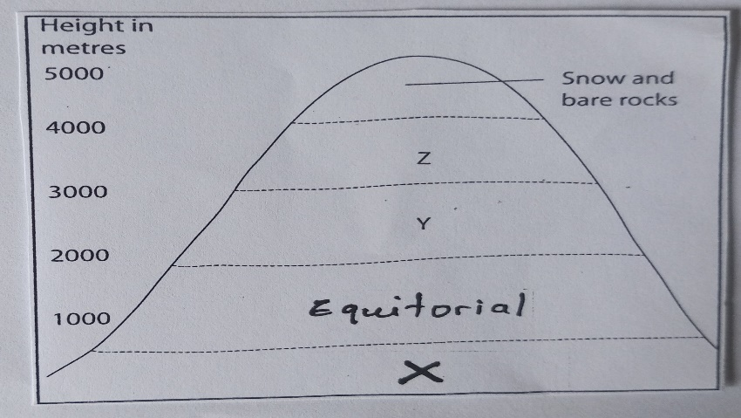
3.The diagram below represents zones of natural vegetation on a mountain. Use it to answer questions (a) and (b)

- Name the zones marked X, Y and Z (3marks)
- Give two reasons why the mountain top has no vegetation (2marks)
4. Describe granular disintegration as a process of physical weathering (5marks)
5.(a) Differentiate between a watershed and a catchment area (2marks)
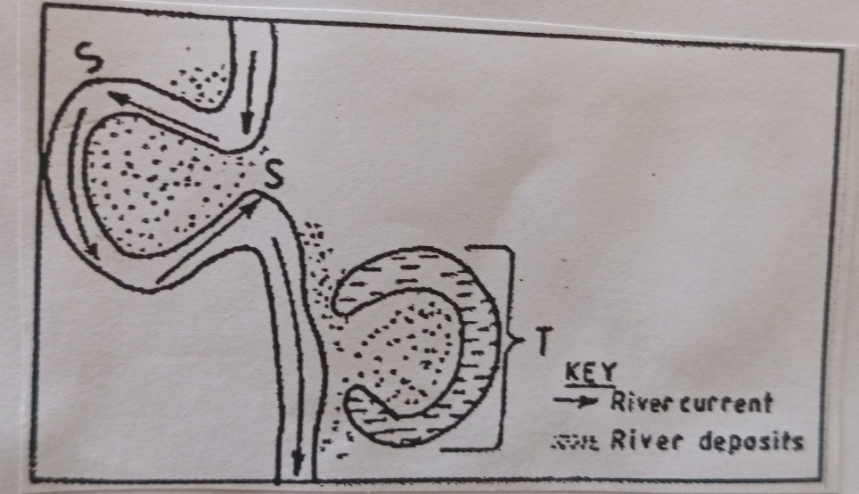
(b) The diagram below shows a section of a river. Use it to answer the question that follow.

(i) Name the process that takes place at the part of the river marked S (1mark)
(ii) State two conditions necessary for the formation of the feature marked T (2marks)
SECTION B
Answer Question 6 And Any Other Two Questions From This Section.
6.Study the map of Kisumu East 1:50,000 (Sheet 116/2)
- i)What type of Map is Kisumu East? (1mark)
ii) In what hemisphere does Kisumu East lie? (1mark)
iii) Give the altitude of the highest point in the area covered by the map (2marks)
iv) Give the six figure grid reference of the Air Photo Principal found in the lake at the South East of the area (2marks)
- i) What is the bearing of trigonometric station at grid square 0383 from Air Photo Principal point at grid square 0286 (2marks)
ii) Measure the length of the Provincial boundary to the west of Easting 00. Give your answer in kilometers. (2marks)
iii) Identify two forms of land transport in Kisumu East (2marks)
- i) Using a scale of 1cm to represent 50 metres, draw cross-section along northing 99 from Easting 04 to 10 (4marks)
ii)On the cross section mark the following
- River (1mark)
- Hill (1mark)
- Footpath (1mark)
iii) Calculate the vertical exaggeration (V.E) of the section (2marks)
- Describe the long profile of River Ombeyi (4marks)
7.(a) i) What are hypabyssal rocks? (2marks)
(ii) Name three examples of hypabyssal rocks. (3marks)
b) i) State three factors that influence rock metamorphism (3marks)
(ii) Describe the following processes of formation of Metamorphic rocks
- Dynamic Metamorphism (4marks)
- Thermal Metamorphism (4marks)
(c)explain the significance of rocks to the economy of Kenya under the following sub headings
(i) Agriculture (2marks)
(ii) Energy (2marks)
(d)You are planning to carry out field study on the rocks within your school environment
(i)Name two secondary sources of information you would use to prepare for the field study
(2marks)
(ii) State three activities you would carry out during the study (3marks)
8.(a) i) Apart from nappe fold, name three other types of folds. (3marks)
(ii) With an aid of well labelled diagram, describe how a nappe fold is formed (8marks)
(b)i) Identify any two orogenies known to exist in the geological time scale (2marks)
(ii)Name three countries where Alps mountains are found (3marks)
(iii)Describe how fold mountains could have formed by contraction theory (4marks)
(c)You are planning to carry out a field study of an area affected by faulting
(i)State three reasons why it is important for you to go for a pre-visit of the area (3marks)
(ii)State two follow up activities you would do after the study (2marks)
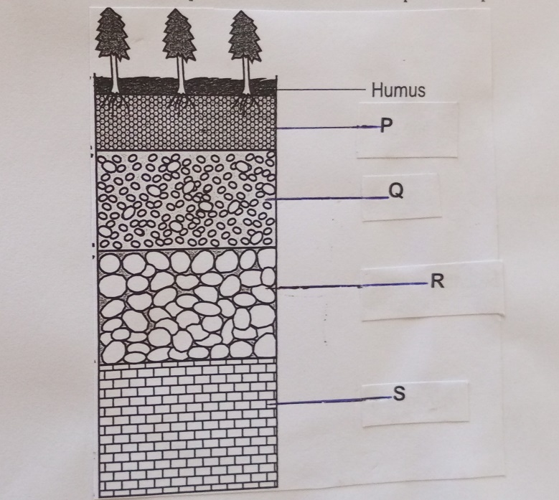
9.The diagram below represents a well-developed soil profile. Use it to answer question (a)

(i) Name the soil layers marked Q, R and S (3marks)
(ii)Describe the characteristics of the layer marked P (4marks)
(b)(i) What is soil catena? (2marks)
(ii)Identify three types of soil based on soil order (3marks)
(c) (i)Explain how the following factors influence soil formation
- Parent rock (4marks)
- Climate (6marks)
(ii) State three activities that may be undertaken in your school to conserve soil. (3marks)
10.(a) (i)The full moon is seen rising today at 7: 00pm.What is the exact time that the moon will rise tomorrow (1marks)
(ii)Name the three types of ocean islands (3marks)
(iii) State the sources of salts in the ocean (3marks)
(b) Explain hydraulic action as a process of wave erosion (4marks)
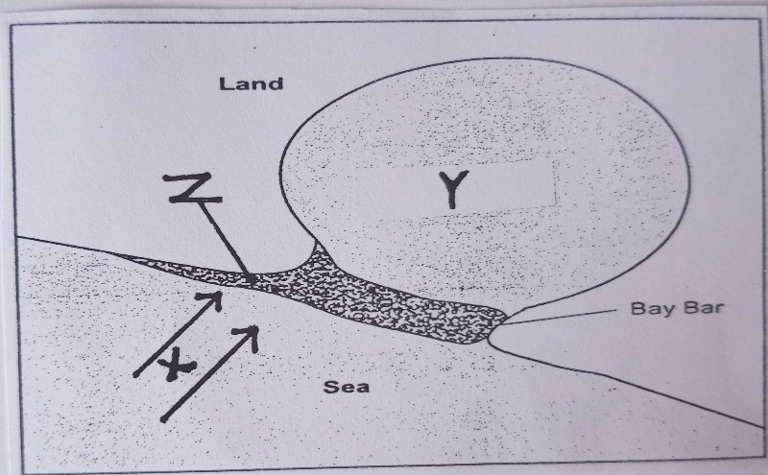
(c) Study the diagram below and answer the questions that follow

(i) Name the features marked X and Y (2marks)
(ii) Describe the formation of the feature marked Z (6marks)
(d)Explain three ways in which Coastal land forms are significant to the economy of Kenya
(6marks)

THIS IS THE LAST PRINTED PAGE

