231/3 - BIOLOGY - Paper 3
1 ³/₄ Hours

MOCK 2023
Name………………………………………Adm No…….............
Index Number.......…………….......... Date………………........
Kenya Certificate of Secondary Education
Instructions to Candidates
- Write your name, Admission number and your other details in the spaces provided above.
- Spend the first 15 minutes of the time allocated to read through the question paper before commencing your work
- Answer ALL the questions in the spaces provided.
- Additional pages must not be inserted
- For Examiner's Use Only
Question | Maximum Score | Candidate’s Score
1 | 13
2 | 16
3 | 11
Total Score | 40

- You are provided with the following materials;
Substance labelled L
2cm³ Copper sulphate solution
2cm³Sodium hydroxide solution
2cm³ DCPIP solution
2cm³ Benedict’s solution
Source of heat
3 test tubes
3 droppers
You are provided with a substance labeled L. Make a solution of substance L by adding 20 ml of distilled water and stir thoroughly. Design an experiment to investigate the food materials present in L. (9 marks)
Substance | Chemical test | Procedure | Observations | Conclusion
L

L

L

- State the importance of the food substances present in L to the human body. (2 marks)
…………………………………………………………………………………………………
…………………………………………………………………………………………………
- Describe how the body deals with the substances mentioned in (a) above when they are in excess. (2 marks)
…………………………………………………………………………………………………
…………………………………………………………………………………………………
2. Study the photographs below and answer the questions that follow.
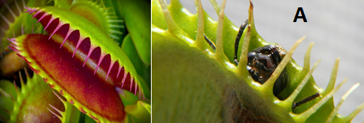
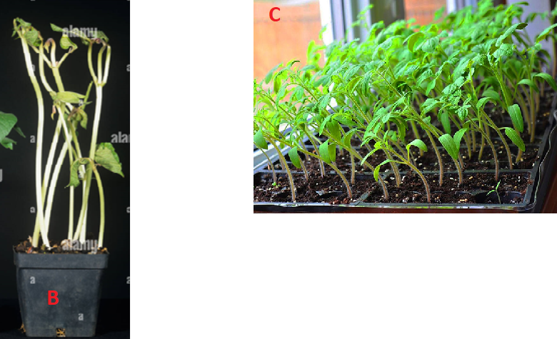
- (i) Identify the type of response exhibited by specimen A. (1 mark)
…………………………………………………………………………………………………
(ii)What is the survival value of the response you have identified in (a)(i) above. (1 mark)
…………………………………………………………………………………………………
- (i) Identify the phenomenon exhibited by specimen B. (1 mark)
…………………………………………………………………………………………………
(ii) State the significance of the phenomenon in (b) (i) above. (1 mark)
…………………………………………………………………………………………………
- Explain how the response exhibited by seedlings in photograph C occurred. (3 marks)
…………………………………………………………………………………………………
…………………………………………………………………………………………………
…………………………………………………………………………………………………
- Study the photograph below showing a certain trait in man.
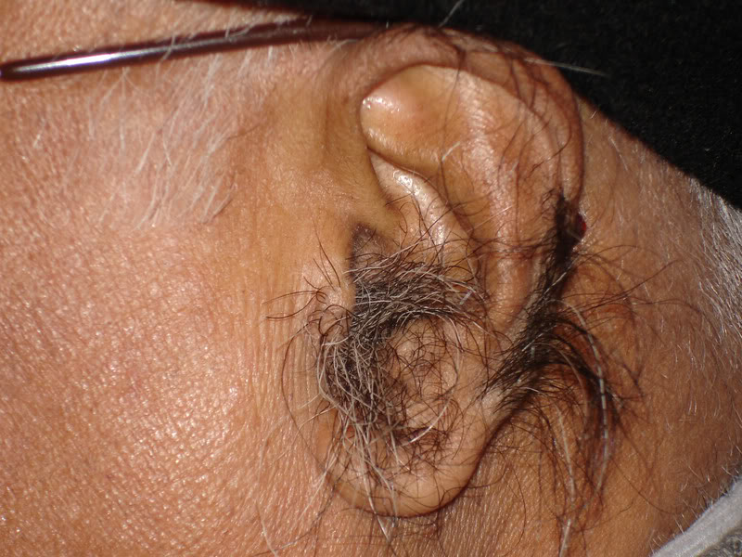
- Identify the trait exhibited in the photograph above. (1 mark)
…………………………………………………………………………………………
- The trait you have identified in (d)(i) above is sex linked. In which chromosome is it contained. (1 mark)
…………………………………………………………………………………………

- Name any other sex linked trait in man. (1 mark)
…………………………………………………………………………………………
- The man in the photograph married a woman. Use a genetic cross to predict the offspring of the above marriage. Let Y^{H} represent the gene for the trait above. (4 marks)

- The photographs below show certain chromosomal mutations.
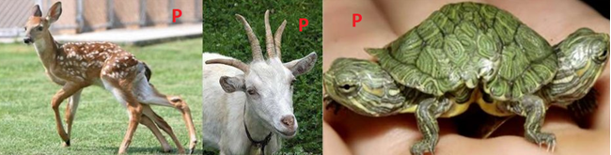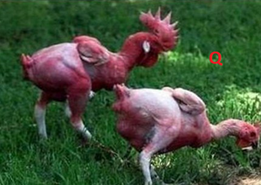
- Identify them
P ………………………………………………………………………… (1 mark)
Q ………………………………………………………………………… (1 mark)

3. Study the photographs below and answer the questions that follow.
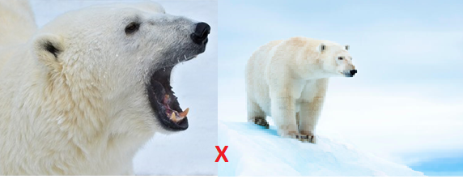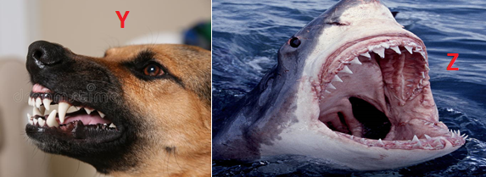
- Give two visible survival adaptive features for the organism in photograph X. (2 marks)
…………………………………………………………………………………………………
…………………………………………………………………………………………………
- Identify the dentitions exhibited in photograph Y and Z (2 marks)
Y ……………………………………………………………………………………………
Z ……………………………………………………………………………………………

- Study the photographs below showing a certain type of tooth and teeth arrangement in man.
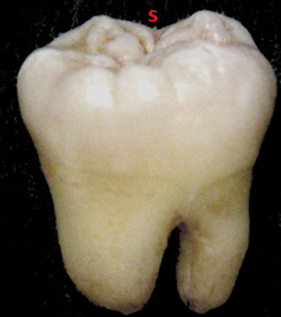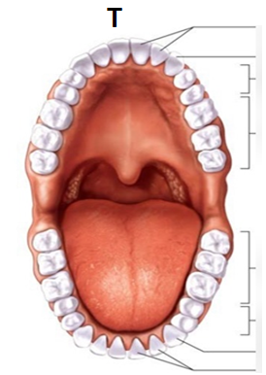

- Label any three parts of the tooth in photograph S. (3 marks)
- Give two adaptations of the tooth to its function. (2 marks)
…………………………………………………………………………………………………
…………………………………………………………………………………………………
- Write the dental formula for the teeth arrangement in photograph T. (1 mark)

This is the last printed page

