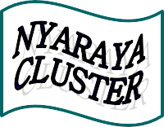

Nyaraya Cluster Examination
Kenya Certificate of Secondary Education

2023 Form Four Evaluation Programme

312/1 GEOGRAPHY Paper 1
JULY/AUGUST 2023

312/1
GEOGRAPHY PAPER1
JULY 2023

MARKING SCHEME

SECTION A

1. The diagram below represent the flow of air currents. Use it to answer question a and b.
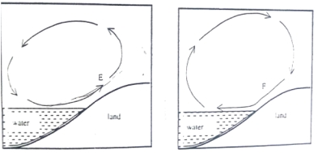
- Name the air current marked F. (1mk)

F – Land Breeze (1mk each)
b) Describe how the air current marked E occurs. (4mks)

- During the day, land heats faster than the sea/lake
- Air on land rises
- Cool air from the sea/lake moves to the land
- Cool air from the sea to the land is the sea/lake Breeze
(4 X 1mk)
2. a) What is Relative Humidity? (2mks)
This is the ratio of the actual amount of moisture/water vapour of a given mass of air to the maximum amount of moisture/water vapour it can hold at the same temperature. (2 X 1mks)
b) The table below shows temperature readings of Dry bulb thermometer and wet bulb thermometer in three weather stations.

STATION | DRY BULB THERMOMETER | WET BULB THERMOMETER
J | 30⁰C | 28⁰C
K | 30⁰C | 5⁰C
L | 30⁰C | 30⁰C

Give the state of relative humidity in station J, K and L. (3mks)
J – High Humidity
K – Low Humidity
L – 100% (1mk each)
3 a) Differentiate between a magnitude of an earthquake and intensity of an earthquake. (2mks)
Magnitude of an earthquake is a measure of energy given off by an earthquake while intensity of an earthquake is a measure of how strong/hard the earthquake shakes the ground. (2 X 1mk)
b) Describe how a dyke is formed. (3mks)
- Magma under high pressure enters crustal rocks
- The semi fluid rock/magma forces itself into vertical cracks/fissures.
- The magma cools and solidifies in vertical cracks.
- The vertical sheet of igneous rock is the dyke.
(Any 3X 1mk)
4 a) Name two types of ice masses found on mountains in East Africa. (2mks)
- Valley glaciers
- cirque glaciers
- Ice caps (Any 2 X 1mk)
b) State three distinctive characteristics of a pyramid peak. (3mks)

- Has steep sides
- Is surrounded by cirques
- Is a sharp rock pinnacle/horn
- Has a radiating systems of a retes. (3 X 1mk)
5 a) Name two ocean currents along the Western Coast of Africa. (2mks)
- Benguela
- Guinea
- Canary
(2 X 1 mk)
b) State three causes of ocean currents. (3mks)
- Differences in water density/salinity
- Differences in ocean temperature
- Wind blowing over ocean
- Rotation of the earth
- Shape of the coastal landmass
(Any 3 X 1mk)
6. Study the map of Kisumu East 1:50,000 (sheet 116/2) provided and answer the following questions.
- i) What type of map is Kisumu East Sheet? (1mk)
Topographical map
(1 X 1mk)
ii) Give the vertical interval of the map. (1mk)
20m
(1 X 1mk)
iii) State the latitudinal and longitudinal position of North West corner of the map. (2mks)
O⁰oo^{l}, 34⁰45^{l}E
OR
Lat O⁰ oo^{l}
Long 34⁰45¹E
(1 X 2mks)

- i) What is the bearing of the trigonometrical station at Grid reference 081980 from rock outcrop at grid reference 071992? (2mks)
139⁰ $±$ 1⁰ (138⁰ – 140⁰)
(1 X 2mks)

ii) Measure the length of all weather road bound surface B2/1 from the junction at Grid reference 974911 to the edge of the map grid reference 947967. Give your answer in kilometres. (2mks)
7.2km $±$ 0.1 (7.1 – 7.3 km)
(1 X 2mks)

- i) Draw a cross section between Grid Reference 070940 and 070980. Use a vertical scale 1cm to represent 100 metres. (4mks)

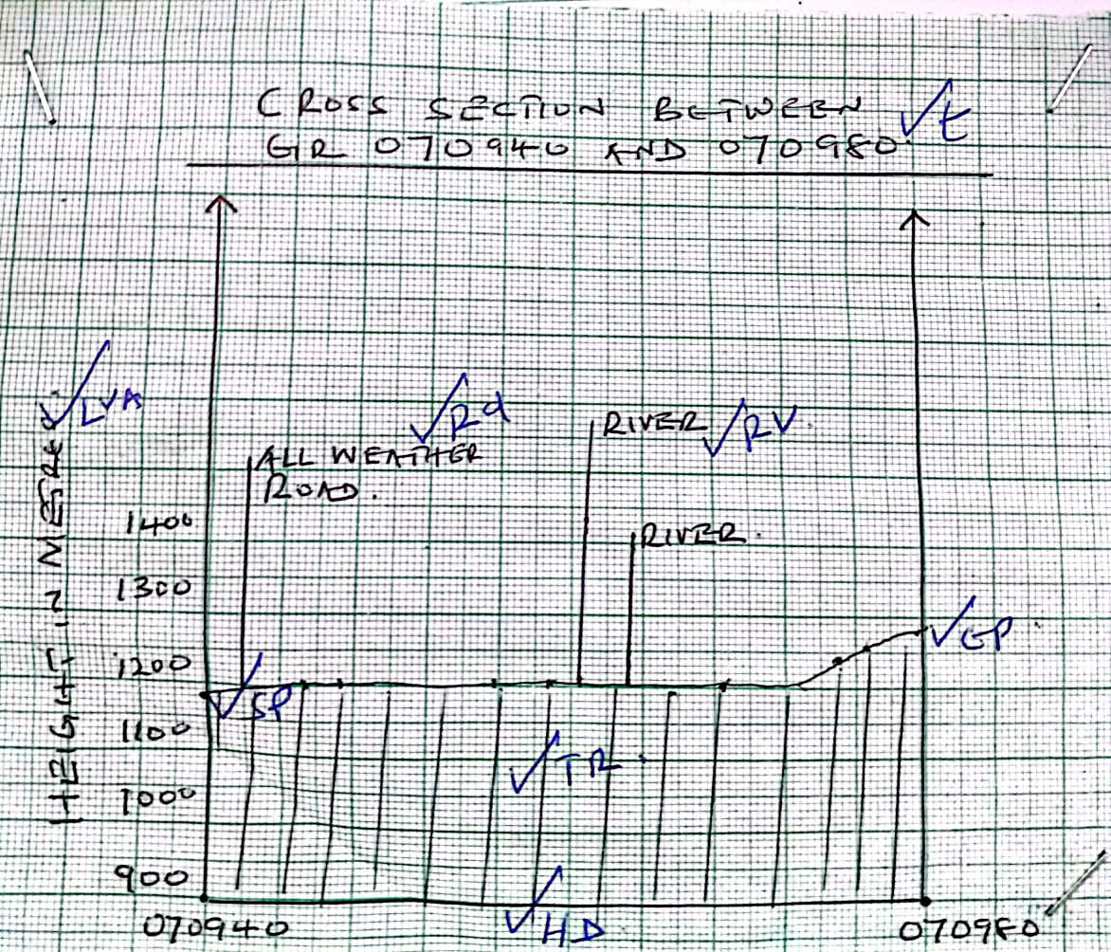

T – 1
VA – 1
HA – 1 5 max 4mks
TR – 1
SP/EP- 1

ii) On the cross section, mark and name:-
- All weather road bound surface. (1mk)
RD – 1

- River (1mk)
RV – 1
iii) Calculate the vertical exaggeration (VE) of the cross section. 2mks)
V.E = $\frac{V . S}{H. S}$

⁼ ¹/_{10,000} ÷ ¹/_{50,000}

= ¹/₁₀₀₀₀ × ^{50,000}/₁
_{= 5 times}

- Describe the relief of the area covered by the map. (5mks)
- The highest area Nyando escarpment/1872m asL
- The lowest area is the South West/1140m asL
- Land slopes from North to South West
- There is Nyando escarpment.
- The East is a plain / Kano plain
- The north western part is hilly with steep slopes
- The east has gentle slopes
- The landscape in the northern part is dissected by rivers
- The south west is a basin/depression occupied by a lake.
- There are many river valleys. (5 X 1mk)

e) Citing evidence from the map, give two social services offered in Kisumu Town. (4mks)
Social services | Evidence
- Educational | - School
- Religion | - Mission/church
- Rehabilitation | - Prison
- Housing | - Huts/built up areas
- Water supply | - Water works
- Health/medical | - Hospital
- Security | - Police lines/police station
- Administration | - DO/DC
- Recreation | - Stadium
- Burial | - Cems/cem

(2 X 2 mks)
7. a) Describe the following characteristics of minerals.
- Lustre (2mks)
- This is the appearance of a mineral as it reflects light.
- Some minerals are dull while others are shinny. (1X2mks)

- Density (2mks)
- Minerals have different weight per unit volume of water.
- Some minerals are heavy while others are light. (1 X 2mks)

- Cleavage (2mks)

- Minerals have patterns in which they break
- Some Minerals break into thin layers while others break along layers.
(1 X 2mks)
b) Giving an example for each, describe the three types of mechanically formed sedimentary rocks. (9mks)
- Arenaceoust - made up of particles of size of sand
Example – Grit/sandstone.
- Agillacteous made up of very small particles such as those of clay and mud
Example – shale/clystone/siltstone/mudstone/loess
- Rudaceouts. Made up of particles larger than sand
Example – conglomeretes/Breccia/ Bounder clay. (3 X 3mks)
c) You are required to carry out a field study on the types of rocks within the vicinity of your school.
i) State four reasons why you would conduct a reconnaissance (4mks)
- To seek permission for the visit
- To prepare a work schedule
- To determine appropriate tools for the study
- To find out possible problems likely experienced during the field study
- To determine appropriate methods of data collection
- To formulate study objectives
- To formulate study hypotheses
- To draw a route map
(Any 4 X1mk)
ii) State how you would use the following items during the field study.
- Geological hammer (2mks)
- Hitting for breaking rocks into portable pieces
- Hitting the rocks to determine hardness. (1 X 2mks)

- Magnifying lens (2mks)
- For viewing rock crystals to determine their shapes/sizes (1 X 2mks)
- Geological map (2mks)
- To guide on the types/location/distribution of rocks in the area. (1 X 2mks)

8 a) Give two types of Earth Movement within the earth’s crust. (2mks)
- Vertical/Epeirogenic
- Horizontal/Lateral/Orogenic
(1 X 2mks)
b) i) Describe the origin of continents according to the theory of
- Continental Drift. (6mks)
- the earth was originally one huge landmass/super continent/pangea
- Pangea was surrounded by a large water body/sea/panthalassa
- Pangea split into two subcontinents to form two other landmasses called Lauvasia and Gondwanaland
- The two landmasses were separated by a sea called Tethys
- The two land masses further split
- Lauvasia broke to form continents in the Northern hemisphere
- Gondwanaland broke to form continents in the southern Hampshire
- The continents gradually drifted to their present position
(Any 6 X1)

ii) Explain the following evidence which support the theory of Continental Drift.
- Paleontological evidence. (2mks)
- The fossils of plants found in Africa are also found in other continents
(1 X 2mks)
- Paleoclimatic evidence. (2mks)
- Southern continents seem to have experienced large scale glaciation at same period/ presence of ancient glacial deposits in southern continents
( 1 X2mks)
- Sea floor spreading. (2mks)
Recent volicanic eruption in the Mid atlantic ridges fill the gaps left by drifting continents
( 1 X2mks)

C i) Name One fold mountain in .
- North America (1mk)
Rockies/Appalachians (1 x 1mk)
- Asia (1mk)
Himalayas (1 X 1mk)
- Africa (1mk)
Cape ranges/Atlas (1 X 1mk)
ii) With the aid of a well labeled diagrams, describe how fold maintains are formed (8mks)
- Extensive shallow depression called Geosyncline develop on the earth’s surface
- Prolonged and extensive erosion occurs on the surrounding higher grounds
- The sediments are deposited in the Geosyncline forming thick layers
- The weight of the sediments causes subsidence of the Geosyncline leading to accumulation of more sediments to great thickness
- Further subsidence of the geosyncline triggers off compressional forces which cause sediments to fold
- The folded layers of the geosyncline are thrust upwards to form fold mountain at the edge of the geosyncline
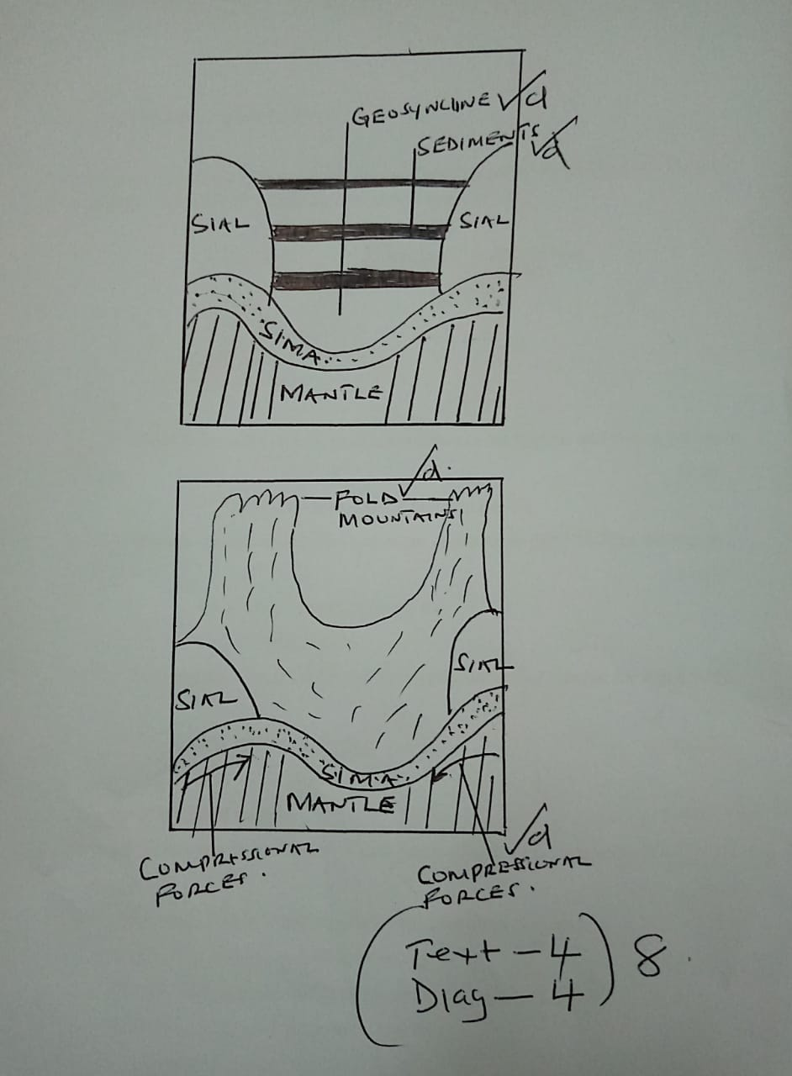

9 a) i) What is a river divide (2mks)
A river divide is a ridge line/ boundary line separating drainage/river systems/basins
ii) Describe the three types of River Erosion (9mks)
- Headward Erosion
Takes place at the river’s source.
It lengthens the river
- Vertical erosion
Takes place on the river bed.
It deepens the river
- Lateral erosion
Takes place on the river’s banks.
It widens the river channel
- X 3mks)
- Explain the following drainage patterns and systems
- Dendritic (2mks)
- It develops in areas where rocks have uniform structure
- Direction of flow is influenced by the slope of the land
- Tributaries join the main river at acute angles
- Tributaries converge on the main river forming s shape like that of a tree and its branches
(Any 2 X1mk)

- Superimposed (4mks)
- Develops on a rock structure that overlie a totally different one
- The river cuts through the surface rock layers into the underlying rocks
- Gradually the surface rocks are removed
- The underlying rock become exposed on the river bed
- The river maintains its original direction of flow despite the new rock structure
(Any 4 X1mk)

- Explain Four ways in which Rivers Negatively affect human environment (8mks)
- When rivers flood, they destroy property/crops, may displace people, may lead to loss of human life
- Wide/deep rivers are barriers to transport especially where bridges have not been constructed
- River water can be a medium of spreading water borne diseases
- Some rivers are habitats to dangerous wild animals which may attack human beings/destroy crops
(Any 4 X 2mks)
- a) i) What is soil texture (2mks)
- soil texture is the degree of fitness/coarseness of the particles making up the soil
- it is the size of soil particles
(Any 1X2mk)
ii) Give two types of soil according to texture
- Gravel
- Sandy
- Silty
- Loamy
- Clay
(Any 2X1mk)
b) Explain how the following factors influence the formation of soil
- Parent Rock (4mks)
- The nature of rock influences the rate of weathering in that soft rocks weather faster/ hard rocks are resistant and weather slowly
- The parent rock determines the soil texture in that large/coarse grained rocks produce large/ coarse grained soil/small/fine grained rocks produces small/fine grained soil.
- The type of minerals in the parent rocks are transferred to the soil during formation.
(2x 2mks)

- Living organisms
- Micro-organism in the soil assist in plant/animal decay to form humus
- Micro-organism mix and aerate the soil
- The roots of plants penetrate the soil enabling it to become porous
- Penetration of plants roots/ ploughing/digging break up rocks into small particles forming soil.
- When plants and animals die, they decompose/ decay to form humus/organic matter in the soil.
(2 X 2mk)

c) The diagram below represents a well developed soil profile. Use it to answer question (c)
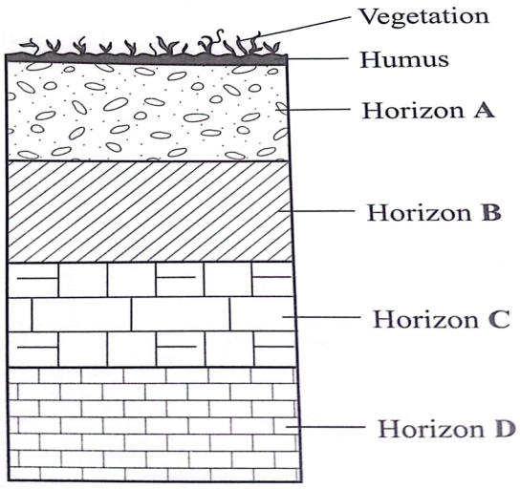

- Name the three layers of horizon A (3mks)
- A00
- A0
- A1
- A2
- A3
(3 x1mk)
- Describe the characteristics of horizon B (3mks)
- It is the accumulation zone for leached minerals from horizon A
- The soil texture is clay in nature
- Soils are generally dark/red/brown in colour
- The zone sometimes form the hard pan/murram /lateritic duricrust
- It is divided into B1, B2 and B3

(Any 3X1mk)
d) i) State three economic benefits of soil (3mks)

- Soil provide the base for crops/forest cultivation
- Some soils are source of valuable minerals
- Soils are raw materials for ceramic/pottery/sculpture industries.
- Soils are used for building houses/roads/bridges
- Organic soils such as peat serve as fuel resource.
- Salt licks are livestock feeds.
(Any 3X1mk)
ii Describe the following types of soil erosion
- Sheet erosion (2mks)
- It occurs on gentle slopes which are bare
- When heavy rains falls water spreads over a large area
- As water moves, it removes the top layer of soil evenly/uniformly over the area
(Any 2X1mk)
- Gully erosion (2mks)
- It occurs on steep slopes
- Rain water cuts deep grooves/channels/rills on slope
- The channels are widened and deepened to form gullies through which soils are curried away
(Any 2X1mk)

