Nyaraya Cluster Examination
Kenya Certificate of Secondary Education

2023 Form Four Evaluation Programme

312/2 GEOGRAPHY Paper 2
JULY/AUGUST 2023

MARKING SCHEME

312/2
GEOGRAPHY
PAPER 2
JULY 2023
TIME 2HOURS 45MINS

INSTRUCTIONS TO CANDIDATES
- Write your name, index number and other required details in the spaces provided.
- Sign and write the date of the examination in the spaces provided.
- This paper consists of two sections A and B.
- Answer all questions in section A.
- Answer question 6 and any other two questions from section B.
- Answers must be written on the foolscaps provided.

FOR EXAMINER’S USE ONLY

SECTION | QUESTIONS | MAXIMUM SCORE | CANDIDATE’S SCORE
A  B | 1-5 | 25
 | 6 | 25
TOTAL SCORE | 100

SECTION A
Answer all questions in this section

- The table below shows petroleum production in thousand barrels per day for countries in Middle East in April 2006. Use it to answer question (a)

COUNTRY | PRODUCTION IN ‘000 BARRELS
Iran | 3,800
Kuwait | 2,550
Qatar | 800
Saudi Arabia | 9,600
United Arab Emirates | 2,500
Iraq | 1,900

a)i) What is the difference in production between the highest and lowest producer. (1mk)
9,600000 - 800,000 = 8,800,000 Barrels
ii) What is the total amount of petroleum produced in April 2006 in the region? (1mk)
21,150,000 barrels X 30 days
634,500,000 Barrels
iii) Calculate the average daily petroleum production for Kuwait for April 2006. (1mk)
2,550,000 X 30 days
30 days
= 2,550,0000 barrels
- State three ways in which Kenya can reduce the use of petroleum as a source of energy. (3mks)
- Encourage people to use bicycles/walk over short distances
- Developing alternative source of energy
- Pooling transport/ encouraging people to use public transport
- Importing vehicles that consume less fuel
- Improving the traffic flow to reduce usage of petrol/diesel
- Proper maintenance of vehicles to avoid high consumption of petrol/diesel
- Improving roads to avoid delays that increase consumption of petrol/diesel
(any 3 x 1)
- State four differences between soft wood forests in Kenya and Canada. (4mks)
- Soft wood forests in Kenya are mainly man made while soft wood in Canada are natural
- Soft wood forests in Kenya are exotic while soft wood forests in Canada are indigenous
- Soft wood forests in Kenya have only a few species while soft wood in Canada have wide variety of species
- Soft wood in Kenya are mainly found in the highlands while softwood forests in Canada are found both in highlands and lowlands
- Soft wood forests in Kenya cover small percentage of the total land area while soft wood forests in Canada cover large tracts of land
(Any 4X1)
- a) Give two provinces in Canada that produce wheat on large scale. (2mks)
  - Saskatchewan
  - Alberta
  - Manitoba
(Any 2 X 1)
b) State three uses of wheat. (3mks)
- Used as animal feeds
- Used as human feed
- Used for brewing/distilling alcohol
- Used for making adhesives/glues
- Used for making paperboards
(Any 3 X 1)

- a) In 1989 Kenya’s population was 21.4 million while in 1999, it was 28.7 million. Calculate the population growth rate over the 10 year period. (2mks)
inter census difference 28.7 m – 21.4 m
= 7.3m
= 7.3m X 100
21.4m
= 3.4%
(Any 2 X 1)
b) State three ways in which the population of Kenya differs from the population of Sweden. (3mks)
- The population of Kenya has a large number of young people below 20 years of age/ youthful population while Sweden has ageing population
- Kenya’s population has a lower life expectancy while Sweden has a higher life expectancy
-The population birth rate in Kenya is high while it is low in Sweden
- The fertility rate in Kenya is high while in Sweden it is low
-The death rate is high in Kenya and low in Sweden
-population growth rate is high in Kenya and low/negative in Sweden
-A high percentage of population in Kenya lives in the rural areas while in Sweden most people live in urban areas/ centres
(Any 3 X 1)

- a) Identify the two types of internal trade. (2mks)
-Retail trade
-Wholesale trade
(Any 2 X 1)

b) Give three factors that limit trade among the member states of the common market for Eastern and Southern Africa. (COMESA) (3mks)
- Poor transport slows/ delays movement of goods/services
- Different in tariffs/custom duties hinder trading activities
- Difference in currency makes transactions difficult
- Production of similar/ duplication of goods limit trade
- Different levels of industrial development creates imbalance in trade
- Movement barriers limits free movement of people/goods/services
- Different political ideologies
- Political instability/insecurity/civil wars

(Any 3 X 1)

SECTION B

Answer question 6 and any other two questions.

- a) The table below shows the distribution of Beef cattle in three regions in country X.
REGION N | NUMBER OF BEEF CATTLE
K | 500,000
L | 350,000
M | 200,000

i) Using a scale of 1 dot to represent 50,000 cattle, draw a dot map to show the distribution of Beef cattle in the three regions in country X. Show all your workings. (8mks)
In your answer booklet draw and use the sketch below

REGION | NUMBER OF BEEF CATTLE | NUMBER OF DOTS
K | 500000 | 500000 = 10  50000
L | 350000 | 350000 =7  50000
M | 200000 | 200000 =4  50000

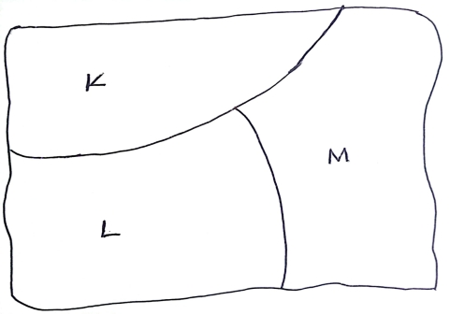
A DOT MAP SHOWING DISTRIBUTION OF BEEF CATTLE IN THE THREE REGIONS IN COUNTRY X
Title 1mk
Frame 1mk
Calculation 3mks 8 mks
Plotting 3mks

ii) Give three advantages of using a dot map to represent geographical data. (3mks)
-It is easy to construct / draw
- It gives a clear visual impression
- It makes comparison easier
- It is easy to interpret/read
-It allows wide range of data to be used
(Any 3 X 1)
b) i) Name three exotic breeds of cattle reared in commercial ranches in Kenya. (3mks)
- Aberdean Angus
- Hereford
- Galloway
- Charolais
- Short horn
- Saihiwal
(Any 3 X 1)

ii) Explain six roles played by Beef farming to the economy of Kenya. (6mks)
- Beef farming provide meat animal products for exports which earn the country foreign exchange
- It provides employment to many people raising their standards of living
- It provides raw materials to related industries
- Products of beef are sold locally to earn income
- It has led to development of roads easing transport
- The government earns revenue through taxation for economic growth
- it has enhanced research leading to high production
- It has led to development of related industries which supply inputs to beef cattle farmers.
(Any 3 X 2)

C) Give five reasons why Beef production is higher in Argentina than Kenya. (5mks)

- Argentina has larger/better organized/managed ranches than Kenya
- Argentina has higher quality cattle than Kenya
- Argentina has better methods of animal husbandry/control of diseases/extension services than Kenya
- Argentina has more nutritious grass/folder/alfalfa through the year due to the year due to Maritime climate/Argentina has pasture throughout the year than Kenya
- Argentina has ranches that are well watered by wind pumps which reduces movemen/ weight loss in search for water unlike Kenya
- Argentina has more capital for intensive care/ refrigeration for beef cattle
- Argentina has a well-developed railway/road network that transport beef cattle to the factories than Kenya
- Argentina has highly advanced technology/refrigeration for beef
- Argentina has larger local/external market
(Any 5 X 1)

- a) i) What is mining. (2mks)
Mining is the extraction of minerals occurring on or below the earth’s surface
ii) Name the area where the following minerals are mined in Kenya. (1mk)
- Diatomite - Kariandusi (1mk)
- Salt -Ngomeni (1mk)
- Lake Magandi
(Any 1mk Each)

b) Explain how the following factors influence the occurrence of minerals.
- Evaporation (2mks)
- High temperatures in arid and semi-arid areas cause evaporation of water in lakes/seas leading to high concentration of mineral salts in water. Continued evaporation causes further recrystallization of salts which may thereafter extracted as minerals e.g. Soda Ash and common salts
(1 X 2)

- Vulcanicity (2mks)
-When molten rock/magma intrudes into rock joints, minerals contained in magma are embedded in joints and are called veins /lodes
- Hot springs/geysers/fumaroles bring minerals to the earth surface
(1 X 2)
- Metamorphism (2mks)
-High pressure/heat causes recrystallization and hardening of certain rocks causing them to change their nature to become minerals e.g diamond
(1 X 2)

c) i) Name two minerals mined by placer mining method. (2mks)
- Gold
- Diamond
- Platinum
- Tin
(1 X 2)
ii) Describe placer mining method. (5mks)
- A mixture of water, sand/mud and mineral particles is scooped from the river bed using a pan.
- water is added if the mixture is thick/ if the water is excess it is decanted
- The material scooped is swirled in the pan. This separates the lighter particles from the heavier particles
- The lighter materials are removed/ poured out
- The heavier materials are sorted to display mineral particles
- Mineral particles are collected from the pan
(Any 5 X 1)

d) Explain four ways through which mining promotes industrialization in Kenya. (8mks)
- Mining has led to development of industries by providing raw materials
- Though exportation of minerals, the country earns foreign exchange which is used to import machinery used in industries/ for development of industries
-Mining has led to establishment of transport network of roads and railways which promotes industrialization as it eases movement of raw materials/ finished products
- Mining attracts settlement/development of towns which attracts industrial development.
-Mining creates employment raising the living standards of the people hence creating a greater demand for industrial products promoting industrial growth.
-Mining attracts settlement which provides labour in the industries
- Mining stimulates growth of related industries by supplying inputs/services
(Any 4 X 2)

- a) i) Give two methods that are used to drain swamps. (2mks)
- Constructing drainage pipes
- Digging open ditches/canals
- Pumping out the water
(Any 2 X1)

ii) State four physical factors which influenced the location of Mwea Irrigation Scheme. (4mks)
- Availability of extensive land
- Hot climatic conditions / high temperatures
- Presence of river Nyamindi/murubara/Thiba
- Gentle sloping land
- Presence of black cotton soil/ Clay
- Low/unreliable rainfall
(Any 4 X 1)

b) i) Name three areas which make up the ZuyderZea reclamation project in the Netherlands. (3mks)
- Wieringerrmeer
- Marker Waad
- South flevoland
- North Eastern polder
- East flevoland
(Any 3 X 1)

ii) Explain four ways in which the Zuyder Zee Project benefits the Netherlands.
(8mks)

- Reclamation has increased the size of the land which is used for settlement/farming
- The reclaimed land has increased agricultural output hence make food
- Damming created a fresh water lake thus improving supply of water for domestic/industrial use
- It has led to employment of many people thus improving their standards of living
- Roads /canals have been constructed hence improving transportation
- Reclamation have created sceneries that have become tourist attractions thereby earning the country foreign exchange
- The construction of Great dyke shortened the coastal distance
- It has controlled disastrous floods
(Any 4 X 2)

c) You intend to carry out a field study on irrigation farming in Perkerra Irrigation Scheme.
i) Identify two types of hypothesis you would develop for the study. (2mks)
- Alternative/substantive/positive
- Null/negative
- Question form
(Any 2 X 1)

ii) Name three crops grown in the scheme you are likely to identify. (3mks)
- Watermelons
- Onions
- Cotton
- Chillies
- Pawpaw
- Seedmaize
- Beans
- Tomatoes
- Kales
(Any 3 X 1)

iii) Give three reasons why you would sample the area of study. (3mks)
- It is cheaper/ less expensive
- It saves on time spent in the study
- It brings out details of the area under study
- It enables one to make generalized conclusion about the area under study
(Any 3 X 1)

- a) i) What is wildlife. (2mks)
- Wildlife refers to the animals/ fauna and plants/flora existing in their natural habitat
ii) State three factors that favour establishment of National Parks in semi-arid areas of East Africa. (3mks)
- Availability of large tracks of land/sparsely populated land
- Availability of a wide variety of vegetation which provide food for the wild animals
- The harsh climatic conditions that discourages farming/ settlement
- The type of vegetation found in such areas provide suitable habitat for wild animals
(Any 3 X 1)

b) i) Apart from Historical sites, name three tourist attractions found at the Coast of Kenya. (3mks)
- Marine parks
- Sandy beaches/coral reefs/coastal scenery
- Sunny climate/Warm climate
- Traditional culture
- Water sports/Beach sports
- Wildlife
(Any 3 X 1)

ii) State three reasons why it is necessary to preserve historical sites in Kenya. (3mks)
- They are a tourist attraction
- For educational purposes/research purposes
- For aesthetic value/ Beauty of land
- For posterity/ For future generation
- For preservation of culture
(Any 3 X 1)

c) Explain four problems associated with tourism in Kenya. (8mks)
- Some of the tourist are drug traffickers/ introduce drugs to the youth/ people which leads to poor health
- High rate of school dropouts which leads to high illiteracy level/moral decay
- Some tourists engage in immoral activities which encourage spread sexually transmitted diseases.
- Encourage environmental pollution which leads to death of wild animals
- Presence of tourists has led to increase in crimes especially those who want to rob them hence discouraging the tourists
- Tourism has encouraged poaching which leads to decline in wild animals /wildlife
- Tourism has led to erosion of social values / culture of the local people who imitate foreign culture
- Tourism has led to interference of animals way of life because of the movement of tourists in the parks
- Tourism has led to international terrorism / piracy leading to loss of life/ destruction of property.
(Any 4 X 2)

d) Explain the differences between tourism in Switzerland and Kenya under the following subheadings.
- Climate (2mks)
Kenya has tropical climate which is warm and sunny most of the year encouraging sun bathing while Switzerland has temperate climate with cold waters which encourage winter sports
(1 X 2)
- Beaches (2mks)
Kenya has coastal beaches while Switzerland has lakeside beaches
(1 X 2)
- Purchasing power (2mks)
Kenya’s low purchasing power limits the ability to travel as tourists while in Switzerland, the high purchasing power enables people to travel as tourists.
(1 X 2)
- a) Name the two types of Human Settlement. (2mks)
-Rural settlement
-Urban settlement
(Any 2 X 1)

b) The map below shows the location of some urban centres in East Africa.
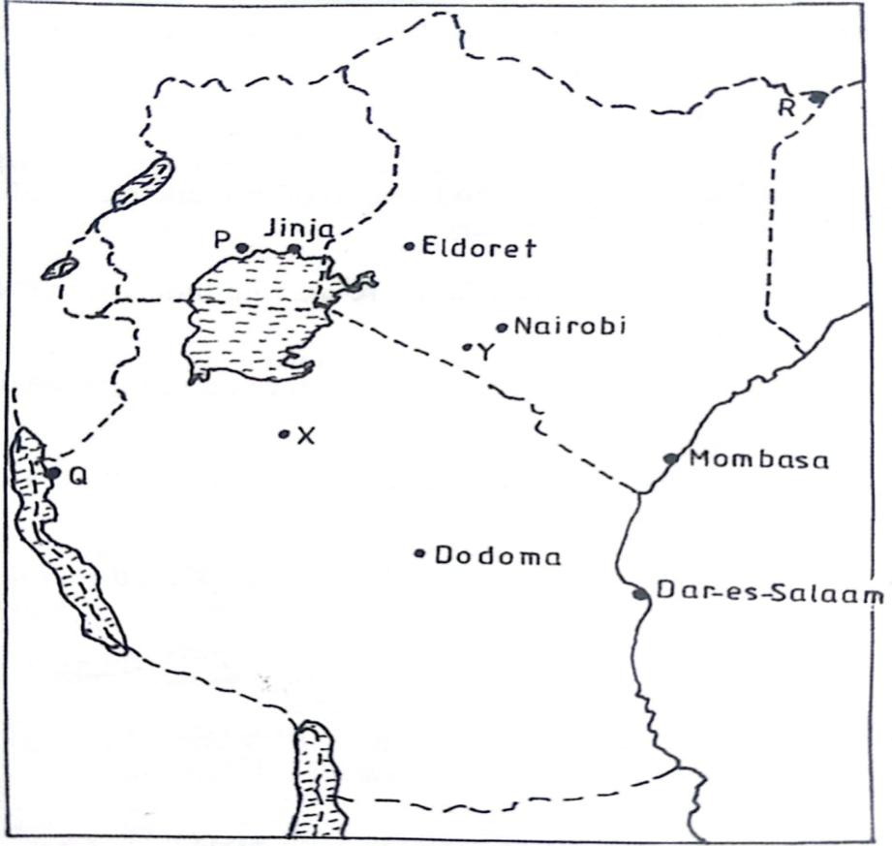

- Name the towns marked P, Q and R. (3mks)
P - Kampala
Q - Kigoma
R – Mandera
(1mks each)
- Name the minerals that influenced the growth of the towns X and Y. (2mks)
X- Diamond
Y- Trona/Soda Ash
c) i) Apart from Thika, Name two other towns in Kenya where motor vehicle assembling plants are located. (2mks)
- Nairobi
- Mombasa
ii) Explain how the following factors led to the growth of Thika town. (2mks)
- Availability of water
- River Chania which passes through through Thika provides fresh water for domestic and industrial uses
- Water for use in the industries and for domestic is available throughout the year since river Chania is permanent
(Any 1 X 2)

- Hinterland (2mks)
- The town has a rich agricultural hinterland which provides raw materials for the industries/ food for the population
- The hinterland is densely populated hence provides cheap labour/ ready market to the industries.
(Any 1 X 2)

- Proximity to Nairobi (2mks)
- Nairobi provides some inputs required by industries in Thika/There is industrial interdependence among industries in Nairobi and Thika
- Nairobi provides a ready/ large market for manufactured goods from Thika
(Any 1 X 2)
- Land (2mks)
- There is ample flat land for development of industries/ settlements
- The cost of land is relatively cheaper hence attracts investors
(Any 1 X 2)

d) Explain four measures that could be taken to control high rate of crimes in urban centres in Kenya. (8mks)
- Encouraging community policing to complement the efforts of police service
- Controlling the influx of illegal arms in order to reduce the incidents of thuggery
- Enforcing laws without favour to provide protection to the law abiding citizens.
- Getting rid of street families to reduce the number of idlers in towns
- Creating more job opportunities to reduce the number of idlers
(Any 4 X 2)

