Nyaraya Cluster Examination
Kenya Certificate of Secondary Education

2023 Form Four Evaluation Programme

312/2 GEOGRAPHY Paper 2
JULY/AUGUST 2023

NAME:.............................................................INDEX NO:.....................................

SCHOOL:...................................................................................... STREAM:..........

ADM.NO:........................DATE:..............................SIGNATURE:........................

312/2
GEOGRAPHY
PAPER 2
JULY 2023
TIME 2HOURS 45MINS

INSTRUCTIONS TO CANDIDATES
- Write your name, index number and other required details in the spaces provided.
- Sign and write the date of the examination in the spaces provided.
- This paper consists of two sections A and B.
- Answer all questions in section A.
- Answer question 6 and any other two questions from section B.
- Answers must be written on the foolscaps provided.

FOR EXAMINER’S USE ONLY

SECTION | QUESTIONS | MAXIMUM SCORE | CANDIDATE’S SCORE
A  B | 1-5 | 25
 | 6 | 25
TOTAL SCORE | 100

SECTION A
Answer all questions in this section

- The table below shows petroleum production in thousand barrels per day for countries in Middle East in April 2006. Use it to answer question (a)

COUNTRY | PRODUCTION IN ‘000 BARRELS
Iran | 3,800
Kuwait | 2,550
Qatar | 800
Saudi Arabia | 9,600
United Arab Emirates | 2,500
Iraq | 1,900

- i) What is the difference in production between the highest and lowest producer. (1mk)
ii) What is the total amount of petroleum produced in April 2006 in the region? (1mk)
iii) Calculate the average daily petroleum production for Kuwait for April 2006. (1mk)
- State three ways in which Kenya can reduce the use of petroleum as a source of energy. (3mks)
- State four differences between soft wood forests in Kenya and Canada. (4mks)
- a) Give two provinces in Canada that produce wheat on large scale. (2mks)
b) State three uses of wheat. (3mks)
- a) In 1989 Kenya’s population was 21.4 million while in 1999, it was 28.7 million. Calculate the population growth rate over the 10 year period. (2mks)
b) State three ways in which the population of Kenya differs from the population of Sweden. (3mks)
- a) Identify the two types of internal trade. (2mks)
b) Give three factors that limit trade among the member states of the common market for Eastern and Southern Africa. (COMESA) (3mks)

SECTION B

Answer question 6 and any other two questions.

- a) The table below shows the distribution of Beef cattle in three regions in country X.
REGION N | NUMBER OF BEEF CATTLE
K | 500,000
L | 350,000
M | 200,000

i) Using a scale of 1 dot to represent 50,000 cattle, draw a dot map to show the distribution of Beef cattle in the three regions in country X. Show all your workings. (8mks)
In your answer booklet draw and use the sketch below
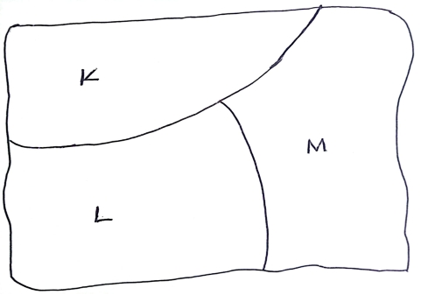
ii) Give three advantages of using a dot map to represent geographical data. (3mks)
b) i) Name three exotic breeds of cattle reared in commercial ranches in Kenya. (3mks)
ii) Explain six roles played by Beef farming to the economy of Kenya. (6mks)
- Give five reasons why Beef production is higher in Argentina than Kenya. (5mks)

- a) i) What is mining. (2mks)
ii) Name the area where the following minerals are mined in Kenya.
- Diatomite (1mk)
- Salt (1mk)
b) Explain how the following factors influence the occurrence of minerals.
- Evaporation (2mks)
- Vulcanicity (2mks)
- Metamorphism (2mks)
c) i) Name two minerals mined by placer mining method. (2mks)
ii) Describe placer mining method. (5mks)
- Explain four ways through which mining promotes industrialization in Kenya. (8mks)
- a) i) Give two methods that are used to drain swamps. (2mks)
ii) State four physical factors which influenced the location of Mwea Irrigation Scheme. (4mks)
b) i) Name three areas which make up the Zuyder Zea reclamation project in the Netherlands. (3mks)
ii) Explain four ways in which the Zuyder Zea Project benefits the Netherlands. (8mks)
c) You intend to carry out a field study on irrigation farming in Perkerra Irrigation Scheme.
i) Identify two types of hypothesis you would develop for the study. (2mks)
ii) Name three crops grown in the scheme you are likely to identify. (3mks)
iii) Give three reasons why you would sample the area of study. (3mks)

- a) i) What is wildlife. (2mks)
ii) State three factors that favour establishment of National Parks in semi-arid areas of East Africa. (3mks)
b) i) Apart from Historical sites, name three tourist attractions found at the Coast of Kenya. (3mks)
ii) State three reasons why it is necessary to preserve historical sites in Kenya. (3mks)
c) Explain four problems associated with tourism in Kenya. (8mks)
d) Explain the differences between tourism in Switzerland and Kenya under the following subheadings.
- Climate (2mks)
- Beaches (2mks)
- Purchasing power (2mks)

- a) Name the two types of Human Settlement. (2mks)
b) The map below shows the location of some urban centres in East Africa.
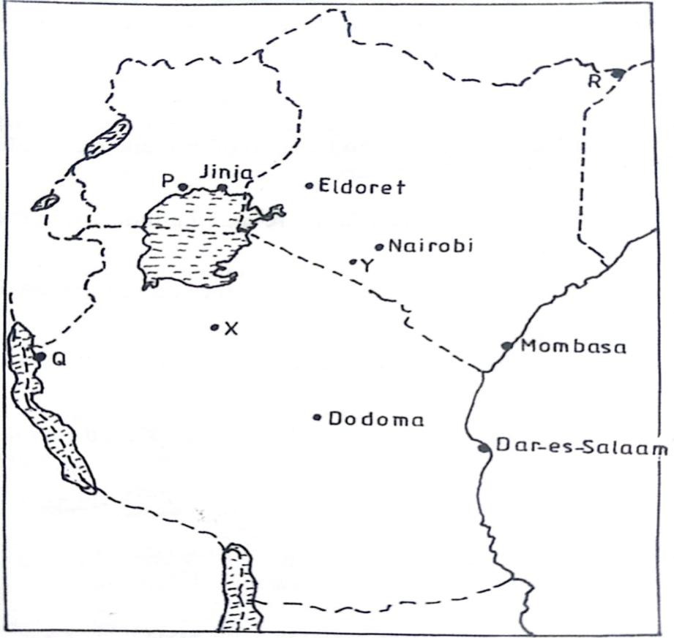

- Name the towns marked P,Q and R. (3mks)
- Name the minerals that influenced the growth of the towns X and Y. (2mks)
c) i) Apart from Thika, Name two other towns in Kenya where motor vehicle assembling plants are located. (2mks)
ii) Explain how the following factors led to the growth of Thika town.
- Availability of water (2mks)
- Hinterland (2mks)
- Proximity to Nairobi (2mks)
- Land (2mks)
d) Explain four measures that could be taken to control high rate of crimes in urban centres in Kenya. (8mks)

