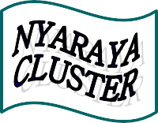

Nyaraya Cluster Examination
Kenya Certificate of Secondary Education

2023 Form Four Evaluation Programme

312/1 GEOGRAPHY Paper 1
JULY/AUGUST 2023
Name: _______________________________________Index No:_________________
Stream:_______________School:_______________________________________________
Adm No: Date: Signature:
GEOGRAPHY
PAPER 1
JULY 2023
Time: 2Hrs. 45mins.
Instructions to the candidates.
Write your name, index number and other required details in the spaces provided.
- Sign and write the date of the examination in the spaces provided.
- This paper consists of two sections A and B.
- Answer all questions in section A.
- Answer questions 6 and any other two questions in section B.
- Answers must be written on the foolscaps provided

FOR EXAMINER’S USE ONLY.
Section | Questions | Maximum score | Candidate’s score
A | 1-5 | 25
B | 6 | 25
 | 25
 | 25
TOTAL SCORE | 100

SECTION A
Answer all questions in this section

- The diagram below represent the flow of air currents. Use it to answer question a and b.
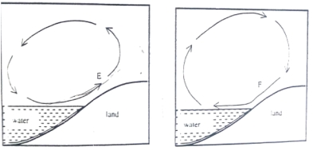

- Name the air current marked F. (1mk)
- Describe how the air current marked E occurs. (4mks)
- a) What is Relative Humidity? (2mks)
b) The table below shows temperature readings of Dry bulb thermometer and wet bulb thermometer in three weather stations.

STATION | DRY BULB THERMOMETER | WET BULB THERMOMETER
J | 30⁰C | 28⁰C
K | 30⁰C | 5⁰C
L | 30⁰C | 30⁰C

Give the state of relative humidity in station J, K and L. (3mks)

- a) Differentiate between a magnitude of an earthquake and intensity of an earthquake. (2mks)
b) Describe how a dyke is formed. (3mks)
- a) Name two types of ice masses found on mountains in East Africa. (2mks)
b) State three distinctive characteristics of a pyramid peak. (3mks)
- a) Name two ocean currents along the Western Coast of Africa. (2mks)
b) State three causes of ocean currents. (3mks)
SECTION B
Answer question 6 and any other two questions.
- Study the map of Kisumu East 1:50,000 (sheet 116/2) provided and answer the following questions.
- i) What type of map is Kisumu East Sheet? (1mk)
ii) Give the vertical interval of the map. (1mk)
iii) State the latitudinal and longitudinal position of North West corner of the map. (2mks)
- i) What is the bearing of the trigonometrical station at Grid reference 081980 from rock outcrop at grid reference 071992? (2mks)
ii) Measure the length of all weather road bound surface B2/1 from the junction at Grid reference 974911 to the edge of the map grid reference 947967. Give your answer in kilometres. (2mks)
- i) Draw a cross section between Grid Reference 070940 and 070980. Use a vertical scale 1cm to represent 100 metres. (4mks)
ii) On the cross section, mark and name:-
- All weather road bound surface. (1mk)
- River (1mk)
iii) Calculate the vertical exaggeration (VE) of the cross section. (2mks)
- Describe the relief of the area covered by the map. (5mks)
- Citing evidence from the map, give two social services offered in Kisumu Town. (4mks)
- a) Describe the following characteristics of minerals.
- Lustre (2mks)
- Density (2mks)
- Cleavage (2mks)
b) Giving an example for each, describe the three types of mechanically formed sedimentary rocks. (9mks)
c) You are required to carry out a field study on the types of rocks within the vicinity of your school.
i) State four reasons why you would conduct a reconnaissance (4mks)
ii) State how you would use the following items during the field study.
- Geological hammer (2mks)
- Magnifying lens (2mks)
- Geological map (2mks)

- a) Give two types of Earth Movement within the earth’s crust. (2mks)
b) i) Describe the origin of continents according to the theory of Continental Drift. (6mks)
ii) Explain the following evidence which support the theory of Continental Drift.
- Paleontological evidence. (2mks)
- Paleoclimatic evidence. (2mks)
- Sea floor spreading. (2mks)
- i) Name one fold mountains in:-
- North America (1mk)
- Asia (1mk)
- Africa (1mk)
ii) With the aid of well labeled diagrams, describe how Fold Mountains are formed. (8mks)
- a) i) What is a river Divide. (2mks)
ii) Describe the three types of River Erosion. (9mks)
b) Explain the following drainage patterns and systems.
i) Dendritic. (2mks)
ii) Superimposed. (4mks)
c) Explain four ways in which Rivers Negatively affect human environment. (8mks)
- a) i) What is soil texture. (2mks)
ii) Give two types of soil according to texture. (2mks)
b) Explain how the following factors influence the formation of soil.
i) Parent Rock (4mks)
ii) Living organisms. (4mks)

c) The diagram below represents a well-developed soil profile. Use it to answer question C.
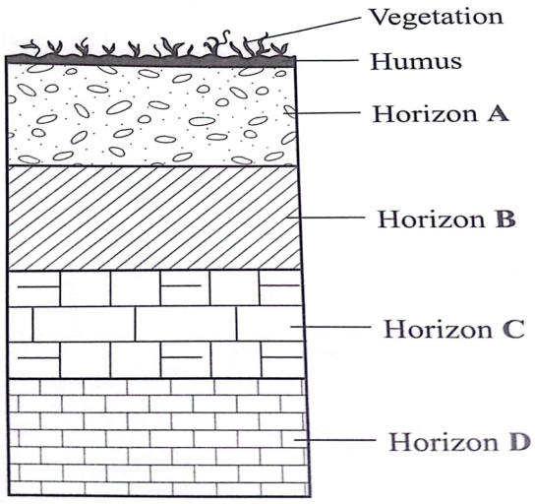

- Name three layers of Horizon A (3mks)
- Describe the characteristics of Horizon B. (3mks)
- i) State three economic benefits of soil. (3mks)
ii) Describe the following types of soil erosion.
- Sheet erosion. (2mks)
- Gully erosion. (2mks)

