MARKING SCHEME
SECTION A
ANSWER ALL THE QEUSTIONS IN THIS SECTION
1a) Define the term Environment. (2mks)
- it is the sum of all the external conditions surrounding an organism which influence the behavior of an organism affecting the life development of organisms and its activities.
b.) List any 3 major areas coved in physical Geography. (3mks)
- The Earth and the solar system
- Weather and climate
- Rocks and minerals
- Internal land forming processes
- External land forming processes
- Vegetation
- soil
2a) The diagram below represents the structure of the atmosphere use it to answer question (a)
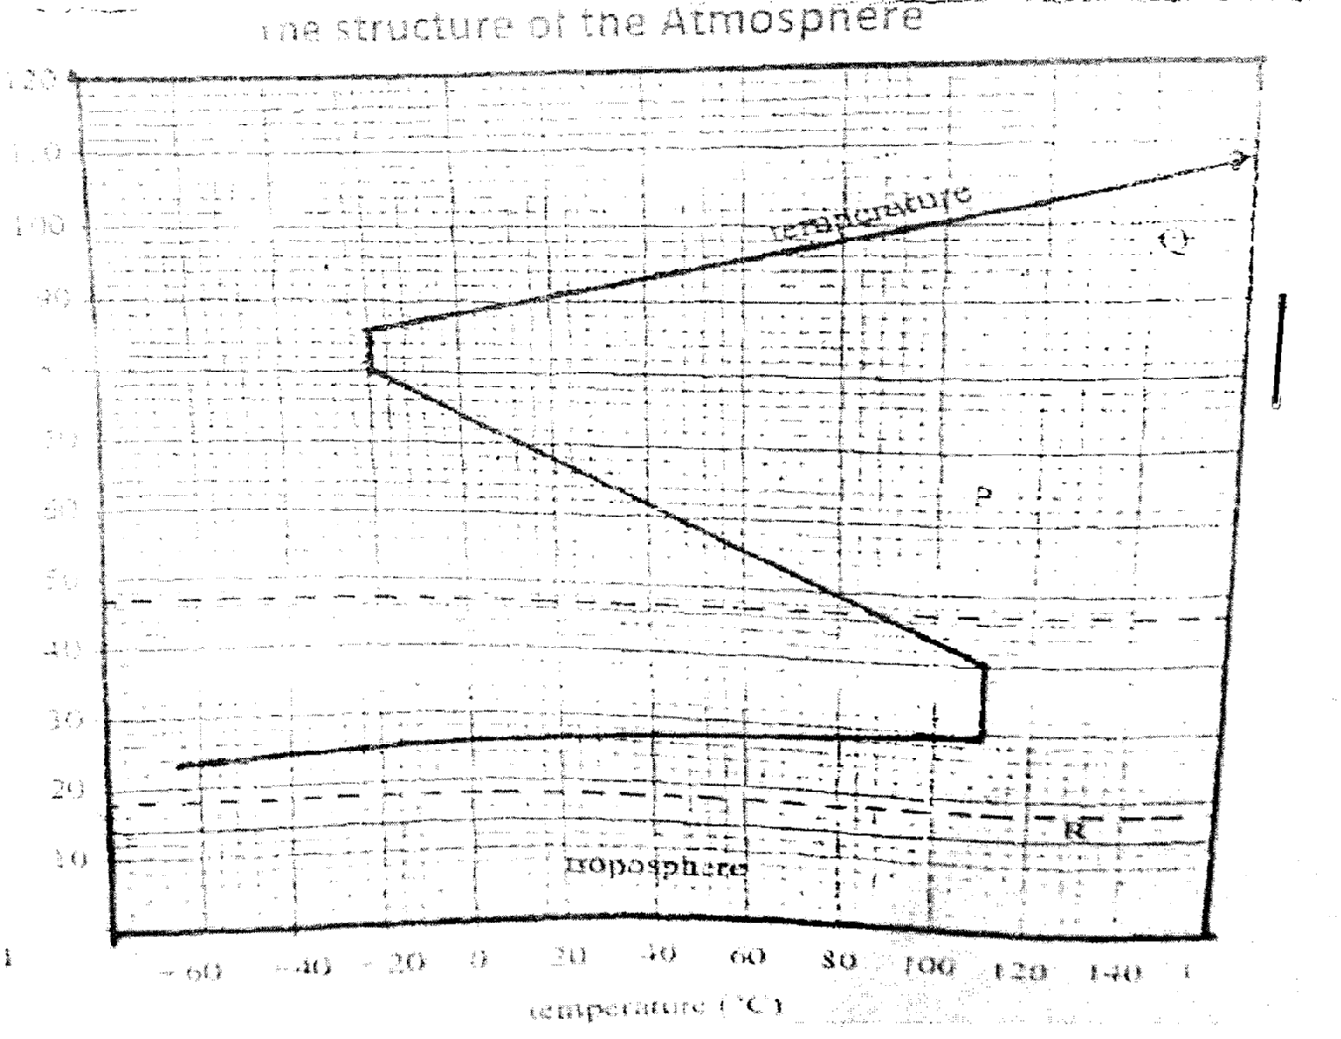

a) Name
i) The parts marked P and Q. (2mks)
P-Mesosphere
Q- ionosphere
ii) The layer of discontinuity marked R. (1mk)
Tropopause
b.) State two characteristics of weather conditions in the troposphere. (2mks)
- temperature decrease with increase in height/normal lapse rate/rate decrease 1ºc for 16cm/environmental
- contains most of atmospheric water vapour
- speed of wind increases with increase in height
- contains most of weather making constituents/ elements
- Atomspheric pressure falls with increase in height
3a) What is an earthquake?. (2mks)
- This is the tremor that occurs in the earth’s crust
- This is the shaking of trembling of the rocks of the surface of the earth, caused by shock waves that originate below the surface of the earth.
b) Identify the scale used to measure
i) The intensity of earthquakes –Rossi –Forrel Scale , Mercalli Scale/ M Scale (1mk)
ii)The magnitude of earthquakes. (1mk)
- Ritcher scale

c) Name one major region where earthquakes are likely to occur. (1mk)
- mid-ocean ridges
- ocean deeps and volcanic island
- regions of crustal compressions
- within the Rift valleys
- in areas of volcanic activity

4a) Distinguish between River Capture and river rejuvenation. (2mks)
- River capture is the diversion of headwater of one rive into the system of an adjacent but more powerful river due to erosion. While/whereas river rejuvenation is the renewal of a river’s erosive ability/power
b) State three characteristics of a river at youthful stage. (3mks)
- steep gradient
- narrow channel
- deep/deep sided /v-shaped valleys/gorge
- flow at high speed/high stream velocity
- dominant vertical erosion/head water erosion
- winding channel
- rapids, waterfall/ cataracts, cascade are common
- interlocking spurs, pothole plunge pools also common
- torrential flow
- low/small volume of water
- low/ small load
5a) Explain two reasons why wind is the dominant agent of erosion in arid area. (4mks)
- The areas have scanty/no vegetation which exposes the land to erosion.
- The areas expenences strong tropical winds which erode the materials
- The areas have dry unconsolidated soils/materials which are easily eroded
b) Identify any one feature formed as a result of wind deposition in arid areas. (1mk)
- Loess, Drass/draas, sandiness, barchans
6. Use the map provided (kisumu east I:50,000 (sheet 116/2) and answer the following questions .
a.) What is the sheet title of the map. (1mk)
East Africa(1:50000) Kenya (2mks)
ii) What is the magnetic declination of the map extract. (1mk)
2º 32¹
b.i) Convert the ratio scale of the map extract into statement scale. (2mks)
1:50000
100,000=1km
=0.5km
1cm rep 0.5km
c.)What is the bearing of trigonometrical station at grid reference 081980 from the Air photo Principals point at grit square 0997. (2mks)
305º
d) Give three types of natural Vegetation found in the area covered by map. (3mks)
Scrub
Scattered trees
Woodland
Marsh vegetation
e)Describe the drainage of the area covered by the map. (5mks)
The main drainage features are rivers
The are many permanent rivers e g river Luands/R. Nyamdsharia
Most rivers form dendritic drainage pattern
There are seasonal swamps in Karo plain
The main river is River Ombeyi
There is a lake to the south Western part of a map
There are water holes to South Easter part of map
f) Draw a rectangle 12cm by 10cm to represent the area enclosed by Easting 03 and 09 and Northing 80 and 85. On the rectangle, mark and name the following features. (5mks)
i) Trigonometrical station 1154.
ii) All weather road B 25/3
iii) Seasonal swamp.
iv) Ombeyi river.

g. Citing evidence from the map ,explain three social factions of Ksumu town . (6mks)
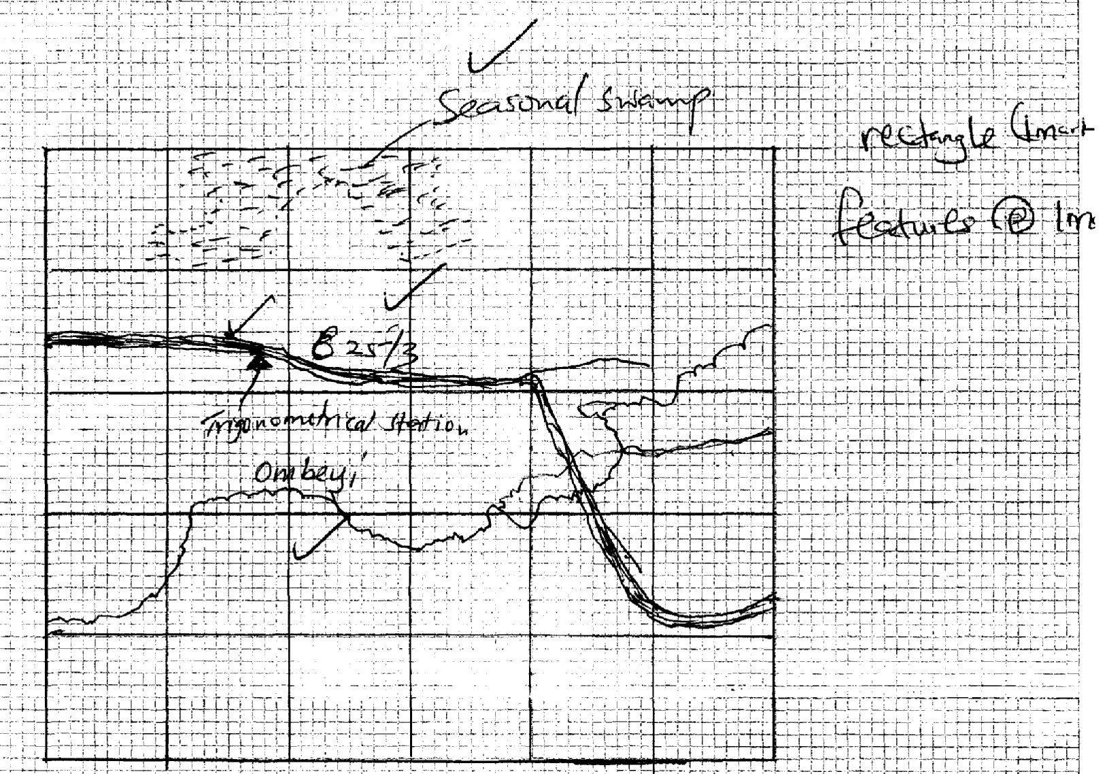
- Water supply centre-water works(3x2=6 mks)
- Education centre-Schools
- Réhabilitation centre-prison
- Religions centre-Church
- Administrative centre –district office
- Health centre-hospital
- Recreational centre station
- Security centre police line
7a) What is folding ? (2mks)
- The process of crustal rocks distortional that causes rocks to bend upwards and down wards due to compressional forces
ii ) State three factors that influence folding . (3mks)
- The age of sedimentary rocks
- The flexibility or elasticity of rocks
- The strength or intensity of compressional forces
- The temperature within the rocks
b)i) Apart from over thrust fold ,name four other types of folds. (4mks)

- Symmetrical fold
- Asymmetrical fold
- Over folds
- Isoclinals folds
- Recumbent fold
- Anticlinonum folds
- Synclinorium folds
ii) With the aid of well labelled diagrams ,describe the formation of an over thrust fold. (8mks)
Earth’s crustal rocks are subjected to compressional forces
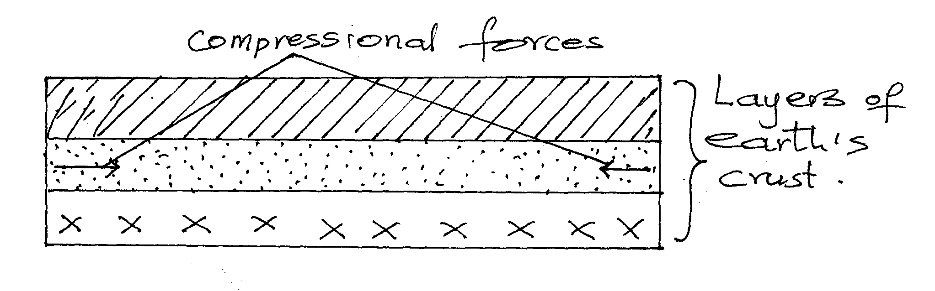
Increased compressional forces used to formation of an over fold
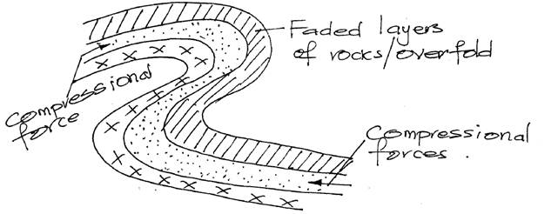
Increase compressional forces on the over fold from a recumbent fold.
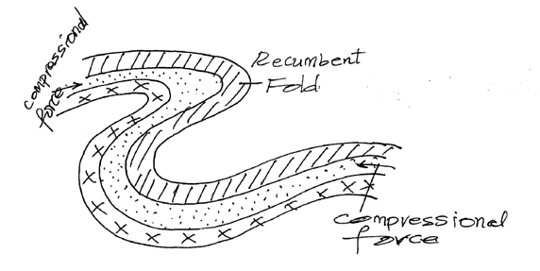

- Grater compressional forces lead to formation of a fracture a long the axis of the recumbent fold form a thrust plane
- Compressional force pushes the upper limb which will be formed over the lower limb along the thrust plane to form an over thrust fold or nappe
Diagram 3
Text 5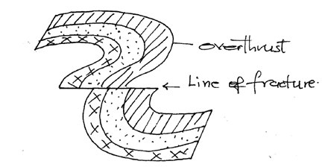Diagram (3mks)

c) Explain four significance of fold maintains to human activities. (8mks)
- Fold mountains may form unique scenery that may attract tourists encourages tourism which the country foreign exchange
- The windward slopes of fold maintain receives high rainfall encourages human settlement
- The windward slopes of fold maintains may support the growth of forest encouraging forestry wildlife
- Windward slopes requires high rainfall which supported arable farming/agriculture
- Some fold mountains have exposed valuable materials encourages mining
- High rainfall on fold mountains or melting ice makes sources of rivers that provide water for domestic use/irrigation/industrial use
8. The map below shows some vegetation regions of the world. Use it to answer questions (a) to (c)
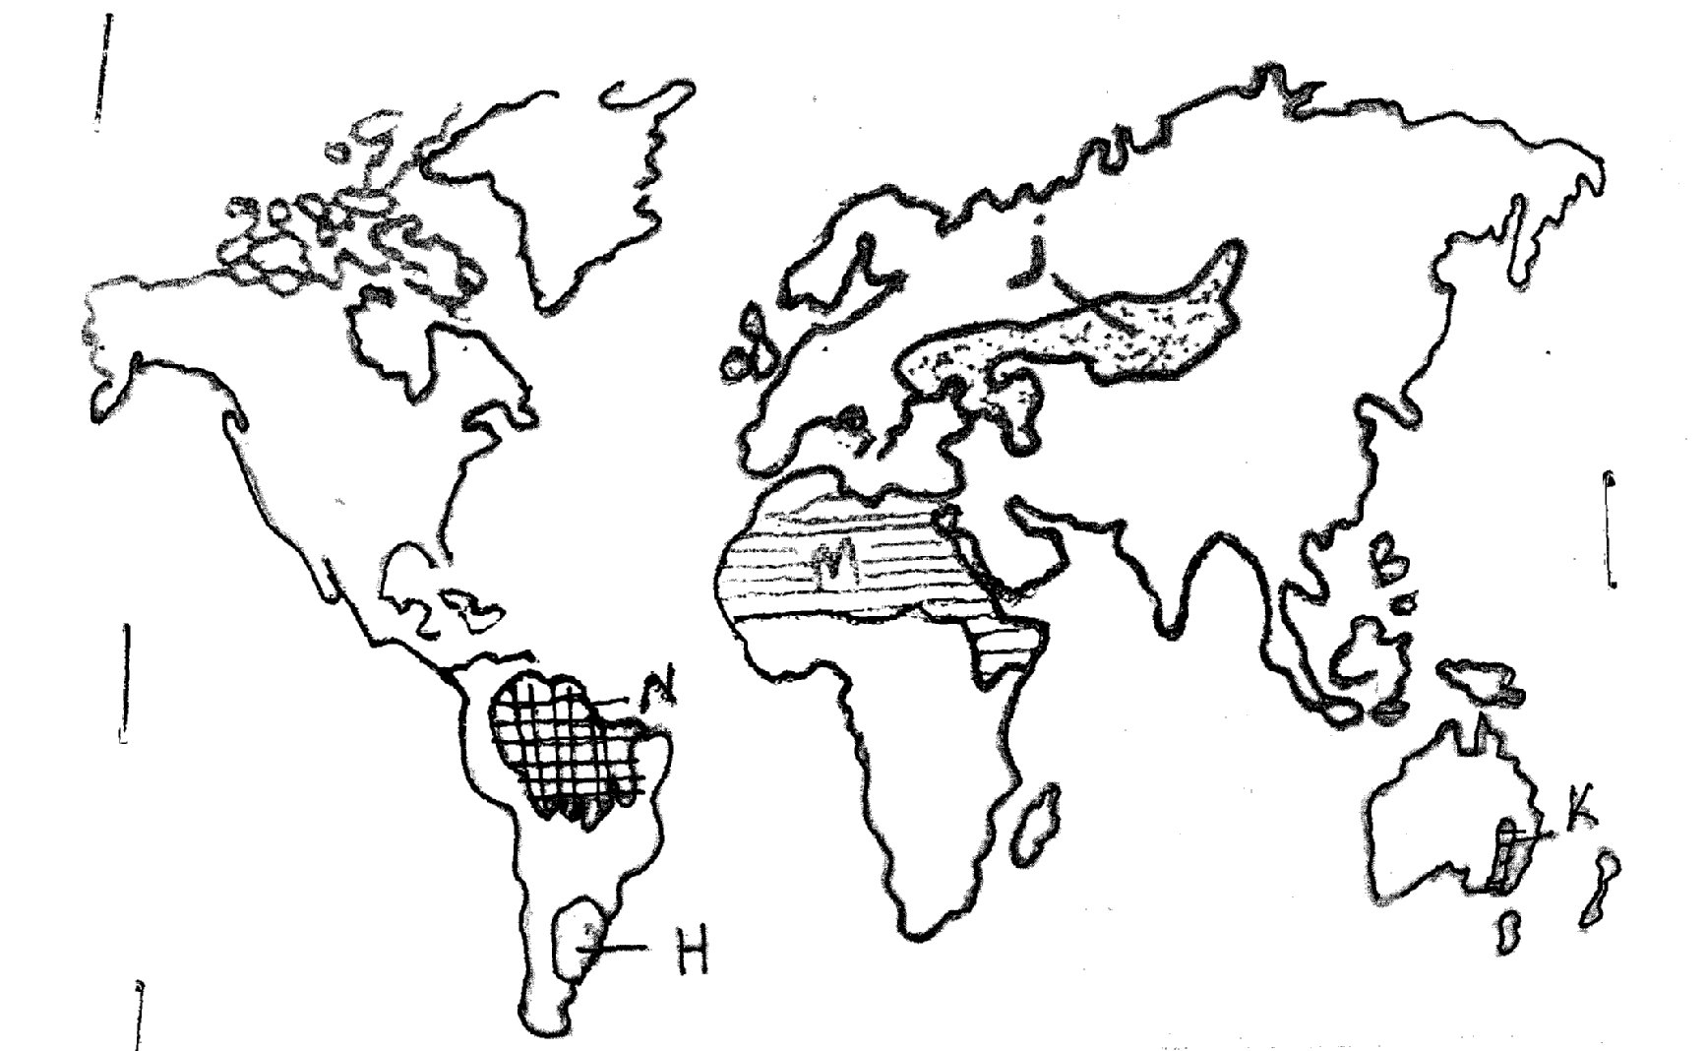

a.) Name the temperate grass lands marked H ,J and K. (3mks)
H- Pampas
J –Steppes
K - Downs

b.) Describe the characteristics of the natural vegetation found in the shaded area marked N. (5mks)
- The vegetations is tropical rainfall/equitorial forest
- The forest consist of mixed variety of tree species
- Most of the trees shed their leaves at different time of the year/evergreen
- Most of the trees have broad leaves/deep trapped leaves
- Most of the trees take long to mature
- The forest has little or no undergrowth due to the canopies
- The forest had numerous liana/climbing plants epiphytes
- Some the trees have buttress roots

c.) Explain four ways in which the vegetation found in the area marked M adapts to the environment conditions of the region. (8mks)
- Some plants have thick /fleshy/succulent leaves/to enable them store water
- Some have long roots to tap the ground water
- Some have no leaves have thin /spiky/waxy/needle like leaves to reduce transpiration
- Some plants have shiny, surface to reflect light
- Some plants have thick hard barks to reduce transpiration

d.) You are required to carry out a field study of the vegetation which the local environment.
i) Apart from identifying the different types of plants, state four other actives you will carry out during the field study. (4mks)
- Measure the plant length/length of some branches
- Collect sample of plant
- Draw sketches/transects
- Record/take notes
- Take photographs of plants/area
- Count plants
ii.) How will you identify the different types of plants. (2mks)
- By their appearance
- Their colour
- By their leaves size
- By their area
- By their nature of their bark
- By their texture
- By the system of their leaves
- By their fruit/ flowers
iii.) Give three reasons for visiting the area before study. (3mks)
- To familiarize with the are with the area of study
- To design methods of data collection and recording
- To formulate relevant objectives and hypothesis
- To identify likely problems to encounter
- To identify suitability of the area.
9.a) Differentiate between a waterfall and a gorge. (2mks)
- A water fall is a sharp break in the river channel over which the river falls. While a govge is a deep narrow and steep-sided river valley
ii.) State two factors that influence the rate of erosion by a river in its upper course. (2mks)
- The amount of stream discharge
- The gradient of the landscape
- she rock type over which a river is flowing The amount of load
- The composition size of sediments/load (2×1=2)

b.)Describe the processes by which a river transport its load. (6mks)
Traction process
- The large and heavy loads of the river are rolled or dragged along the river by the force of the moving water and gravity
Saltation
- Some large fragment that cannot remain suspended in the water are momentarily lifted and dropped by water turbulence. The series of hops move the load down the river
- Suspension
- Light insoluble materials such as sand and silt grains are carried and maintained within down stream
- Solution process
- The soluble minerals or materials are dissolved in river water and carried away (6×2=6)

ii) Name three river depositional features. (3mks)
- Alluvia fan
- Natural leaves and raised river bends
- Braided channels
- Deltas and distributaries
- Flood plains. (3x1=3)
c.) Describe each of the following drainage pattern using diagrams.
i) Centripetal. (2mks)
- Many river flow into a central basin from all direction
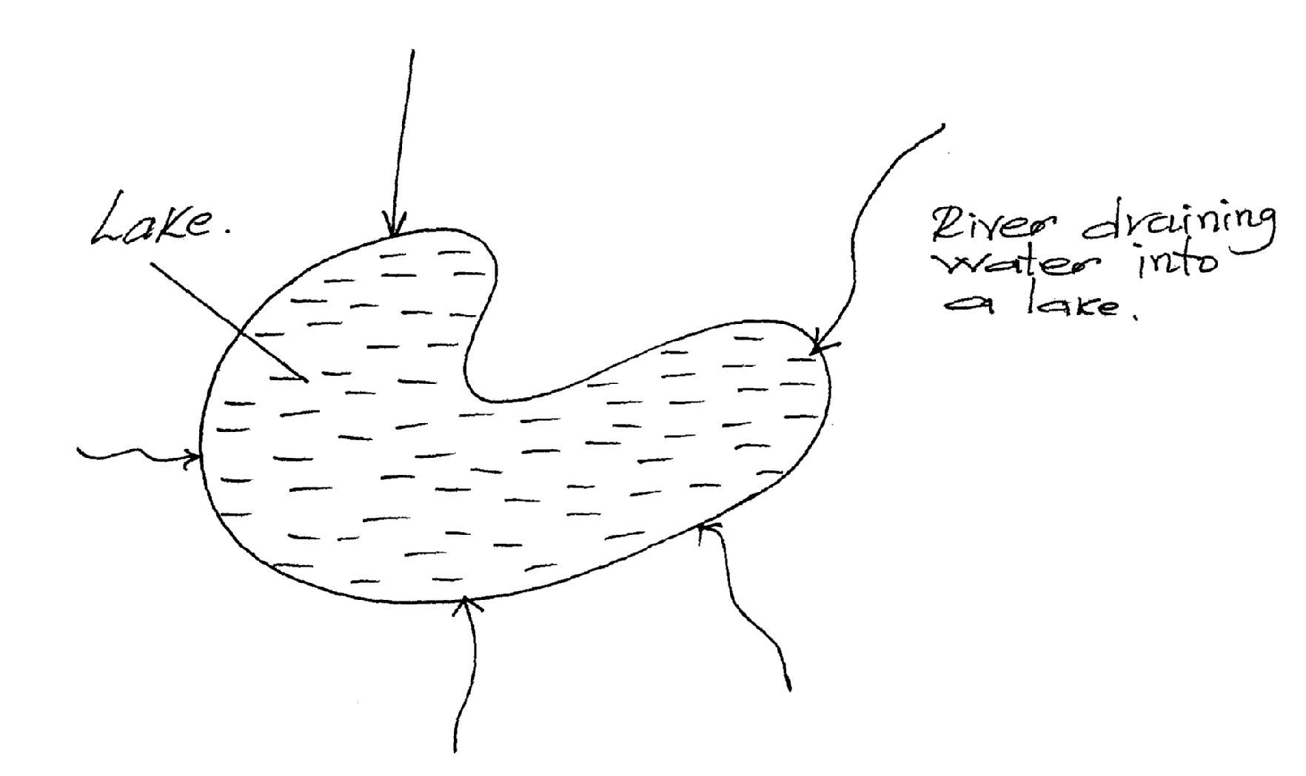
ii) Radial. (2mks)
- River flow outwards from a mountain/hill/highland, like the spikes of a bicycle wheel
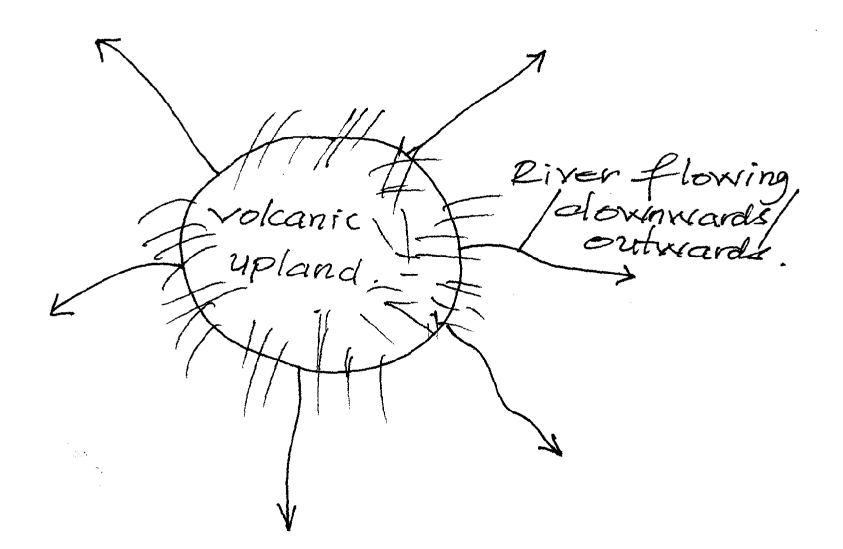

iii)Fault-guided. (2mks)
- River flow down along the fault line because they are relatively weak and can easily erode (2x1=2)
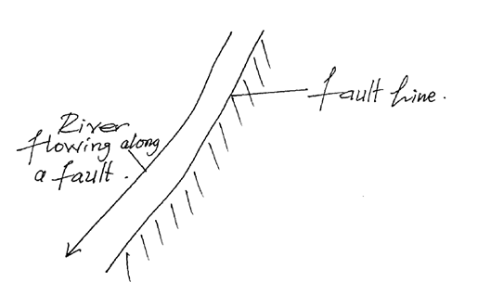
d) Your class is planning to carry out a field study of a river in its mature stage
i.) Give three methods you would use to record the information collected. (3mks)
- Taking notes
- Photographing
- Field sketching/drawing (1x3=3)
ii.) State three characteristics of a river at the mature stage that you are likely to observe during the study. (3mks)
- At this stage, lateral erosion is more dominant is joined by many tributaries from up stream increasing its erosive pover
- The river channel is wider and the valley develop U-shape appearance
- The concave bark is corroded and under cut steepening it to form river cliffs (3x1=3)
10a.) i State three conditions necessary for the development of Karst scenery. (3mks)
- The surface rock and the rock beneath should be thick limestone, dolomite or chalk
- The rock should be hard and well jointed
- The climate should be hot and humid to accelerate chemical weathering by solution processes
- The water table in the limestone area should be deep below the surface. (3x1=3)
ii.) Give three sources of underground water. (3mks)
- Rain water
- Melting ice
- Magnetic water
- Lake and
- Sea
- Connate/fossi/water
b. i) Differentiate between Artesian basin and Artesian. (3mks)
- Artesian basin is sauser-shaped depression which consist of a layer of permeable rock that is sandwiched between two layer of impermeable rock while Artesian well is a well sunk into the aquifer where water normally come to the surface by hydraulic pressure.
ii.)A part from stalagmites, name three other underground features formed in limestone areas. (3mks)
- Pyretic caves
- Stalagmite
- Stalactite
- Underground river
- Underground cave and caverns (3x1=3)

iii) With the aid of a diagram, describe how a stalagmite is formed. (8mks)
- Rainwater of dissolves carbon iv oxide in the atmosphere forming a weak carbonic acid
- The weak carbonic acid seeps through the roof of an underground cave
- It reacts with the limestone rock to form calcium hydrogen carbonate solutions
- The solution drip slowly through the roof of the cave to the floor spread out and evaporates Residue of sodium carbonate which is the form of tiny crystal is left on the floor
- More crystals form on top of the previous ones.
- The accumulation of crystal builds a structure upward called a stalagmite
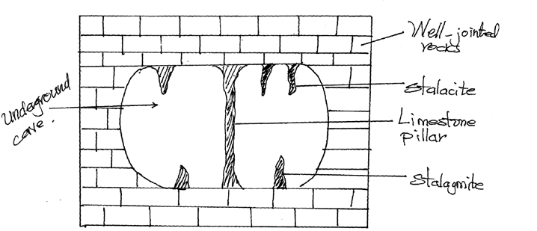
c.) Explain three positive significance of resultant features in Limestone area. (6mks)
- Caves, gorges and dry valleys form attractive site hence favouring tourism
- Collapse of do lines into the water tables may lead to lakes in karst area. Lakes provides permanent water sources in limestone area
- Limestone is used in iron and steel industry where it used to separate iron from other impurities
(3x2=6)

