Kenya Certificate of Secondary Education. (K.C.S.E)

GEOGRAPHY PAPER ONE
MOCK 2023
NAME…………………………………………….………...... ADM NO………….……...........……
SIGN…….............................……….
CLASS........................................................................................ DATE……………………….......…
312/1
GEOGRAPHY
PAPER 1
TIME: 2³/₄ HOURS

Kenya Certificate of Secondary Education.(K.C.S.E)

INSTRUCTIONS TO CANDIDATES
- Write your name and index number in the spaces provided above
- This paper consists of TWO sections A and B
- Answer ALL questions in Section A. In section B answer QUESTION 6 and any other TWO.
- All answers MUST be written in the spaces provided at the end of question 10
- Do not remove any pages from this booklet
- This paper consists of 12 printed pages. Candidates should check to ensure that all pages are printed as indicated and no questions are missing.
For Examiners Use Only
Section | Questions | Maximum Score | Candidates Score
A | 1 – 5 | 25
B | 6 | 25
 |  | 25
 |  | 25
 | TOTAL SCORE | 100

SECTION A
ANSWER ALL THE QEUSTIONS IN THIS SECTION
1a) Define the term Environment. (3mks)
b.) List any three major areas coved in physical Geography. (3mks)
2a) The diagram below represents the structure of the atmosphere use it to answer question (a)
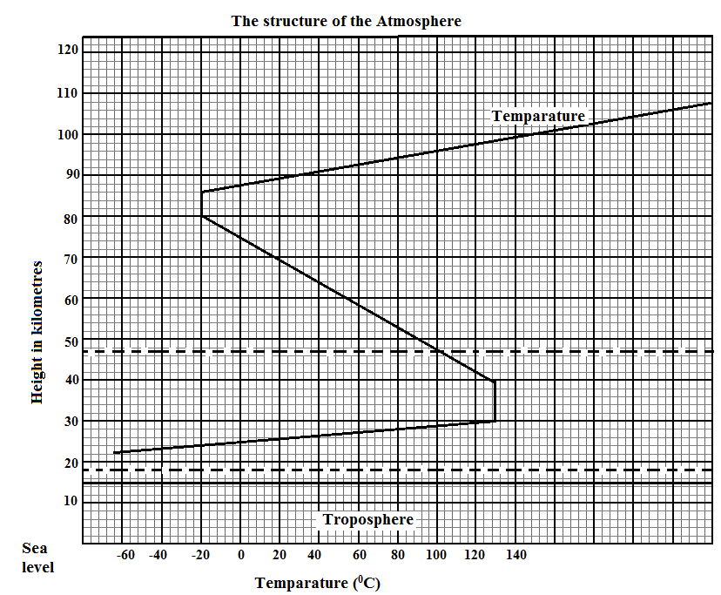
a) Name
i) The parts marked P and Q. (2mks)
ii) The layer of discontinuity marked R. (1mk)
b.) State two characteristics of weather conditions in the troposphere. (2mks)
3. a) What is an earthquake? (2mks)
b) Identify the scale used to measure
i) The intensity of earthquakes. (1mk)
ii) The magnitude of earthquakes. (1mk)

c) Name one major region where earthquakes are likely to occur. (1mk)
4. a) Distinguish between River Capture and river rejuvenation. (2mks)
b) State three characteristics of a river at youthful stage. (3mks)
5. a) Explain two reasons why wind is the dominant agent of erosion in arid area. (4mks)
b) Identify any one feature formed as a result of wind deposition in arid areas. (1mk)
6. Use the map PROVIDED KISUMU EAST I:50,000 (SHEET 116/2) and answer the following questions .
a.) i) What is the sheet title of the map (1mk)
ii). What is the magnetic declination of the map extract (1mk)
b. i) Convert the ratio scale of the map extract into statement scale. (2mks)
c.) What is the bearing of trigonometrical station at grid reference 081980 from the Air photo Principals point at grit square 0997. (2mks)
d) Give three types of natural Vegetation found in the area covered by map. (3mks)
e) Describe the drainage of the area covered by the map. (5mks)
f) Draw a rectangle 12cm by 10cm to represent the area enclosed by Easting 03 and 09 and Northing 80 and 85. On the rectangle, mark and name the following features. (5mks)
i) Trigonometrical station 1154.
ii) All weather road B 25/3
iii) Seasonal swamp.
iv) Ombeyi river.
g. Citing evidence from the map ,explain three social factions of Ksumu town . (6mks)
7. a) i) What is folding ? (2mks)
ii) State three factors that influence folding . (3mks)
b) i) Apart from over thrust fold ,name four other types of folds. (4mks)
ii) With the aid of well labelled diagrams ,describe the formation of an over thrust fold. (8mks)
c) Explain four significance of fold maintains to human activities. (8mks)

8. The map below shows some vegetation regions of the world.
Use it to answer questions (a) to (c)
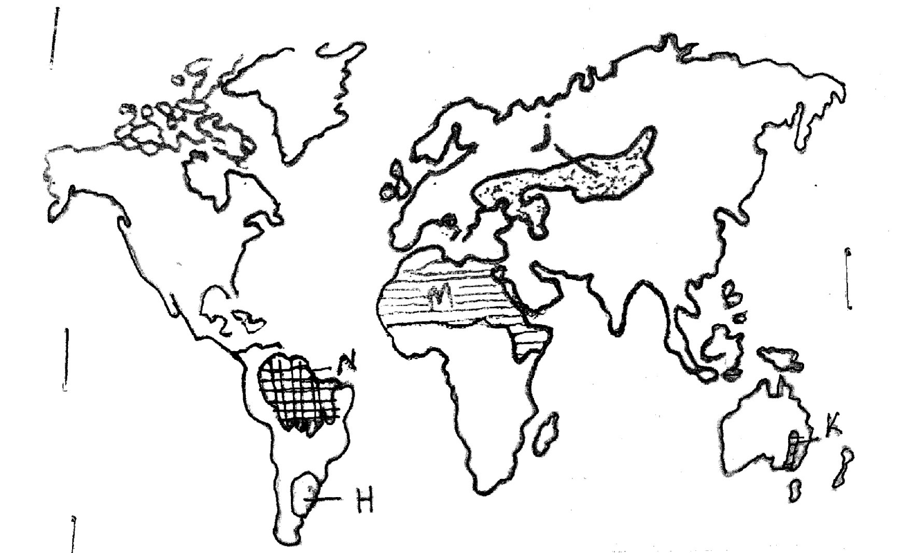
a.) Name the temperate grass lands marked H ,J and K. (3mks)
b.) Describe the characteristics of the natural vegetation found in the shaded area marked N. (5mks)
c.) Explain four ways in which the vegetation found in the area marked M adapts to the environment conditions of the region. (8mks)
d.) You are required to carry out a field study of the vegetation which the local environment.
i) Apart from identifying the different types of plants, state four other activities you will carry out during the field study. (4mks)
ii.) How will you identify the different types of plants. (2mks)
iii.) Give three reasons for visiting the area before study. (3mks)
9. a) i) Differentiate between a waterfall and a gorge. (2mks)
ii.) State two factors that influence the rate of erosion by a river in its upper course. (2mks)
b.) i) Describe the processes by which a river transport its load. (6mks)
ii) Name three river depositional features. (3mks)
c.) Describe each of the following drainage pattern using diagrams.
i) Centripetal. (2mks)
ii) Radial. (2mks)
iii) Fault-guided. (2mks)
d) Your class is planning to carry out a field study of a river in its mature stage
i.) Give three methods you would use to record the information collected. (3mks)
ii.) State three characteristics of a river at the mature stage that you are likely to observe during the study. (3mks) 10 a.) i) State three conditions necessary for the development of Karst scenery. (3mks)
ii.) Give three sources of underground water. (3mks)
b) i) Differentiate between Artesian basin and Artesian well (2mks) ii.) A part from stalagmites, name three other underground features formed in limestone areas. (3mks)
iii) With the aid of a diagram, describe how a stalagmite is formed. (8mks)
c.) Explain three positive significance of resultant features in Karst scenery. (6mks)
.........................................................................................................................................................................
.........................................................................................................................................................................
.........................................................................................................................................................................
.........................................................................................................................................................................
.........................................................................................................................................................................
.........................................................................................................................................................................
.........................................................................................................................................................................
.........................................................................................................................................................................
.........................................................................................................................................................................
.........................................................................................................................................................................
.........................................................................................................................................................................
.........................................................................................................................................................................
.........................................................................................................................................................................
.........................................................................................................................................................................
.........................................................................................................................................................................
.........................................................................................................................................................................
.........................................................................................................................................................................
.........................................................................................................................................................................
.........................................................................................................................................................................
.........................................................................................................................................................................
.........................................................................................................................................................................
.........................................................................................................................................................................
.........................................................................................................................................................................
.........................................................................................................................................................................
.........................................................................................................................................................................
.........................................................................................................................................................................
.........................................................................................................................................................................
.........................................................................................................................................................................
.........................................................................................................................................................................
.........................................................................................................................................................................
.........................................................................................................................................................................
.........................................................................................................................................................................
.........................................................................................................................................................................
.........................................................................................................................................................................
.........................................................................................................................................................................
.........................................................................................................................................................................
.........................................................................................................................................................................
.........................................................................................................................................................................
.........................................................................................................................................................................
.........................................................................................................................................................................
.........................................................................................................................................................................
.........................................................................................................................................................................
.........................................................................................................................................................................
.........................................................................................................................................................................
.........................................................................................................................................................................
.........................................................................................................................................................................
.........................................................................................................................................................................
.........................................................................................................................................................................
.........................................................................................................................................................................
.........................................................................................................................................................................
.........................................................................................................................................................................
.........................................................................................................................................................................
.........................................................................................................................................................................
.........................................................................................................................................................................
.........................................................................................................................................................................
.........................................................................................................................................................................
.........................................................................................................................................................................
.........................................................................................................................................................................
.........................................................................................................................................................................
.........................................................................................................................................................................
.........................................................................................................................................................................
.........................................................................................................................................................................
.........................................................................................................................................................................
.........................................................................................................................................................................
.........................................................................................................................................................................
.........................................................................................................................................................................
.........................................................................................................................................................................
.........................................................................................................................................................................
.........................................................................................................................................................................
.........................................................................................................................................................................
.........................................................................................................................................................................
.........................................................................................................................................................................
.........................................................................................................................................................................
.........................................................................................................................................................................
.........................................................................................................................................................................
.........................................................................................................................................................................
.........................................................................................................................................................................
.........................................................................................................................................................................
.........................................................................................................................................................................
.........................................................................................................................................................................
.........................................................................................................................................................................
.........................................................................................................................................................................
.........................................................................................................................................................................
.........................................................................................................................................................................
.........................................................................................................................................................................
.........................................................................................................................................................................
.........................................................................................................................................................................
.........................................................................................................................................................................
.........................................................................................................................................................................
.........................................................................................................................................................................
.........................................................................................................................................................................
.........................................................................................................................................................................
.........................................................................................................................................................................
.........................................................................................................................................................................
.........................................................................................................................................................................
.........................................................................................................................................................................
.........................................................................................................................................................................
.........................................................................................................................................................................
.........................................................................................................................................................................
.........................................................................................................................................................................
.........................................................................................................................................................................
.........................................................................................................................................................................
.........................................................................................................................................................................
.........................................................................................................................................................................
.........................................................................................................................................................................
.........................................................................................................................................................................
.........................................................................................................................................................................
.........................................................................................................................................................................
.........................................................................................................................................................................
.........................................................................................................................................................................
.........................................................................................................................................................................
.........................................................................................................................................................................
.........................................................................................................................................................................
.........................................................................................................................................................................
.........................................................................................................................................................................
.........................................................................................................................................................................
.........................................................................................................................................................................
.........................................................................................................................................................................
.........................................................................................................................................................................
.........................................................................................................................................................................
.........................................................................................................................................................................
.........................................................................................................................................................................
.........................................................................................................................................................................
.........................................................................................................................................................................
.........................................................................................................................................................................
.........................................................................................................................................................................
.........................................................................................................................................................................
.........................................................................................................................................................................
.........................................................................................................................................................................
.........................................................................................................................................................................
.........................................................................................................................................................................
.........................................................................................................................................................................
.........................................................................................................................................................................
.........................................................................................................................................................................
.........................................................................................................................................................................
.........................................................................................................................................................................
.........................................................................................................................................................................
.........................................................................................................................................................................
.........................................................................................................................................................................
.........................................................................................................................................................................
.........................................................................................................................................................................
.........................................................................................................................................................................
.........................................................................................................................................................................
.........................................................................................................................................................................
.........................................................................................................................................................................
.........................................................................................................................................................................
.........................................................................................................................................................................
.........................................................................................................................................................................
.........................................................................................................................................................................
.........................................................................................................................................................................
.........................................................................................................................................................................
.........................................................................................................................................................................
.........................................................................................................................................................................
.........................................................................................................................................................................
.........................................................................................................................................................................
.........................................................................................................................................................................
.........................................................................................................................................................................
.........................................................................................................................................................................
.........................................................................................................................................................................
.........................................................................................................................................................................
.........................................................................................................................................................................
.........................................................................................................................................................................
.........................................................................................................................................................................
.........................................................................................................................................................................
.........................................................................................................................................................................
.........................................................................................................................................................................
.........................................................................................................................................................................
.........................................................................................................................................................................
.........................................................................................................................................................................
.........................................................................................................................................................................
.........................................................................................................................................................................
.........................................................................................................................................................................
.........................................................................................................................................................................
.........................................................................................................................................................................
.........................................................................................................................................................................
.........................................................................................................................................................................
.........................................................................................................................................................................
.........................................................................................................................................................................
.........................................................................................................................................................................
.........................................................................................................................................................................
.........................................................................................................................................................................
.........................................................................................................................................................................
.........................................................................................................................................................................
.........................................................................................................................................................................
.........................................................................................................................................................................
.........................................................................................................................................................................
.........................................................................................................................................................................
.........................................................................................................................................................................
.........................................................................................................................................................................
.........................................................................................................................................................................
.........................................................................................................................................................................
.........................................................................................................................................................................
.........................................................................................................................................................................
.........................................................................................................................................................................
.........................................................................................................................................................................
.........................................................................................................................................................................
.........................................................................................................................................................................
.........................................................................................................................................................................
.........................................................................................................................................................................
.........................................................................................................................................................................
.........................................................................................................................................................................
.........................................................................................................................................................................
.........................................................................................................................................................................
.........................................................................................................................................................................
.........................................................................................................................................................................
.........................................................................................................................................................................
.........................................................................................................................................................................
.........................................................................................................................................................................
.........................................................................................................................................................................
.........................................................................................................................................................................
.........................................................................................................................................................................
.........................................................................................................................................................................
.........................................................................................................................................................................
.........................................................................................................................................................................
.........................................................................................................................................................................
.........................................................................................................................................................................
.........................................................................................................................................................................
.........................................................................................................................................................................
.........................................................................................................................................................................
.........................................................................................................................................................................
.........................................................................................................................................................................
.........................................................................................................................................................................
.........................................................................................................................................................................
.........................................................................................................................................................................
.........................................................................................................................................................................
.........................................................................................................................................................................
.........................................................................................................................................................................
.........................................................................................................................................................................
.........................................................................................................................................................................
.........................................................................................................................................................................
.........................................................................................................................................................................
.........................................................................................................................................................................
.........................................................................................................................................................................
.........................................................................................................................................................................
.................................................................................................................................................................................................................................................................................................................
.........................................................................................................................................................................
.........................................................................................................................................................................
.........................................................................................................................................................................
.........................................................................................................................................................................
.........................................................................................................................................................................
.........................................................................................................................................................................
.........................................................................................................................................................................
.........................................................................................................................................................................
.........................................................................................................................................................................
.........................................................................................................................................................................
.........................................................................................................................................................................
.........................................................................................................................................................................
.........................................................................................................................................................................
.........................................................................................................................................................................
.........................................................................................................................................................................
.........................................................................................................................................................................
.........................................................................................................................................................................
.........................................................................................................................................................................
.........................................................................................................................................................................
.........................................................................................................................................................................
.........................................................................................................................................................................
.........................................................................................................................................................................
.........................................................................................................................................................................
.........................................................................................................................................................................
.........................................................................................................................................................................
.........................................................................................................................................................................
.........................................................................................................................................................................
.........................................................................................................................................................................
.........................................................................................................................................................................
.........................................................................................................................................................................
.........................................................................................................................................................................
.........................................................................................................................................................................
.........................................................................................................................................................................
.........................................................................................................................................................................
........................................................................................................
..........................................................................................................................
.........................................................................................................................................................................
.........................................................................................................................................................................
.........................................................................................................................................................................
.........................................................................................................................................................................
.........................................................................................................................................................................
.........................................................................................................................................................................
.........................................................................................................................................................................
.........................................................................................................................................................................

