Nyaraya Cluster Examination
Kenya Certificate of Secondary Education

2023 Form Four Evaluation Programme

511/3 MUSIC Paper 3
AUGUST 2023

511/3
MUSIC
TIME: 2½ hours
THE YEAR 2023
Instructions to candidates;

a) This paper contains 11 printed pages.
b) Write your name and index number .
c) Answer all the questions in the spaces provided
d) In question 4 choose any two of the questions numbered (a), (b), (c) and (d).

For examiner’s use only

SECTION | QUESTION | MAXIMUM  SCORE | CANDIDATE’S  SCORE
A | 1 | 15
 | 2 | 15
B | 3 | 14
 | 4 | 14
 | 5 | 10
 | 6 | 10
 | 7 | 6
C | 8 | 16
 | TOTAL SCORE | 100%

1a) Continue the following opening to make a melody of 16 bars for voice with a modulation to the dominant and back to the Tonic. Incorporate a duplet. (9mks)

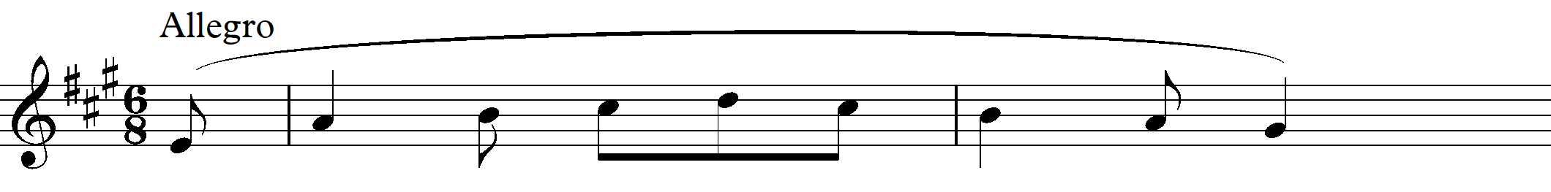

b) Using staff notation, compose a tune to suite the following lyrics. Add phrase marks .(6marks)

Mungu mwenye enzi, u mwaminifu.

Siku zangu zote, kamwe sitapungukiwa.

2 Harmonize the following melody for soprano, alto, tenor and bass (SATB). Choose appropriate chords from I, II , IV, V and VI. Include a passing six four chord. (15marks)

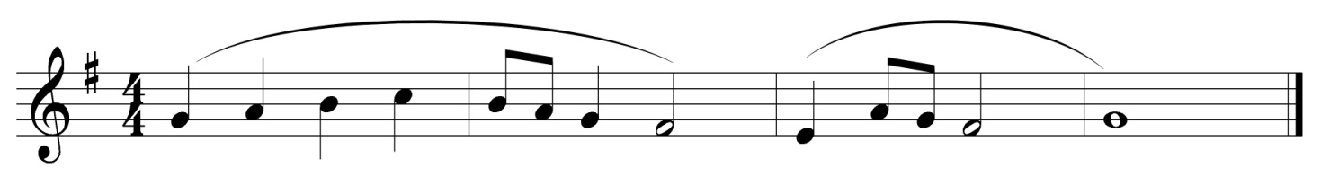

SECTION B: HISTORY AND ANALYSIS [54MARKS]

3. AFRICAN HISTORY [14MARKS]

a) Apart from warming, state two other ways of tuning membranophones. (2marks)

b) Solo and chorus as a style of singing has its advantages. Outline any four of these
advantages. (4marks)

c) State any four functions of lullabies in an African traditional society. (4marks)
_________________________________________________________________________________________________________________________________________________________________________________________________________________________________________________________________________________________________________________________________________________________________________________________________________________________________________________________________________________________

d) Kamabeka is a traditional dance in Kenya. Identify: (3marks)

i. The community that performs it.
ii. The gender of the performance.
iii. The occasion during which it is performed .

e) What is the difference between orutu and Arutu? (2marks)

___
------------------------------------------------------------------------------------------------------------------------------------------------------------------------------------------------------------------------------------------------------------------------------------------------------------------------------------------------
4. WESTERN MUSIC. [14MARKS]

Answer any two questions from (a), (b), (c) and (d)

a) CLAUDIO MONTEVERDI

i) Name Claudio Monteverdi’s nationality. (1mark)

ii) State any three capacities in which Monteverdi served at the court of Gonzaga in
Mantua. (3marks)

iii) What is an Opera? (1mark)

iv) Name the two operatic masterpieces that Montervedi composed for the court of
Mantua (2marks)

b) ALLESANDRO SCARLLATI

i) In which musical period did Allesandro live? (1mark

ii) Who was Allesandro’s teacher in Rome? ________________________________ (1 mark)
iii) State any three of Allesandros musical appointments. (3marks)
____________________________________________________________________________________________________________________________________________________________________________________________________________________________________________________________________________________________________________________________________________________________

iv) State any two features of Allesandros operas. (2marks)

______________________________________________________________________________________________________________________________________________________________________________________________________________________________________________________________________________________________________________________________________________________________________________________________________

c). CHRISTOPH GLUCK

i. Name his nationality (1mark)

ii. Name two non-musical artistes who influenced Gluck as a composer. (2marks)

iii. Discuss his relationship with Handel. (2marks)

iv. Name the two operas associated with conquering. (2marks)

d). CLAUDE DEBUSSY

i. Outline four characteristics that depict impressionistic style in Debussy musical works.
(4marks)

ii. State two sources that influenced Debussy’s musical life and style. (2marks)

iii. Name the opera that Debussy composed. (1mark)

5. Prescribed African Music

Chuka drummers from Tharaka Nithi (PPMC)

a).Give four ways through which variation has been achieved in the music. (4marks)

b). Outline three roles of voice in the performance? (3marks)

_________________________________________________________________________

d) Give three roles of drums in the performance. (3marks)

_________________________
---------------------------------------------------------------------------------------------------------------------------------------------------------------------------------------------------------------------------------------------------------------------------------------------------------------------------------------------------------------------------------------------------------------------------------------------6. PRESCRIBED WESTERN ANALYSIS : Trio sonata by Archangello Corelli

a) What is the main role of the organ in the composition? (1mark)
--------------------------------------------------------------------------------------------------------------------------------------------------------------------------------------------------------------------------------------------
b) Name the bars that have got parts crossing (2marks)

c). Indicating bar numbers, state the main form of the work. (2marks)

d). Describe bars 1-19 in terms of :

i).Tonality (2marks)

ii).Texture (1mark)

iii).Tempo (1mark)

iv).Media
(2marks)

- UNPREPARED ANALYSIS

Use the music below to answer the questions that follow.

(a) (i) On which degree of the scale does the melody begin from? ________________ (1 mark)
(ii) Give two ways in which variation has been achieved in the melody. (1 mark)
______________________________________________________________________________
______________________________________________________________________________
______________________________________________________________________________
______________________________________________________________________________
______________________________________________________________________________

- Describe the tonality of the music. __________________________________ (1 mark)

- For what medium is the melody written for? ____________________________ (1 mark)

d) State any articulation mark used in the melody __________________________ (1mark)
e) Describe the cadence between the last two notes. ____________________________(1mark)

8. General Music knowledge
a) Give two transposing instruments with high pitched sounds (2marks)

_____________________________________________________________________________________________

b) Outline three roles of a music producer. (3marks)

c) Name any three arrangers of the Kenya national anthem ( 3marks)

______________________________________________________________________________
______________________________________________________________________________
______________________________________________________________________________
d) Explain any four points justifying the importance of a music student participating in the Kenya music festival competitions (4marks)
______________________________________________________________________________
______________________________________________________________________________
______________________________________________________________________________
______________________________________________________________________________
______________________________________________________________________________

e) Explain four ways through which harmonic effect is achieved in traditional African music
(4marks)
______________________________________________________________________________
______________________________________________________________________________
______________________________________________________________________________
______________________________________________________________________________
______________________________________________________________________________
______________________________________________________________________________

This is the last page

