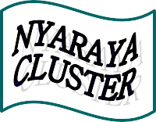
Nyaraya Cluster Examination
Kenya Certificate of Secondary Education

2023 Form Four Evaluation Programme

511/1 MUSIC Paper 1
AUGUST 2023

511/1
MUSIC PRACTICAL
Paper 1
THE YEAR 2023
SIGHT READING EXERCISES

SPAPER 1
SIGHT READING EXERCISES

____________________________________________

SIGHT READING EXERCISES.

TREBLE AND DESCANT RECORDER/ VOICE
1.
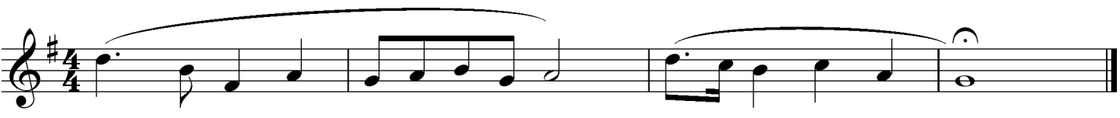
2.
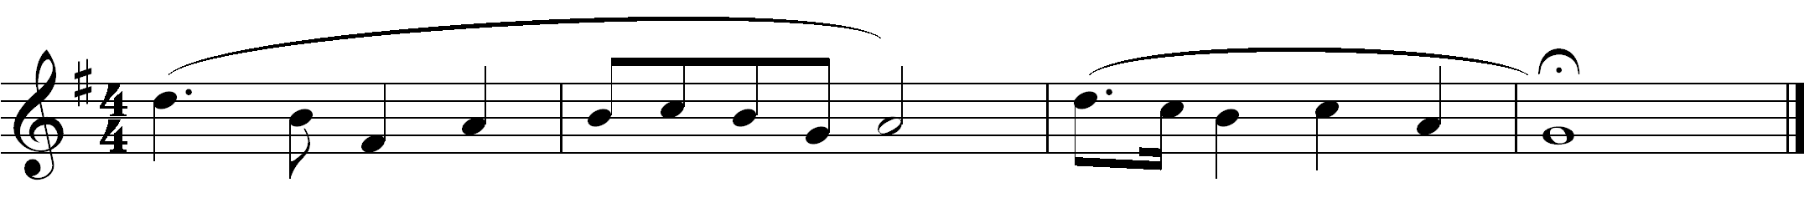
3.
4.
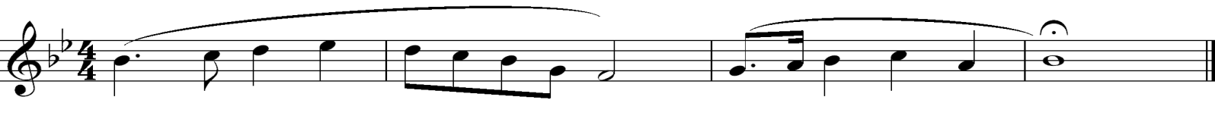

CLARINET/ SAXOPHONE
5.
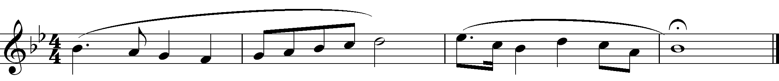
6.
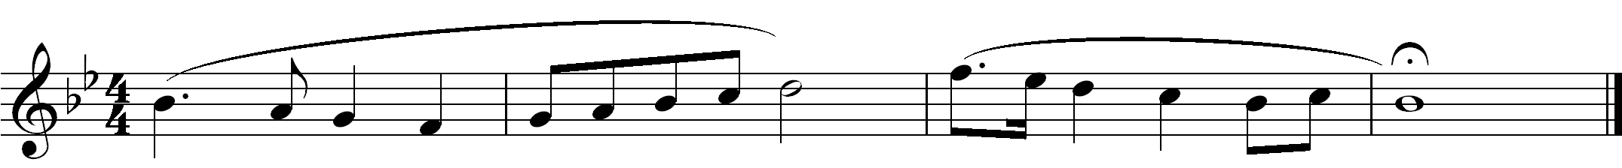

7. PIANO
.
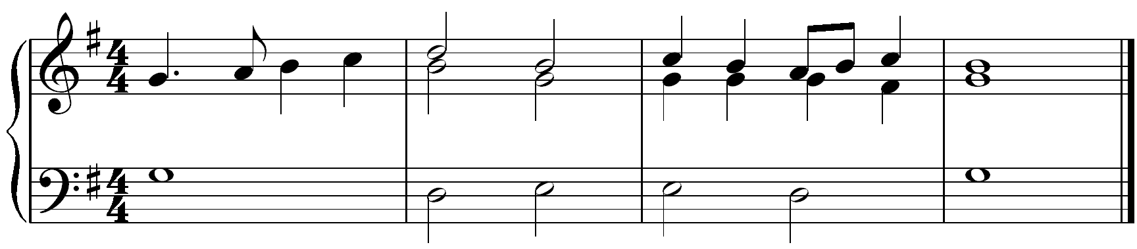

TRUMPET/CORNET
8.
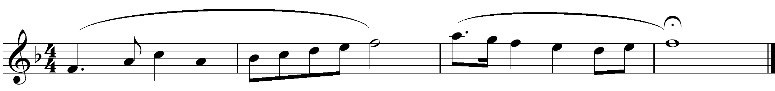
9.
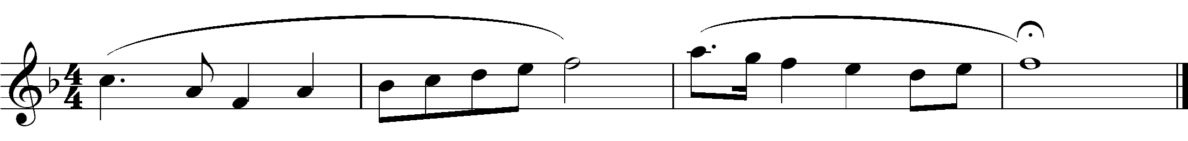

10. TROMBONE / EUPHONIUM/TUBA
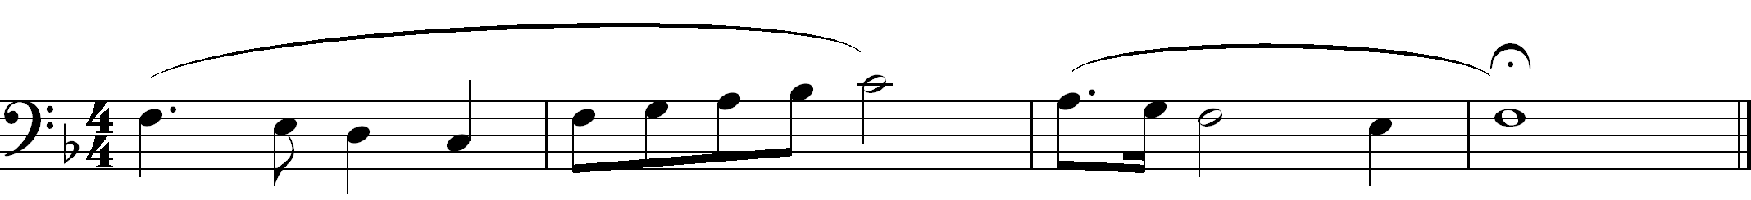

VIOLIN
11.
