NYARAYA MARKING SCHEME
Kenya Certificate of Secondary Education

233/1
Chemistry Theory
Paper 1
Time: 2 Hours
July 2023

INSTRUCTIONS
- Write your name and school and index number in the spaces provided at the top of this page
- All answers should be written in the spaces provided.
- Non-programmable silent electronic calculators and KNEC mathematical tables may be used.
- Students should check the question paper to ascertain that all pages are printed as indicated and that no questions are missing.

FOR EXAMINERS USE ONLY
QUESTION | MAXIMUM SCORE | CANDIDATES SCORE
1 – 29 | 80

This paper consists of 11 printed pages. Candidates should check to ascertain that all pages are printed as indicated and that no questions are missing.

- In the extraction of zinc, the zinc ore is crushed to a powder, mixed with oil and water and air blown through the mixture.
- What is the name given to this process? (1 mark)
Froth floatation √1
Explain how this process works. (1 mark) A froth forms on top with most of the minerals and the waste materials or impurities at the bottom. √1
- Name the chief ore from which zinc is extracted. (1 mark)
Zinc blende √1
- (a) Using the oxidation number, identify and explain oxidizing and reducing agent (2 marks) 2 H₂S(g) + SO₂(g) → 3S(s) + 2H₂O(l)
+1 -2 +4 -2 0 +1 -2
SO₂ is the oxidizing agent √ ½ since the oxidation number of S reduces from +4 to 0 √ ½, while H₂S is the reducing agent √ ½ since the oxidation number of S increases from -2 to 0 √ ½
(b) Atomic number of Sulphur is 16. Write the electron configuration of S in SO₃²⁻ (1 mark) 2.8.4 √1
- Name the process which takes place when: (3 marks)
- Solid carbon (IV) oxide changes to gas
Sublimation √1
- Red litmus paper turns white when dropped in chlorine water
Bleaching √1
- Ethene gas molecules are converted into giant molecules
Polymerisation √1
- 3.1g of an organic compound containing carbon, hydrogen and oxygen only, produced 4.4g of carbon (IV) oxide and 1.8g of water on complete combustion. Determine its molecular formula if its formula mass is 60. (3 marks)
Element | C | H | O
Mass | 12/44g X 4.4  = 1.2g | 2/18 X 1.8  = 0.2g | 3.1- (1.2+0.2)  = 1.7g √ ½
RAM | 12 | 1 | 16
Moles | 1.2/12  = 0.1 | 0.2/1  = 0.2 | 1.7/16  = 0.10625 √ ½
Mole ratio | 0.1/0.10625  = 0.94 | 0.2/0.1  = 2.0 | 0.10625/0.1  = 1.0625√ ½

E.F. = CH₂O √ ½

(CH₂O)n = 60
30n = 60 √ ½
n = 60/30 = 2
M.F. = C₂H₄0₂ √ ½

- Use the table below to answer the question that follow:

Element | Atomic number
A | 11
B | 13
C | 14
D | 17
E | 19

- Write an equation for the reaction between element A and water. (1 mark)
2A(s) + 2H₂O(l) → 2AOH(aq) + H₂(g) / 2Na(s) + 2H₂O(l) → 2NaOH(aq) + H₂(g) √1
- Explain the trend of atomic radii between elements A and D. (2 marks)
D has a smaller atomic radius than A √1 because D has more protons √ ½, hence greater nuclear attraction on the electrons. √ ½ (Accept the converse)
- (a) Define the term allotropy (1 mark)
It is the existence of an element in more than one form in the same physical state. √1
(b) In terms of structure and bonding, explain why graphite is used as a lubricant. (2 marks)
Layers of graphite are held together by van der Waals forces, √1 therefore easily slide over each other when pressed and this gives graphite its slippery feel. √1
- (a) State Boyles Law. (1 mark) The volume of a fixed mass of a gas is inversely proportional to its pressure at constant temperature.
(b) A given mass of the gas occupies 20cm³ at 25⁰ C and 670mmHg pressure. Find the volume it will occupy at 10⁰ C and 335mmHg. (2 marks)
P1V1 = P2V2 670mmHg X 20cm³ = 335mmHg X V2
T1 T2 298K 283K

V2 = 670mmHg X 20cm³ X 283K
298K X 335mmHg √1
= 37.99cm³ √1
- Concentrated sodium chloride was electrolysed using graphite electrodes. Name the product formed at the anode and give a reason for your answer. (2 marks)
Chlorine. √1 The concentration of chloride ions is higher than that of hydroxide ions in brine√ ½, hence chloride ions are preferentially discharged at the anode. √ ½
- (a) What is meant by lattice energy? (1 mark)
It is the amount of heat energy released when one mole of an ionic compound is formed from its constituent ions in gaseous state. √1

(b) Study the energy level diagram below and answer the question that follows:

NaOH _{(aq)} + H₂O _{(l)}

∆H

Na⁺ _{(aq)} + OH⁻ _{(aq)}

What type of reaction is represented by the diagram? (1 mark)
Exothermic reaction. √1
- Magnesium chloride dissolves in water to form a neutral solution while aluminium (III) chloride forms an acidic solution. Explain. (3 marks)
Magnesium chloride is an ionic compound√ ½ which dissolves in water√ ½ to form a neutral solution, while aluminium (III) chloride which is a molecular compound√ ½, is hydrolysed in water.√ ½
- When solid B was heated strongly, it gave off water and a solid residue. When water was added to the solid residue, the original solid B, was formed.
- What name is given to the process described? (1 mark)
Temporary chemical change √1
(b) Give one example of solid B. (1 mark)
Hydrated copper (II) sulphate / Hydrated cobalt (II) chloride √1
- The scheme below was used to prepare a cleansing agent. Study it and answer the questions that follow.

Fat

Solution of cleansing
agent and an alcohol

Solid cleansing agent

NaOH
(
aq
)
; Boil

Step I

Step II

(a) What name is given to the type of cleansing agent prepared by the method shown in the scheme? (1 mark)
Soapy detergent √1
(b) Name one chemical substance added in step II. (1 mark)
Sodium chloride √1
(c) What is the purpose of adding the chemical substance named in (ii) above? (1 mark)
Causes soap to come out of the solution and collect as a layer on the surface √1
- The diagram below represents part of a setup arranged for the collection of hydrogen gas in the laboratory. Study it and answer the questions that follow.
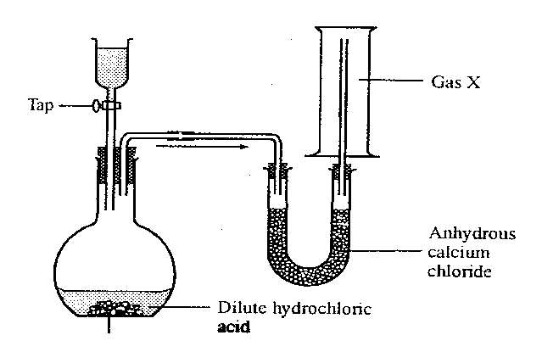√√
- Complete the diagram to show how a dry sample of hydrogen can be collected. (2 marks)
Drying agent √ ½ ( Accept fused CaO in a U-tube or conc H₂SO₄ in a retort flask or conical flask)
Method of collection √ ½
Workability √ ½
Diagram √ ½
- Give the most suitable identity of solid Z. (1 mark)
Zinc metal √1
- (a) Define ionization energy. ` (1 mark)
It is the minimum energy required to remove an electron from the outermost energy level of an atom in gaseous state. √1
(b) Explain why the second ionization energy of magnesium is higher than its first ionization energy. (2 marks)
When the first electron is lost from the magnesium atom, the remaining electrons experience a greater pull by the nucleus, √1 hence more energy is required to remove the second electron. √1
- A state of equilibrium between dichromate (VI) and Chromate ions is established as shown below.
Cr₂O₇²⁻ (aq) +2OH⁻ (aq) CrO₄²⁻ (aq) + H₂O (l)
(Orange) (Yellow)
- What is meant by a dynamic equilibrium? (1 mark)
It refers to a state in which both forward and backward reactions continue to take place, but the concentrations of reactants and products do not change. √1
- State and explain observation made when a few pellets of potassium hydroxide are added to the equilibrium mixture. (2 marks)
The solution turns yellow. √1 Addition of potassium hydroxide to the mixture increases the concentration of OH⁻ ions√ ½, favouring the forward reaction/ equilibrium shifts to the right. √ ½

- Describe how you would obtain solid sample of each of the following components of solid mixture containing lead (II) chloride, ammonium chloride and copper (II) oxide (3 marks)
Heat the mixture√ ½ in a glass beaker covered with a watch glass containing cold water. NH₄Cl sublimes then deposits√ ½ underneath the watch glass. Add hot water√ ½ to the mixture remaining in the beaker and stir to dissolve PbCl₂. √ ½ Filter√ ½ to obtain a filtrate of PbCl₂ and CuO residue. Allow the filtrate cool to obtain PbCl₂ crystals. √ ½
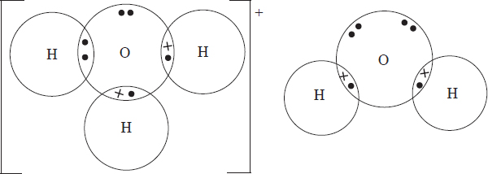
- (a) Using dot and cross diagrams, show bonding in hydroxonium ion, H₃O⁺. (2 marks)
√√
(b) Identify the type of bonds represented by p and q in the substances below.
H
H
H
H
O
p
q
O
O
H
H

q

p Covalent bond √1 (½ mark)
q Hydrogen bond √1 (½ mark)
- The diagram below shows a ‘jiko’ when in use. Study it and answer the questions that follow.
Region B
Region A
Burning charcoal
Air
Ash

(a) Identify the gas formed at region B (1 mark)
Carbon (IV) oxide/ CO₂ √1
(b) Using an equation, explain what happens at region A (1 mark)
CO₂ (g) + C (s) → 2CO(g) √1
- The following table gives the melting point of oxides of the third period elements. Study it and answer the questions that follow.

Formula of oxides | Na₂O | MgO | Al₂O₃ | S_{i}O₂ | P₄O₁₀ | SO₂
Melting point (⁰O) | 1190 | 3080 | 3050 | 1730 | 560 | -73

- Explain the large difference in the melting points of Na₂O and SO₂. (2 marks)
Na₂O forms a giant ionic structure with strong ionic bonds√ ½ that require a lot of heat energy to break, √ ½ while SO₂ forms a molecular structure with weak van der Waals forces of attraction √ ½ between its molecules which require little heat to break. √ ½

(b) Write the equation for the reaction between Al₂O₃ with;
(i) NaOH (1 mark)
Al₂O₃(s) + 2NaOH(aq) 2NaAlO₂(aq) + H₂O(l) √1
(ii) HCl (1 mark)
Al₂O₃ (s) + 6HCl(aq) 2AlCl₃(aq) + 3H₂O(l) √1
- Use the scheme below to answer the question that follow.
Solid H
Carbon (IV) oxide
Solid J
(red-brown when hot, yellow when cold)

N

- Identify process N. (1 mark)
Heating / Thermal dissociation √1
- Identify the solids (2 marks)
H- Lead (II) carbonate √1
J- Lead (II) oxide √1
- A form one class carried out an experiment to determine the active part of air. The diagram below shows the set-up of the experiment and also the observation made.
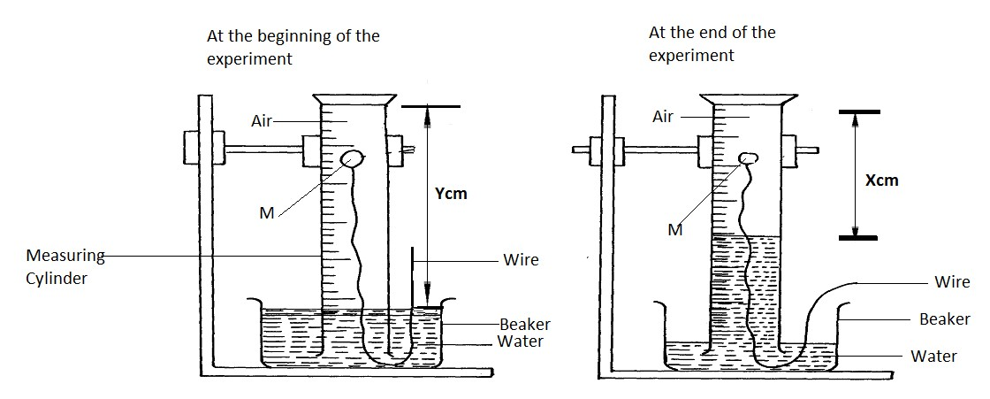
(a) Identify substance M (1 mark)
White phosphorous √1
(b) State two reasons for the suitability of substance M for this experiment (1 mark)
- Does not react with water √ ½
- Smoulders in air √ ½
(c) Write the equation for the reaction of substance M and the active part of air (1 mark)
P₄ (s) + 5O₂ (g) → P₄O₁₀ (s) / P₄ (s) + 3O₂ (g) → 2 P₂O₃ (s) √1
- The table below gives three experiments on the reaction of excess hydrochloric acid and 1.5g of zinc done under different conditions. In each the volume of gas was recorded at different time internals.

Experiment | Form of Zinc | Hydrochloric acid solution
I | Powder | 1.5M
II | Granules | 1.0 M
III | Powder | 1.0 M
On the axis below draw and label three curves that could be obtained from such results. (3 marks)
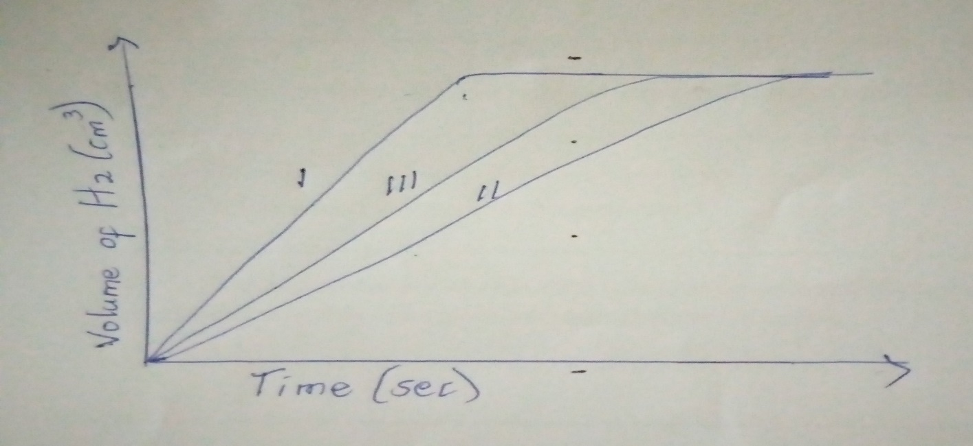
- When solid magnesium carbonate was added to a solution of hydrogen chloride in methylbenzene, there was no observable change. On addition of some water to the mixture, there was effervescence. Explain the observation. (2 marks)
When hydrogen chloride dissolves in water, its molecules dissociate to release hydrogen ions, √ ½ which are responsible for the acidic properties. √ ½ A solution of hydrogen chloride in methylbenzene will not release hydrogen ions√ ½ because the hydrogen chloride molecules do not dissociate, √ ½ hence does not exhibit acidic properties.
- (a) Define the term solubility. (1 mark)
This is the maximum mass of solute required to saturate 100 g of the solvent at a particular temperature. √1
(b) The solubility curve of potassium nitrate is shown in the figure below.

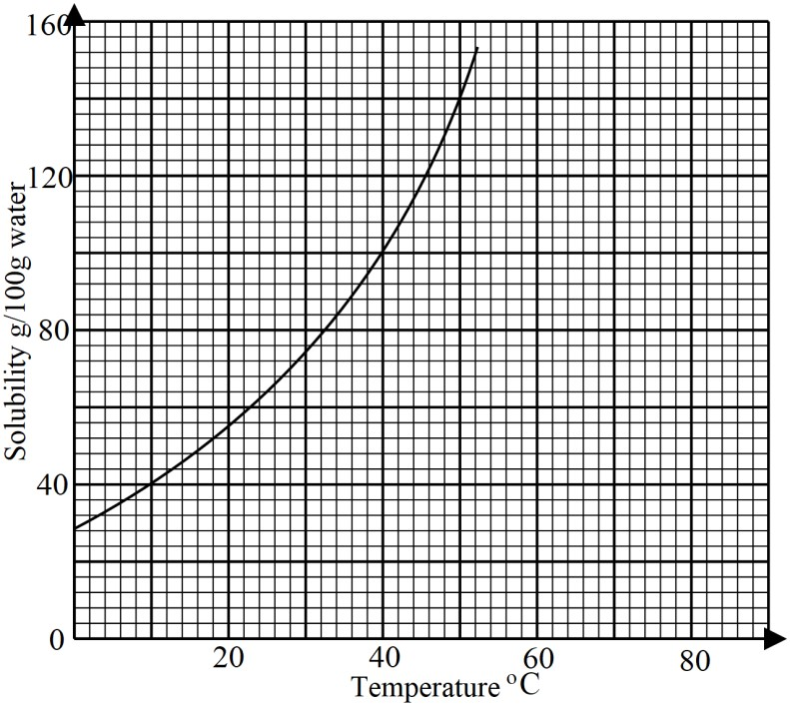
- Determine the solubility of potassium at 50ºC. (1 mark)
140g/100g of water √1
- Determine the molar concentration of saturated potassium nitrate at 50ºC. (K = 39.0, O = 16.0, N = 14.0 and density of water 1 g/cm³). (2 marks)
100g of water = 140g of KNO₃
1 litre of wate r= 1000g = 1000 X 140√ ½
100
= 1400g of KNO₃√ ½
No. of moles of KNO₃ in 1 litre = mass = 1400 √ ½ =
molar mass 101
= 13.86moles/litre of water√ ½

- Use the bond energies given below to calculate the heat of reaction for: (3 marks)
H₂ (g) +Cl₂ (g) 2HCl (g)

Bond | Energy (Kj/Mol)
H – H | 435
Cl – Cl | 243
H – Cl | 431

Energy absorbed in bond breaking = 435 + 243 = +678 kJ/mol √1
Energy released in bond formation = 2 X 431 = -862kJ/mol √1
ΔH = +678+-862 = -184kJ/mol √1
- The following table shows the products formed when nitrates of metals J, Y, and W are heated strongly.
Nitrate of | Products formed
J | Metal oxide + Nitrogen (IV) oxide + Oxygen
Y | Metal + Nitrogen (IV) oxide + Oxygen
W | Metal nitrite + Oxygen
- Arrange the metals in their order of decreasing reactivity. (1 mark)
W, J, Y √1
- Which metal forms a soluble carbonate? (½ mark)
W √ ½
- Give an example of nitrate Y. (½ mark)
Silver nitrate / mercury nitrate √ ½

- Use the set up below to answer the questions that follow.

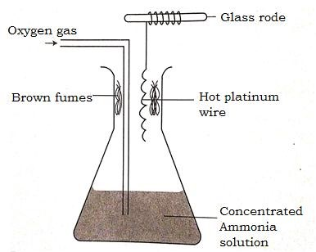

- Describe the formation of brown fumes. (2 marks)
In the presence of a hot platinum wire catalyst, ammonia burns in oxygen to form colourless nitrogen (II) oxide gas, √1 which is further oxidised to brown nitrogen (IV) oxide gas. √1
- Name another substance that can be used instead of platinum. (1 mark)
Nichrome wire√1

- An experiment was carried out to determine the presence of substances A, B, C and D in mixture E. the results obtained are shown in the figure below.

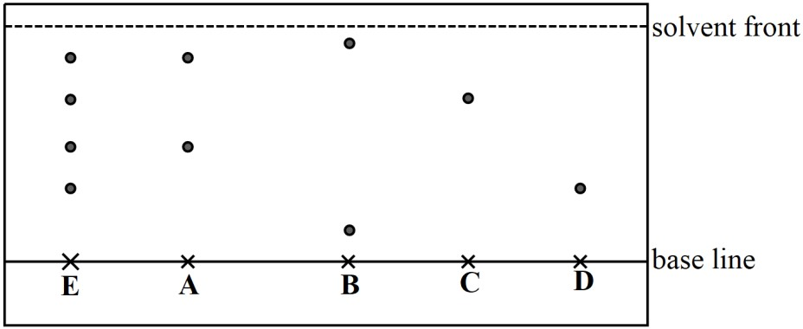

- Name a suitable solvent used in the method of separation illustrated in the figure. (1 mark)
Propanone/ propanol/ ethanol √1
- Select:
- one substance which contains a component not present in E. (½ mark)
B √ ½
- a pure substance which is least soluble in the solvent used. (½ mark)
D √ ½
- State one application of chromatography in an athletics competition. (1 mark)
To test samples of blood or urine of athletes for steroids √1

