Nyaraya Cluster Examination

Kenya Certificate of Secondary Education

2023 Form Four Evaluation Programme

Name ………………………………………………………………. Index. No……………………………
School……………………………………………………………...... Date: ……………………………….

233/1
Chemistry Theory
Paper 1
Time: 2 Hours
July 2023

INSTRUCTIONS
- Write your name and school and index number in the spaces provided at the top of this page
- All answers should be written in the spaces provided.
- Non-programmable silent electronic calculators and KNEC mathematical tables may be used.
- Students should check the question paper to ascertain that all pages are printed as indicated and that no questions are missing.

FOR EXAMINERS USE ONLY
QUESTION | MAXIMUM SCORE | CANDIDATES SCORE
1 – 29 | 80

This paper consists of 11 printed pages. Candidates should check to ascertain that all pages are printed as indicated and that no questions are missing.

- In the extraction of zinc, the zinc ore is crushed to a powder, mixed with oil and water and air blown through the mixture.
- What is the name given to this process? (1 mark)
………………………………………………………………………………………………………………………
- Explain how this process works. (1 mark)
………………………………………………………………………………………………………………………
………………………………………………………………………………………………………………………
- Name the chief ore from which zinc is extracted. (1 mark)
……………………………………………………………………………………………………………….
- (a) Using the oxidation number, identify and explain oxidizing and reducing agent (2 marks) 2 H₂S(g) + SO₂(g) → 3S(s) + 2H₂O(l)
………………………………………………………………………………………………………………………
………………………………………………………………………………………………………………………………………………………………………………………………………………………………………...........
(b) Atomic number of Sulphur is 16. Write the electron configuration of S in SO₃²⁻ (1 mark)
………………………………………………………………………………………………………………………
- Name the process which takes place when: (3 marks)
- Solid carbon (IV) oxide changes to gas ………………………………………………………………………………………………
- Red litmus paper turns white when dropped in chlorine water ………………………………………………………………………………………………
- Ethene gas molecules are converted into giant molecules ………………………………………………………………………………………………
- 3.1g of an organic compound containing carbon, hydrogen and oxygen only, produced 4.4g of carbon (IV) oxide and 1.8g of water on complete combustion. Determine its molecular formula if its formula mass is 60. (3 marks)

- Use the table below to answer the question that follow:

Element | Atomic number
A | 11
B | 13
C | 14
D | 17
E | 19

- Write an equation for the reaction between element A and water. (1 mark)
………………………………………………………………………………………………………
- Explain the trend of atomic radii between elements A and D. (2 marks)
………………………………………………………………………………………………………………………………………………………………………………………………………………………………………………………………………………………………………………………………………………
- (a) Define the term allotropy (1 mark)
…………………………………………………………………………………………………………………………………………………………………………………………………………………………
(b) In terms of structure and bonding, explain why graphite is used as a lubricant. (2 marks)
……………………………………………………………………………………………………………………………………………………………………………………………………………………………………………………………………………………………………………….…….......................................
- (a) State Boyles Law. (1 mark) ………………………………………………………………………………………………………………………………………………………………………………………………………………………………
(b) A given mass of the gas occupies 20cm³ at 25⁰ C and 670mmHg pressure. Find the volume it will occupy at 10⁰ C and 335mmHg. (2 marks)

- Concentrated sodium chloride was electrolysed using graphite electrodes. Name the product formed at the anode and give a reason for your answer. (2 marks)

………………………………………………………………………………………………………………...

………………………………………………………………………………………………………………..

…………………………………………………………………………………………………………….

- (a) What is meant by lattice energy? (1 mark)

………………………………………………………………………………………………………………
………………………………………………………………………………….

(b) Study the energy level diagram below and answer the question that follows:

NaOH _{(aq)} + H₂O _{(l)}

∆H

Na⁺ _{(aq)} + OH⁻ _{(aq)}

What type of reaction is represented by the diagram? (1 mark)
…………………………………………………………………………………………………………….
- Magnesium chloride dissolves in water to form a neutral solution while aluminium (III) chloride forms an acidic solution. Explain. (3 marks)
………………………………………………………………………………………………………………………………………………………………………………………………………………………………………………………………………………………………………………………………………………
- When solid B was heated strongly, it gave off water and a solid residue. When water was added to the solid residue, the original solid B, was formed.
- What name is given to the process described? (1 mark)

………………………………………………………………………………………………………………
(b) Give one example of solid B. (1 mark)

………………………………………………………………………………………………………………
- The scheme below was used to prepare a cleansing agent. Study it and answer the questions that follow.

Fat

Solution of cleansing
agent and an alcohol

Solid cleansing agent

NaOH
(
aq
)
; Boil

Step I

Step II

- What name is given to the type of cleansing agent prepared by the method shown in the scheme? (1 mark)
…………………………………………………………………………………………………………………….
- Name one chemical substance added in step II. (1 mark)
………………………………………………………………………………………………………
- What is the purpose of adding the chemical substance named in (ii) above? (1 mark)
……………………………………………………………………………………………………
- The diagram below represents part of a setup arranged for the collection of hydrogen gas in the laboratory. Study it and answer the questions that follow.
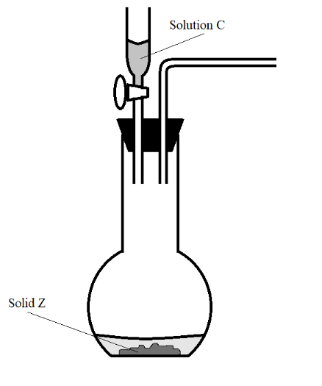
- Complete the diagram to show how a dry sample of hydrogen can be collected. (2 marks)
- Give the most suitable identity of solid Z. (1 mark)
……………………………………………………….......................................
- (a) Define ionization energy. ` (1 mark)
………………………………………………………………………………………………………………………………………………………………………………………………………………
(b) Explain why the second ionization energy of magnesium is higher than its first ionization energy. (2 marks)
………………………………………………………………………………………………………..………………………………………………………………………………………………………………………………………………………………………………………………………………………….
- A state of equilibrium between dichromate (VI) and Chromate ions is established as shown below.
Cr₂O₇²⁻ (aq) +2OH⁻ (aq) CrO₄²⁻ (aq) + H₂O (l)
(Orange) (Yellow)
- What is meant by a dynamic equilibrium? (1 mark)
………………………………………………………………………………………………………………………
………………………………………………………………………………………………………
- State and explain observation made when a few pellets of potassium hydroxide are added to the equilibrium mixture. (2 marks)
………………………………………………………………………………………………………………………
………………………………………………………………………………………………………………………..
…………………………………………………………………………………………………………………….
- Describe how you would obtain solid sample of each of the following components of solid mixture containing lead (II) chloride, ammonium chloride and copper (II) oxide (3 marks)
……………………………………………………………………………………………………………………….……………………………………………………………………………………………………………………….……………………………………………....………………………………………………………………………………………………………………………………………………………………………………………………
………………………………………………………………………………………………………………..
- (a) Using dot and cross diagrams, show bonding in hydroxonium ion, H₃O⁺. (2 marks)

(b) Identify the type of bonds represented by p and q in the substances below.
H
H
H
H
O
p
q
O
O
H
H

q

p ………………………………………………………………………...…….... (½ mark)
q …………………………………………………………………………………. (½ mark)
- The diagram below shows a ‘jiko’ when in use. Study it and answer the questions that follow.
Region B
Region A
Burning charcoal
Air
Ash

(a) Identify the gas formed at region B (1 mark)
………………………………………………………………………………………………………
(b) Using an equation, explain what happens at region A (1 mark)
……………………………………………………………………………………………………………………
- The following table gives the melting point of oxides of the third period elements. Study it and answer the questions that follow.

Formula of oxides | Na₂O | MgO | Al₂O₃ | S_{i}O₂ | P₄O₁₀ | SO₂
Melting point (⁰O) | 1190 | 3080 | 3050 | 1730 | 560 | -73

- Explain the large difference in the melting points of Na₂O and SO₂. (2 marks)
…………………………………………………………………………………………………………….………………………………………………………………………………………………………………………………………………………………………………………………………………………………………………..
(b) Write the equation for the reaction between Al₂O₃ with;
(i) NaOH (1 mark)
………………………………………………………………………………………………………………
(ii) HCl (1 mark)
………………………………………………………………………………………………………………
- Use the scheme below to answer the question that follow.
Solid H
Carbon (IV) oxide
Solid J
(red-brown when hot, yellow when cold)

N

- Identify process N. (1 mark)
…………………..………………………………………………………………………………
- Identify the solids (2 marks)
H- ………………………………………………………………………………………………
J- ………………………………………………………………………………………………
- A form one class carried out an experiment to determine the active part of air. The diagram below shows the set-up of the experiment and also the observation made.
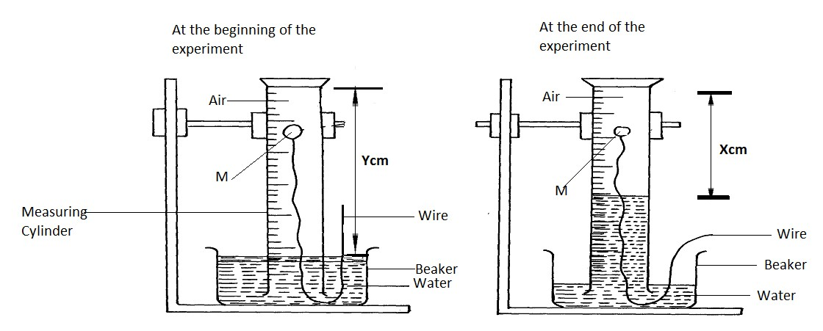
(a) Identify substance M (1 mark)
………………………………………………………………………………………………………
(b) State two reasons for the suitability of substance M for this experiment (1 mark)
……………………………………………………………………………………………………………………….…..…………………..…………………………………………………………………………………
(c) Write the equation for the reaction of substance M and the active part of air (1 mark)
……………………………………………………………………………………………………………..
- The table below gives three experiments on the reaction of excess hydrochloric acid and 1.5g of zinc done under different conditions. In each the volume of gas was recorded at different time internals.

Experiment | Form of Zinc | Hydrochloric acid solution
I | Powder | 1.5M
II | Granules | 1.0 M
III | Powder | 1.0 M
On the axis below draw and label three curves that could be obtained from such results. (3 marks)

Time (sec)

V
olume of
H
2

(
cm
3
)

- When solid magnesium carbonate was added to a solution of hydrogen chloride in methylbenzene, there was no observable change. On addition of some water to the mixture, there was effervescence. Explain the observation. (2 marks)
……………………………………………………………………………………………………………………………………………………………………………………………………………………………………………………………………………………………………………………………………………….
- (a) Define the term solubility. (1 mark)
……………………………………………………………………………………………………………….
……………………………………………………………………………………………………………….
(b) The solubility curve of potassium nitrate is shown in the figure below.

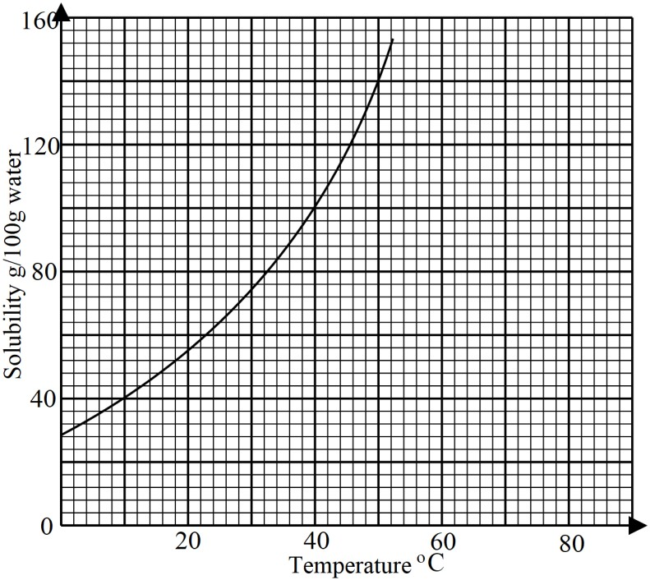
- Determine the solubility of potassium at 50ºC. (1 mark)
…………………………………………………………………………………………………
- Determine the molar concentration of saturated potassium nitrate at 50ºC. (K = 39.0, O = 16.0, N = 14.0 and density of water 1 g/cm³). (2 marks)

- Use the bond energies given below to calculate the heat of reaction for: (3 marks)

H₂ (g) +Cl₂ (g) 2HCl (g)

Bond | Energy (kJ/Mol)
H – H | 435
Cl – Cl | 243
H – Cl | 431

- The following table shows the products formed when nitrates of metals J, Y, and W are heated strongly.
Nitrate of | Products formed
J | Metal oxide + Nitrogen (IV) oxide + Oxygen
Y | Metal + Nitrogen (IV) oxide + Oxygen
W | Metal nitrite + Oxygen
- Arrange the metals in their order of decreasing reactivity. (1 mark)
…………………………………………………………………
- Which metal forms a soluble carbonate? (½ mark)
……………………………………………………………………
- Give an example of nitrate Y. (½ mark)
…………………………………….........................................................
- Use the set up below to answer the questions that follow.

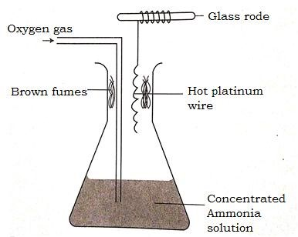
- Describe the formation of brown fumes. (2 marks)

…………………………………………………………………………………………………………………….
……………………………………………………………………………………………………………...........
- Name another substance that can be used instead of platinum. (1 mark)
…………………………………………………………………………
- An experiment was carried out to determine the presence of substances A, B, C and D in mixture E. the results obtained are shown in the figure below.

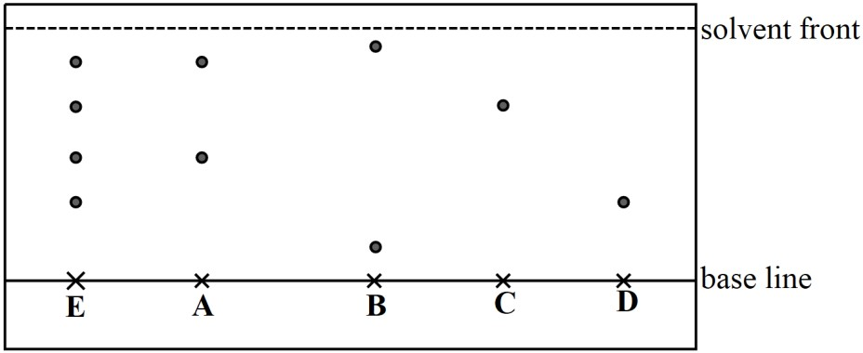

- Name a suitable solvent used in the method of separation illustrated in the figure. (1 mark)
……………………………………………………………………………………….
- Select:
- one substance which contains a component not present in E. (½ mark)
……………………………………………………………………………….
- a pure substance which is least soluble in the solvent used. (½ mark)
……………………………………………………………………………….
- State one application of chromatography in an athletics competition. (1 mark)
………………………………………………………………………………………………………………

