Nyaraya Cluster Examination

Kenya Certificate of Secondary Education

2023 Form Four Evaluation Programme

Name ………………………………………………………………. Index. No……………………………
School……………………………………………………………...... Date: ……………………………….

233/2
Chemistry Theory
Paper 2
Time: 2 Hours
July 2023

INSTRUCTIONS
- Write your name and school and index number in the spaces provided at the top of this page
- All answers should be written in the spaces provided.
- Non-programmable silent electronic calculators and KNEC mathematical tables may be used.
- Students should check the question paper to ascertain that all pages are printed as indicated and that no questions are missing.

FOR EXAMINER’S USE ONLY

Questions | Maximum score | Candidates score
1 | 12
2 | 13
3 | 12
4 | 11
5 | 11
6 | 10
7 | 11
Total score | 80

This paper consists of 13 printed pages. Candidates are advised to check and to make sure all pages are as indicated and no question is missing.
- Study the diagram below and use it to answer the questions that follow

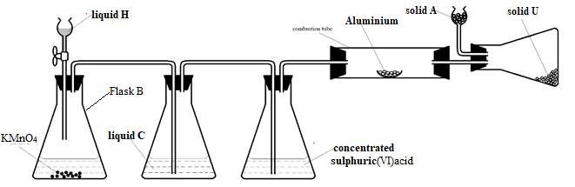
(a) i) Suggest a suitable reagent that can be used as solid A (1 mark)
……………………………………………………………………………………………………………...
ii) Name liquids C and H. (2 marks)
C ……………………………………………………………………………………………………….
H ………………………………………………………………………………………………………
iii) Write a balanced chemical equation for the reaction in conical flask B (1 mark)
…………………………………………………………………………………………………..
iv) Explain why solid U collects further away from aluminium metal (1 mark)
………………………………………………………………………………………………
(b) During a class experiment, chlorine gas was bubbled into a solution of potassium iodide.
  - State the observation made. (1 mark)
………………………………………………………………………………………………………..
  - Write the ionic equation for the reaction that took place. (1 mark)
…………………………………………………………………………………………………………
(c) Write a balanced chemical equation for the reaction between hot concentrated sodium hydroxide and chlorine gas. (1 mark)
…………………………………………………………………………………………………………..

(d) Explain the difference in bleaching by chlorine and bleaching by sulphur (IV) oxide gas. (2 marks)
…………………………………………………………………………………………………………..……………………………………………………………………………………………………………………………………………………………………………………………………………………..…………………………………………………………………………………………………………
(e) Describe how to test for the presence of chloride ions in a water sample (2 marks)
………………………………………………………………………………………………………………………………………………………………………………………………………………………………………………………………………………………………………………………………………………
- (a) Give the systematic name of the following organic compound:
- CH₃CH(CH₃)CH(OH)CH₃ (1 mark)
…………………………………………………………………………………………………………
- CHC(CH₂)₂CH₃ (1 mark)
…………………………………………………………………………………………………………
(b) The following tests were carried out on some organic compound Q. Study the information in the table and use it to answer the questions that follow.

Test | Observation
- Three drops of acidified potassium manganate (vii) was added to Q | The acidified potassium manganate  (vii) was decolourised
(ii) Universal indicator solution was added to Q | pH 6

- Identify the functional group of the organic compound Q. (1 mark)
…………………………………………………………………………………………………………
- Draw the structural formula of the first member of the homologous series in which the organic compound Q belongs. (1 mark)

- Study the flow chart below and answer the questions that follow.
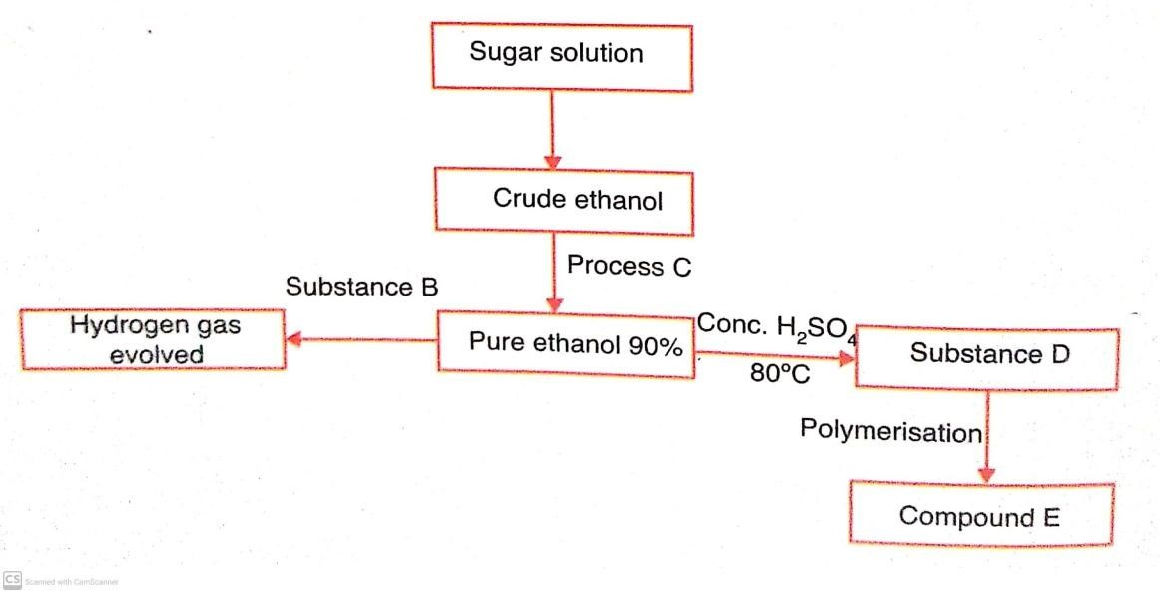
Give the name of:
  - Substance B …………………………………………………………… (1 mark)
  - Substance D ………………………………………………………….. (1 mark)
  - Compound E ………………………………………………………….. (1 mark)
- Explain the effect of continued use of the polymer E on the environment. (2 marks)
………………………………………………………………………………………………………………
……………………………………………………………………………………………………………..
- Describe the role of sugar solution in the scheme above. (2 marks)
………………………………………………………………………………………………………………
………………………………………………………………………………………………………………
- Give two commercial uses of ethanol other than the manufacture of alcoholic drinks. (2 marks)
………………………………………………………………………………………………………………
………………………………………………………………………………………………………………

- The figure below represents a section of the periodic table. Study it and answer the questions that follow. The letters do not represent the actual symbol of the element.

B
C | L |  | D | E |  |  | W | G
H | J

- Give the chemical family to which element J belongs to. (1 mark)
………………………………………………………………………………………………………….
- Compare the reactivity of elements C and H. Explain your answer. (2 marks)
……………………………………………………………………………………………………………………………………………………………………………………………………………………………………………………………………………………………………………………………
- Give one property of elements found in the shaded region. (1 mark)
…………………………………………………………………………………………………………
- Write the chemical formula of the chloride of D. (1 mark)
………………………………………………………………………………………………………
- i) Name the type of structure of the chloride in (d) above. (1 mark)
……………………………………………………………………………………….………………….
ii) Identify the bonds that exist in the compound in (d) above. (1 mark)

………………………………………………………………………………………
………………………………………………………………………………………
iii) Using dots and crosses to represent the valence electrons show the bonding in the compound formed in (d) above. (2 marks)

- State and explain the difference in atomic and ionic radius of element W. (2 marks)
……………………………………………………………………………………………………………………………………………………………………………………………………………………………………………………………………………………………………………………………
- Give one observation made when element C is placed in water. (1 mark)
………………………………………………………………………………………………………..

- (a) During the electrolysis magnesium sulphate a current of 2 amperes was passed through the solution for 4 hours. Calculate the volume of the gas produced at the anode. (1 faraday 96,500 coulombs and volume of a gas at room temperature is 24,000cm³). (2 marks)

(b) The table below gives standard reduction potentials for some half cells.
Half-cell | Half-cell equation | E^{θ} /V
I | Cr³⁺ (aq) + e⁻ → Cr²⁺ (aq) | -0.41
II | Cd²⁺ (aq) + 2e⁻ → Cd (s) | -0.40
III | Na⁺ (aq) + e⁻→ Na (s) | -2.71
IV | Cu²⁺ (aq) + 2e⁻ → Cu (s) | +0.34
V | Pb²⁺ (aq) + 2e⁻ → Pb (s) | -0.13
VI | Br₂ (aq) + 2e⁻ → 2Br⁻ (aq) | +1.07
VII | 2H⁺(aq) + 2e⁻ → H₂(g) | 0.00
VIII | Fe²⁺(aq) + 2e⁻ → Fe(s) | -0.44V
IX | O₂(g) + 2H₂O (l) + 4e⁻ → 4OH⁻(aq) | +0.40V
X | H₂O₂(aq) + 2H⁺(aq) + 2e⁻ → 2H₂O(l) | +1.23V
i) Identify: (1 mark)
- The strongest oxidizing agent.
……………………………………………………………………………………
- The strongest reducing agent.
……………………………………………………………………………………
- Construct an electrochemical cell from half-cells IV and V. (3 marks)

- Write the equation and calculate the electrode potential for the electrochemical cell constructed from half-cells IV and V. (2 marks)
………………………………………………………………………………………………………………
………………………………………………………………………………………………………………
- Explain why it is not advisable to use aqueous sodium sulphate as the salt bridge in the electrochemical cell formed between half-cells IV and V. (1 mark)
………………………………………………………………………………………………………………
…………………………………………………………………………………………………….
- Write the cell diagram for an electrochemical cell made using half-cells VIII and IX. (1 mark)
……………………………………………………………………………………
- Give one reason why electroplating is necessary. (1 mark)
…………………………………………………………………………………………………………
- In an experiment to determine the heat of combustion of compound X, a pupil used heat from the burning compound of X to heat 100cm³ of water in a beaker. He obtained the following results:
Volume of water in the beaker = 100cm³
Initial temperature of water = 17ºC
Final temperature of water = 42⁰C
Initial mass of burner + compound X = 10.5g
Final mass of burner + compound X = 10.2g.
- Determine the mass of the compound burnt. (1 mark)

- Calculate the rise in temperature. (1 mark)

- Determine the amount of heat produced by the compound. (2 marks)
(specific heat capacity 4200Jg⁻¹K⁻¹, density of H₂O = 1g/cm³)

- Calculate the molar heat of combustion of compound X (R.M.M. of X = 256) (2 marks)

- Use the following thermochemical equations below to answer the questions that follow.
C₂H_{6 (g)} + ⁷/₂ O_{2 (g)} 2CO_{2(g)} + 3H₂O _{(s)} ∆H₁, = -1560kJmol⁻¹
C _{(graphite)} + O_{2(g)} CO_{2 (g)} ∆H₂ = - 394 kJ mol⁻¹
H_{2 (g)} + ½ O_{2(g)} H₂O_{(l)} ∆H₃ = - 286 kJ mol⁻¹
- Calculate the molar enthalpy of formation of C₂H₆. (2 marks)

- Draw an energy level diagram for the reaction represented by the first equation above. (3 marks)

- (a) Define nuclear fission. (1 mark)
………………………………………………………………………………………………………………………………………………………………………………………………………………………
(b) State two similarities between nuclear fission and nuclear fusion. (2 marks)
………………………………………………………………………………………………………………………
………………………………………………………………………………………………………………………

(c) The following table shows the activity of a sample of protactinium (²³⁴₉₁Pa), a radioactive element, measured at regular intervals.
Time (sec) | 10 | 30 | 50 | 70 | 90 | 110 | 130 | 150 | 170 | 190
Activity(c/s) | 33 | 29 | 23 | 17 | 14 | 12 | 10 | 9 | 8 | 6
(i) Plot a graph of activity against time. (3 marks)

- From the graph, determine:
- The initial activity of the element. (1 mark)
……………………………………………………………………………………
- The half-life of the nuclide. (1 mark)
……………………………………………………………………………………
(d) State two dangers associated with radioactivity. (2 marks)
………………………………………………………………………………………………………………
……………………………………………………………………………………………………………..
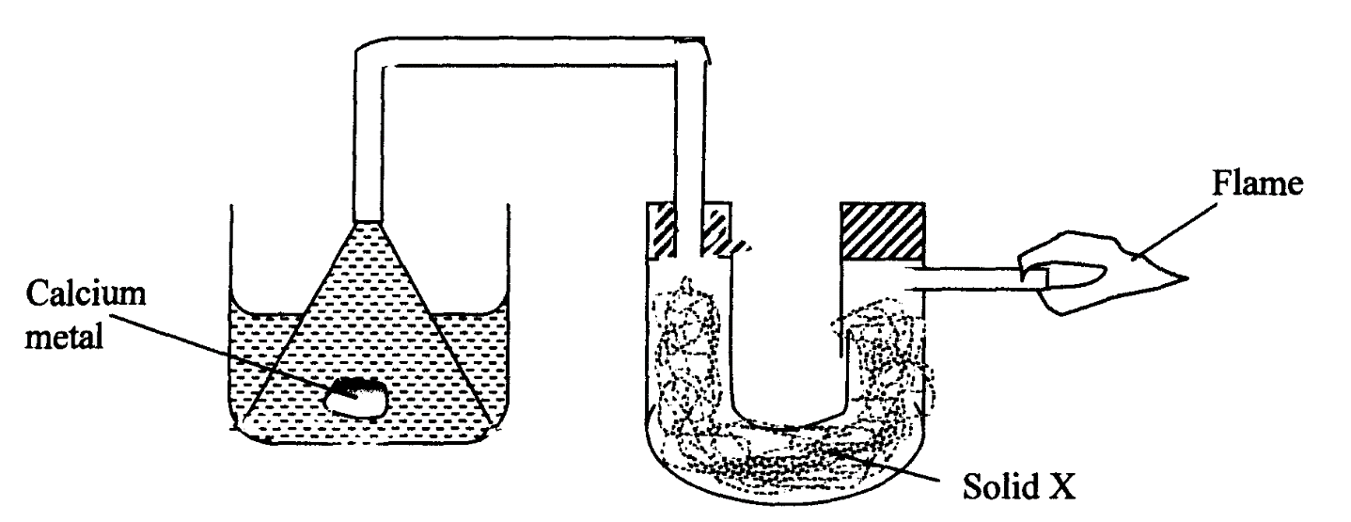
- (a) The setup below was used to investigate the reaction between metals and water.

Water
- Identify solid X and state its purpose.
Solid X ……………………………………………………………. (½ mark)
Purpose …………………………………………………………… (½ mark) ii) Write a chemical equation for the reaction that produces the flame. (1 mark)
…………………………………………………………………………………………………………..
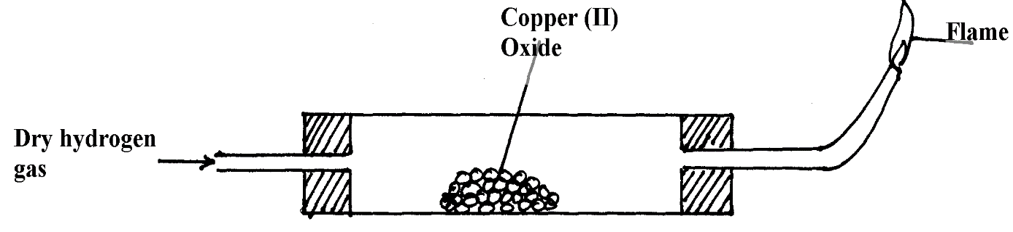
(b) The set-up below was used to investigate the properties of hydrogen.

- On the diagram, indicate what should be done for the reaction to occur. (1 mark)

- Hydrogen gas is allowed to pass through the tube for some time before it is lit. Explain. (1 mark)
………………………………………………………………………………………………………………………………………………………………………………
- Write an equation for the reaction that occurs in the combustion tube. (1 mark)
…………………………………………………………………………………………………
- When the reaction is complete, hydrogen gas is passed through the apparatus until it cools down. Explain. (2 marks)
……………………………………………………………………………………………………………………………………………………………………………………………………………………
- What property of hydrogen is being investigated? (1 mark)
…………………………………………………………………………………………………………..
- What observation confirms the property stated in (v) above? (1 mark)
…………………………………………………………………………………………………………
- Why is zinc oxide not used to investigate this property of hydrogen gas? (2 marks)
………………………………………………………………………………………………………………………………………………………………………………………………………………

