NYARAYA MARKING SCHEME
Kenya Certificate of Secondary Education
233/2
Chemistry Theory
Paper 2
Time: 2 Hours
July 2023

INSTRUCTIONS
- Write your name and school and index number in the spaces provided at the top of this page
- All answers should be written in the spaces provided.
- Non-programmable silent electronic calculators and KNEC mathematical tables may be used.
- Students should check the question paper to ascertain that all pages are printed as indicated and that no questions are missing.

FOR EXAMINER’S USE ONLY.

Questions | Maximum score | Candidates score
1 | 12
2 | 13
3 | 12
4 | 11
5 | 11
6 | 10
7 | 11
Total score | 80

This paper consists of 13 printed pages. Candidates are advised to check and to make sure all pages are as indicated and no question is missing.

- Study the diagram below and use it to answer the questions that follow

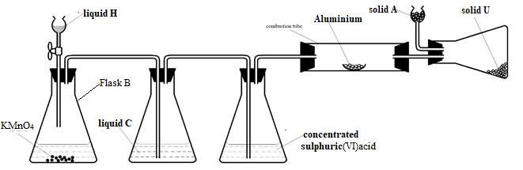
(a) i) Suggest a suitable reagent that can be used as solid A (1 mark)
Calcium oxide / anhydrous calcium chloride √1
ii) Name liquids C and H. (2 marks)
C- water √1
H - concentrated hydrochloric acid √1
iii) Write a balanced chemical equation for the reaction in conical flask B (1 mark)
2KMnO₄(s) + 16HCl(aq) → 2KCl₍aq) + 2MnCl₂(aq) + 8H₂O(l) + 5Cl₂(g) √1
iv) Explain why solid U collects further away from aluminium metal (1 mark)
Solid U sublimes √ ½ when heated and deposits in flask B where the temperature is low. √ ½
(b) During a class experiment, chlorine gas was bubbled into a solution of potassium iodide.
  - State the observation made. (1 mark)
Colourless solution changes to dark brown √ ½ then a black solid √ ½ is deposited.
  - Write the ionic equation for the reaction that took place. (1 mark)
Cl₂(g) + 2I⁻₍aq) → I₂(s) + 2Cl⁻₍aq) √1
(c) Write a balanced chemical equation for the reaction between hot concentrated sodium hydroxide and chlorine gas. (1 mark) 6NaOH(aq) + 3Cl₂(g) → NaClO₃(aq) + 5NaCl(aq) + 3H₂O(l) √1
(d) Explain the difference in bleaching by chlorine and bleaching by sulphur (IV) oxide gas. (2 marks)
Chlorine bleaches by adding oxygen to the dye (oxidation) √1 hence permanent, while Sulphur (IV) oxide bleaches by removing oxygen from the dye (reduction) √1 hence temporary since the action can be reversed when the dyed material is exposed to air.
(e) Describe how to test for the presence of chloride ions in a water sample (2 marks)
To the water sample, add a few drops of lead(II) nitrate/ silver nitrate solution. √1 Formation of a white precipitate confirms the presence of chloride ions. √1
- (a) Give the systematic name of the following organic compound:
- CH₃CH(CH₃)CH(OH)CH₃ (1 mark)
3-methylbutan-2-ol √1
- CHC(CH₂)₂CH₃ (1 mark)
pent-1-yne √1
(b) The following tests were carried out on some organic compound Q. Study the information in the table and use it to answer the questions that follow.

Test | Observation
- Three drops of acidified potassium manganate (vii) was added to Q | The acidified potassium manganate (vii) was decolourised
(ii) Universal indicator solution was added to Q | pH 6

- Identify the functional group of the organic compound Q. (1 mark) Carboxyl group √1

- Draw the structural formula of the first member of the homologous series in which the organic compound Q belongs. (1 mark)

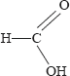 √1

- Study the flow chart below and answer the questions that follow.
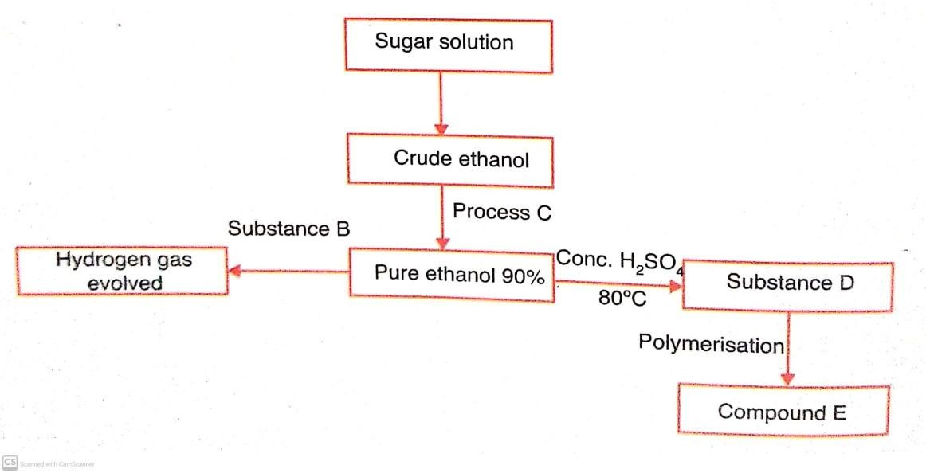
Give the name of:
  - Substance B - sodium / any other reactive metal √1 (1 mark)
  - Substance D - ethene √1 (1 mark)
  - Compound E - polyethene √1 (1 mark)
- Explain the effect of continued use of the polymer E on the environment. (2 marks)
Polymer E is non- biodegradable, √1 hence pollutes the environment. √1
- Describe the role of sugar solution in the scheme above. (2 marks)
Sugar solution undergoes fermentation √1 in a series of reactions catalysed by enzymes found in yeast. √1
- Give two commercial uses of ethanol other than the manufacture of alcoholic drinks. (2 marks)
-As a fuel e.g. as gasohol and in spirit lamps and burners. √1
-Disinfectant for wounds and surgical sites. √1
-Manufacture of other organic substances e.g ethanoic acid, PVC, ethylene glycol. √1
-Solvent for paints, dyes, varnishes, cosmetics, perfumes and medicinal drugs. √1 any two

- The figure below represents a section of the periodic table. Study it and answer the questions that follow. The letters do not represent the actual symbol of the element.

B
C | L |  | D | E |  |  | W | G
H | J

- Give the chemical family to which element J belongs to. (1 mark)
Alkaline earth metals. √1
- Compare the reactivity of elements C and H. Explain your answer. (2 marks)
H is more reactive than C because H has a larger atomic radius, √1 hence its valence electron is less strongly attracted by the nucleus, √ ½ making it easier for H/ H requires less energy to lose its valence electron. √ ½
- Give one property of elements found in the shaded region. (1 mark)
Have variable valencies, hence show different oxidation states in their compounds/ form coloured compounds as solids and in aqueous solutions/ have very high melting and boiling points/ do not react with water/ have very high densities. √1
- Write the chemical formula of the chloride of D. (1 mark)
DCl₃ / AlCl₃ √1
- i) Name the type of structure of the chloride in (d) above. (1 mark)
(Simple) molecular √1
ii) Identify the bonds that exist in the compound in (d) above. (1 mark)
- Covalent √ ½
-Dative √ ½
iii) Using dots and crosses to represent the valence electrons show the bonding in the compound formed in (d) above. (2 marks)
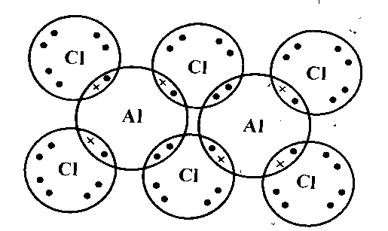√√ 2
- State and explain the difference in atomic and ionic radius of element W. (2 marks)
Ionic radius of W is larger than its atomic radius √1 because W forms an ion by gaining an electron which is repelled by other electron in the outermost energy level. √1
- Give one observation made when element C is placed in water. (1 mark)
C darts about on the surface of water/ melts into a silvery ball/ hissing sound is produced. √1
- (a) During the electrolysis magnesium sulphate a current of 2 amperes was passed through the solution for 4 hours. Calculate the volume of the gas produced at the anode. (1 faraday 96,500 coulombs and volume of a gas at room temperature is 24,000cm³). (2 marks)
Electricity charge 2 X 4 X 60 X 60=28,800C √ ½
28,800C X 24,000cm³ √1
(96,500 X 4) = 1,790.67 cm³ √ ½

(b) The table below gives standard reduction potentials for some half cells.
Half-cell | Half-cell equation | E^{θ} /V
I | Cr³⁺ (aq) + e⁻ → Cr²⁺ (aq) | -0.41
II | Cd²⁺ (aq) + 2e⁻ → Cd (s) | -0.40
III | Na⁺ (aq) + e⁻→ Na (s) | -2.71
IV | Cu²⁺ (aq) + 2e⁻ → Cu (s) | +0.34
V | Pb²⁺ (aq) + 2e⁻ → Pb (s) | -0.13
VI | Br₂ (aq) + 2e⁻ → 2Br⁻ (aq) | +1.07
VII | 2H⁺(aq) + 2e⁻ → H₂(g) | 0.00
VIII | Fe²⁺(aq) + 2e⁻ → Fe(s) | -0.44V
IX | O₂(g) + 2H₂O (l) + 4e⁻ → 4OH⁻(aq) | +0.40V
X | H₂O₂(aq) + 2H⁺(aq) + 2e⁻ → 2H₂O(l) | +1.23V
i) Identify: (1 mark)
- The strongest oxidizing agent.
Half-cell VI / Br₂(aq) √1
- The strongest reducing agent.
Half-cell III / Na(s) √1
- Construct an electrochemical cell from half-cells IV and V. (3 marks)
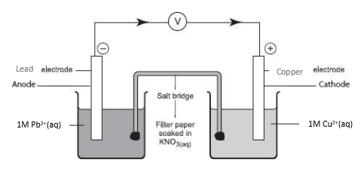
- Write the equation and calculate the electrode potential for the electrochemical cell constructed from half-cells IV and V. (2 marks)
Pb(s) + Cu²⁺(aq) → Pb²⁺(aq) + Cu(s) √1
+0.34 +0.13 √ ½ = +0.47V √ ½
- Explain why it is not advisable to use aqueous sodium sulphate as the salt bridge in the electrochemical cell formed between half-cells IV and V. (1 mark)
It leads to the formation of insoluble PbSO₄ √ ½ which reduces the concentration of ions in the electrolyte/ reduces the effectiveness of the cell. √ ½
- Write the cell diagram for an electrochemical cell made using half-cells VIII and IX. (1 mark)
2Fe(s) → 2Fe²⁺(aq) + 4e⁻ +0.44V
O₂(g) + 2H₂O (l) + 4e⁻ → 4OH⁻(aq)+0.40V
2Fe(s) + O₂(g) + 2H₂O (l) → 2Fe²⁺+ 4OH⁻(aq) E=+0.84V √1
OR 2Fe(s) + ³/₂O₂(g) + 2H₂O (l) → Fe₂O₃.2H₂O(s)+0.84V √1
- Give one reason why electroplating is necessary. (1 mark)
Improves appearance / Prevents corrosion √1
- In an experiment to determine the heat of combustion of compound X, a pupil used heat from the burning compound of X to heat 100cm³ of water in a beaker. He obtained the following results:
Volume of water in the beaker = 100cm³
Initial temperature of water = 17ºC
Final temperature of water = 42⁰C
Initial mass of burner + compound X = 10.5g
Final mass of burner + compound X = 10.2g.
- Determine the mass of the compound burnt. (1 mark)
Mass of compound X= 10.5g-10.2g √ ½ = 0.3g√ ½
- Calculate the rise in temperature. (1 mark)
Rise in temperature = 42⁰C - 17ºC √ ½ = 25ºC // 25K√ ½
- Determine the amount of heat produced by the compound. (2 marks)
(specific heat capacity 4200Jg⁻¹K⁻¹, density of H₂O = 1g/cm³)
Heat lost by compound X = Heat gained by water
ΔH = mcΔT
= 100g X 4200Jg⁻¹K⁻¹ X 25K √1
=420000J // 420kJ √1

- Calculate the molar heat of combustion of compound X (R.M.M. of X = 256) (2 marks)
0.3g = 420000J
256g = 256gX420000J √1= 358400000J// 358400kJ √1
0.3g

- Use the following thermochemical equations below to answer the questions that follow.
C₂H_{6 (g)} + ⁷/₂ O_{2 (g)} 2CO_{2(g)} + 3H₂O _{(s)} ∆H₁, = -1560kJmol⁻¹
C _{(graphite)} + O_{2(g)} CO_{2 (g)} ∆H₂ = - 394 kJ mol⁻¹
H_{2 (g)} + ½ O_{2(g)} H₂O_{(l)} ∆H₃ = - 286 kJ mol⁻¹
- Calculate the molar enthalpy of formation of C₂H₆. (2 marks)
ΔH₄ + ΔH_{1 = Δ}H₂ +ΔH₃
ΔH₄ = _{Δ}H₂ +ΔH₃ -ΔH₁
ΔH₄ = (-394)2 +(-286)3+ 1560 √1
ΔH₄ = -86 kJ mol⁻¹ √1

- Draw an energy level diagram for the reaction represented by the first equation above. (3 marks)
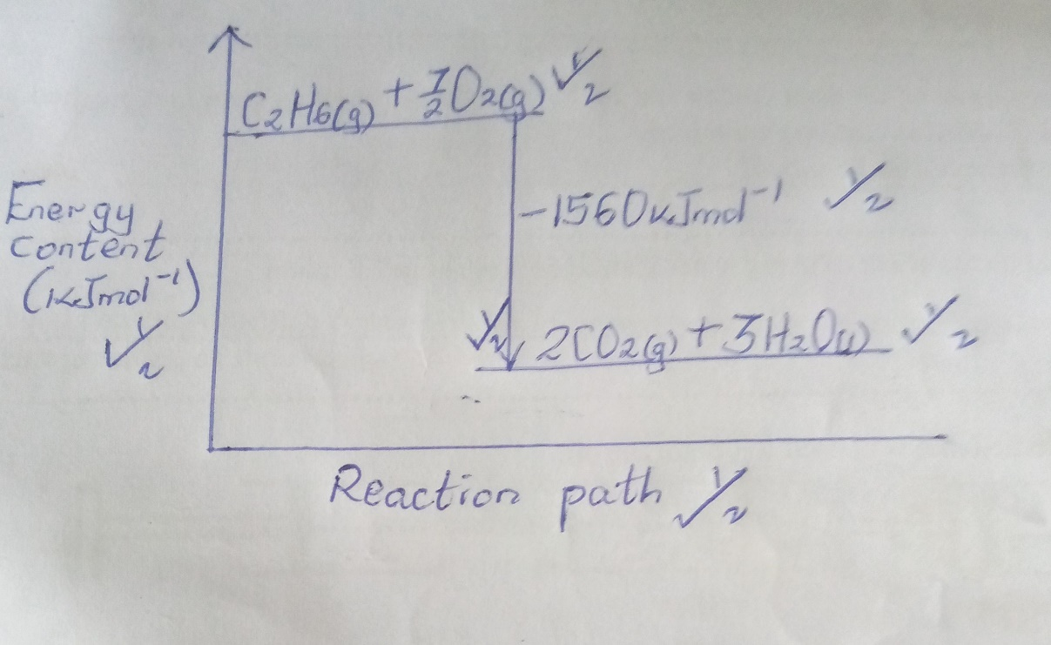
- (a) Define nuclear fission. (1 mark)
Nuclear fission is the splitting process a heavy nuclide undergoes when bombarded by a fast moving neutron. √1
(b) State two similarities between nuclear fission and nuclear fusion. (2 marks)
-In both cases a large quantity of energy is released. √1
-Both processes result in chain reactions. √1
-Are both nuclear reactions. √1

(c) The following table shows the activity of a sample of protactinium (²³⁴₉₁Pa), a radioactive element, measured at regular intervals.
Time (sec) | 10 | 30 | 50 | 70 | 90 | 110 | 130 | 150 | 170 | 190
Activity(c/s) | 33 | 29 | 23 | 17 | 14 | 12 | 10 | 9 | 8 | 6
(i) Plot a graph of activity against time. (3 marks)
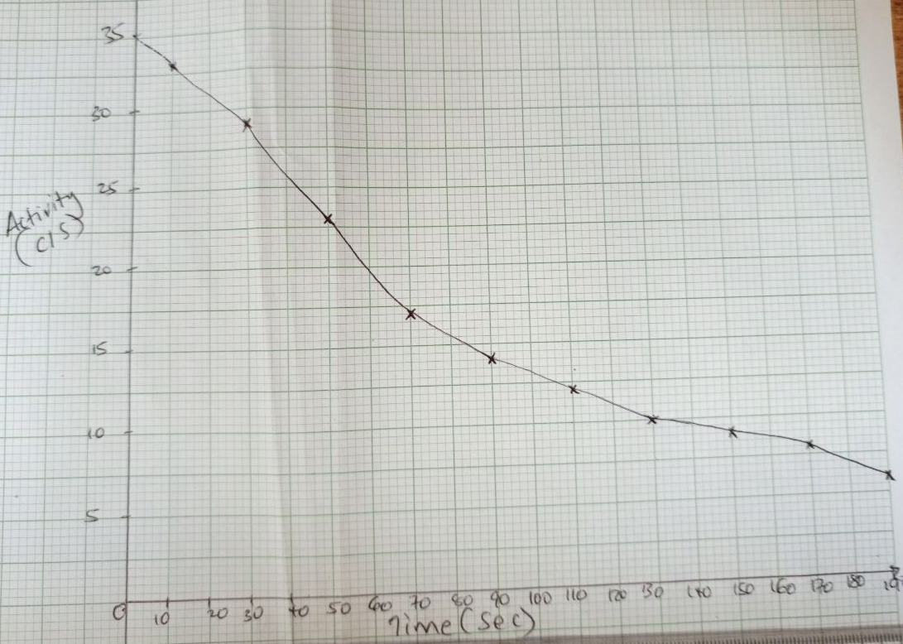
Scale √ ½
Axes √ ½
Plots √1
Line √1
- From the graph, determine:
- The initial activity of the element. (1 mark)
35 √1
- The half-life of the nuclide. (1 mark)
24.5 √1
(d) State two dangers associated with radioactivity. (2 marks)
-Testing of nuclear weapons in the oceans also causes environmental pollution since plants and other living organisms may take in the radioactive materials released in the water. √1
-When not put into proper use, radioisotopes can be used as weapons of mass destruction. √1
- Radiations can cause sickness due to bone marrow or intestinal damage, which eventually cause death in humans. √1
-Exposure to radiations could cause gene mutations, resulting in birth defects and cancer. √1

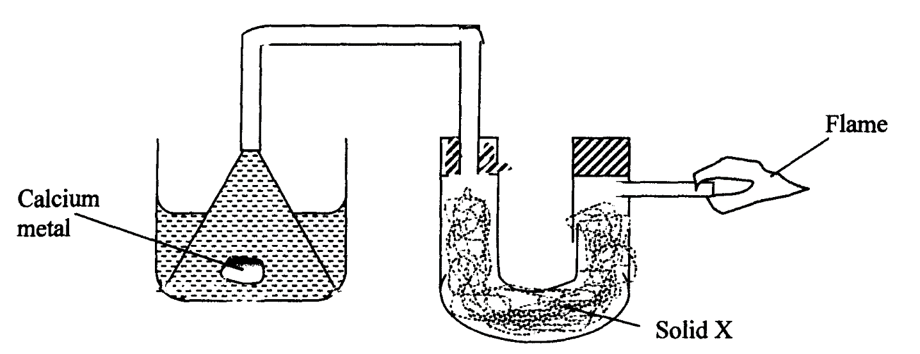
- (a) The setup below was used to investigate the reaction between metals and water.

water
- Identify solid X and state its purpose.
Solid X Anhydrous calcium chloride/ Calcium oxide √ ½ (½ mark)
Purpose To dry hydrogen gas √ ½ (½ mark)
- Write a chemical equation for the reaction that produces the flame. (1 mark)
2H₂(g) + O₂(g) 2H₂O(g) √1
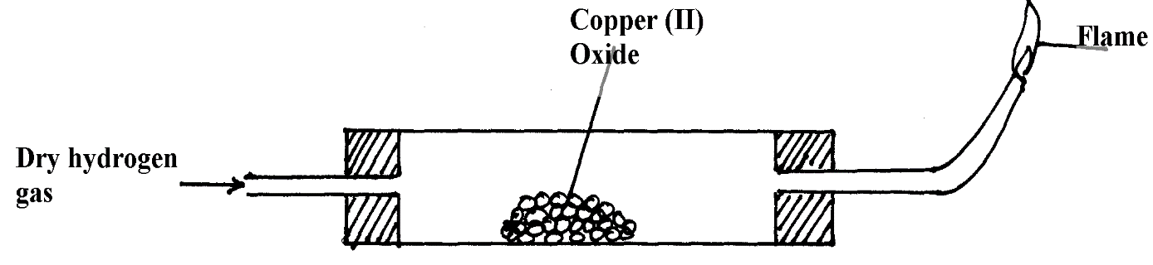
(b) The set-up below was used to investigate the properties of hydrogen.

Heat √1
- On the diagram, indicate what should be done for the reaction to occur. (1 mark)
- Hydrogen gas is allowed to pass through the tube for some time before it is lit. Explain. (1 mark)
To drive away air which would form an explosive mixture with hydrogen when ignited. √1
- Write an equation for the reaction that occurs in the combustion tube. (1 mark)
CuO(s) + H₂(g) Cu(s) + H₂O(l) √1
- When the reaction is complete, hydrogen gas is passed through the apparatus until it cools down. Explain. (2 marks)
To prevent re-oxidation of hot copper metal √1 by atmospheric oxygen. √1
- What property of hydrogen is being investigated? (1 mark)
Reducing property / Reduction. √1
- What observation confirms the property stated in (v) above? (1 mark)
Black copper (II) oxide powder turns to reddish brown copper metal. √1
- Why is zinc oxide not used to investigate this property of hydrogen gas? (2 marks)
Zinc is more reactive than hydrogen, √1 hence cannot be displaced from its oxide by hydrogen. √1

