Nyaraya Cluster Examination
Kenya Certificate of Secondary Education
Form Four Mock Evaluation Programme

NAME.................................................................................................... INDEX. NO........................ /.......... SCHOOL ........................................................................ STREAM…………….. ADM. NO………
443/2
AGRICULTURE PAPER 1 (THEORY) FORM FOUR
JULY, 2023. TIME: 2 HRS

INSTRUCTIONS

• Write your Name, Index Number, School, Date, Admission Number and signature in the spaces provided above.
• This paper consists of THREE Sections A, B andC.
• Answer ALL the questions in Section A and B and any TWO question in Section C.
• ALL answers must be written in the spaces provided in the question paper.
FOR E XA MINER’S U S E ONL Y

Section | Questions | Maximum Score | Candidate’s Score
A | 1 - 16 | 30
B | 17 - 20 | 20
C | 21 | 20
 | 22 | 20
 | 23 | 20
Total Score |  | 90

This paper consists of 12 printed pages. Each candidate should confirm that all the pages are printed and that no page is missing.

Turn Over
SECTION A: (30 MARKS)
Answer ALL questions in this section:

1. State THREE influences of soil pH on crop growth. (1½ Marks)

.................................................................................................................................................................................

.................................................................................................................................................................................

.................................................................................................................................................................................

2. State FOUR factors considered when selecting planting materials. (2 Marks)

.................................................................................................................................................................................

.................................................................................................................................................................................

.................................................................................................................................................................................

.................................................................................................................................................................................

3. Name FIVE sources of agriculture credit in Kenya (2½ Marks)

.................................................................................................................................................................................

.................................................................................................................................................................................

.................................................................................................................................................................................

.................................................................................................................................................................................

.................................................................................................................................................................................

4. State FOUR reasons for pruning in coffee. (2 Marks)

.................................................................................................................................................................................

.................................................................................................................................................................................

.................................................................................................................................................................................

.................................................................................................................................................................................

.................................................................................................................................................................................

5. Give TWO limitations of chemical weed control. (1 Mark)

.................................................................................................................................................................................

.................................................................................................................................................................................
6. List any FOUR basis for classification of crop pests (2 Marks)

.................................................................................................................................................................................

.................................................................................................................................................................................

.................................................................................................................................................................................

.................................................................................................................................................................................

7. Name FOUR disadvantages of mulching. (2 Marks)
.................................................................................................................................................................................

.................................................................................................................................................................................

.................................................................................................................................................................................

.................................................................................................................................................................................

8. State TWO importance of tissue culture. (1 Mark)

.................................................................................................................................................................................

.................................................................................................................................................................................

9. State FOUR factors that influence crop rotation programme. (2 Marks)

.................................................................................................................................................................................

.................................................................................................................................................................................

.................................................................................................................................................................................

.................................................................................................................................................................................

10. Give FOUR nursery management practices. (2 Marks)

.................................................................................................................................................................................

.................................................................................................................................................................................

.................................................................................................................................................................................

.................................................................................................................................................................................
11. State FOUR factors that determined spacing of crops (2 Marks)
.................................................................................................................................................................................

.................................................................................................................................................................................

.................................................................................................................................................................................

.................................................................................................................................................................................

12. Differentiate between a complete and incomplete fertiliser. (2 Marks)
.................................................................................................................................................................................

.................................................................................................................................................................................

.................................................................................................................................................................................

13. Give FOUR objectives of land tenure reform in Kenya (2 Marks)
.................................................................................................................................................................................

.................................................................................................................................................................................

.................................................................................................................................................................................

.................................................................................................................................................................................

13. List THREE post-harvest practices carried out in the growing of maize. (1 ½ Marks)

.................................................................................................................................................................................

.................................................................................................................................................................................

.................................................................................................................................................................................

14. Name THREE materials required during budding. (1½ Marks)

.................................................................................................................................................................................

.................................................................................................................................................................................

.................................................................................................................................................................................

15. Give THREE methods of forage conservation. (1½ Marks)

.................................................................................................................................................................................

.................................................................................................................................................................................

.................................................................................................................................................................................
16. Give THREE disadvantages of using plastic pipes. (1 ½ Marks)

.................................................................................................................................................................................

.................................................................................................................................................................................

.................................................................................................................................................................................

SECTION B (20 MARKS)
Answer all questions in this section in the spaces provided

17. The diagrams labelled A and B below illustrate some of the methods used to propagate some field crops. Study the diagrams and use them to answer the questions that follow.
.

Shoot

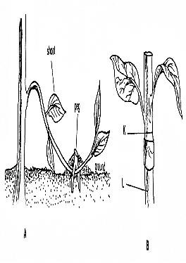Peg

K

L

A B

a) Identify the two methods of propagation. (2 Marks)

...........................................................................................................................................................................

........................................................................................................................................................................... b) Name one crop each propagated using methods A and B above. (2 Marks)

...........................................................................................................................................................................

........................................................................................................................................................................... c) Name the parts labelled K and L in B. (1 Mark)

...........................................................................................................................................................................

...........................................................................................................................................................................
18. A farmer has a 2 hectare piece of land on which to grow wheat. His farm records for wheat production for 9 year period is as follows.

Year | Fertilizer Applied (50kg bags) | Wheat output (90kg bags)
1999 | 0 | 4
2000 | 2 | 10
2001 | 4 | 28
2002 | 6 | 42
2003 | 8 | 52
2004 | 10 | 60
2005 | 12 | 66
2006 | 14 | 66
2007 | 16 | 64

a) (i) Using the appropriate scale draw a graph on the space provided below to show the relationship between input and output. (3 Marks)

(ii) From the graph above, how many bags of wheat would be produced if the farmer applied 9 bags
of fertilizer. (½ Mark)

..........................................................................................................................................................................
(iii) Calculate the farmer’s marginal product for the year 2001. (½ Mark)

..........................................................................................................................................................................

b) Assuming the average price of wheat is Kshs. 1,000.00 per bag and the cost of fertilizer is Kshs. 1,200.00 a bag. Calculate the gross income for the year 2002. (1 Mark)

..........................................................................................................................................................................

..........................................................................................................................................................................

19. Study the illustration below of a tomato fruit as observed in field production.

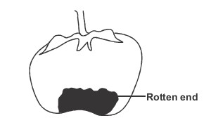

i) Identify the condition illustrated above. (1 Mark)

.......................................................................................................................................................................... ii) State TWO conditions that predispose a tomato plant to the conditions stated in (a) above (1 Mark)
..........................................................................................................................................................................

.......................................................................................................................................................................... iii) Suggest FOUR possible ways of controlling the condition stated in (a) above (2 Marks)
..........................................................................................................................................................................

..........................................................................................................................................................................

..........................................................................................................................................................................

.......................................................................................................................................................................... iv) Name TWO other tomato diseases (1 Mark)
..........................................................................................................................................................................

..........................................................................................................................................................................
20. The diagrams below show certain varieties of a field crop. Study them and use them to answer the questions that follow.

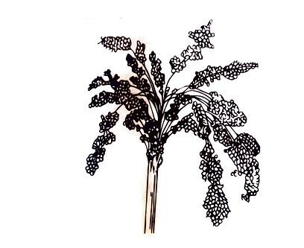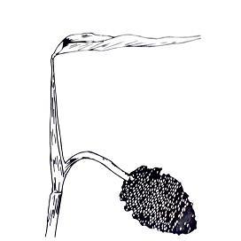
A B

a) Identify the field crop shown above. (1 Mark)

............................................................................................................................................................................. b) What is the advantage of B over A? (1 Mark)

............................................................................................................................................................................. c) Describe the harvesting of the field crop shown above. (3 Marks)

.............................................................................................................................................................................

.............................................................................................................................................................................

.............................................................................................................................................................................
SECTION C (40 Marks)
Answer two questions from this section.

21. (a) Outline the factors to consider when selecting a farm enterprise. (12 Marks) (b) Explain any four cultural methods of soil erosion control (8 Marks)

22. (a) State and explain THREE factors that influence choice of the type of irrigation to be used. (6 Marks) (b) Sate SIX importance of farm records. (6 Marks) (c) Describe the various management practices carried out in the nursery bed. (8 Marks)

23.(a) State and explain FIVE factors considered when choosing seed rates. (10 Marks) (b) Explain FIVE reasons why crop rotation is important. (10 Marks)

.....................................................................................................................................................................................

.....................................................................................................................................................................................

.....................................................................................................................................................................................

.....................................................................................................................................................................................

.....................................................................................................................................................................................

.....................................................................................................................................................................................

.....................................................................................................................................................................................

.....................................................................................................................................................................................

.....................................................................................................................................................................................

.....................................................................................................................................................................................

.....................................................................................................................................................................................

.....................................................................................................................................................................................

.....................................................................................................................................................................................

.....................................................................................................................................................................................

.....................................................................................................................................................................................

.....................................................................................................................................................................................

.....................................................................................................................................................................................

