# Nyaraya Cluster Examination

**Kenya Certificate of Secondary Education**

**Form Four Mock Evaluation Programme**

MARKING SCHEME

**MARKING SCHEME**

**AGRICULTURE**

**SECTION A (30 MARKS)**

***Answer all questions in the spaces provided***

**1. *Give* the major features of exotic beef cattle breeds (2 marks)**

* Blocky/ square/ rectangular in shape
* Low set/ short strong legs
* A fleshy body
* Thick neck
* Smaller udders

(4x ½ =2 marks)

**2. State four factors considered when selecting female rabbits for breeding (2 marks)**

* *Fast growth rate/ large body side/heavy body weight*
* *Healthy*
* *High productivity / large size litter/ highly prolific*
* *Good mothering ability*
* *Appropriate age*
* *Free from physical deformities*
* *Proper breed appropriateness*

(4x ½ =2 marks)

**3. State four ways of controlling tsetse flies. (2 marks)**

* Spraying insecticides to the breeding places
* Clearing the vegetation
* Use of appropriate insecticides to spray cattle
* Sterilization of the male tsetse flies
* Used impregnated net to trap and kill
* Creating buffer zones

(4x ½ =2 marks)

**4. Give four ways of stimulating milk let-down in a dairy cow. (2 marks)**

* Washing the udder with warm water.
* Allow the calf to suck for a while/presence of a calf
* Feeding the cow during milking.
* Regular milking time
* Sound associated with milking.
* Massaging the udder when washing it

(4x ½ =2 marks)

***5. State* four disadvantages of natural mating as a method of breeding in dairy cattle management. (2 marks)**

* It is uneconomical to keep a bull
* May lead to uncontrolled mating
* High risk of transmission of breeding diseases
* Only a small number of cows can be served
* Small cows can be injured by large bulls

(4x ½ =2 marks)

**6. Rabbit houses (1 mark)**

* *The hutch*
* *The Morant cage.*

(4x ½ =2 marks)

**7. *State* four factors that would determine the amount of concentrate fed to dairy cattle.(2 marks)**

* Level of milk production
* Quality of roughages.
* Availability of the concentrates.
* Economic factors/cost of concentrates.
* Physiological status.

(4x ½ =2 marks)

**8. State four maintenance practices of a calf pen. (2marks)**

* Calf pen should be kept clean
* Leaking roof should be repaired
* Walls should be white washed instead of painting
* Floor should be kept dry and warm by placing dry litter
* Replace broken rails

(4x ½ =2 marks)

**9. Name four implements operated through PTO shaft. (2 marks)**

* Rotary or gyro mower
* Reciprocating mower
* Hay bailer
* Rotavators.
* Boom sprayers
* Maize sheller.

(4x ½ =2 marks)

**10. ,a)Dry cow therapy. (½mark)**

practice of infusing antibiotics into the udder for the control of mastitis when a cow is undergoing drying off.

P

b) **Qualities of colostrum**

Highly nutritious

*Has laxative effect*

*Highly digestible*

*Palatable*

*Contain antibodies*

11. ***State* four disadvantages of a tractor as a source of power**

**(2 marks)**

* *Expensive to buy*
* *Requires skilled personnel*
* *Their use is limited in certain areas i.e slopy areas*
* *It requires support services*
* *Expensive to maintain*

(4x ½ =2 marks)

**12. List four types of vaccine (2marks)**

* Live virulent vaccine
* Live attenuated vaccines
* Killed or dead vaccines
* Toxoids

(4x ½ =2 marks)

**13. State four factors to consider when siting a fish pond. (2marks)**

* Source of water
* Type of soil
* Topography.
* Accessibility.
* Closeness to the market/consumers.
* security

(4x ½ =2 marks)

**14. State four conditions that would encourage hens to eat eggs in poultry production (2marks)**

* Calcium deficiency in the bird’s body.
* Blight light in the laying nests
* Birds laying on the floor/ inadequate laying nests
* Presence of broken, soft shelled eggs.
* Prolonged stay of eggs in the laying boxes.
* Idleness of birds.
* Inadequate feeding.

(4x ½ =2 marks)

**15. State four methods of dehorning (2 marks)**

* Using of caustic potash stick
* Use of disbudding iron
* Use of dehorning saw or wire
* Use of rubber ring and elastrator
* Use of dehorning collodion

(4x ½ =2 marks)

**16. Causal organism of the following diseases. (1mark)**

a) Bacillus anthracis

b) Brucella abortus

(2x ½ =1 mark)

**SECTION B (20 marks)**

***Answer ALL the questions in the spaces provided***

**17. The diagram below illustrates a livestock handling structure**

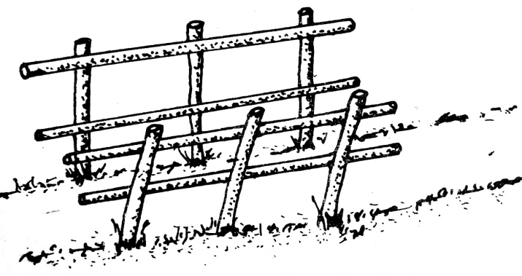

**a) Identify the structure ( 1 mark)**

* crush (1x 1 =1 mark)

**b) Name any four practices that a farmer can carry out in the structure (4 marks)**

* spraying livestock against external parasites
* identification
* vaccination
* administering prophylactic drugs to the animals
* treating sick animals
* dehorning
* pregnancy test
* artificial insemination
* taking body temperatures
* hoof trimming
* milking

(10x 1 =10 marks)

**18. Below are illustrations of farm tools labelled A, B, C and D**

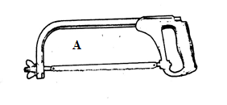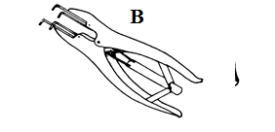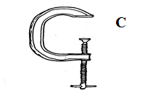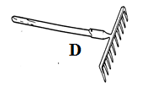

**a) Identify the tool/ equipment labeled A and B (2 marks)**

* A Hack saw
* B Elastrator

(2x 1 =2 marks)

**b) State one appropriate use of the tool labeled D. (1 mark)**

* Collecting trash
* Levelling a nursery bed

(1x 1 =1 mark)

**c) Explain two maintenance practices for the tool labelled C. (2 marks)**

* apply oil/ paint to prevent rusting
* grease the moving part to reduce friction

(2x 1 =2 marks)

**19. Given below are illustrations of two adult internal parasites of sheep labelled P and Q**

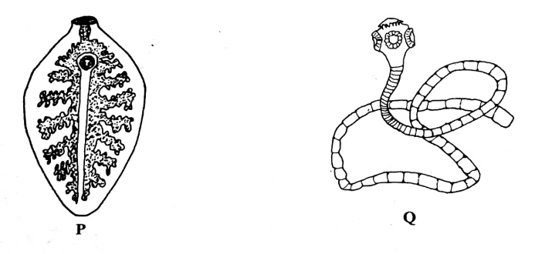

1. **Identify the parasites (2 marks)**

*P: Liver fluke/ Fasciola spp*

*Q: Tapeworm/ Taenia spp*

(2x 1 =2 marks)

1. **In which organs are parasite P and Q found? (2 marks)**

*P: Bile duct / liver*

*Q: Small intestines*

(2x 1 =2 marks)

1. **How should sheep suffering from parasite Q infestation be treated (1 mark)**

* *Deworming/ drenching with appropriate anthelminthics*

(1x 1 =1 mark)

**20. The diagram below represents an implement**

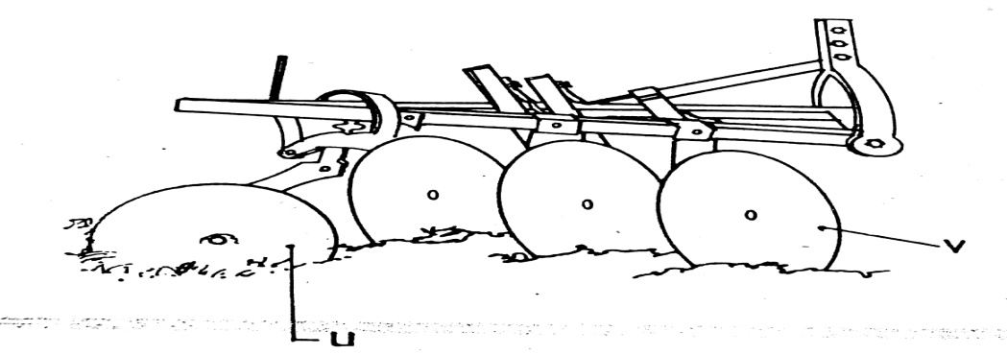

1. **identify the implement (1 mark)**

* *disc plough*

(1x 1 =1 mark)

1. **Name the parts labelled U and V and give one function of each (2marks)**

|  |  |  |
| --- | --- | --- |
|  | **Name of part** | **Function** |
| **U** | **Furrow/ rear thrust wheel** | **Balances the plough by resisting side thrust from the unploughed land** |
| **V** | **Concave plain disc** | **Cut, turn and invert furrow slices** |

1. ***State* two maintenance practices carried out on the implement shown in the diagram (2 marks)**

* Clean after work
* storing under shed
* Tighten loose nuts and bolts
* Replacing worn- out parts
* Repair broken parts
* Greasing moving parts
* Apply Oil/ painting for long storage

(2x 1 =2 marks)

**SECTION C**

***Answer any two questions from this section in the spaces provided after question 23.***

**21 a). Describe how each stroke in a four stroke cycle petrol engine operates. (8 marks)**

**(i) Induction stroke;**

* The piston moves down the cylinder; causing the inlet valve to open; and draw in fresh fuel- air mixture into the cylinder; exhaust valve closed

**(ii) Compression stroke.;**

* The inlet valve closes ;and the piston moves up the cylinder;. This compresses the fresh fuel – air mixture into the combustion chamber;, exhaust valve is closed.

**(iii) The power stroke.;**

* A spark is produced at the spark plug. This causes the fuel- air mixture to ignite and expand; resulting in pressure that forces the piston down the cylinder; Inlet valve and exhaust valve closed;

**(iv) The exhaust stroke;**

* The piston moves upwards; and the exhaust valve open;s. Exhaust gases escape through the open exhaust valve.; Inlet valve remains closed.
* **Stating the stroke – ½ mark**
* **Opening/closing of valves- ½ mark**
* **Action in the cylinder – ½ mark**

**b) *State* six signs that are likely to be observed when a cow is on heat ( 6 marks)**

* Swelling of the vulva
* Clear slimy mucus discharge from the vulva
* Frequent bellowing/ mooing
* Cow mount others and stands still when mounted by others
* Cow becomes restless
* Slight rise in body temperature
* Slight drop in milk in lactating cows
* Loss of appetite
* urinating frequently

(6x 1 =6 marks)

1. **Describe six factors considered when choosing the type of poultry rearing system (6 marks)**

* *Availability of land for rearing*
* *Topography of the land*
* *Availability of labour*
* *Availability of appropriate equipment*
* *Availability of capital*
* *Security*
* *Availability of market knowledge of the farmer.*

(6x 1 =6 marks)

**22 a) Discuss Foot and Mouth disease under the following headings:**

**(i) Casual organisms. (1mark)**

* Virus/ virus types O, A, C/ south African types SAT1, SAT2, SAT3, / Asian type 1

(1x 1 =1 mark)

**(ii) Livestock species attacked. (2marks)**

* *Cattle*
* *Pigs*
* *Goats*
* *Sheep*

(2x 1 =2 marks)

**(iii) Symptoms of attack. (4marks)**

* *Profuse salivation*
* *Blisters which are painful around the mouth and hooves of the feet leading to lameness*
* *Drop in milk production in lactating cows*
* *Sharp rise in temperature/ high fever*
* *Emaciation*
* *Complete loss of appetite*
* *Diarrhea*

(4x 1 =4 marks)

**22 b) State the uses of fences in farms. (8 marks)**

* Provide security from thieves, predators
* Enable paddocking/ rotational grazing/ mixed farming
* Control parasites and diseases by keeping away foreign animals
* Show boundaries between farms
* Hedges act as wind breaks/ conserve soil and water/ source of fruits/ fodder/ firewood
* Have an aesthetic value
* Provides privacy
* Enables isolation of animals for different purposes
* Add value to the farm
* Prevents formation of unnecessary paths within the farm

(any 8x 1 =8 marks)

**c) Describe digestion of grass in small intestines of ruminant animals (5marks)**

* In the duodenum food is mixed with bile and pancreatic juice (pancreatic amylase, lipase and trypsin)
* Bile emulsifies fats to increase the surface area for enzyme action; bile has salt to neutralize acid from stomach;
* Pancreatic amylase converts starch to maltose
* Trypsin converts proteins to peptones and peptides
* In the rest of small intestines, food is mixed with intestinal juice/ erepsin/peptidase, Maltase, sucrose/invertase & lactase enzymes)
* Sucrase (invertase) converts sucrose to glucose
* digested food material is absorbed in the ileum

(any 5x 1 =5 marks)

**23 a) Describe the factors considered when culling livestock. (5 marks)**

* *Poor health;*
* *Old age;*
* *Physical deformities;*
* *Hereditary defects;*
* *Infertility;*
* *Poor mothering ability*
* *Poor quality products;*
* *Low production;*
* *Bad temperament.*

(any 5x 1 =5 marks)

**b) Describe fivefactors that affect milk composition in dairy farming. (5 marks)**

* **Age of the animal**. - Butter fat reduces as the animal gets old thus young animals produce milk with higher butter fat than old animals.
* **Breed**. - Different breeds produce milk with differing percentages eg Jersey produce higher B/F content than Friesian.
* **Type of food eaten by the animal** - Roughage produce milk with higher fat, lactose and protein than that produced from grains.
* **Diseases**.- Diseases like mastitis reduces the lactose composition since bacteria attack milk sugars.
* **Physiological condition of the animal**- . Sickly/ extremely emaciated animals register low % B/F/ late pregnancy gives low B/F content.
* **Stage of lactation**. - Early and late stages of lactation yield milk with low B/F content than the middle stage.
* **Time of milking** - Milk produced in the morning has higher B/F content than milk produced in the evening.
* **Season of the year**- . Cold season yields milk with a higher B/F content.
* **Completeness of milking**.- Milk drawn last from the udder during milking has more B/F content.

(any 5x 1 =5 marks)

**23. c) Explain measures used to control livestock diseases. (10 marks)**

* General farm hygiene/ cleanliness of houses to avoid predisposing causes of diseases
* proper carcass disposal; to destroy pathogens
* Isolation; prevents spread of the diseases
* Deworming; to control internal parasites
* Treat sick animals; prevent spread of the diseases
* Vaccination; develop resistance against diseases by boosting immunity.
* Control vectors; prevent transmission of diseases
* Prophylaxis; avoids infection
* Slaughtering en- mass; prevent spread of diseases
* Proper breeding; control breeding diseases
* Quarantine; prevent spread of the diseases
* Hoof trimming; minimize occurrence of foot rot
* Proper housing; avoid predisposing causes of diseases
* Proper nutrition: prevent nutritional disorders/ boost immunity

(any 10x 1 =10 marks)