Nyaraya Cluster Examination
Kenya Certificate of Secondary Education
Form Four Mock Evaluation Programme

Name ………………………………………………………….………..Index no……..

School ……………………………………..….Date……………..Sign ……..…………..

Agriculture

443/2

Time: 2 hours

July 2023

Instructions

• Write down your name and index number in the spaces provided above
• Sign and write the date of examination in the spaces provided above
• This paper consists of three sections; A, B and C
• Answer ALL the questions in section A and B
• Answer any two questions in section C
• Candidates should answer all the questions in English

For exa min er ’s use onl y

Section | Question | Maximum score | Candidate’s score
A | 1-16 | 30
B | 17-20 | 20
C | 21 | 20
 | 22 | 20
 | 23 | 20
TOTAL |  | 90

SECTION A (30 MARKS)

Answer all questions in the spaces provided

1. Give four major features of exotic beef cattle breeds (2 Marks)

.......................................................................................................................................................

.......................................................................................................................................................

.......................................................................................................................................................

.......................................................................................................................................................

2. State four factors considered when selecting female rabbits for breeding (2 Marks)

.......................................................................................................................................................

.......................................................................................................................................................

.......................................................................................................................................................

.......................................................................................................................................................

3. State four ways of controlling tsetse flies. (2 Marks)

.......................................................................................................................................................

.......................................................................................................................................................

.......................................................................................................................................................

.......................................................................................................................................................

4. Give four ways of stimulating milk let-down in a dairy cow. (2 Marks)

.......................................................................................................................................................

.......................................................................................................................................................

.......................................................................................................................................................

.......................................................................................................................................................
5. State four disadvantages of natural mating as a method of breeding in dairy cattle management. (2 Marks)

.......................................................................................................................................................

.......................................................................................................................................................

.......................................................................................................................................................

.......................................................................................................................................................

6. Name two types of rabbit house. (1 Mark)

.......................................................................................................................................................

.......................................................................................................................................................

.......................................................................................................................................................

.......................................................................................................................................................

7. State four factors that would determine the amount of concentrate fed to dairy cattle.(2 Marks)

.......................................................................................................................................................

.......................................................................................................................................................

.......................................................................................................................................................

.......................................................................................................................................................

8. State four maintenance practices of a calf pen. (2 Marks)

.......................................................................................................................................................

.......................................................................................................................................................

.......................................................................................................................................................

.......................................................................................................................................................

9. Name any four farm implements that are operated through PTO shaft (2 Marks)

.......................................................................................................................................................

.......................................................................................................................................................

.......................................................................................................................................................

.......................................................................................................................................................
10. (a)What is dry cow therapy. (½ Marks)

.......................................................................................................................................................
....................................................................................................................................................... (b)Give three qualities of colostrum that makes it suitable for newborn calves. (1½ Marks)
.......................................................................................................................................................

.......................................................................................................................................................

.......................................................................................................................................................

.......................................................................................................................................................

11. State four disadvantages of a tractor as a source of power. (2 Marks)

.......................................................................................................................................................

.......................................................................................................................................................

.......................................................................................................................................................

.......................................................................................................................................................

12. List four types of vaccine used in livestock (2 Marks)

.......................................................................................................................................................

.......................................................................................................................................................

.......................................................................................................................................................

.......................................................................................................................................................

13. State four factors to consider when siting a fish pond. (2 Marks)

.......................................................................................................................................................

.......................................................................................................................................................

.......................................................................................................................................................

.......................................................................................................................................................

14. State four conditions that would encourage hens to eat eggs in poultry production (2 Marks)

.......................................................................................................................................................

.......................................................................................................................................................

.......................................................................................................................................................

.......................................................................................................................................................

15. State four methods of dehorning (2 Marks)

.......................................................................................................................................................

.......................................................................................................................................................

.......................................................................................................................................................

.......................................................................................................................................................

16. What is the causal organism for the following diseases

(a) Anthrax (½ Mark)

....................................................................................................................................................... (b)Bang's disease in pigs. (½ Mark)
.......................................................................................................................................................
SECTION B (20 Marks)

Answer ALL the questions in the spaces provided

17. The diagram below illustrates a livestock handling structure

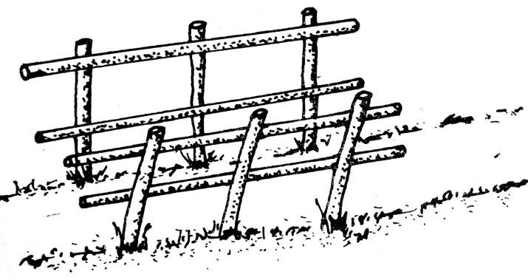

a) Identify the structure (1 Mark)

....................................................................................................................................................... b) Name any four practices that a farmer can carry out in the structure (4 Marks)

.......................................................................................................................................................

.......................................................................................................................................................

.......................................................................................................................................................

.......................................................................................................................................................

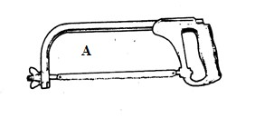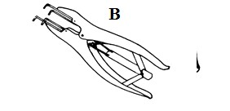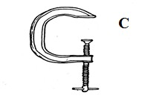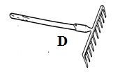18. Below are illustrations of farm tools labelled A, B, C and D

a) Identify the tool/ equipment labeled A and B (2 Marks)

A…………………………………………………………………………………………………………
B…………………………………………………………………………………………………………

b) State one appropriate use of the tool labeled D. (1 Mark)

.......................................................................................................................................................

....................................................................................................................................................... c) Explain two maintenance practices for the tool labelled C. (2 Marks)
.......................................................................................................................................................

.......................................................................................................................................................

19. Given below are illustrations of two adult internal parasites of sheep labelled P and Q

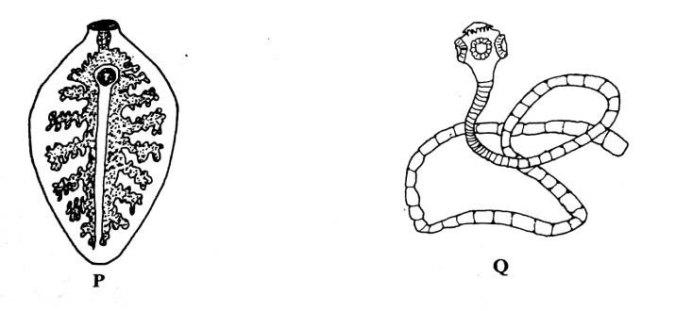

a) Identify the parasites (2 Marks) P……………………………………………………………………………………………………
Q……………………………………………………………………………………………………

b) In which organs in livestock are parasite P and Q found? (2 Marks)

.......................................................................................................................................................

....................................................................................................................................................... c) How should sheep suffering from parasite Q infestation be treated (1 Mark)
.......................................................................................................................................................

.......................................................................................................................................................

20. The diagram below represents an implement
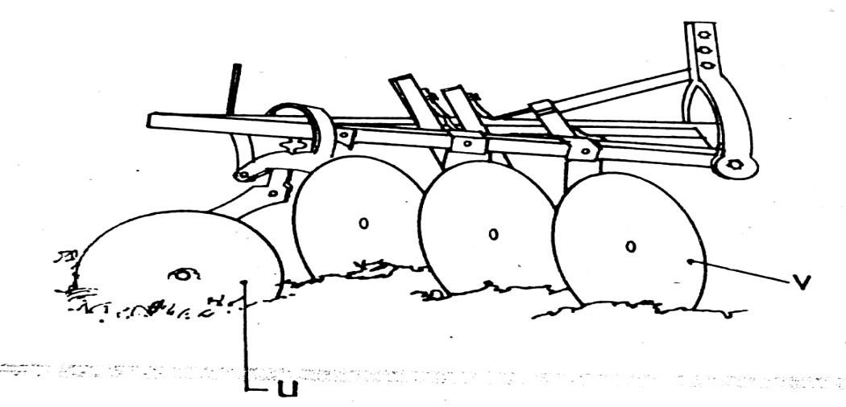

a) Identify the implement (1 Mark)

…………………………………………………………………………………………………………

b) Name the parts labelled U and V and give one function of each (2 Marks) U.................................................................................................

V............................................................................................

c) State four maintenance practices carried out on the implement shown in the diagram(2 Marks)

.......................................................................................................................................................

.......................................................................................................................................................

.......................................................................................................................................................

.......................................................................................................................................................
SECTION C (40 MARKS)

Answer any two questions from this section in the spaces provided after question 23.

21 a).Describe how each stroke in a four stroke cycle petrol engine operates. (8 Marks) b) State six signs that are likely to be observed when a cow is on heat (6 Marks) c) Describe six factors considered when choosing the type of poultry rearing system(6 Marks)

22 a) Discuss Foot and Mouth disease under the following headings:

(i) Casual organisms. (1 Mark) (ii) Livestock species attacked. (2 Marks) (iii) Symptoms of attack. (4 Marks) b) State the uses of fences in farms. (8 Marks) c) Describe digestion of grass in small intestines of ruminant animals (5 Marks)

23 a) Describe the factors considered when culling livestock. (5 Marks) b) Describe five factors that affect milk composition in dairy farming. (5 Marks) c) Explain measures used to control livestock diseases. (10 Marks)

………………………………………………………………………………………………………

………………………………………………………………………………………………………

………………………………………………………………………………………………………

………………………………………………………………………………………………………

………………………………………………………………………………………………………

………………………………………………………………………………………………………

………………………………………………………………………………………………………

………………………………………………………………………………………………………

